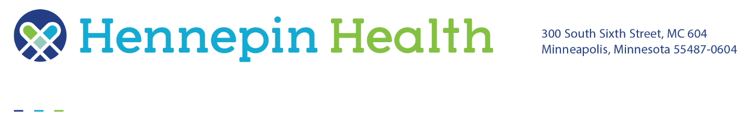

Hennepin Health car seat program

Frequently asked questions (FAQ)

Hennepin Health cares for the safety of all members, including children. Car seats keep babies and children safe and reduce the risk of injury and death.

**Who is eligible to receive a car seat?**

* A Hennepin Health member who is at least 28 weeks pregnant or
* A Hennepin Health member who is a child between 0 to 8 years old

**Are the car seats free?**

Yes, the car seats are free to Hennepin Health members who meet the eligibility requirements above.

**How do I get a car seat?**

You will receive a car seat after completing the class. Parents or guardians who are not Hennepin Health members can complete the class and receive a car seat, if the seat is for a member who is an infant/child.

**How many car seats can a member receive?**

Each Hennepin Health member who has or is an infant/child can receive an age-appropriate car seat.

**What types of car seats are available?**

Three types of car seats are available: a convertible seat, a combination seat, and a booster seat. The type of seat a member receives is based upon whichever one is safest for the child using it. This is determined at the time of the class. Most members, if they stay with Hennepin Health, could receive all three car seats.

**If my car seat is involved in a crash, can I receive a new one?**

Yes, the member should contact us with proof of the accident (e.g., police report) and can receive a new car seat without having to attend another class.

**How do I register for a car seat class?**

Members can register online or by phone at either Milk Moms or Everyday Miracles. Your provider can assist you in registering for a car seat class. Please contact Hennepin Health Member Services at 612-596-1036 if you need assistance.

*Milk Moms*

To sign up for a class, call 763-259-8824 or fill out the [Service Request Form](https://www.milkmoms.com/service-request-form/) to register for the [Car Seat Program](https://www.milkmoms.com/programs/car-seat-program/). Once registered, the car seat pick-up appointment date and time will be set. The car seat class is provided via video.

* Video class is about 30 minutes long. Appointment to receive the car seat is about 10 minutes.
* Car seats are picked up at the Milk Moms Andover location. Hours are 10 a.m. -4 p.m.
* Types of car seats available: convertible (newborn to 3 years), high back booster (3-6 years), backless booster (6-9 years).
* Also offer free breast pumps, support belt, compression socks, blood pressure monitor and other maternity items. Visit [https://www.milkmoms.com/ insurance-covered-programs](https://www.milkmoms.com/%20insurance-covered-programs) for more information.

*Everyday Miracles*

To sign up for a class, call 612-353-6293 or visit <https://www.everyday-miracles.org/requests> and click on “begin my request.” A car seat technician will call you to schedule a time to deliver the seat and provide one-on-one safety education (this usually takes 3 weeks from the date of request).

* Location of class can be determined with your car seat technician. They will come to your home or other location to provide class and deliver car seat.
* In-person class is about 30 minutes long
* Types of car seats available: convertible (newborn to 3 years), high back booster (3-6 years), backless booster (6-9 years).
* Also offer doula services, breast pumps and education classes (available in Spanish)

**What if I can’t attend the class after I have scheduled it?**

If you need to cancel or reschedule a car seat class, please call where you are registered for a class to let them know and to reschedule the class.

**What if I need transportation to the class?**

When you register for the class, let the staff know that you need transportation. They will arrange it for you.

You can also call Hennepin Health Member Services at 612-596-1036, TTY 711.

**Can I have an interpreter at my class?**

Yes, Milk Moms and Everyday Miracles have interpretation available, but may be limited.

If you cannot get the interpretation you need from Milk Moms or Everyday Miracles, call Hennepin Health Member Services at 612-596-1036, TTY 711 to schedule an interpreter for your class.