METRO Blue Line extension (Bottineau LRT) and health
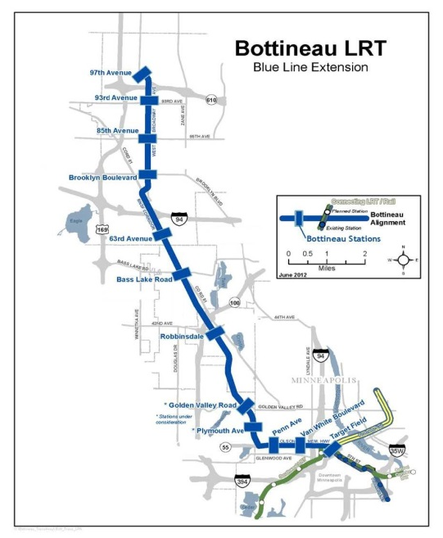
Health starts in the environments where we live, learn, work and play. The way we plan and design our communities plays a big role in our physical, emotional and financial health. Transportation features such as highways, roads and sidewalks are part of community design. Traditionally, the health costs and benefits of transportation projects were not considered when planning a project, but that is changing. Planning for the Bottineau light rail transit (LRT) line is considering these impacts, first in a study called the Bottineau Transitway Health Impact Assessment (HIA) and now in the process for planning the areas around each Bottineau LRT station.
Improving health for all
Oak Grove Parkway
Healthy communities make healthy choices easy for all. The Bottineau HIA found that the transit line offers real potential to improve health for people in communities near the transit stations as well as for transit users from around the region, by improving physical activity levels, job access, housing and transportation costs, traffic safety, education access and access to healthy food.
Many of us would like to make healthier choices, but that can be hard if things like sidewalks, parks and healthy foods aren’t available in our community. Historically, a person’s race determined which community they lived in.
In Hennepin County, low-income communities and communities of color have higher rates of preventable health problems, such as obesity and type II diabetes, than do white and higher income populations. These differences are the result of a wider set of forces: economics, social policies, politics, and our built environment.
These forces can be influenced and changed. Health equity results when avoidable differences in health are eliminated. Station area plans should advance community health and health equity.
The METRO Blue Line extension (Bottineau LRT) is a 13-mile LRT corridor that will connect Golden Valley, Robbinsdale,
Crystal, and Brooklyn Park to downtown Minneapolis and our region’s transitway system. The LRT line will have up to 11 stations.
Health at your station
Housing and transportation costs
Transportation and housing costs are the two largest expenses for families. Locations with low-cost housing can still be expensive to live in because of higher transportation costs. Lowering transportation costs can leave more money in budgets for resources that promote health, like nutritious food and health care. Budgets less burdened by transportation costs can help reduce stress and prevent homelessness. The transit line could make housing and transportation more affordable because neighborhoods with access to transit, walkable streets and a variety of services have lower transportation costs. Efforts are needed to ensure that housing is kept affordable at station areas.
Employment
When people have a job with a living wage, they tend to live longer and have better physical and mental health. The transit line may also encourage economic and job growth in the community and station area. Increasing transit connections to jobs expands options for employment. In some areas along the Bottineau LRT line, nearly 60 percent of households do not own a car.
Traffic safety
Transit is one of the safest forms of transportation available. More people riding transit means more people are using a safer mode of transportation and will be less likely to be involved in traffic crashes. Investments for improved walking and biking environments, such as improved crossings and bike lanes, can reduce the risk of traffic related injuries and death. There is safety in numbers, increased pedestrian and bicycle activity can result in lower rates of bike and pedestrian traffic accidents.
Access and mobility
Transit can increase access to important destinations, and increase opportunity and reduce social isolation among those who do not drive. One in five adults aged 65 and older in Hennepin County do not drive and one in five households in the station areas do not own a car. The transit line could improve access to important destinations such as schools, health care, grocery stores, jobs and parks for area residents and the region’s transit users – particularly for those under age 18, over age 65 and the disabled.
Healthy community design in station area planning
You can have input on healthy community design in the station area planning process for the Bottineau LRT line. Planning for the areas around the proposed stations in will begin in 2014, starting in Minneapolis and Golden Valley. Information will be posted on www.hennepin.us/bottineau.
Some healthy community design features are listed below. How should station area planning address these features? Which are most important to you?
    - Housing for different incomes and different stages of life
    - Easy connections to the public transit system
    - Mixed-land use: homes, shops, schools, and work are close together
    - Socially equitable & accessible community
    - Jobs and education are accessible within and from the community
    - Safe and comfortable places for walking and biking
    - Safe public places for social interaction
    - Green spaces and parks that are easy to get to
    - Outlets for fresh, healthy food
Resources
- For more information on the METRO Blue Line extension (Bottineau LRT) visit the Metropolitan Council’s project website at BlueLineExt.org.
- For information on Bottineau LRT & health visit www.hennepin.us/bottineau.
- For healthy community planning resources visit http://www.cdc.gov/healthyplaces/toolkit/.

