Zero Waste Challenge media kit

About the challenge
The Hennepin County Zero Waste Challenge provides personalized help to households to assess the waste they generate, develop a customized waste-reduction plan, and make low-waste lifestyle changes.
Throughout the eight-month challenge, participating households develop a personalize waste reduction plan, receive one-on-one coaching and support, attend educational workshops, receive waste reduction tips, get access to supplies and educational materials, and connect with other households.
The challenge will run from September 2024 through April 2025. The application is open from August 1 through August 31, 2024 at hennepin.us/zerowastechallenge.

Help spread the word and encourage households to apply
Ways to encourage households to join the challenge:
- Use the sample newsletter article to share on your organization’s website or in your newsletters. These are editable so you can customize the length or message.
- Use the sample social media posts to share through your social media channels. These are editable so you can customize the message and website.
- Follow and reshare messages posted on the Hennepin County Environment and Energy social media channels: Hennepin Environment on Facebook, Hennepin Environment on Instagram, and @hennepinenviro on X/Twitter
- Share the information and resources available at hennepin.us/zerowastechallenge

Contact
For more information about the Zero Waste Challenge, contact:
- Amy Maas, Zero Waste Challenge coordinator, amy.maas@hennepin.us

Sample newsletter article – short

Get personalized help to adopt a lower waste lifestyle by joining the Zero Waste Challenge
Many people are interested in reducing waste, decluttering, and recycling more but aren’t sure where to start or how to take the next step. Joining Hennepin County’s Zero Waste Challenge is a great way to learn more and get hands-on help.

A lifestyle game-changer for past participants
Carolyn Wieland of Eden Prairie said the Zero Waste Challenge was “truly life changing for our family. It made us take an in depth look at our consumption and waste habits and equipped us with tools and strategies to become better stewards of the environment.”
Jenny Mikkelson of Minnetonka said the support from county staff and volunteers made taking steps toward a lower waste lifestyle less overwhelming and more obtainable. “It was a great opportunity to learn as a family, adults and child alike,” adds the Nolan-Eickholt family of Osseo.

Apply to join the challenge
Throughout the eight-month challenge, participating households receive personalized coaching and support, attend educational workshops, receive waste reduction tips, get access to supplies and educational materials, and connect with other households striving to live lower waste lifestyles.
The challenge will run from September 2024 through April 2025. The application is open from August 1 through August 31, 2024 at hennepin.us/zerowastechallenge.

Sample newsletter article – long

Get personalized help to adopt a lower waste lifestyle by joining the Zero Waste Challenge
Many people are interested in reducing waste, decluttering, and recycling more but aren’t sure where to start or how to take the next steps. Joining Hennepin County’s Zero Waste Challenge is a great way to learn more and get hands-on help.
The county is looking for households to participate in the eight-month-long challenge that takes an in-depth look at the goods we buy and waste we create to uncover opportunities to recycle more and reduce waste.

How the challenge works
Participating households:
- Assess the waste generated in their household then develop a personalized waste reduction plan based on their biggest opportunities to reduce waste and what will work best for their lifestyle.
- Receive one-on-one coaching and support from county waste reduction and recycling specialists or certified Community Recycling Ambassadors to make low-waste lifestyle changes.
- Attend educational workshops on waste-reduction topics such as low-waste shopping, preventing food waste, and backyard composting.
- Receive waste reduction tips and get access to supplies and educational materials.
- Connect with other households striving to live lower waste lifestyles.

A lifestyle game-changer for past participants
Carolyn Wieland of Eden Prairie said the Zero Waste Challenge was “truly life changing for our family. It equipped us with tools and strategies to become better stewards of the environment.”
Households on average reduce their waste by 25% to 30%. By the end of the challenge, they recycle or compost 60% to 70% of their waste – which is much higher than the county average of about 40%.
Jenny Mikkelson of Minnetonka said the support from county staff and volunteers made taking steps toward a lower waste lifestyle less overwhelming and more obtainable. “It was a great opportunity to learn as a family, adults and child alike,” adds the Nolan-Eickholt family of Osseo.

Learn practical solutions to prevent waste and practice more thoughtful consumption
You may be surprised by the variety of actions you can take to reduce waste!
Most participants use some form of composting to achieve high recycling rates. Gale Cannon from Brooklyn Park started taking her food scraps and other compostable items to the county’s Brooklyn Park drop-off facility during the challenge. She said, “I appreciated the help along the way and great ideas to reduce waste and become more environmentally friendly.”
Participants also focus on eliminating disposables, preventing waste in the first place, and learning new skills. Many have had a greater impact by sharing what they’ve learned with their friends, family, and community.
“I was inspired by other people in the challenge. Being part of the group was empowering,” said Heidi Voss of Bloomington. “I try to demonstrate to my family, friends, and coworkers how to reduce and reuse, and how to incorporate this mindset in every purchase we make. It can actually be a really fun challenge.”

Participate in the next Zero Waste Challenge
The challenge will run from September 2024 through April 2025. The application is open from August 1 through August 31, 2024 at hennepin.us/zerowastechallenge.

Social media posts
Suggested hashtags: #HennepinZeroWaste #ZeroWasteChallenge #ZeroWaste #ZeroWasteLiving
To use images and graphics: right click on image and select Save as Picture.

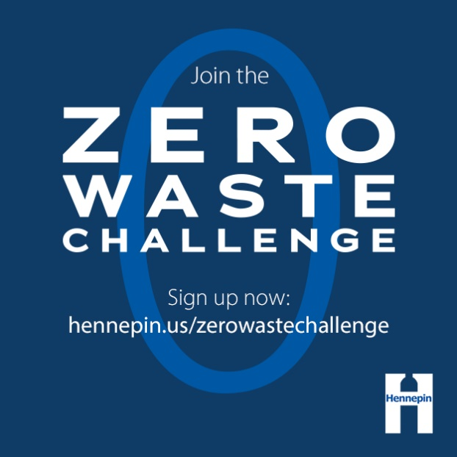
Post 1: Get personalized help
Facebook: Households that participate in the Zero Waste Challenge reduce their waste 25%! If you’re interested in reducing waste and recycling more but aren’t sure where to start or how to take the next step, joining the challenge is a great way to learn more and get personalized help to live a lower-waste lifestyle. Apply by August 31 at hennepin.us/zerowastechallenge
Twitter: Households that participate in the Zero Waste Challenge reduce their waste 25%! Get personalized help to live a lower-waste lifestyle by joining the Zero Waste Challenge. Apply by August 31 at hennepin.us/zerowastechallenge #ZeroWasteChallenge #ZeroWaste
Instagram: Households that participate in the Zero Waste Challenge reduce their waste 25%! Many people are interested in reducing waste and recycling more but aren’t sure where to start or how to take the next step. Joining the challenge is a great way to learn more and get hands-on help to live a lower-waste lifestyle. Apply by August 31 at the link in our bio. #ZeroWasteChallenge #ZeroWaste
Images:
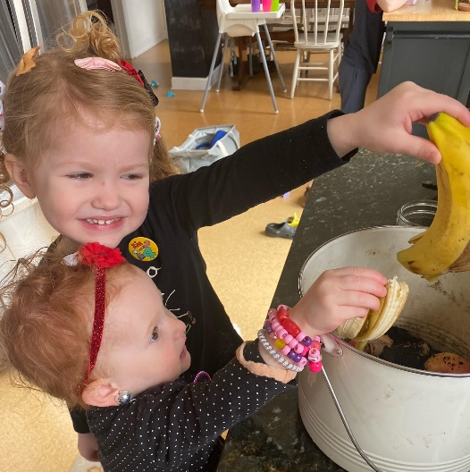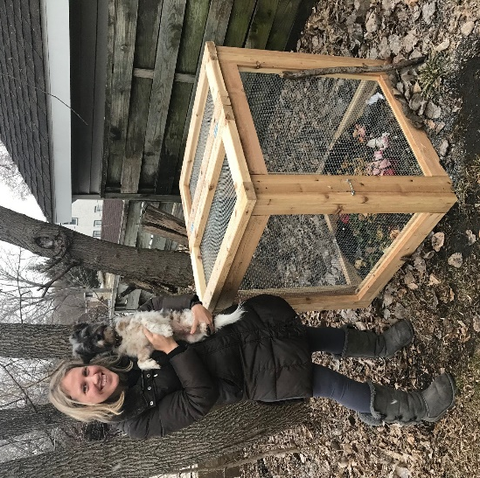

Post 2: Households receive
Facebook: Join the Zero Waste Challenge to receive a customized waste-reduction plan, personalized coaching from waste reduction experts, access to supplies and resources, and opportunities to connect with other households. Learn about the impressive results that participating households achieve and join the challenge at hennepin.us/zerowastechallenge. Apply by August 31.
Twitter: Join the Zero Waste Challenge to receive a customized waste-reduction plan, personalized coaching from waste reduction experts, access to supplies and resources, and opportunities to connect with other households. Apply by August 31: hennepin.us/zerowastechallenge #ZeroWaste
Instagram: Join the Zero Waste Challenge to receive a customized waste-reduction plan, personalized coaching from waste reduction experts, access to supplies and resources, and opportunities to connect with other households taking the challenge. Apply by August 31 at the link in our bio. #ZeroWaste
Images:
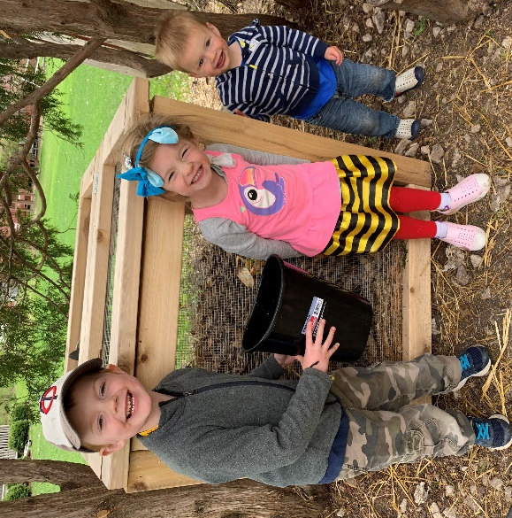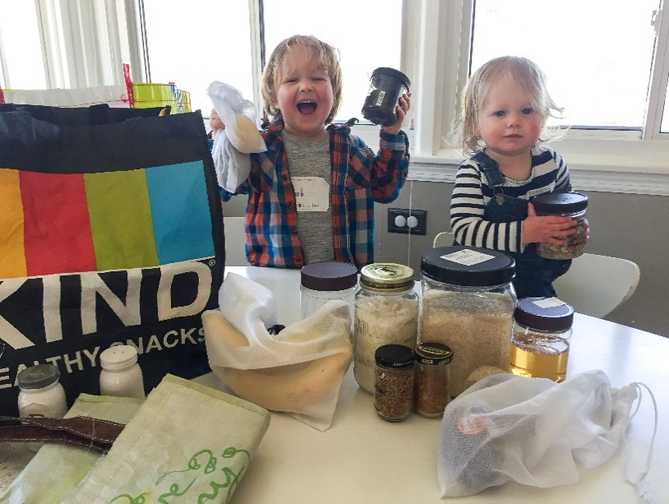
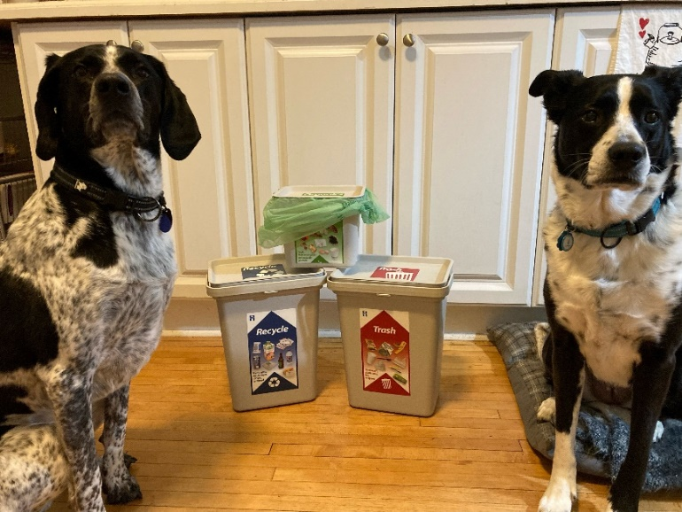

Additional photos for promotions
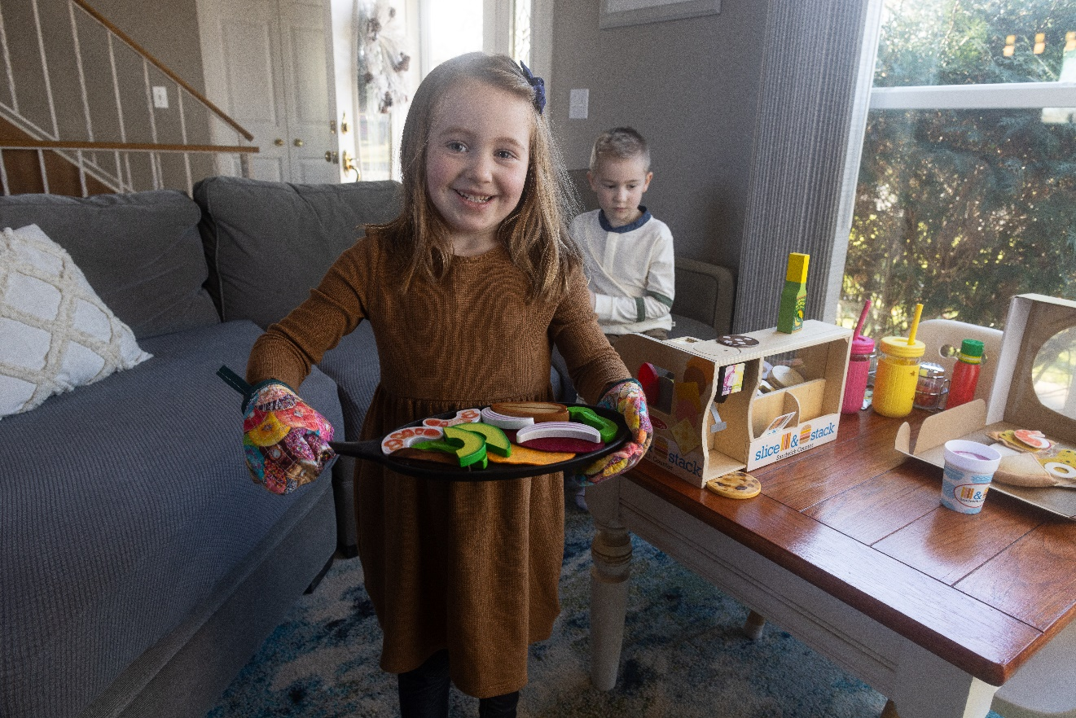

Testimonials

Testimonial 1: Life changing
Facebook: “Truly life-changing for our family,” is what Carolyn Wieland of Eden Prairie said of the Hennepin County Zero Waste Challenge. “It equipped us with tools and strategies to become better stewards of the environment.” Get personalized help to live a lower-waste lifestyle by joining the Zero Waste Challenge. Apply by August 31 at hennepin.us/zerowastechallenge
Twitter: “Truly life-changing for our family,” is what Carolyn Wieland of Eden Prairie said of the Hennepin County Zero Waste Challenge. Get personalized help to live a lower-waste lifestyle by joining the Zero Waste Challenge. Apply by August 31 at hennepin.us/zerowastechallenge #ZeroWaste
Instagram: “Truly life-changing for our family,” is what Carolyn Wieland, @edenprairielife, said the Hennepin County Zero Waste Challenge. “It equipped us with tools and strategies to become better stewards of the environment.” The Zero Waste Challenge offers personalized help to live a lower-waste lifestyle. Applications to join the challenge are being accepted through August 31 at the link in our bio. #ZeroWasteChallenge
Image:
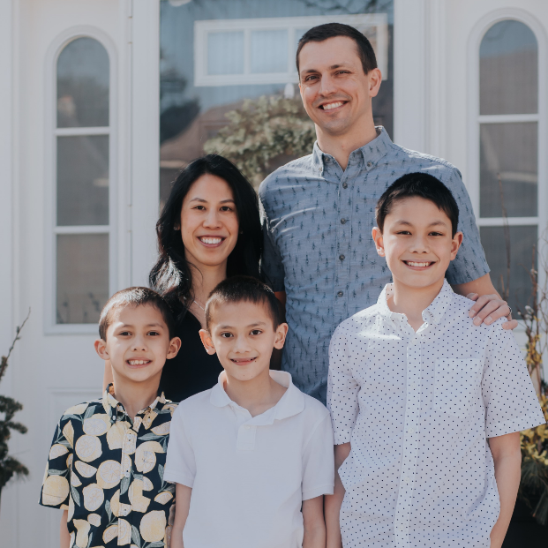

Testimonial 2: I learned a lot
Facebook: “I learned a lot. I appreciated the help along the way and great ideas to reduce waste and become more environmentally friendly.” Like a lot of participants in Hennepin County’s Zero Waste Challenge, Gale Cannon from Brooklyn Park started composting her food scraps and other compostable items during the challenge. Get personalized help to live a lower-waste lifestyle by joining the Zero Waste Challenge. Apply by August 31 at hennepin.us/zerowastechallenge
Twitter: "I appreciated the help and great ideas to reduce waste and become more environmentally friendly,” said Gale Cannon from Brooklyn Park on her experience in Hennepin County's Zero Waste Challenge. Get personalized help to live a lower-waste lifestyle hennepin.us/zerowastechallenge #ZeroWasteChallenge #ZeroWaste
Instagram: “I learned a lot. I appreciated the help along the way and great ideas to reduce waste and become more environmentally friendly.” Like a lot of participants in Hennepin County’s Zero Waste Challenge, Gale Cannon from Brooklyn Park started composting her food scraps and other compostable items during the challenge. The Zero Waste Challenge offers personalized help to live a lower-waste lifestyle. Applications to join the challenge are being accepted through August 31 at the link in our bio. #ZeroWasteChallenge #ZeroWaste
Image:

Testimonial 3: It was a great opportunity to learn as a family
Facebook: “It was a great opportunity to learn as a family, adults and child alike.” The Nolan-Eickholt family of Osseo highly recommends the Hennepin County Zero Waste Challenge to others. "Our experience was entirely positive. It changed the way we bring items in and dispose of items in our lives. And, we have been able to pass on nuggets of knowledge to friends and family who are eyeing a reduced waste lifestyle.”
Learn about the impressive results that participating households achieve, how they do it, and join the challenge hennepin.us/climate-action/what-we-can-do/low-waste-lifestyle
Twitter: "It was a great opportunity to learn as a family.” The Nolan-Eickholt family of Osseo highly recommends the Zero Waste Challenge, both because it helped them reduce their waste and gave them knowledge to pass on to others. hennepin.us/climate-action/what-we-can-do/low-waste-lifestyle #ZeroWasteChallenge #ZeroWaste
Instagram: “It was a great opportunity to learn as a family, adults and child alike.” The Nolan-Eickholt family of Osseo highly recommends the Hennepin County Zero Waste Challenge to others. "Our experience was entirely positive, and it has changed the way we bring items in and dispose of items in our lives. And, we have been able to pass on nuggets of knowledge to friends and family who are eyeing a reduced waste lifestyle.” Applications for the challenge are being accepted through August 31 at the link in our bio. #ZeroWasteChallenge #ZeroWaste
Image:
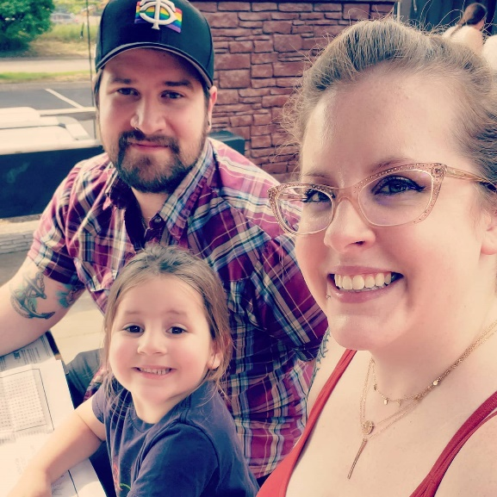

Testimonial 4: The challenge was informative, easy, and fun
Facebook: Informative, easy, and fun! That’s how Mark Werley of Minnetonka describes the Hennepin County Zero Waste Challenge. The compost bin they set up with support from county staff that “has dramatically reduced the weight and volume of our trash while getting us to think that much more about reducing our food waste. Overall, the program helped us feel more confident about what we can and should recycle - and even better - what to reuse or repurpose!” Apply now at hennepin.us/zerowastechallenge.
Twitter: Informative, easy, and fun! That’s how Mark Werley of Minnetonka describes the Zero Waste Challenge. “Overall, the program helped us feel more confident about what we can and should recycle – and even better – what to reuse or repurpose!” Apply now at hennepin.us/zerowastechallenge #ZeroWasteChallenge #ZeroWaste
Instagram: Informative, easy, and fun! That’s how Mark Werley of Minnetonka describes the Hennepin County Zero Waste Challenge. The compost bins they set up with support from county staff that “dramatically reduced the weight and volume of our trash while getting us to think that much more about reducing our food waste. Overall, the program helped us feel more confident about what we can and should recycle - and even better - what to reuse or repurpose! Applications are being accepted through August 31 at the link in our bio. #ZeroWasteChallenge #ZeroWaste
Image:
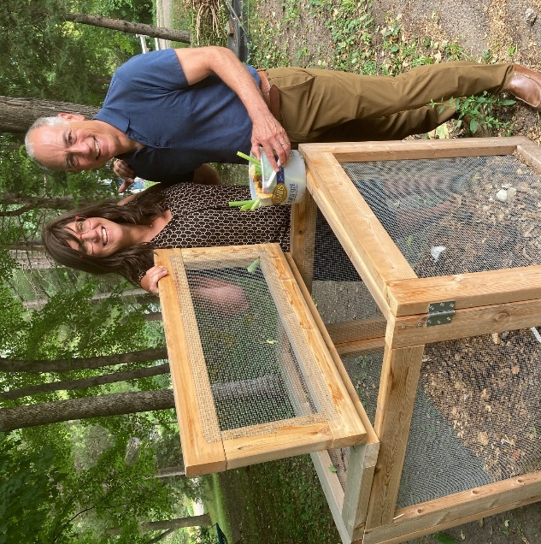

Testimonial 5: It was important to get the younger generation involved
Facebook: Support from county staff and volunteers through the Hennepin County Zero Waste Challenge made taking steps toward a lower waste lifestyle less overwhelming and more obtainable for Jenny Mikkelson of Minnetonka.
“It was important to start getting the younger generation (our son) to understand and appreciate the importance of recycling, visiting secondhand stores, learning our city has organics drop off, putting in our own compost, visiting libraries, reusing bags at the grocery store and farmers market, and even fixing items around the house that we deemed broken.”
Join the challenge at hennepin.us/zerowastechallenge.
Twitter: Support from county staff and volunteers through the Hennepin County Zero Waste Challenge made taking steps toward a lower waste lifestyle less overwhelming and more obtainable for Jenny Mikkelson of Minnetonka. Join the challenge hennepin.us/zerowastechallenge #ZeroWasteChallenge #ZeroWaste
Instagram: Support from county staff and volunteers through the Hennepin County Zero Waste Challenge made taking steps toward a lower waste lifestyle less overwhelming and more obtainable for Jenny Mikkelson of Minnetonka.
“It was important to start getting the younger generation (our son) to understand and appreciate the importance of recycling, visiting secondhand stores, learning our city has organics drop off, putting in our own compost, visiting libraries, reusing bags at the grocery store and farmers market, and even fixing items around the house that we deemed broken.” #ZeroWasteChallenge #ZeroWaste
Image:
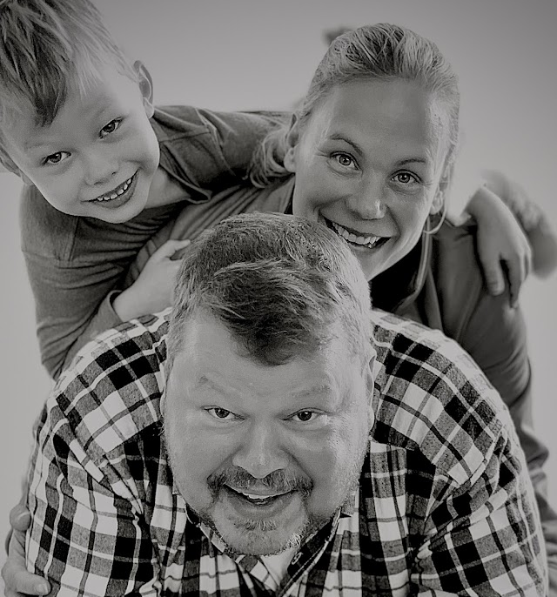

Testimonial 6: A fantastic experience that opened our eyes
Facebook: The Hennepin County Zero Waste Challenge “opened our eyes to many wasteful habits we had and inspired us to continue to find ways to reduce our environmental impact,” said Claire Zeise of Minneapolis. “Through the informative presentations, helpful resources, and supportive staff, we were able to implement many easy and impactful changes to reduce our household waste.” Join the challenge at hennepin.us/zerowastechallenge.
Twitter: Claire Zeise of Minneapolis called the Hennepin County Zero Waste Challenge a fantastic experience. “Through the informative presentations, helpful resources, and supportive staff, we were able to implement many easy and impactful changes.” Join now at hennepin.us/zerowastechallenge #ZeroWasteChallenge #ZeroWaste
Instagram: The Hennepin County Zero Waste Challenge “opened our eyes to many wasteful habits we had and inspired us to continue to find ways to reduce our environmental impact,” said Claire Zeise of Minneapolis. “Through the informative presentations, helpful resources, and supportive staff, we were able to implement many easy and impactful changes to reduce our household waste.” Join now – applications are being accepted through August 31 at the link in our bio. #ZeroWasteChallenge #ZeroWaste
Image:
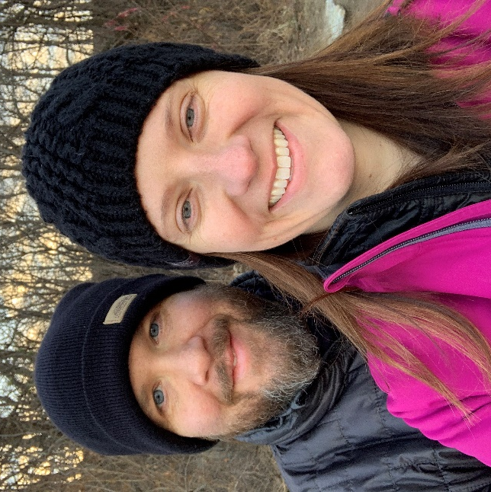

Testimonial 7: Just what we needed to start composting and reduce food waste
Facebook: “The challenge was just the thing we needed to start composting,” said Linda Solheid of Eden Prairie. With help through the Hennepin County Zero Waste Challenge, the Solheid’s also reduced their food waste. “The challenge helped us change our eating habits to make sure we use up leftovers so they don’t go to waste, and I check my refrigerator before shopping so I don’t overbuy.” Join the challenge at hennepin.us/zerowastechallenge.
Twitter: “The challenge was just the thing we needed to start composting,” said Linda Solheid of Eden Prairie. With help through the Hennepin County Zero Waste Challenge, the Solheid’s also reduced their food waste! Join the challenge at hennepin.us/zerowastechallenge. #ZeroWasteChallenge #ZeroWaste
Instagram: “The challenge was just the thing we needed to start composting,” said Linda Solheid of Eden Prairie. With help through the Hennepin County Zero Waste Challenge, the Solheid’s also reduced their food waste. “The challenge helped us change our eating habits to make sure we use up leftovers so they don’t go to waste, and I check my refrigerator before shopping so I don’t overbuy.” Join now – applications are being accepted through August 31 at the link in our bio. #ZeroWasteChallenge #ZeroWaste
Image:
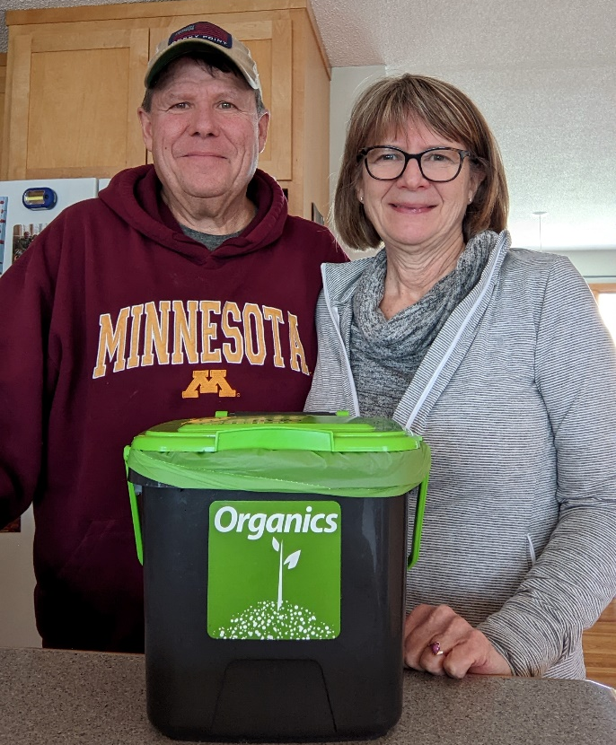

Testimonial 8: Others in the challenge were inspiring and empowering
Facebook: “I was inspired by other people in the challenge. Being part of the group was empowering,” said Heidi Voss of Bloomington of the Hennepin County Zero Waste Challenge. She’s using that inspiration to encourage others in her life. “I try to demonstrate to my family, friends, and coworkers how to reduce and reuse, and how to incorporate this mindset in every purchase we make. It can actually be a really fun challenge.” Reduce your waste and be a model for your community by joining the Zero Waste Challenge at hennepin.us/zerowastechallenge.
Twitter: “I was inspired by other people in the challenge. Being part of the group was empowering,” said Heidi Voss of Bloomington of the Hennepin County Zero Waste Challenge. Reduce your waste and be a model for your community by joining the Zero Waste Challenge at hennepin.us/zerowastechallenge. #ZeroWasteChallenge #ZeroWaste
Instagram: “I was inspired by other people in the challenge. Being part of the group was empowering,” said Heidi Voss of Bloomington of the Hennepin County Zero Waste Challenge. She’s using that inspiration to encourage others in her life. “I try to demonstrate to my family, friends, and coworkers how to reduce and reuse, and how to incorporate this mindset in every purchase we make. It can actually be a really fun challenge.” Reduce your waste and be a model for your community by joining the Zero Waste Challenge. Applications are being accepted through August 31 at the link in our bio. #ZeroWasteChallenge #ZeroWaste
Image:
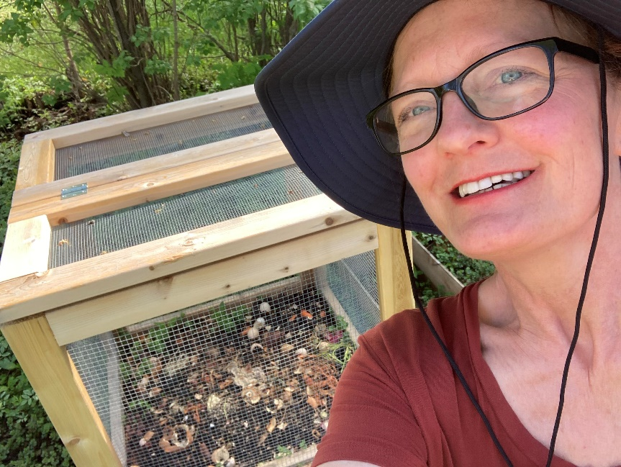

Testimonial 9: The challenge changed the way we think
Facebook: The Hennepin County Zero Waste Challenge “profoundly changed the way we think about what and how we consume on a daily basis,” said Val Black of Minneapolis. “Now we actually stop to think about every purchase we make, asking ourselves: do we really need this? Can we limit the packaging? Can this item be recycled or reused in any way?” Gain the knowledge and skills to reduce waste in your life by joining the Zero Waste Challenge at hennepin.us/zerowastechallenge.
Twitter: The Hennepin County Zero Waste Challenge “profoundly changed the way we think about what and how we consume on a daily basis,” said Val Black of Minneapolis. Gain the knowledge and skills to reduce waste in your life by joining the Zero Waste Challenge at hennepin.us/zerowastechallenge. #ZeroWasteChallenge #ZeroWaste
Instagram: The Hennepin County Zero Waste Challenge “profoundly changed the way we think about what and how we consume on a daily basis,” said Val Black of Minneapolis. “Now we actually stop to think about every purchase we make, asking ourselves: do we really need this? Can we limit the packaging? Can this item be recycled or reused in any way?” Gain the knowledge and skills to reduce waste in your life by joining the Zero Waste Challenge. Applications are being accepted through August 31 at the link in our bio. #ZeroWasteChallenge #ZeroWaste
Image:
