Promotional materials for the Stop Food Waste Challenge

About the challenge
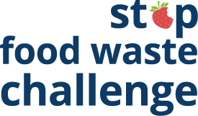
Nearly 40% of food is wasted somewhere along the supply chain in the U.S., and much of that food waste happens at home. All that wasted food adds up to wasted money. The average family of four spends more than $2,500 on food that goes to waste every year.
By wasting less food, we can save money, save time at the grocery store, and gain confidence in the kitchen. By coming together with our community, we can make a real difference toward reducing waste and fighting climate change.
The Stop Food Waste Challenge, stopfoodwaste.ecochallenge.org, will help participants learn more about why food goes to waste in their households and improve skills in cooking, planning, shopping, and storing food. The challenge has more than 60 actions to choose from in six categories. Participants check off the actions they already take, then select up to 10 actions to track progress on during the four-week challenge.
Participants can create or join a team to take the challenge along with their family, friends, or neighbors. Organizations and businesses, including community groups, neighborhoods, schools, retailers, and more, can become a Stop Food Waste Challenge partner. Partners help increase promotion, recruitment, and engagement for the challenge.

Contact
The online Stop Food Waste Challenge is offered in partnership with Hennepin County, Ramsey County, and Washington County and is powered by EcoChallenge.
For more information about the challenge, contact the Zero Waste Challenge coordinator at ZWC@hennepin.us

Help spread the word and encourage others to join
Some ways that you can help spread the word about the Stop Food Waste Challenge and encourage others to join:
- Use the sample newsletter articles (pages 5-8) to share on an organization’s website or in newsletters. Customize the length or message.
- Use the sample social media posts and graphics (pages 10-16) to share on your social media channels. Customize the message. Use #StopFoodWaste.
- Download additional resources from stopfoodwaste.ecochallenge.org/about/resources
- Become a Stop Food Waste Challenge partner – details about partnership are on page 3.
- Download, print, and post or hand out flyers – linked on page 4 – to promote the event and encourage others to join your team.
- Invite people you know directly using the sample email message on page 9.
- Create a team or join an existing team and invite people you know – your friends, family, neighbors, colleagues, etc. – to join you. Your teammates will keep each other motivated and accountable. Invitations can be sent through the Stop Food Waste Challenge website.
- Follow and reshare messages posted on the Hennepin, Ramsey, and Washington counties’ social media channels:
  - Hennepin County:
    - Hennepin Environment on Facebook
    - @hennepinenvironment on Instagram
    - @HennepinEnviro on Twitter
  - Ramsey County:
    - Ramsey County Minnesota on Facebook
    - @ramseycountymn on Instagram
    - @RamseyCounty on Twitter
  - Washington County:
    - Washington County MN on Facebook
    - @WashingtonCoMN on Twitter

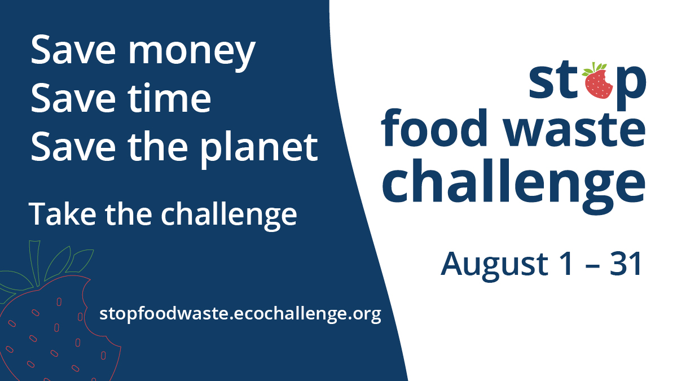
Become a Stop Food Waste Challenge partner

The Stop Food Waste Challenge (stopfoodwaste.ecochallenge.org), offered by Hennepin, Ramsey, and Washington counties, helps residents learn more about why food goes to waste in their households and improve skills in cooking, planning, shopping, and storing food. By wasting less food, we can save money, save time at the grocery store, and gain confidence in the kitchen. By coming together with our community, we can make a real difference toward reducing waste and fighting climate change.
But we can’t do it alone!
We need your organization’s help with promotion and engagement for the upcoming Stop Food Waste Challenge, which will run in August 2025.
All partners will have their logo displayed on the challenge website, gain access to promotional materials, and get recognition and cross-promotion during the challenge. There is no cost to becoming a partner. Being a challenge partner shows your organization’s commitment to sustainability, helps build community, and promotes collective action.
Learn how to become a 2025 partner and fill out the partnership form. Businesses, community groups, cities, neighborhoods, schools, and retailers are welcome partners.

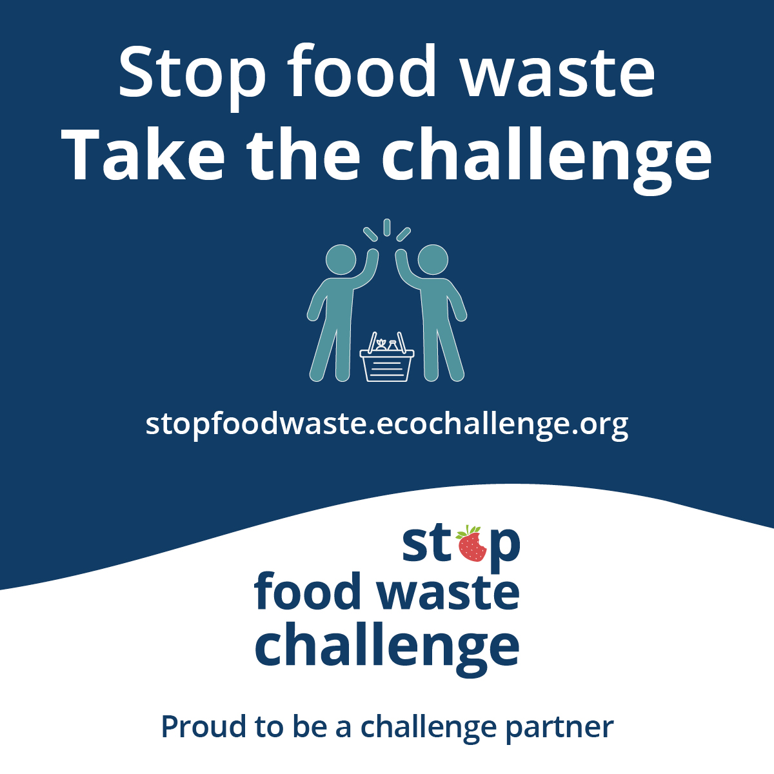
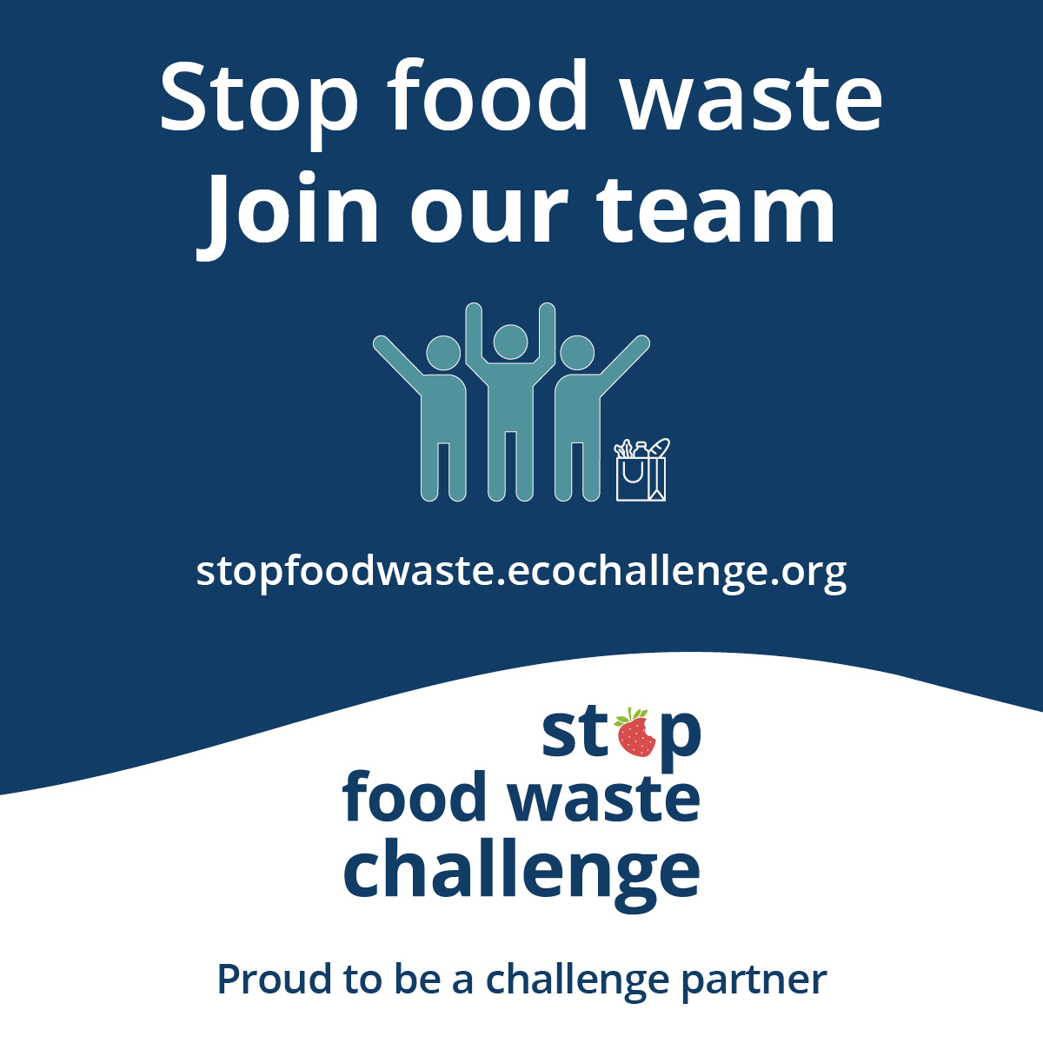

What does it mean to be a partner?
There are many ways to be a partner in the Stop Food Waste Challenge. Here are some ways we ask partners to get involved. Find the way that works for you!
- Expand our reach by promoting the challenge to your audience.
- Strengthen engagement in the challenge by creating teams of colleagues, friends, and neighbors who motivate and hold each other accountable.
- Increase our impact by offering educational events or promotions on food waste prevention topics.

Posters and flyers
Download posters and flyers to help promote the challenge and encourage others to join your team:
- Join our Stop Food Waste Challenge team 8.5x11 (PDF)
- Take the Stop Food Waste Challenge flyer 8.5x11 (PDF)
- Take the Stop Food Waste Challenge half page flyer 5.5x8.5 (PDF) – this PDF has two half-page flyers side-by-side to make it easy to print and cut flyers to hand out at events
- Team up against food waste event poster 11x17 (PDF)
- Reduce your wasted food, drop-off poster 11x17 (PDF)

Sample newsletter article – short

Save money, save time, save the planet: Take the Stop Food Waste Challenge

Take the Stop Food Waste Challenge to see how you can save money, time, and the planet by tweaking your kitchen habits.
Wasted food is a waste of money. The average family of four spends more than $2,500 on food that gets tossed every year. We waste time shopping for food we don’t have a plan to use and cooking food we forget to eat. All that uneaten food wastes the resources, energy, and labor used to create it.
By coming together with our community, we can make a real difference toward reducing waste and fighting climate change. Take the Stop Food Waste Challenge this August to learn better strategies for buying food you’ll eat and eating the food you buy.

Sample newsletter article – long

Save money, save time, save the planet: Take the Stop Food Waste Challenge

Take the Stop Food Waste Challenge to see how you can save money by tweaking your kitchen habits. Nearly 40% of food is wasted somewhere along the supply chain in the U.S., and much of that food waste happens at home.
Wasted food is a waste of money. The average family of four spends more than $2,500 on food that gets tossed every year. We waste time shopping for food we don’t have a plan to use and cooking food we forget to eat. All that uneaten food wastes the resources, energy, and labor used to create it.
“As a mother, I was initially interested in controlling food waste to save money. It wasn't until later that I learned how wasted food is also an environmental issue. So now I have several reasons for cutting my food waste,” said Anne S., a participant in a past Stop Food Waste Challenge.

How the challenge works
When you join the challenge this August, you commit to taking actions that will have the most impact in your household and get credit for what you’re already doing.
The first step is to sign up! Then join or start a team and start browsing the actions.
It's recommended that everyone starts with tracking their food waste for one week – it’s the best way to learn what’s going to waste in your household and identify ways to prevent it. Then choose actions that will have a big impact and build on your strengths, like better meal planning or cooking creatively.
Once the challenge starts August 1, you will report your progress, see the positive impact of your actions add up, and connect with others. Participants will get email updates with resources and tips and opportunities to attend events hosted by Stop Food Waste Challenge partners.
By coming together with our community, we can make a real difference toward reducing waste and fighting climate change. The challenge runs August 1-31. Sign up opens July 1. Join the challenge at stopfoodwaste.ecochallenge.org.

Sample newsletter article – organics recycling connection
Note: Update the name of the composting/organics recycling program to what is used in your community. Most Hennepin County communities use organics recycling pickup or drop-off, while Ramsey County and Washington County communities use food scraps pickup or drop-off.

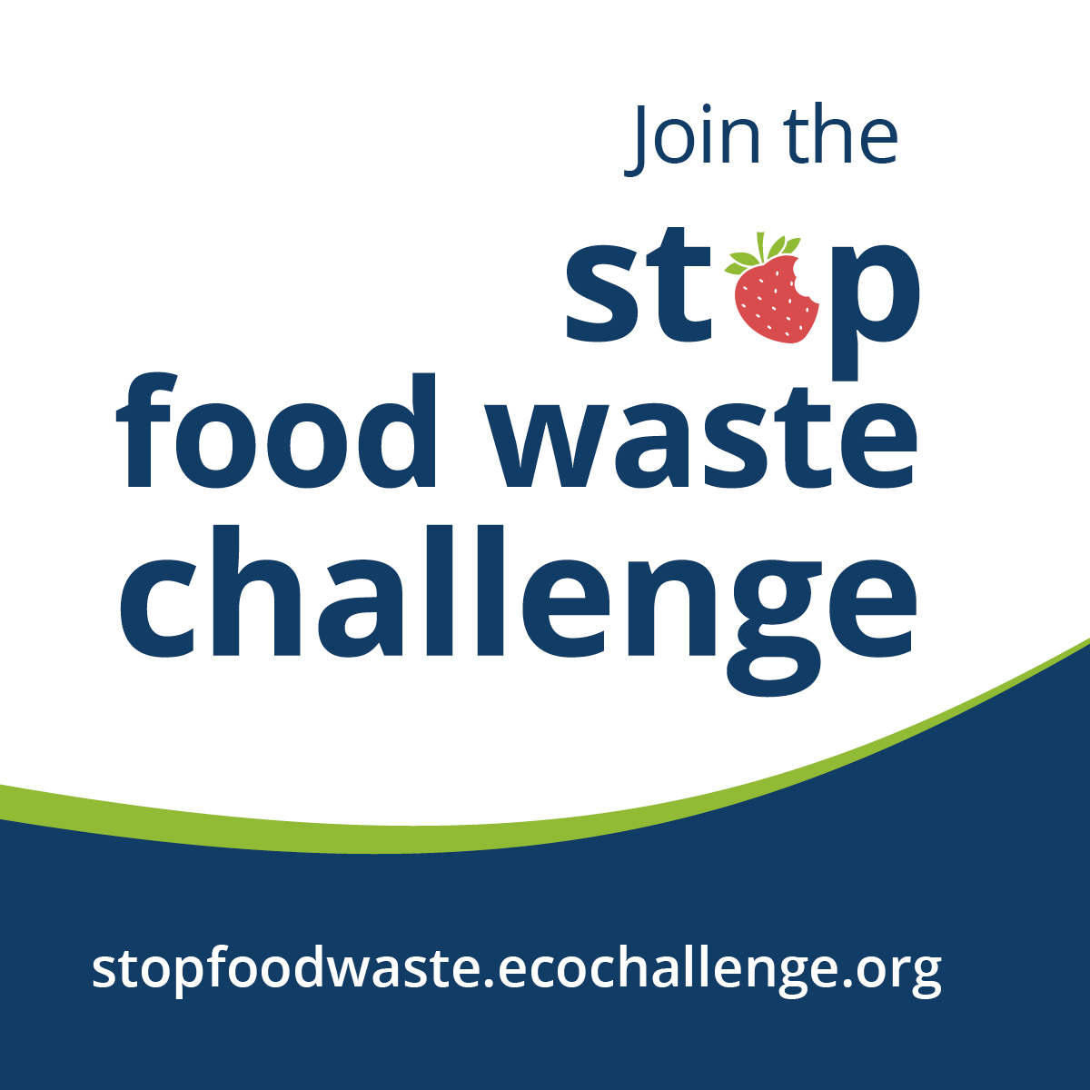
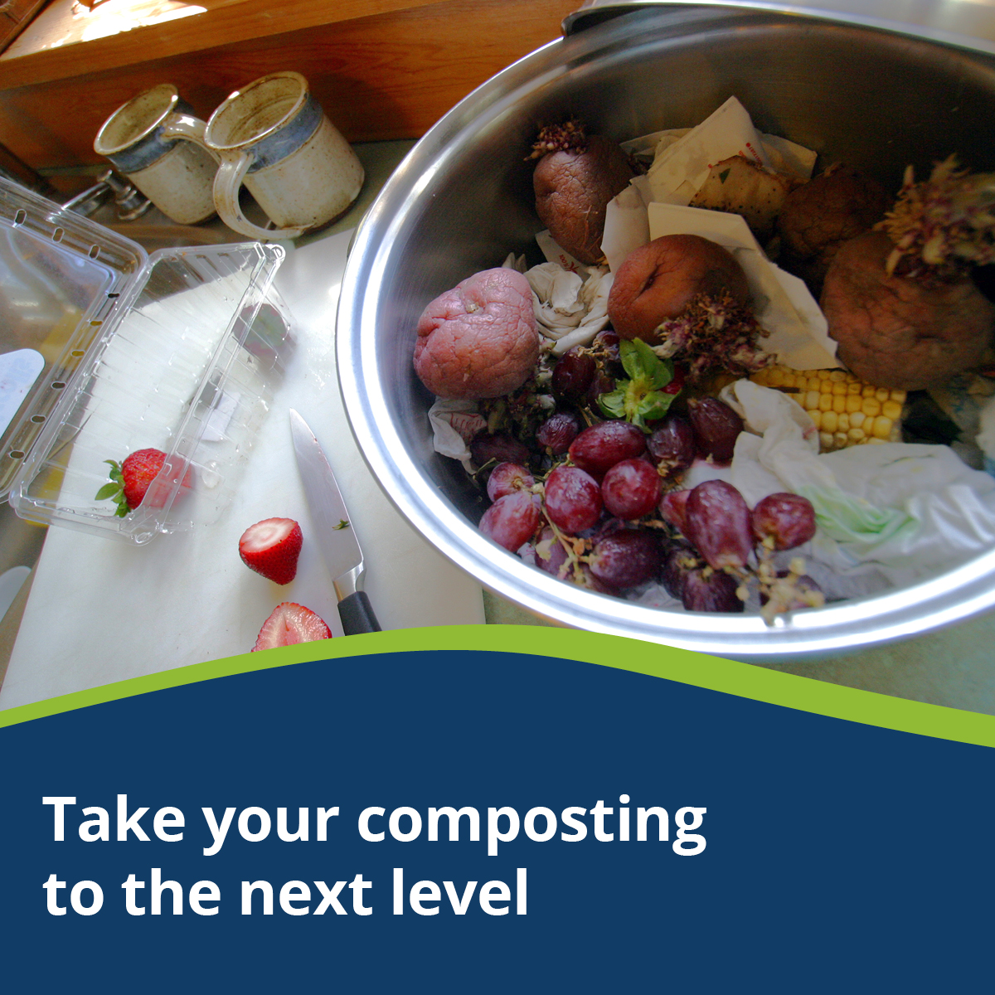
Take your composting to the next level: Join the Stop Food Waste Challenge

Thank you for keeping food out of the trash through the organics recycling program! Now is a great time to take the next step and learn how to save money by wasting less food.
While organics recycling makes a positive impact on reducing our waste, when we toss food we could have eaten, we are still wasting all the resources that went into making our food.
Join the Stop Food Waste Challenge to upgrade your kitchen strategies so you can buy food you’ll eat and eat the food you buy. Less wasted edible food, more money saved!
Join the challenge now at stopfoodwaste.ecochcallenge.org.

Sample email message
Subject: Join me in taking the Stop Food Waste Challenge!
Dear [name],
I love food, which leaves me wondering: why do we let so much of it go to waste? Nearly 40% of food is wasted somewhere along the supply chain, and I was surprised to learn that much of that food waste happens at home.
If you’re like me, staying on top of my busy schedule makes it hard to keep track of the food I buy and create a meal plan and stick to it. But taking steps to reduce food waste has so many benefits, including saving money, saving time at the grocery store, and feeling more confident in the kitchen.
[Edit the message above or insert a personal message – why is this important to you, why do you think this person would be interested in joining, etc.]
That’s why I’m taking the Stop Food Waste Challenge in August, and I hope you will join me! By coming together with our community, we can make a real difference toward reducing waste and fighting climate change.
With the challenge, you can focus on the actions that will have the biggest impact for your household. You check off the actions you already take, then select up to 10 actions to try during the 4-week challenge. During the challenge, you get email updates with resources and tips, access to workshops and events hosted by Stop Food Waste Challenge partners, and opportunities to connect with others.
Join the challenge now at stopfoodwaste.ecochallenge.org. The challenge runs August 1-31.
Sincerely,
[your name]

Social media posts
Suggested hashtags: #StopFoodWaste #WastedFood #SaveTheFood #ZeroWaste
To use images and graphics: right click on the image and select Save as Picture.
All graphics can also be downloaded from the resources page on the EcoChallenge site here: stopfoodwaste.ecochallenge.org/about/resources

Post 1: Take the Stop Food Waste Challenge

Facebook:
Save money, time, and the planet by taking the Stop Food Challenge this August. Committing to waste less food could help you save over $2,500 a year on groceries, be more efficient at the grocery store, and gain confidence in the kitchen. By coming together with our community, we can make a real difference toward reducing waste and fighting climate change. Sign up by July 31. stopfoodwaste.ecochallenge.org

Instagram:
Save money, time, and the planet by taking the Stop Food Challenge this August. Committing to waste less food could help you save over $2,500 a year on groceries, be more efficient at the grocery store, and gain confidence in the kitchen. By coming together with our community, we can make a real difference toward reducing waste and fighting climate change. Sign up by July 31 at the link in our bio.
#StopFoodWaste #LoveFoodHateWaste #SaveTheFood #ZeroWaste

X/Twitter:
Save money, time, and the planet by taking the Stop Food Challenge this August. By coming together with our community, we can make a real difference toward reducing waste and fighting climate change. Sign up by July 31. stopfoodwaste.ecochallenge.org #StopFoodWaste

Nextdoor:
Save money, time, and the planet by taking the Stop Food Challenge this August. Committing to waste less food could help you save over $2,500 a year on groceries, be more efficient at the grocery store, and gain confidence in the kitchen. By coming together with our community, we can make a real difference toward reducing waste and fighting climate change. Sign up by July 31. stopfoodwaste.ecochallenge.org

Graphics (square, horizontal, story)
Use the square graphic for Instagram and Facebook posts, the horizontal for X/Twitter and Nextdoor posts, and the story for Instagram stories. For Instagram stories, you can also add a link to stopfoodwaste.ecochallenge.org.
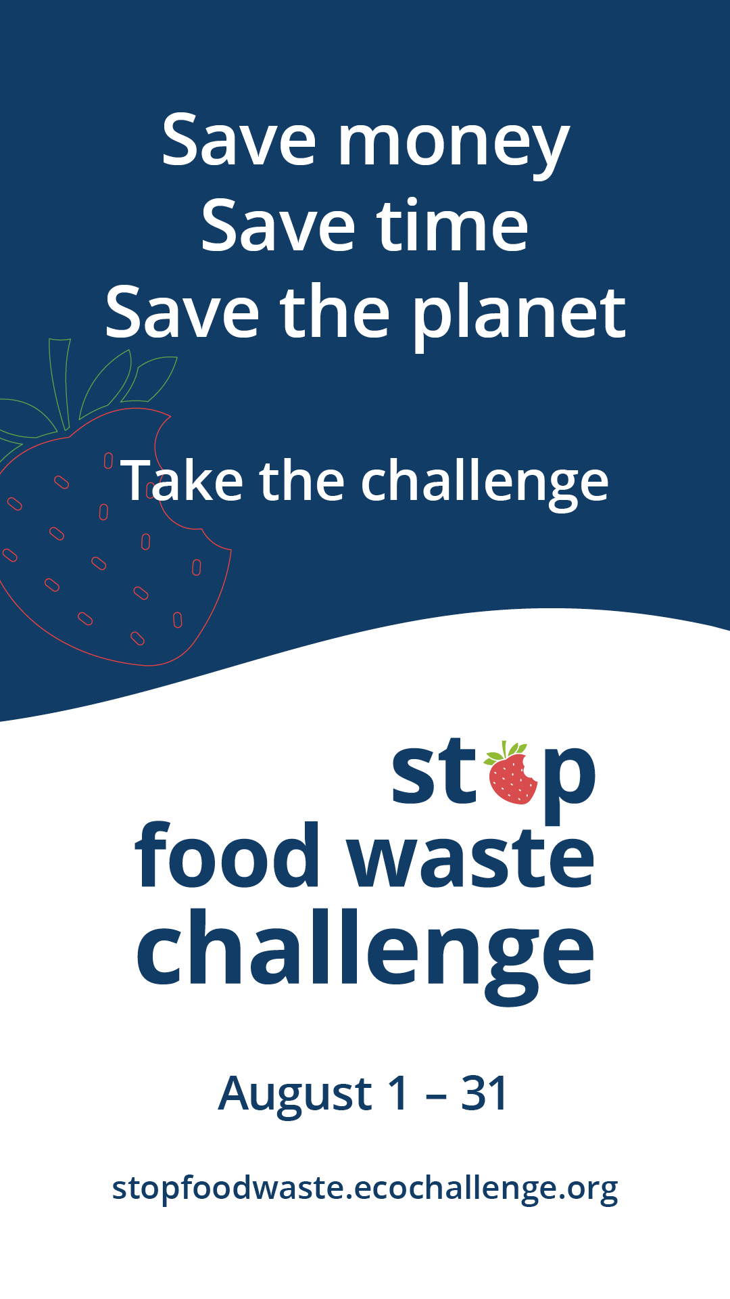
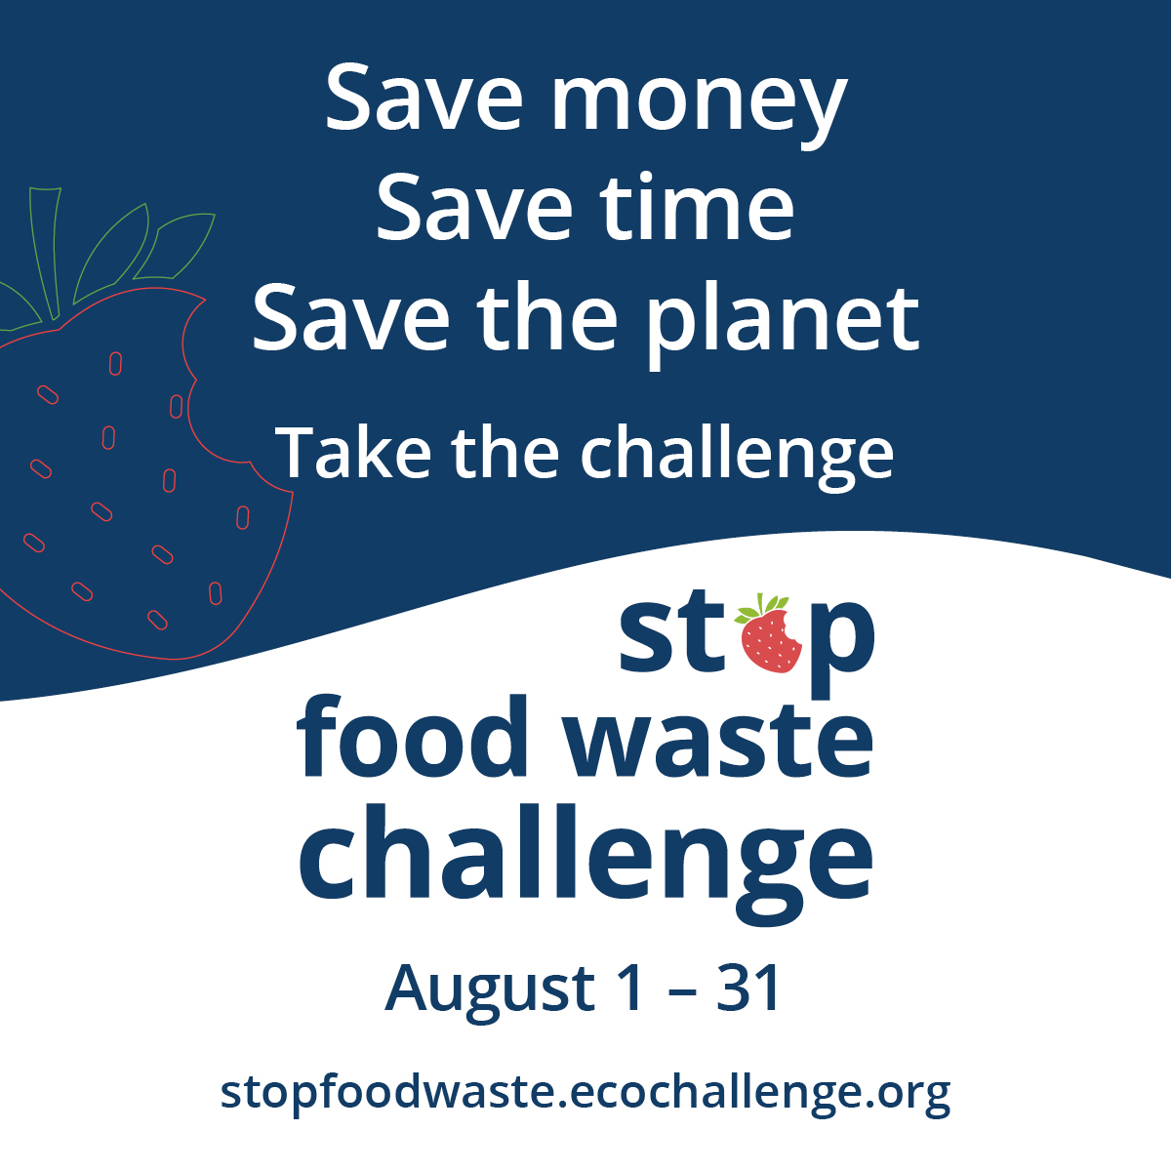

Post 2: Team up against food waste

Facebook:
It’s time to team up for the Stop Food Waste Challenge! By committing to actions that reduce food waste, we can save time and money, gain confidence in the kitchen, and come together to make a difference for our community and the planet. Sign up at stopfoodwaste.ecochallenge.org and join our team (optionally, insert the name of your team)

Instagram:
It’s time to team up for the Stop Food Waste Challenge! By committing to actions that reduce food waste, we can save time and money, gain confidence in the kitchen, and come together to make a difference for our community and the planet. Sign up at the link in our bio and join our team (optionally, insert the name of your team).
#StopFoodWasteChallenge #WastedFood #ZeroWaste

X/Twitter:
It’s time to team up for the Stop Food Waste Challenge! By committing to actions that reduce food waste, we can save time and money, gain confidence in the kitchen, and come together to make a difference. Sign up and join our team (optionally, insert the name of your team) stopfoodwaste.ecochallenge.org #StopFoodWasteChallenge

Nextdoor:
It’s time to team up for the Stop Food Waste Challenge! By committing to actions that reduce food waste, we can save time and money, gain confidence in the kitchen, and come together to make a difference for our community and the planet. Sign up at stopfoodwaste.ecochallenge.org and join our team (optionally, insert the name of your team)

Graphics:
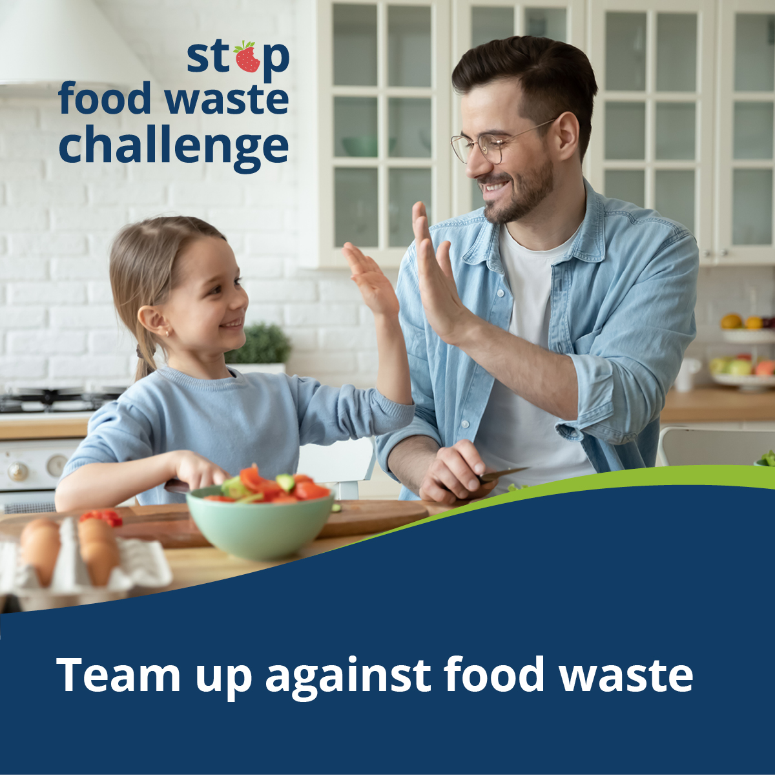

Post 3: 6 reasons to join the Stop Food Waste Challenge

Facebook:
Why take the Stop Food Waste Challenge? The challenge can help you:
- Learn to use up all your groceries
- Have an answer to "what's for dinner?"
- Spend less time (and money) at the grocery store
- Make your food last longer
- Be a confident cook
- Come together to make a difference
Save money, save time, save the planet. Join the challenge this August. Sign up by July 31 at stopfoodwaste.ecochallenge.org

Instagram:
Why take the Stop Food Waste Challenge? The challenge can help you:
- Learn to use up all your groceries
- Spend less time (and money) at the grocery store
- Have an answer to "what's for dinner?"
- Be a confident cook
- Make your food last longer
- Come together to make a difference
Save money, save time, save the planet. Join the challenge this August. Sign up by July 31 at the link in our bio.
#StopFoodWaste #WastedFood #ZeroWaste

X/Twitter:
Why take the Stop Food Waste Challenge? Learn to use up all your groceries, spend less time (and money) at the grocery store, have an answer to "what's for dinner?”, be a confident cook, make a difference, and much more. Sign up by July 31 stopfoodwaste.ecochallenge.org #StopFoodWaste

Graphics:
This set of graphics is meant to be used in a photo gallery on Facebook or as an Instagram carousel post. X/Twitter is limited to 4 photos – suggest using the graphics “Learn to use up all your groceries,” “Spend less time (and money) at the grocery story,” “Finally have an answer to ‘what’s for dinner’,” and the final graphic “Take the Stop Food Waste Challenge.”
For Instagram stories, you can add a link to stopfoodwaste.ecochallenge.org to the Take the Stop Food Waste Challenge graphic at the end.

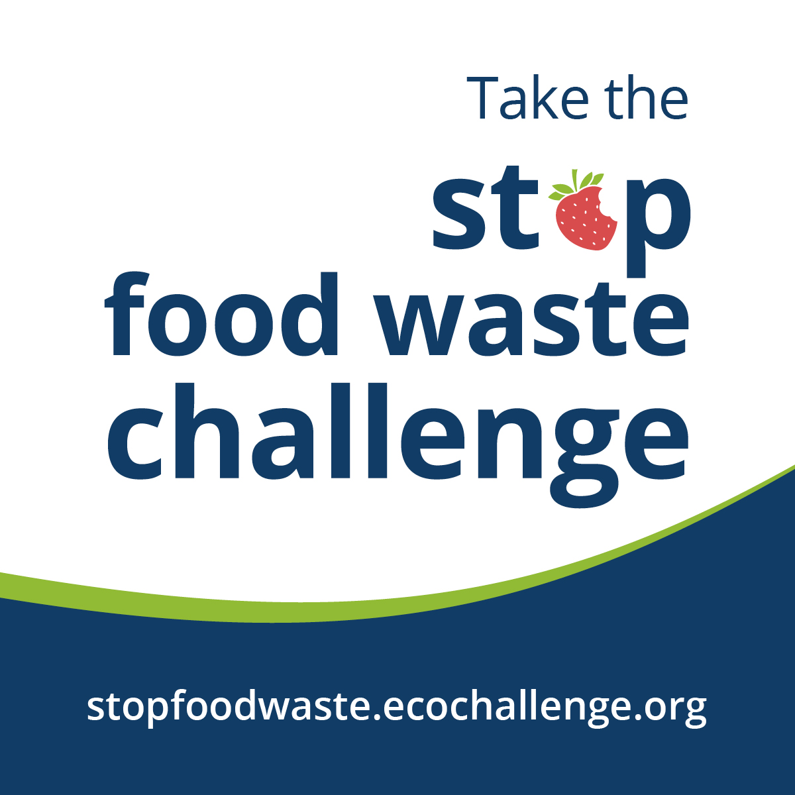

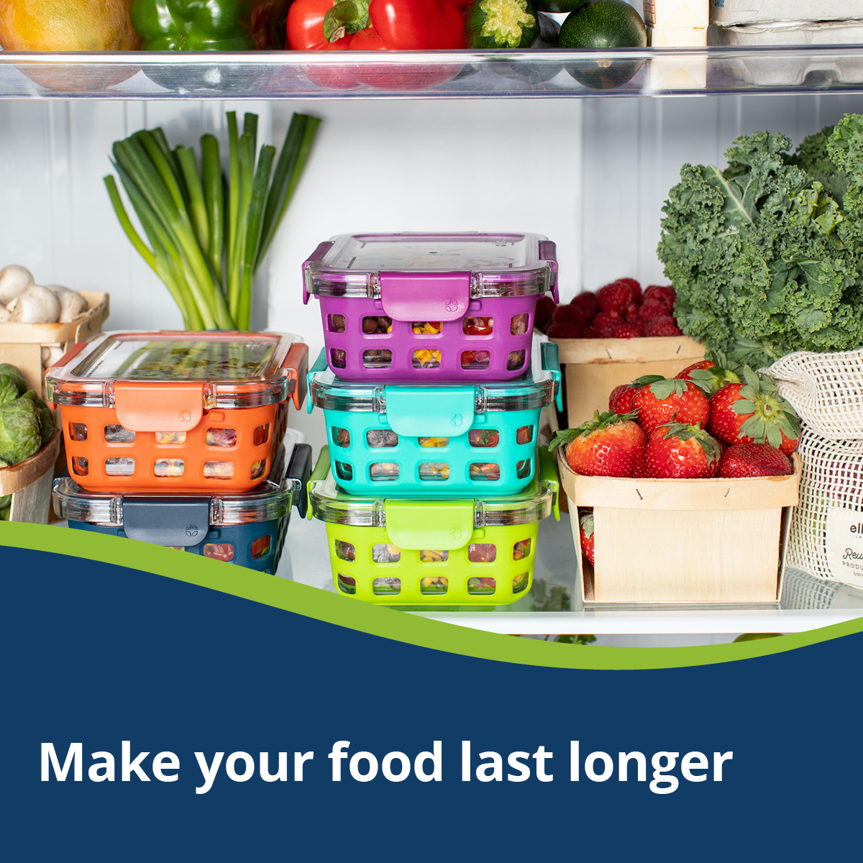


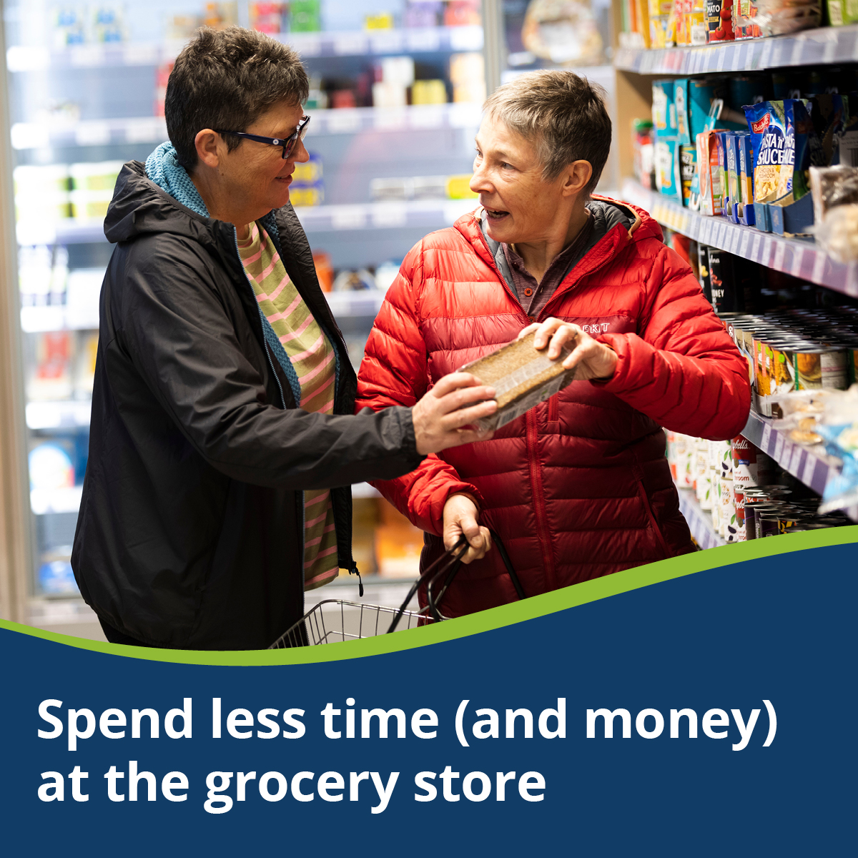

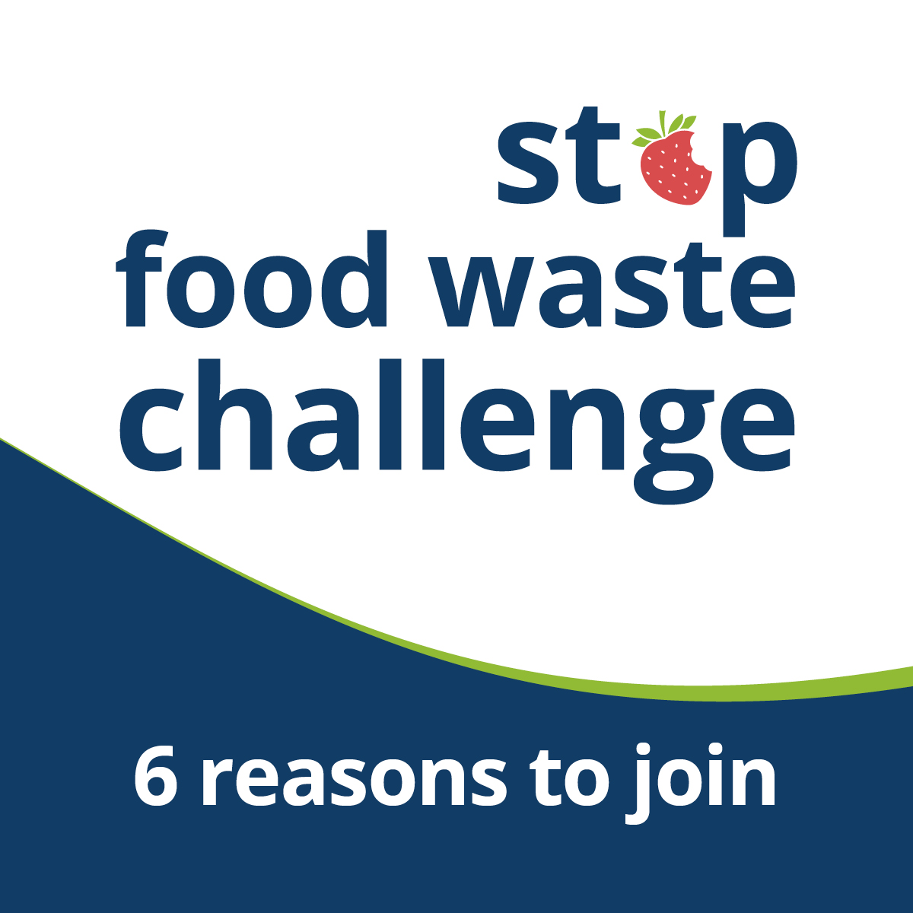

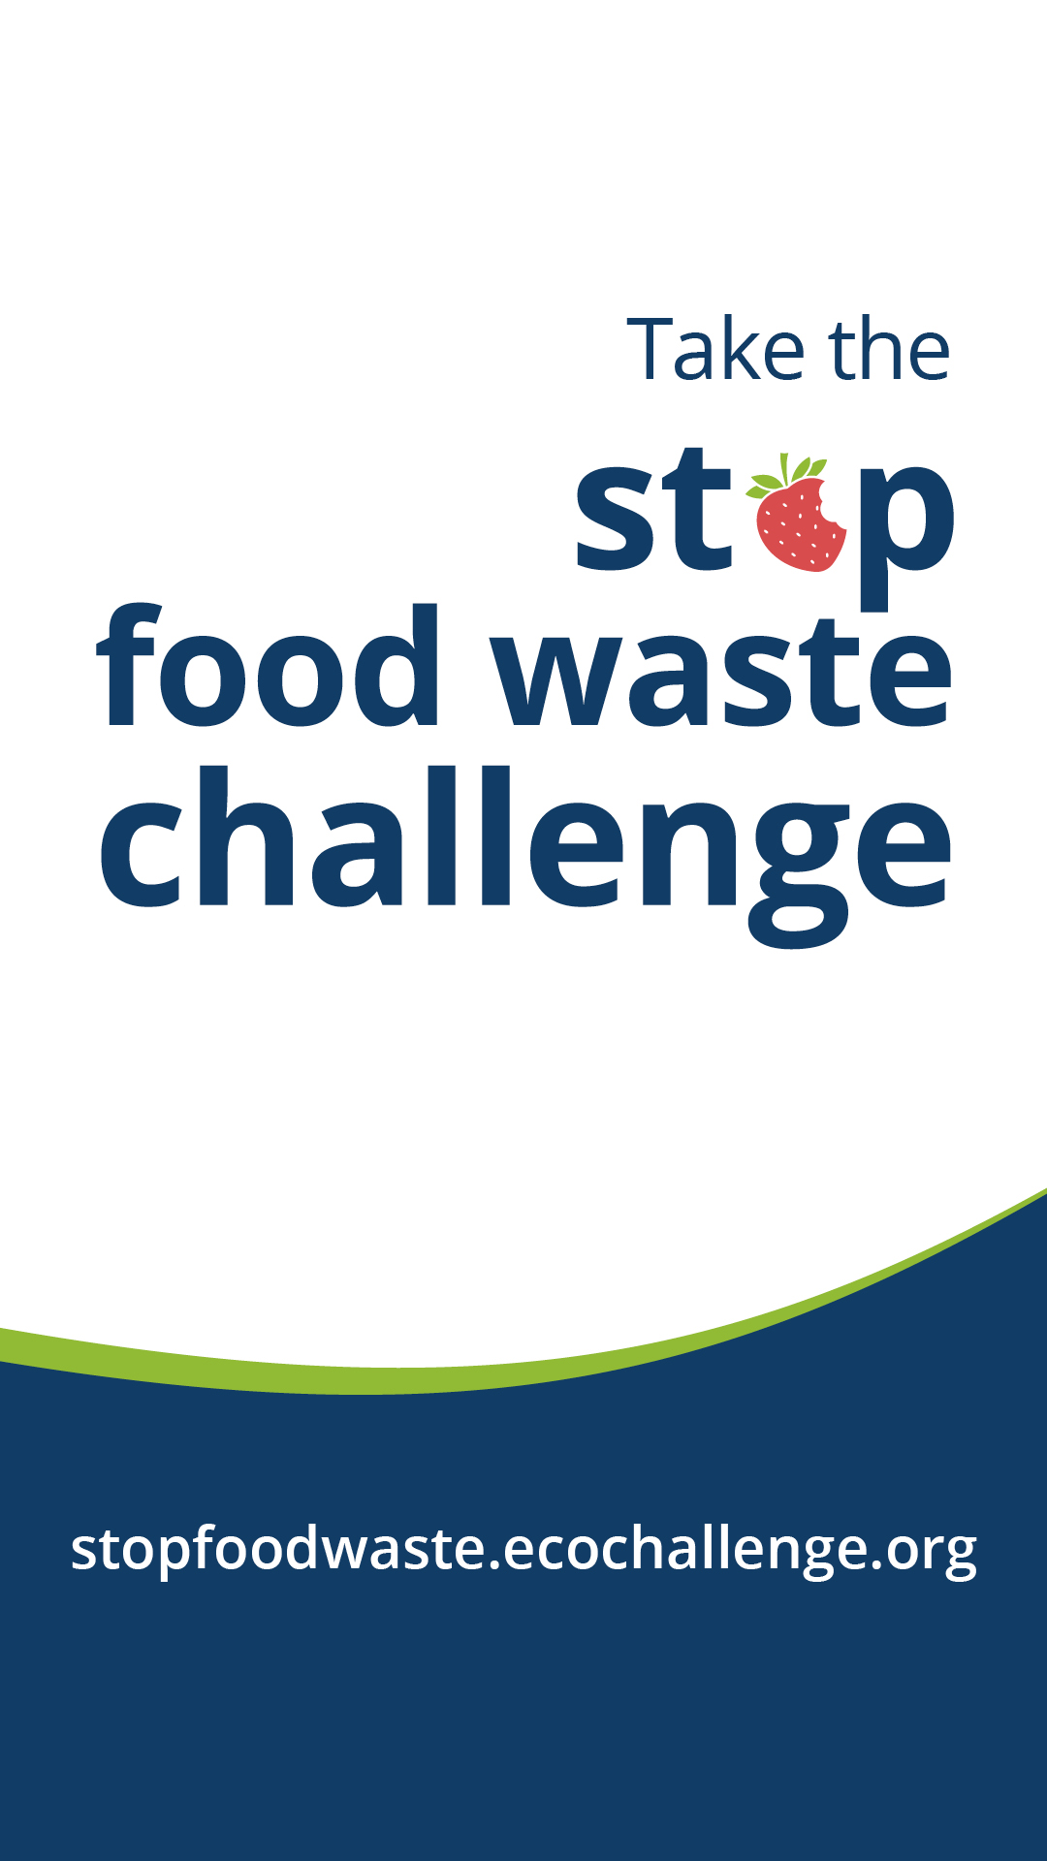
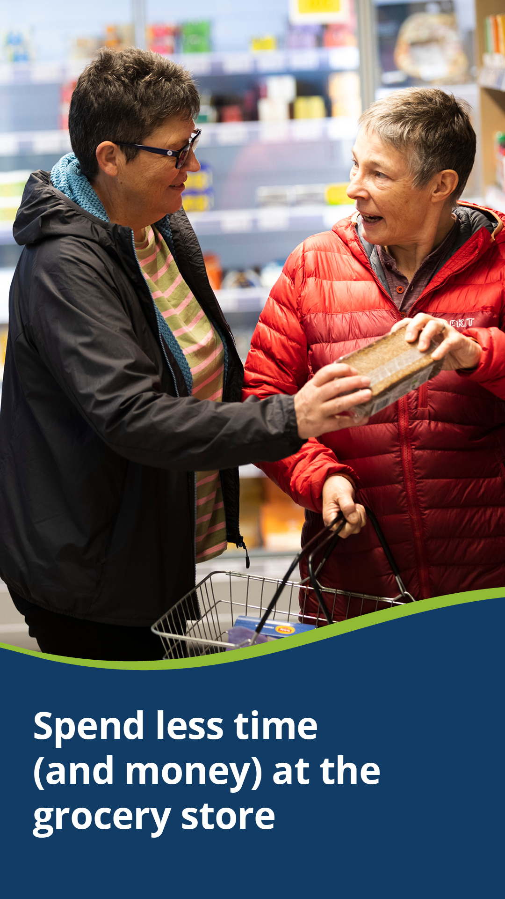

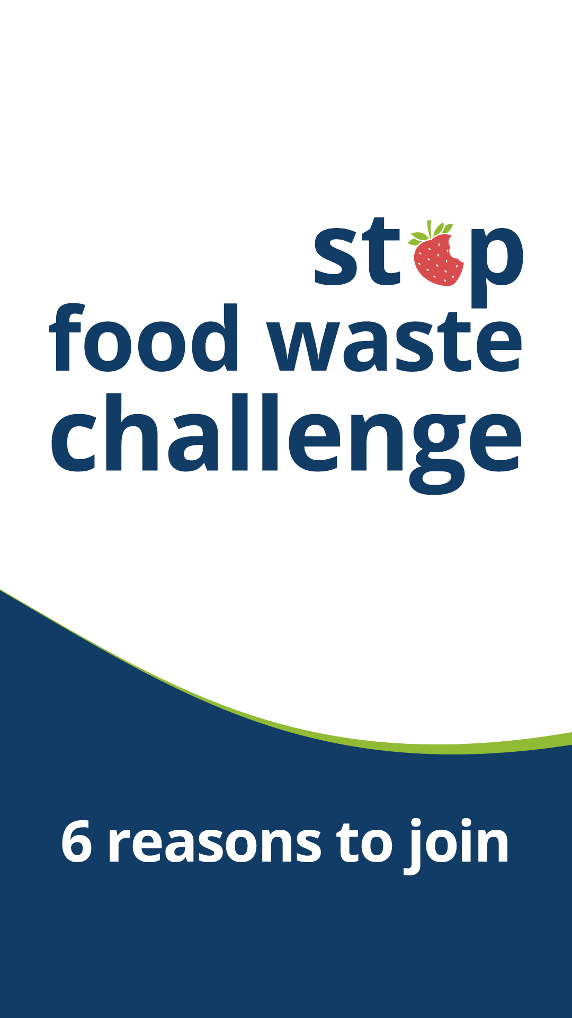



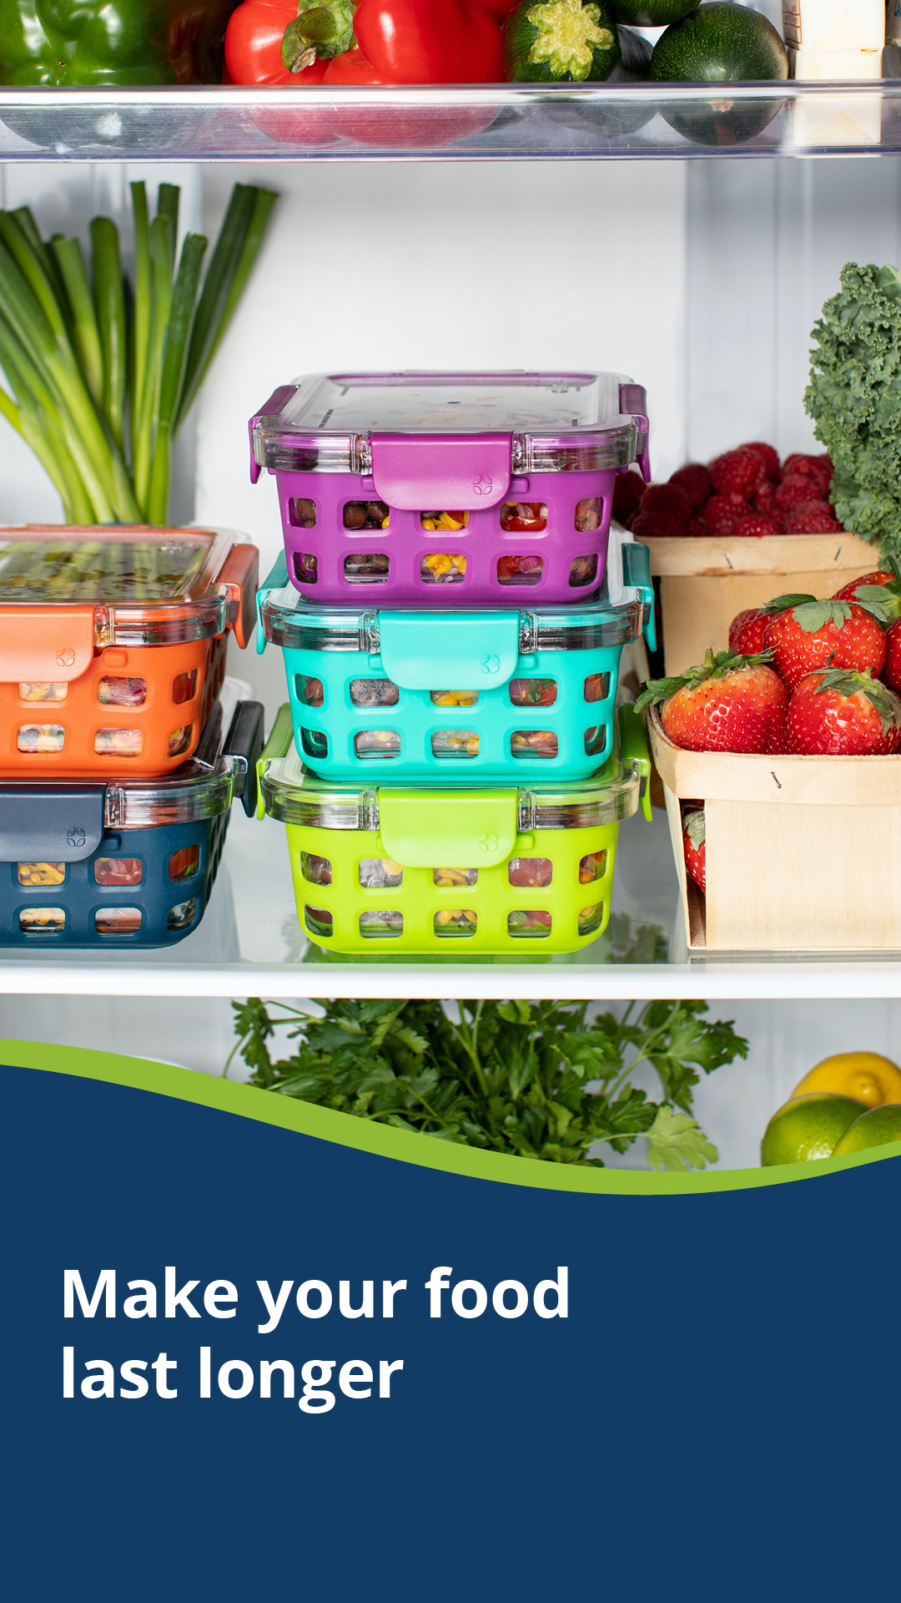

Image credits
- https://unsplash.com/photos/AEU9UZstCfs, Photo by Ello on Unsplash
- https://unsplash.com/photos/my1mDMraGf0, Photo by Jimmy Dean on Unsplash

Post 4: Connection to organics recycling, food scraps, or drop-off programs
Note: Update the name of the composting/organics recycling program to what is used in your community. Most Hennepin County communities use organics recycling, while Ramsey County and Washington County communities use food scraps recycling.

Facebook:
What’s better than composting? Eating your food!
We love organics recycling, but tossing food we could have eaten wastes all the resources and money that went into making it. Join the Stop Food Waste Challenge this August to learn better strategies for buying food you’ll eat and eating the food you buy. Sign up by July 31 at stopfoodwaste.ecochallenge.org

Instagram:
What’s better than composting? Eating your food!
We love organics recycling, but tossing food we could have eaten wastes all the resources and money that went into making it. Join the Stop Food Waste Challenge this August to learn better strategies for buying food you’ll eat and eating the food you buy. Sign up by July 31 at the link in bio.
#StopFoodWaste #WastedFood #Comosting #ZeroWaste

X/Twitter:
Ready to take your composting to the next level? Join the Stop Food Waste Challenge this August to learn how to keep edible food out of your organics bin and save money! Sign up by July 31 at stopfoodwaste.ecochallenge.org #StopFoodWaste

Graphics:

