Promotional materials for the Stop Food Waste Challenge

About the challenge
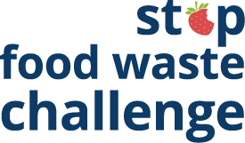
About 40% of food is wasted somewhere along the supply chain. All that wasted food adds up to wasted money. The average family of four spends more than $2,500 on food that goes to waste every year. By taking steps to reduce food waste, we can save money, fight climate change, provide for our families, and improve our cooking skills.
The Stop Food Waste Challenge, stopfoodwaste.ecochallenge.org will help participants learn more about food waste and improve skills in cooking, planning, shopping, and storage. The challenge has more than 60 actions to choose from in six categories. Participants check off the actions they already take, then select up to five one-time actions and five daily actions to track progress on during the four-week challenge.
Participants can create or join a team to take the challenge along with their family, friends, or neighbors. Organizations and businesses, including community groups, neighborhoods, schools, retailers, and more, can become a Stop Food Waste Challenge partner. Partners help increase promotion, recruitment, and engagement for the challenge.

Contact
The online Stop Food Waste Challenge is offered in partnership with Hennepin County, Ramsey County, and Washington County and is powered by EcoChallenge.
For more information about the challenge, contact the Zero Waste Challenge coordinator at ZWC@hennepin.us

Help spread the word and encourage others to join
Some ways that you can help spread the word about the Stop Food Waste Challenge and encourage others to join:
- Use the sample newsletter articles (pages 5-7) to share on an organization’s website or in newsletters. These are editable so you can customize the length or message.
- Use the sample social media posts and graphics (pages 9-20) to share on your social media channels. These are editable so you can customize the message. Use #StopFoodWaste.
- Download additional resources from stopfoodwaste.ecochallenge.org/about/resources
- Become a Stop Food Waste Challenge partner – details about partnership are on page 3.
- Download, print, and post or hand out flyers – linked on page 4 – to promote the event and encourage others to join your team.
- Invite people you know directly using the sample email message on page 8
- Create a team or join an existing team and invite people you know – your friends, family, neighbors, colleagues, etc. – to join you. Your teammates will keep each other motivated and accountable. Invitations can be sent through the EcoChallenge website.
- Follow and reshare messages posted on the Hennepin, Ramsey, and Washington counties’ social media channels:
  - Hennepin County:
    - Hennepin Environment on Facebook
    - @hennepinenvironment on Instagram
    - @HennepinEnviro on Twitter
  - Ramsey County:
    - Ramsey County Minnesota on Facebook
    - @ramseycountymn on Instagram
    - @RamseyCounty on Twitter
  - Washington County:
    - Washington County MN on Facebook
    - @WashingtonCoMN on Twitter

Become a Stop Food Waste Challenge partner
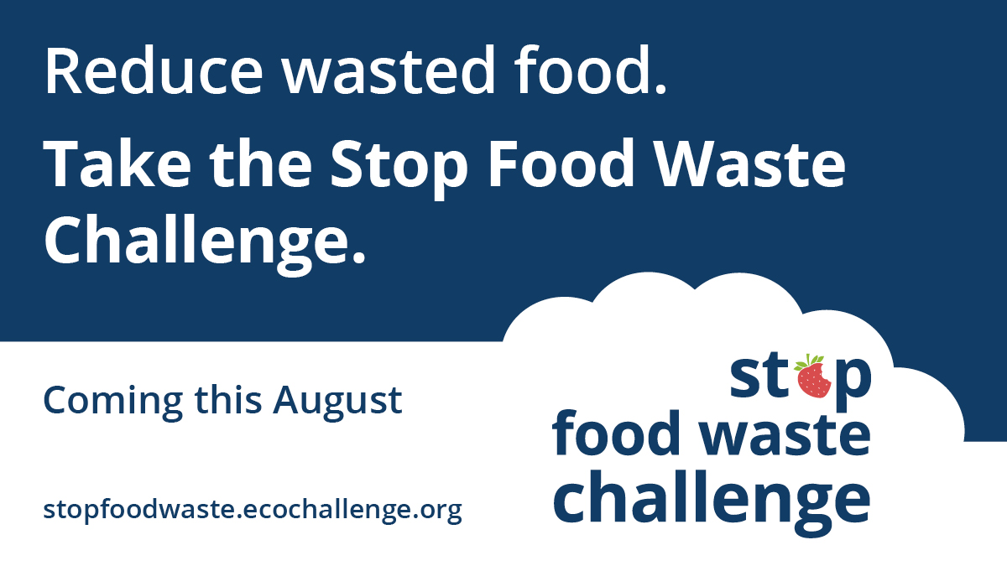
Minimizing food waste is one of the most effective things we can do to reduce waste and fight climate change. The Stop Food Waste Challenge (stopfoodwaste.ecochallenge.org), offered by Hennepin, Ramsey, and Washington counties, engages residents in learning easy, practical skills that will help them prevent wasted food, save money, provide for their families, and create a healthier environment.
But we can’t do it alone!
We need your organization’s help with promotion and engagement for the upcoming Stop Food Waste Challenge, which will run in August 2024.
All partners will have their logo displayed on the challenge website, gain access to promotional materials, and get various recognition and cross-promotion during the challenge. There is no cost to becoming a partner. Being a challenge partner shows your organization’s commitment to sustainability, helps build community, and promotes collective action.
See the Stop Food Waste Challenge partnership page for details on how to become a 2024 Stop Food Waste Challenge partner and fill out the partnership form. Businesses, community groups, cities, neighborhoods, schools, and retailers are welcome partners.

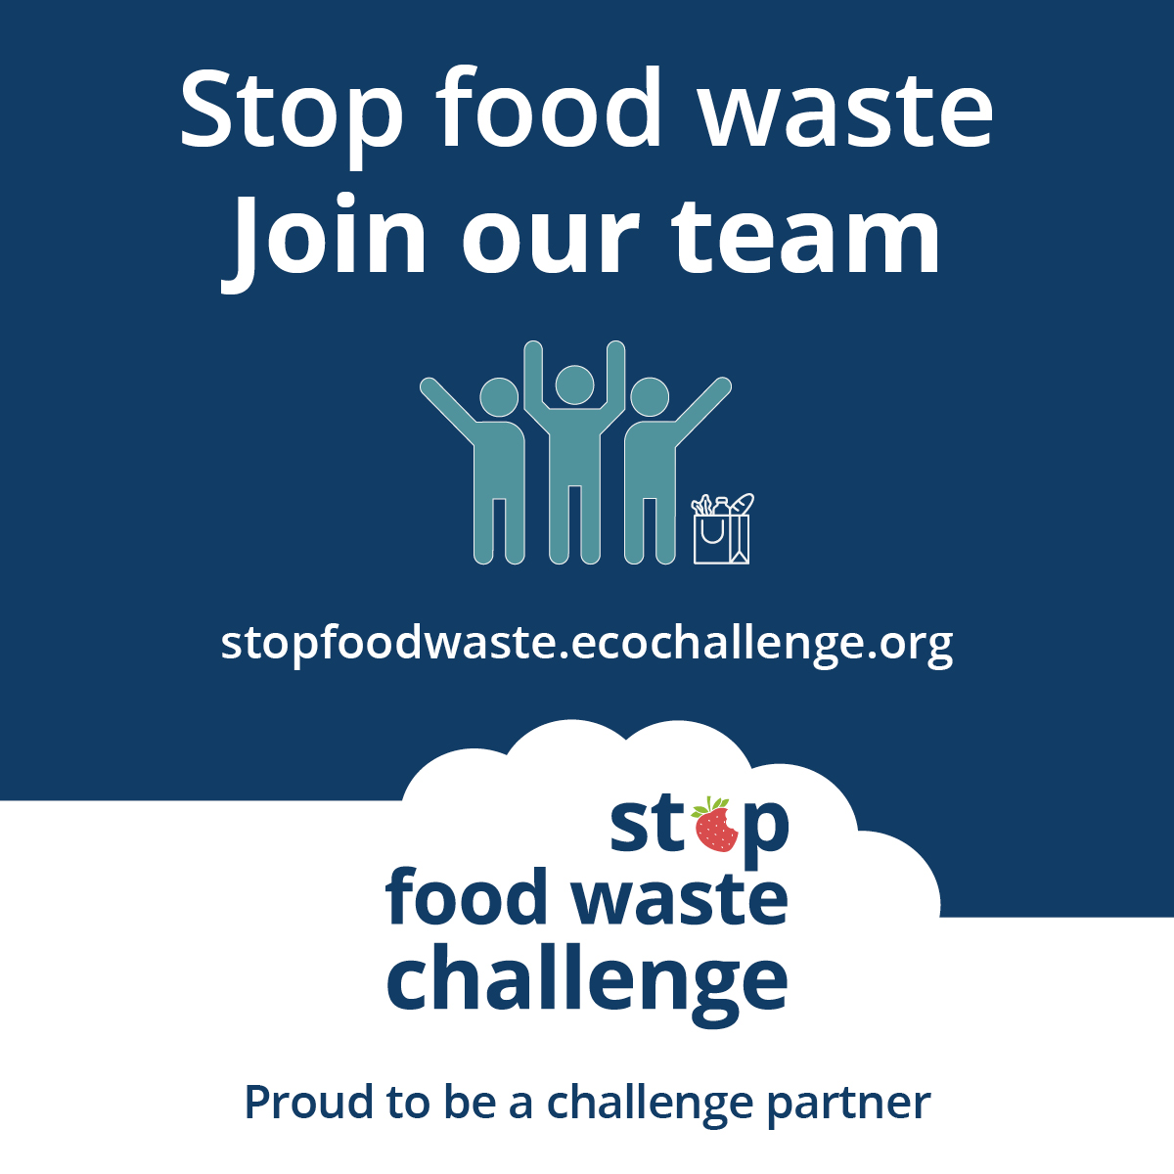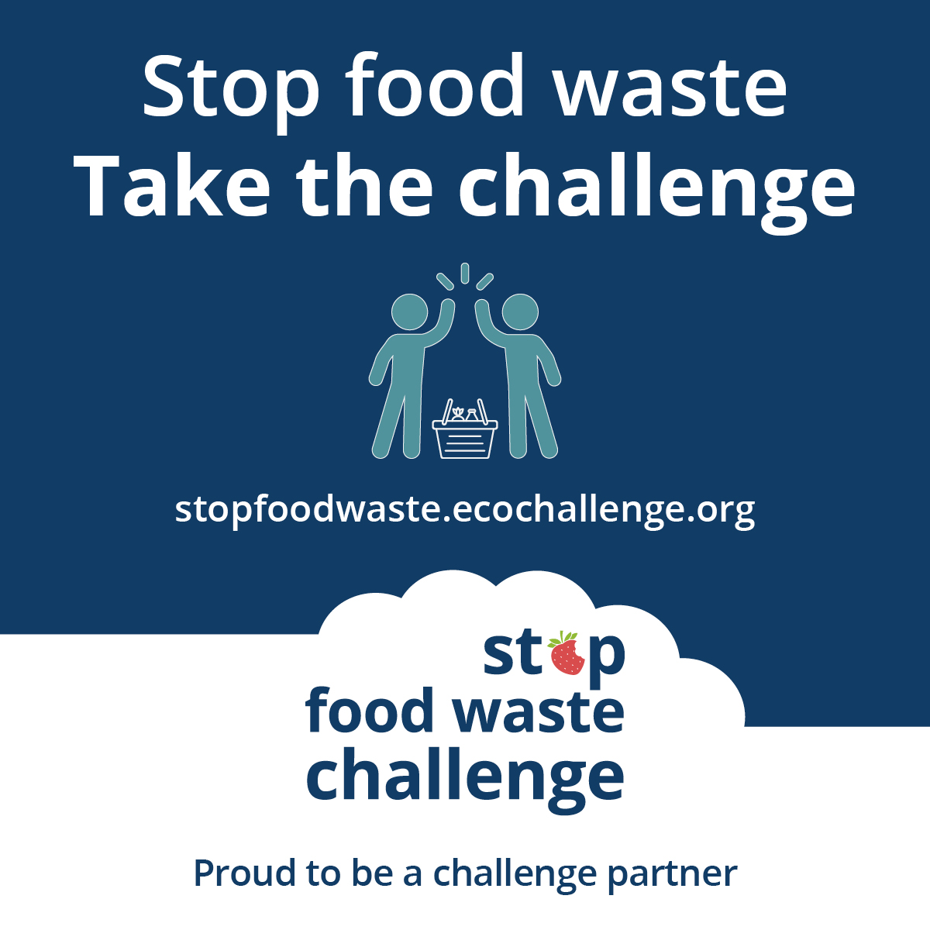

What does it mean to be a partner?
There are many ways to be a partner in the Stop Food Waste Challenge. Here are some ways we ask partners to get involved. Find the way that works for you!
- Expand our reach by promoting the challenge to your audiences.
- Strengthen engagement in the challenge by creating teams of colleagues, friends, and neighbors who motivate and hold each other accountable.
- Increase our impact by offering educational events or promotions on food waste prevention topics.

Posters and flyers
Download posters and flyers to help promote the challenge and encourage others to join your team:
- Join our Stop Food Waste Challenge team 8.5x11 (PDF)
- Take the Stop Food Waste Challenge flyer 8.5x11 (PDF)
- Take the Stop Food Waste Challenge half page flyer 5.5x8.5 (PDF) – this PDF has two half-page flyers side-by-side to make it easy to print and cut flyers to hand out at events
- Team up against food waste event poster 11x17 (PDF)
- Reduce your wasted food, drop-off poster 11x17 (PDF)

Sample newsletter article – long

Create meals, not waste: Take the Stop Food Waste Challenge
We love food, which leaves us wondering: why do we let so much of it go to waste? In the U.S., about 40% of food is wasted somewhere along the supply chain, and much of that food waste happens at home.
Most of the food we throw in the trash is leftovers or unspoiled food that could have been eaten, according to a recent waste study in Minneapolis. All that wasted food adds up to wasted money. The average family of four spends more than $2,500 on food that goes to waste every year.
“As a mother, I was initially interested in controlling food waste as a way to save money. Saving money on my family's food made it possible for me to donate food to the local food shelf that was supported by my church. It wasn't until later that I learned how wasted food is also an environmental issue. So now I have several reasons for cutting my food waste,” said Anne S., a participant in a past Stop Food Waste Challenge.

How the challenge works
When you join the challenge, you can commit to taking actions that will have the most impact in your household – the challenge has more than 60 actions to choose from in six categories.
Learning skills like creating a meal plan, buying just what you need at the grocery store, cooking creatively, and properly storing food can have a big impact on reducing the amount of food in your home that goes to waste.
The first step is to sign up, create your profile, and join or start a team. Then, browse the categories and actions, check off the actions you already take, and select up to five one-time actions and five daily actions to make progress on during the four-week challenge.
It's recommended that everyone starts with tracking their food waste for one week – it’s the best way to learn what’s going to waste in your household and identify ways to prevent it.
Once the challenge starts, you will report what actions you take, see the impact of your actions add up, and connect with others. Participants will get email updates with resources and tips for taking action and opportunities to attend workshops and events hosted by Stop Food waste Challenge partners.
The challenge runs during the month of August 2024. Sign up opens on July 1. Sign up to be notified when registration opens. OR Join the challenge now at stopfoodwaste.ecochallenge.org.

Sample newsletter article – short

Create meals, not waste: Take the Stop Food Waste Challenge
We love food, which leaves us wondering: why do we let so much of it go to waste? In the U.S., about 40% of food is wasted somewhere along the supply chain, and much of that food waste happens at home.
Most of the food we throw in the trash is leftovers or unspoiled food that could have been eaten, according to a recent waste study in Minneapolis. All that wasted food adds up to wasted money. The average family of four spends more than $2,500 on food that goes to waste every year.
Take the Stop Food Waste Challenge to learn better strategies for buying food you’ll eat and eating the food you buy.

Improve your food-waste-fighting skills
The Stop Food Waste Challenge is a month-long effort starting August 1 to help you notice when you are wasting food, commit to actions that will have the greatest impact in your household, connect you with helpful resources, and provide support and motivation along the way. Businesses, organizations, and community groups can also join the challenge as Stop Food Waste Challenge partners.
The challenge runs during the month of August 2024. Sign up opens on July 1. Sign up to be notified when registration opens. OR Join the challenge now at stopfoodwaste.ecochallenge.org.

Sample newsletter article – organics program or organics drop-off connection

Reduce your wasted food: Take the Stop Food Waste Challenge
You have already taken steps to reduce your trash by participating in organics recycling/using the organics drop-off site. Now is a great time to take the next step and learn how to save money by wasting less food.
About one-third of the food put in organics recycling is leftovers or unspoiled food that could have been eaten. Join the Stop Food Waste Challenge to learn better strategies for buying food you’ll eat and eating the food you buy. This will help you minimize the volume of wasted food your household produces, keep edible food out of your organics bin, and save money!

Improve your food-waste-fighting skills
The Stop Food Waste Challenge is a month-long effort starting August 1 to help you notice when you are wasting food, commit to actions that will have the greatest impact in your household, connect you with helpful resources, and provide support and motivation along the way. Businesses, organizations, and community groups can also join the challenge as Stop Food Waste Challenge partners.

How the challenge works
Create your profile, join or start a team, then browse the categories and actions. Select up to five one-time actions and five daily actions to make progress on during the four-week challenge. It’s recommended that everyone starts with tracking their food waste for one week – it’s the best way to learn what’s going to waste in your household and identify ways to prevent it.
The challenge runs during the month of August 2024. Sign up opens on July 1. Sign up to be notified when registration opens. OR Join the challenge now at stopfoodwaste.ecochallenge.org.

Sample email message
Subject: Join me in taking the Stop Food Waste Challenge!
Dear [name],
I love food, which leaves me wondering: why do we let so much of it go to waste? About 40% of food is wasted somewhere along the supply chain, and I was surprised to learn that much of that food waste happens at home.
If you’re like me, staying on top of my busy schedule makes it hard to keep track of the food I buy and create a meal plan and stick to it. But taking steps to reduce food waste has so many benefits, including saving money, fighting climate change, providing for our families, and becoming a better cook.
[Edit the message above or insert a personal message – why is this important to you, why do you think this person would be interested in joining, etc.]
That’s why I’m taking the Stop Food Waste Challenge, and I hope you will join me!
With the challenge, you can focus on the actions that will have the biggest impact for your household. The challenge has more than 60 actions to choose from in six categories. You can check off the actions you already take, then select up to five one-time actions and five daily actions to make progress on during the 4-week challenge. During the challenge, you will get email updates with resources and tips for taking action, access to workshops and events hosted by Stop Food Waste Challenge partners, and opportunities to connect with others.
Join the challenge now at stopfoodwaste.ecochallenge.org. The challenge runs August 1 through August 31.
Sincerely,
[your name]

Social media posts
Suggested hashtags: #StopFoodWaste #LoveFoodHateWaste #SaveTheFood #ZeroWaste

Guidance on using the graphics
Each set of graphics includes a cover image, three educational messages, and a call-to-action graphic. When used together in a photo gallery or carousel post on Instagram, the graphics entice, educate, and inspire residents to take the challenge.
If you choose to use the graphics individually, the graphics best suited to this are the cover graphic (the first graphic in the series) and the call-to-action graphic (the last graphic in the series).
To use images and graphics: right click on the image and select Save as Picture.
All graphics can also be downloaded from the resources page on the EcoChallenge site here: stopfoodwaste.ecochallenge.org/about/resources

Example of carousel post:
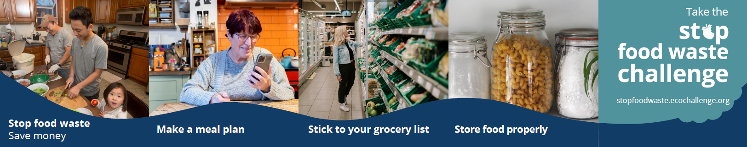
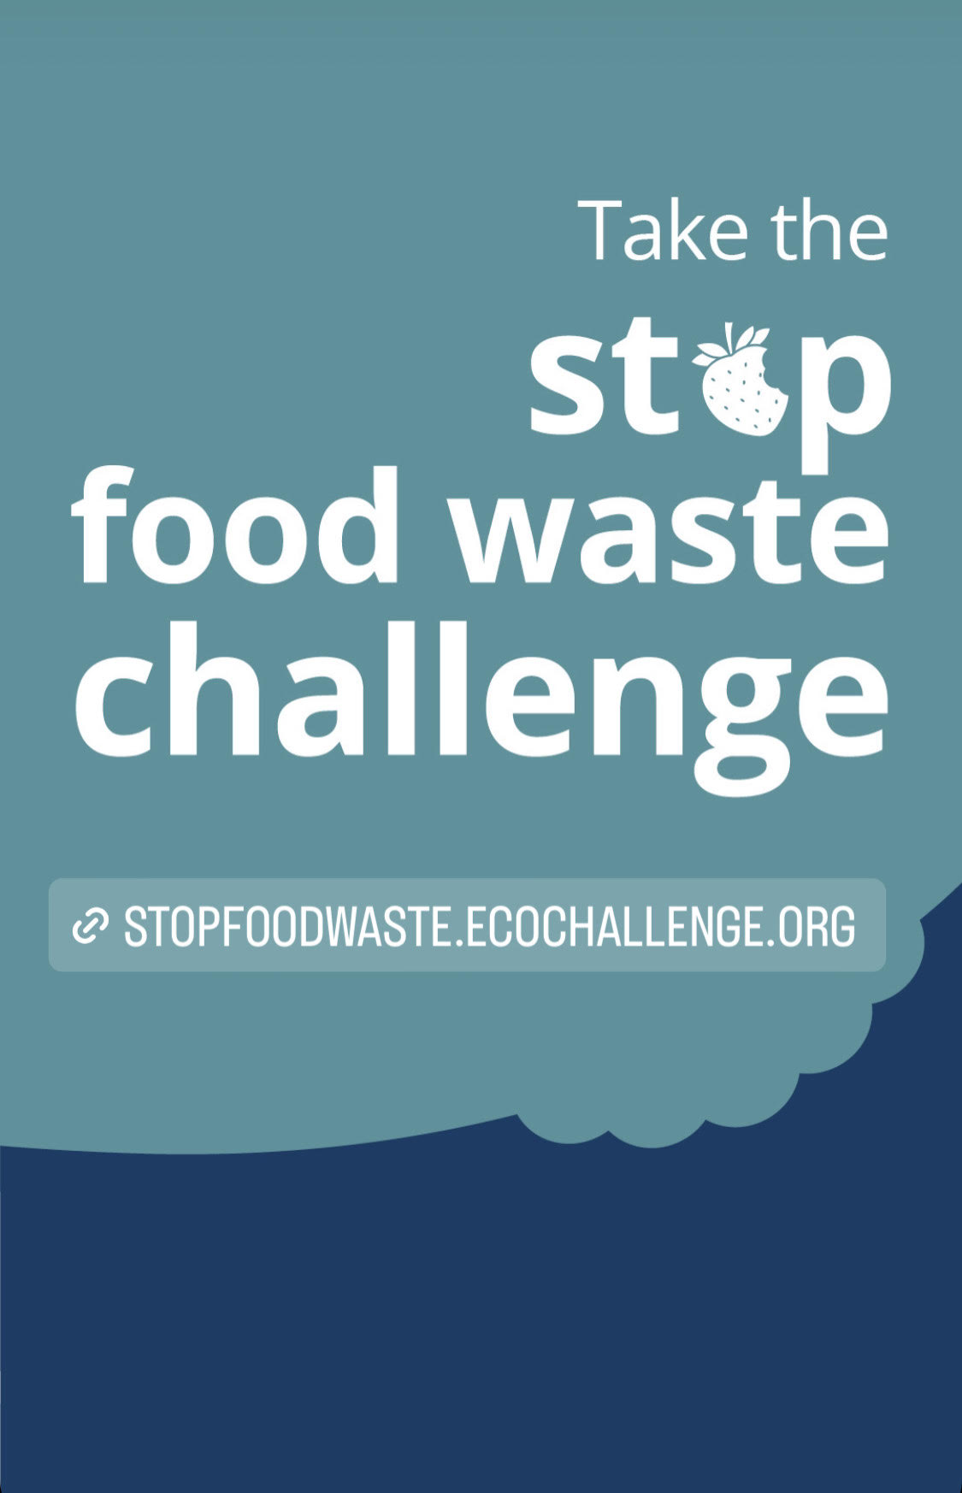
Instagram stories
For Instagram stories, add a link to stopfoodwaste.ecochallenge.org to the Take the Stop Food Waste Challenge graphic, as shown in the graphic to the right.

Image credits
- https://unsplash.com/photos/nSoj6ufj1Ws, Photo by Chandra Oh on Unsplash
- https://unsplash.com/photos/UX87Pz74ukY, Photo by Brooke Lark on Unsplash
- https://unsplash.com/photos/AEU9UZstCfs, Photo by Ello on Unsplash
- https://unsplash.com/photos/I4e1cY1I0FQ, Photo by Conscious Design on Unsplash
- https://unsplash.com/photos/7MAjXGUmaPw, Photo by Jason Briscoe on Unsplash
- https://unsplash.com/photos/my1mDMraGf0, Photo by Jimmy Dean on Unsplash

Get notified when sign up is open! (if promoting before July 1)

Facebook:
Team up to fight food waste with the Stop Food Waste Challenge! By committing to actions that reduce food waste, we can save money, fight climate change, provide for our families, and improve our cooking skills. Get notified when sign up is open: public.govdelivery.com/accounts/MNHENNE/signup/38814

Twitter:
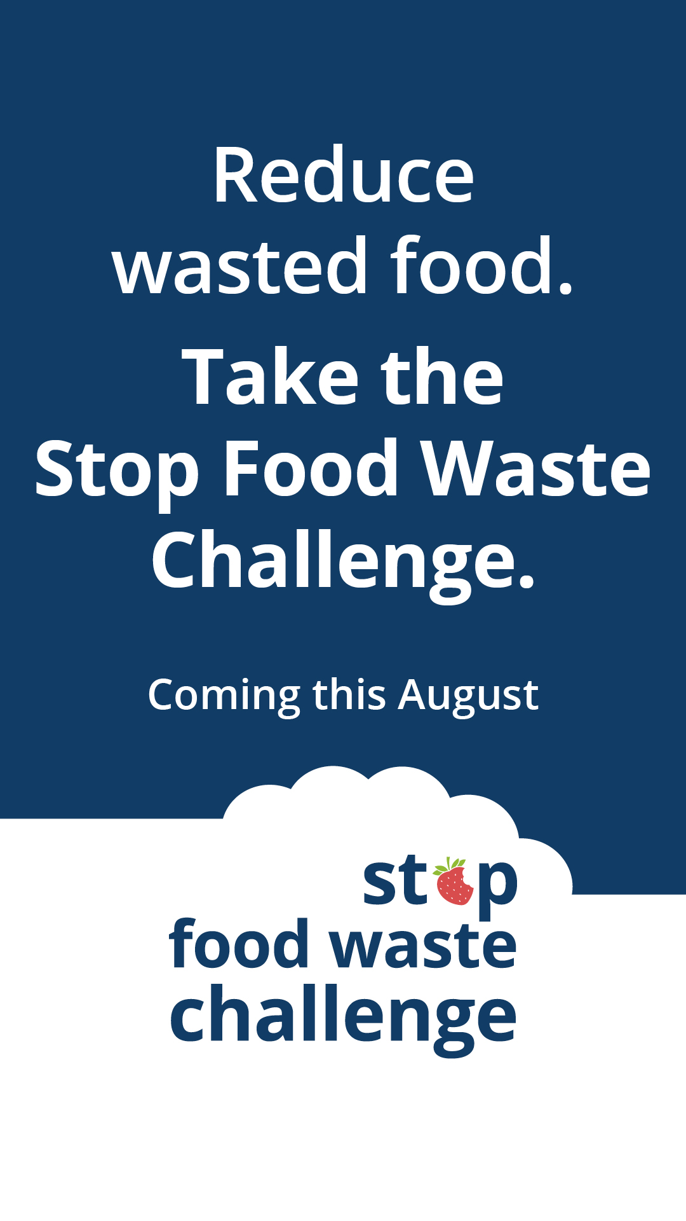
Team up to fight food waste with the Stop Food Waste Challenge! By committing to actions that reduce food waste, we can save money, fight climate change, provide for our families, and improve our cooking skills. Get notified when sign up is open: public.govdelivery.com/accounts/MNHENNE/signup/38814 #StopFoodWasteChallenge

Instagram:
Team up to fight food waste with the Stop Food Waste Challenge! By committing to actions that reduce food waste, we can save money, fight climate change, provide for our families, and improve our cooking skills. Get notified when sign up is open at the link in our bio. #StopFoodWasteChallenge #WastedFood #ZeroWaste

Nextdoor:
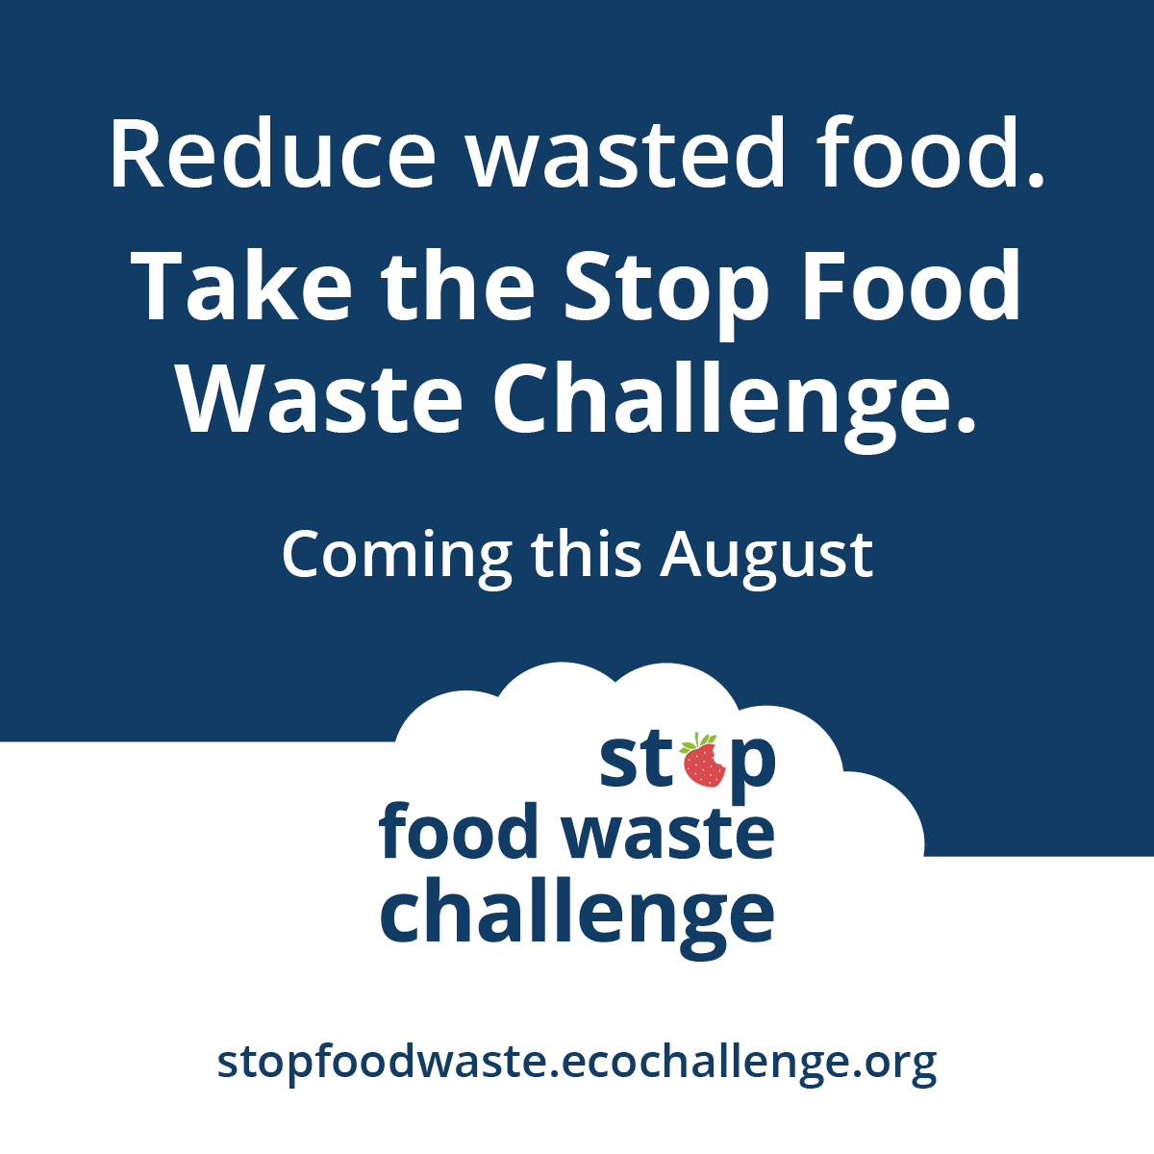
Team up to fight food waste with the Stop Food Waste Challenge! By committing to actions that reduce food waste, we can save money, fight climate change, provide for our families, and improve our cooking skills. Get notified when sign up is open: public.govdelivery.com/accounts/MNHENNE/signup/38814

General announcement message (if promoting after July 1)

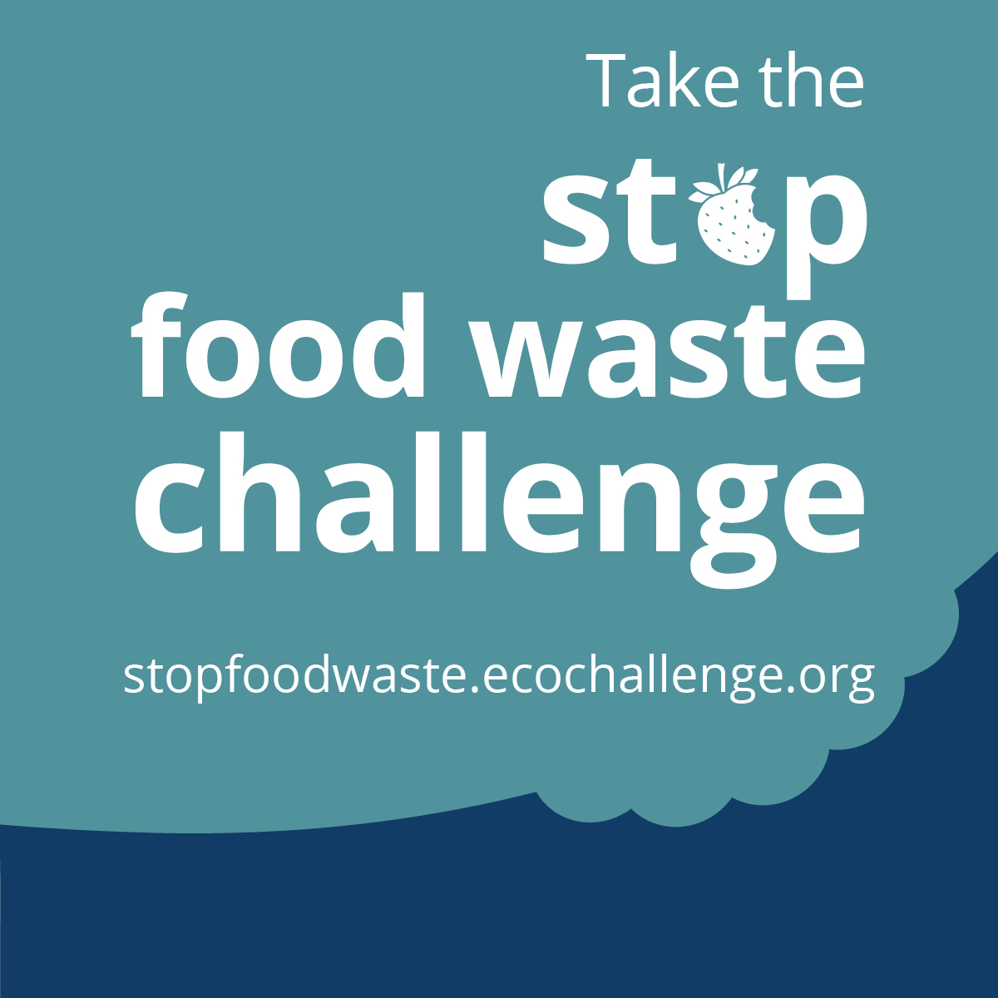
Facebook:
Team up to fight food waste with the Stop Food Waste Challenge! By committing to actions that reduce food waste, we can save money, fight climate change, provide for our families, and improve our cooking skills. Sign up by July 31. The challenge runs from August 1 through August 31. Join the challenge now at stopfoodwaste.ecochallenge.org

Twitter:
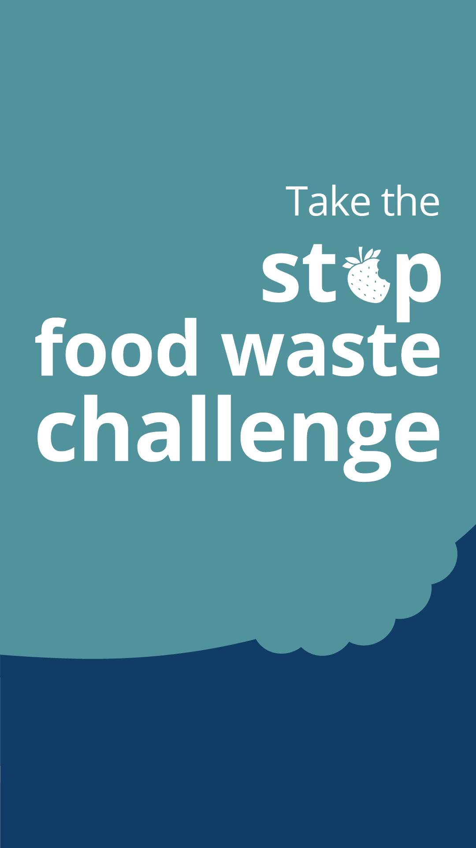
Team up to fight food waste with the Stop Food Waste Challenge! By committing to actions that reduce food waste, we can save money, fight climate change, provide for our families, and improve our cooking skills. Sign up by July 31. Join the challenge now at stopfoodwaste.ecochallenge.org #StopFoodWasteChallenge

Instagram:
Team up to fight food waste with the Stop Food Waste Challenge! By committing to actions that reduce food waste, we can save money, fight climate change, provide for our families, and improve our cooking skills. Sign up by July 31. The challenge runs from August 1 through August 31. Join the challenge now at the link in our bio. #StopFoodWasteChallenge #WastedFood #ZeroWaste

Nextdoor:
Team up to fight food waste with the Stop Food Waste Challenge! By committing to actions that reduce food waste, we can save money, fight climate change, provide for our families, and improve our cooking skills. Sign up by July 31. The challenge runs from August 1 through August 31. Join your neighbors at stopfoodwaste.ecochallenge.org

Organics program, food scraps, or drop-off connection

Facebook:
About one-third of the food put in organics recycling is leftovers or unspoiled food that could have been eaten. Join the Stop Food Waste Challenge to learn better strategies for buying food you’ll eat and eating the food you buy. This will help you minimize the volume of wasted food your household produces, keep edible food out of your organics bin, and save money! Join the challenge now at stopfoodwaste.ecochallenge.org

Twitter:
About one-third of the food put in organics recycling is food that could have been eaten. Join the Stop Food Waste Challenge to learn how to keep edible food out of your organics bin and save money! Join the challenge now at stopfoodwaste.ecochallenge.org #WastedFood

Instagram:
About one-third of the food put in organics recycling is leftovers or unspoiled food that could have been eaten. Join the Stop Food Waste Challenge to learn better strategies for buying food you’ll eat and eating the food you buy. This will help you minimize the volume of wasted food your household produces, keep edible food out of your organics bin, and save money! Join the challenge now at the link in our bio. #StopFoodWasteChallenge #WastedFood #ZeroWaste

Nextdoor:
About one-third of the food put in organics recycling is leftovers or unspoiled food that could have been eaten. Join the Stop Food Waste Challenge to learn better strategies for buying food you’ll eat and eating the food you buy. This will help you minimize the volume of wasted food your household produces, keep edible food out of your organics bin, and save money! Join your neighbors at stopfoodwaste.ecochallenge.org

Message group one: Stop food waste. Save money.

Facebook:
Throwing away food is like throwing away money. By making a meal plan, buying just what you need, using up leftovers, and properly storing your food, your family can save over $2,500 per year on groceries. Stop food waste. Save money. Take the Stop Food Waste Challenge. Sign up by July 31. stopfoodwaste.ecochallenge.org

Twitter:
Throwing away food is like throwing away money. By making a meal plan, buying just what you need, and properly storing your food, your family can save over $2,500 a year on groceries. Stop food waste. Save money. Sign up by July 31. stopfoodwaste.ecochallenge.org #StopFoodWaste

Instagram:
Throwing away food is like throwing away money. By making a meal plan, buying just what you need, using up leftovers, and properly storing your food, your family can save over $2,500 per year on groceries. Stop food waste. Save money. Take the Stop Food Waste Challenge. Sign up by July 31. #StopFoodWaste

Carousel of graphics:
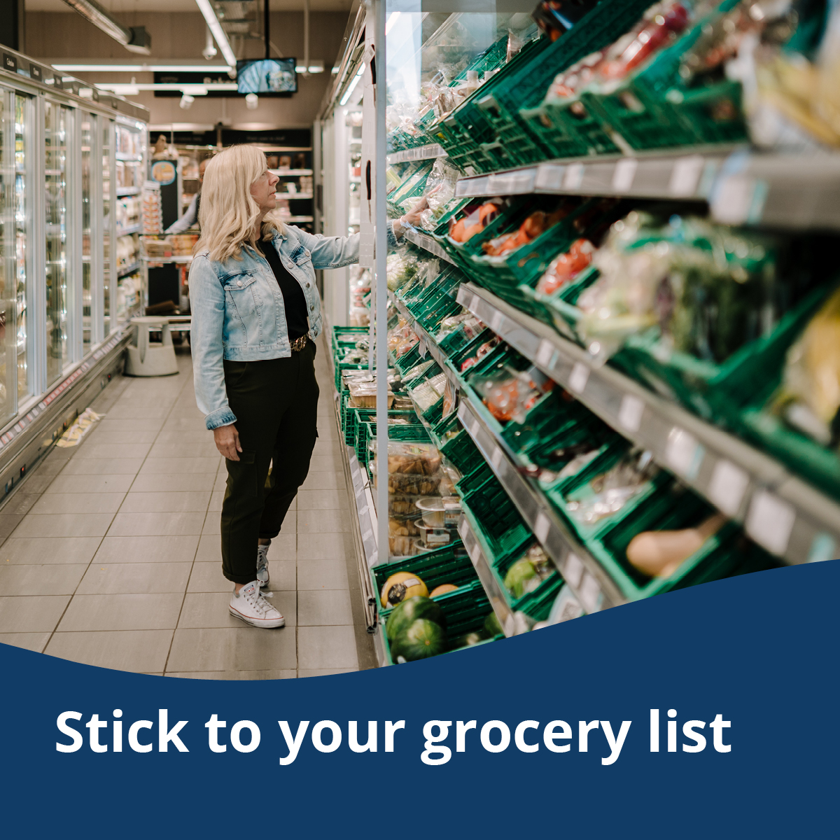
To use images and graphics: right click on the image and select Save as Picture or download graphics at stopfoodwaste.ecochallenge.org/about/resources
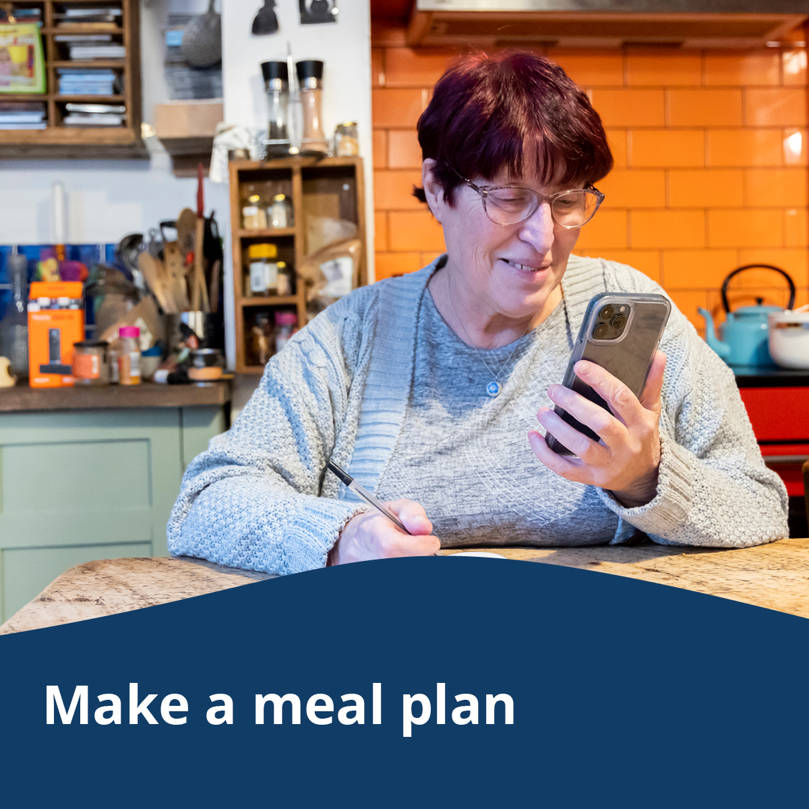
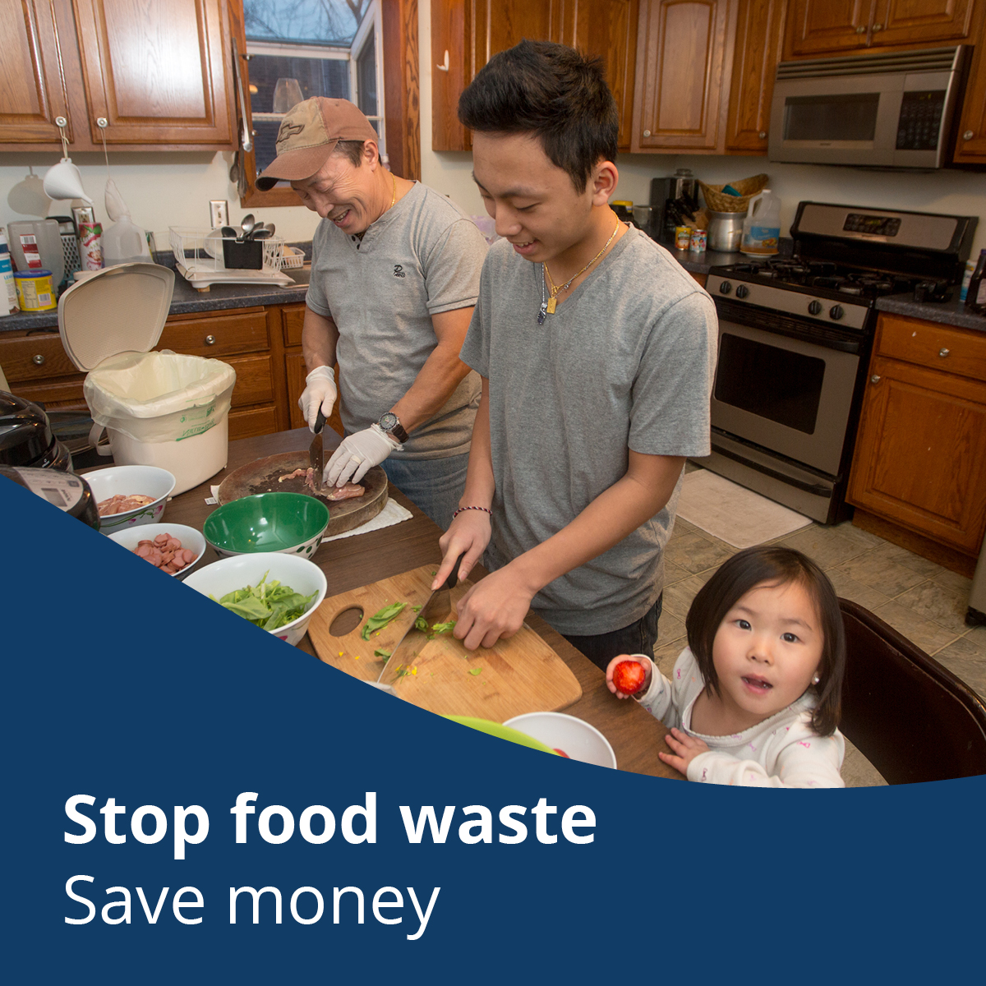

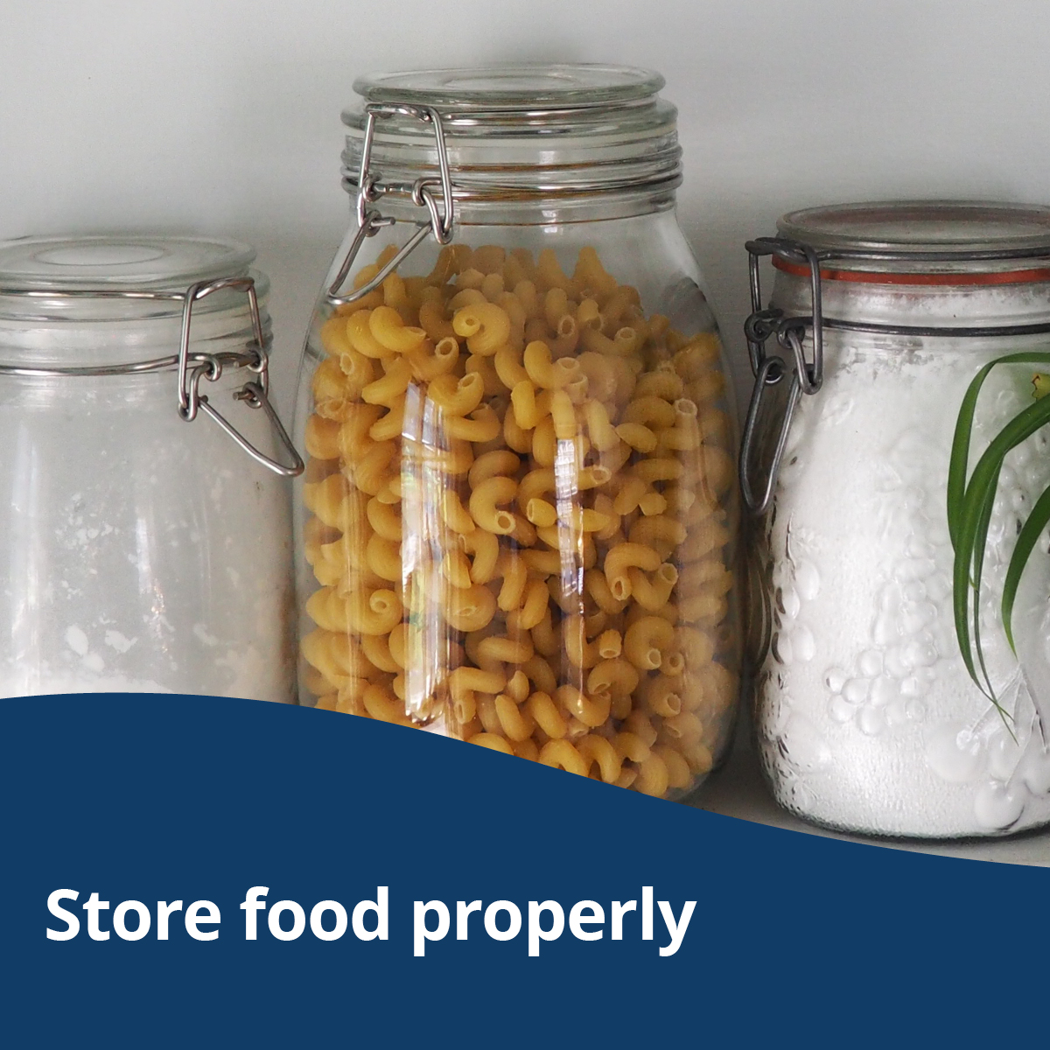

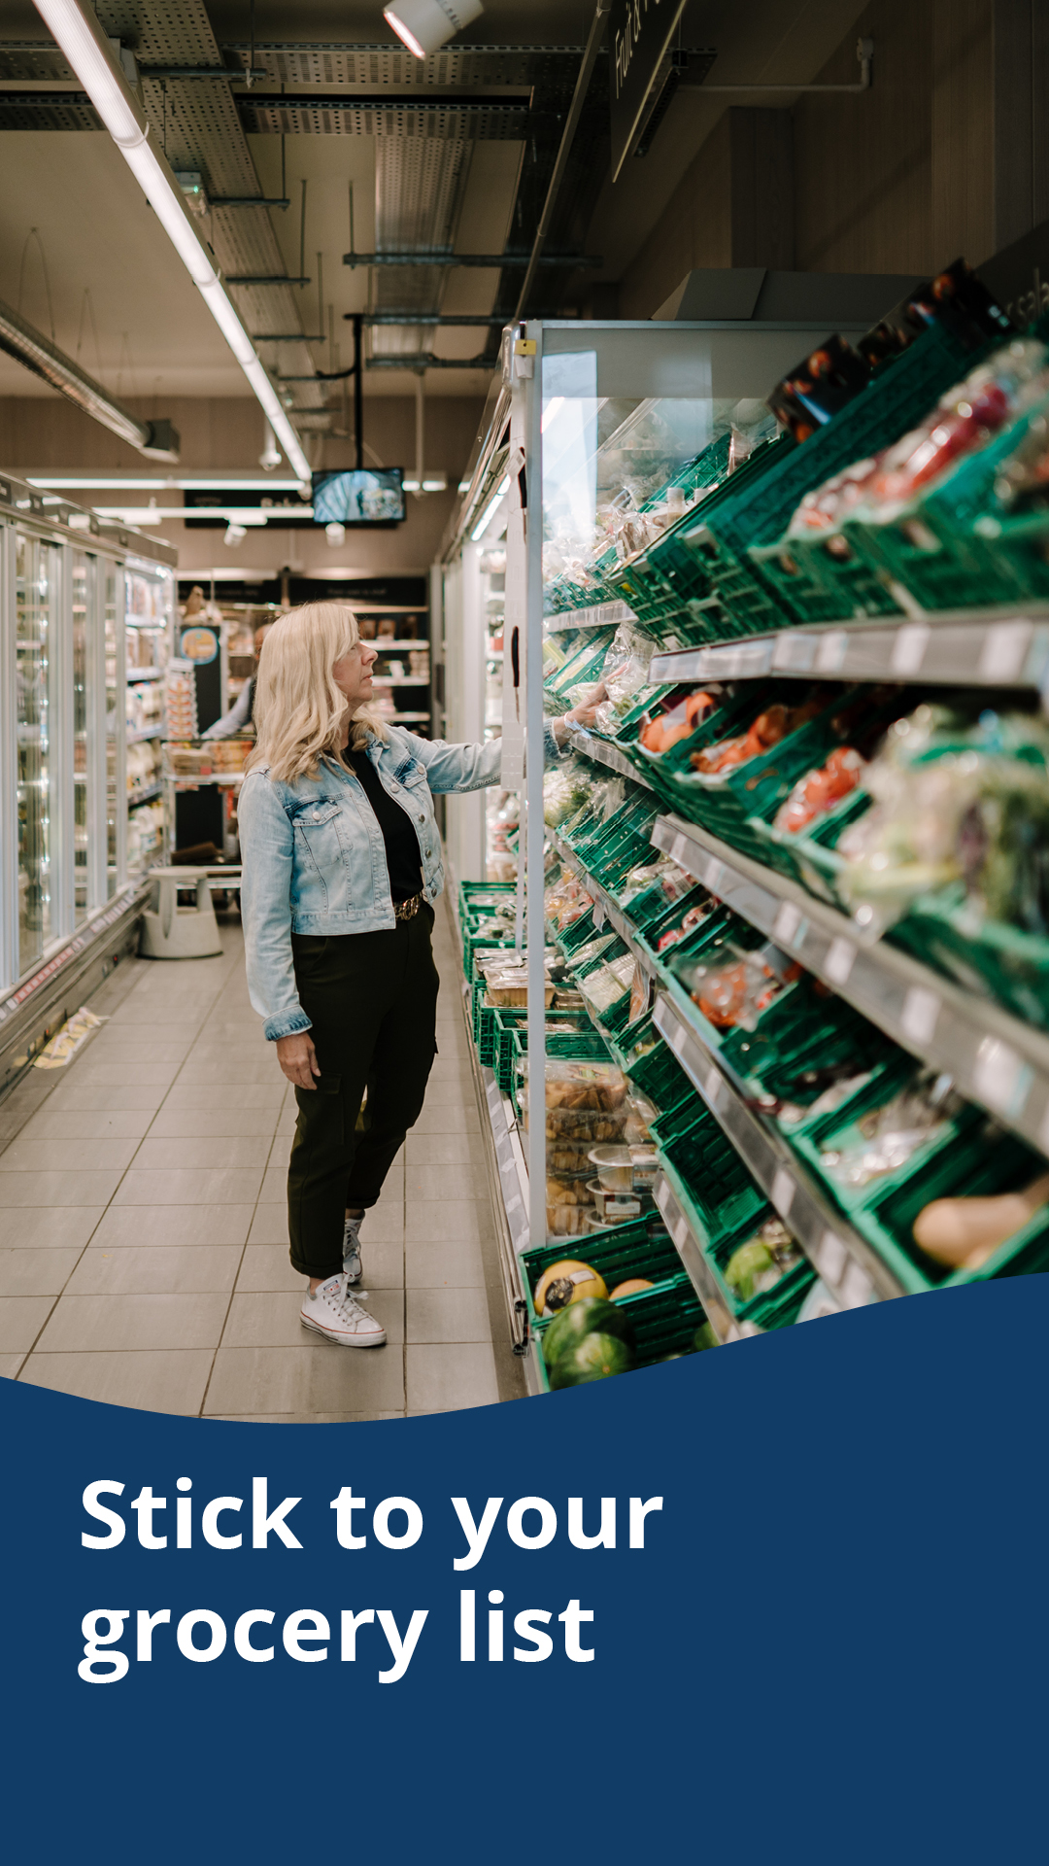
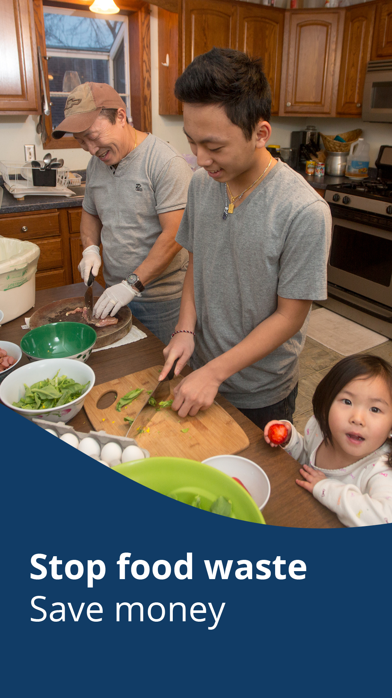
Instagram story graphics

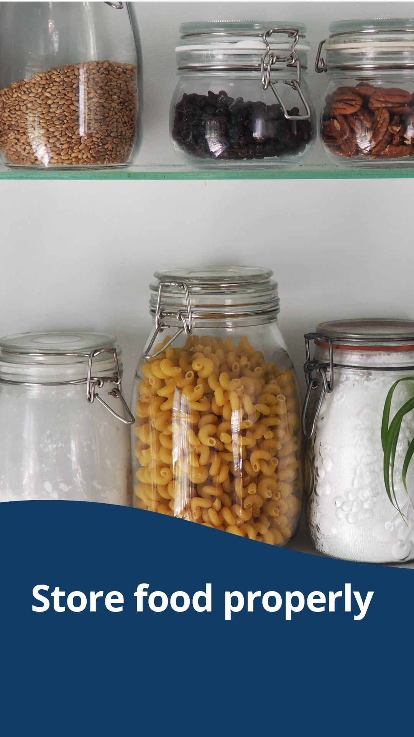

Message group two: Stop food waste. Fight climate change.

Facebook:
Reducing food waste is a surprisingly powerful climate solution. The buildings, equipment, and vehicles involved in growing, processing, transporting, and disposing of food use fossil fuels, which when burned for energy release excess greenhouse gases that contribute to climate change. Additionally, food waste decomposing in landfills produces methane, a potent greenhouse gas.
By buying local foods and eating your food before it spoils, you can reduce emissions that contribute to climate change. Stop food waste. Fight climate change. Take the Stop Food Waste Challenge. Sign up by July 31. stopfoodwaste.ecochallenge.org

Twitter:
Reducing food waste is a surprisingly powerful climate solution. By buying local foods and eating food before it spoils, you can reduce emissions that contribute to climate change. Stop food waste. Fight climate change. Sign up by July 31. stopfoodwaste.ecochallenge.org #StopFoodWaste

Instagram:
Reducing food waste is a surprisingly powerful climate solution. The buildings, equipment, and vehicles involved in growing, processing, transporting, and disposing of food use fossil fuels, which when burned for energy release excess greenhouse gases that contribute to climate change. Additionally, food waste decomposing in landfills produces methane, a potent greenhouse gas.
By buying local foods and eating your food before it spoils, you can reduce emissions that contribute to climate change. Stop food waste. Fight climate change. Take the Stop Food Waste Challenge. Sign up by July 31. #StopFoodWaste

Carousel of graphics:
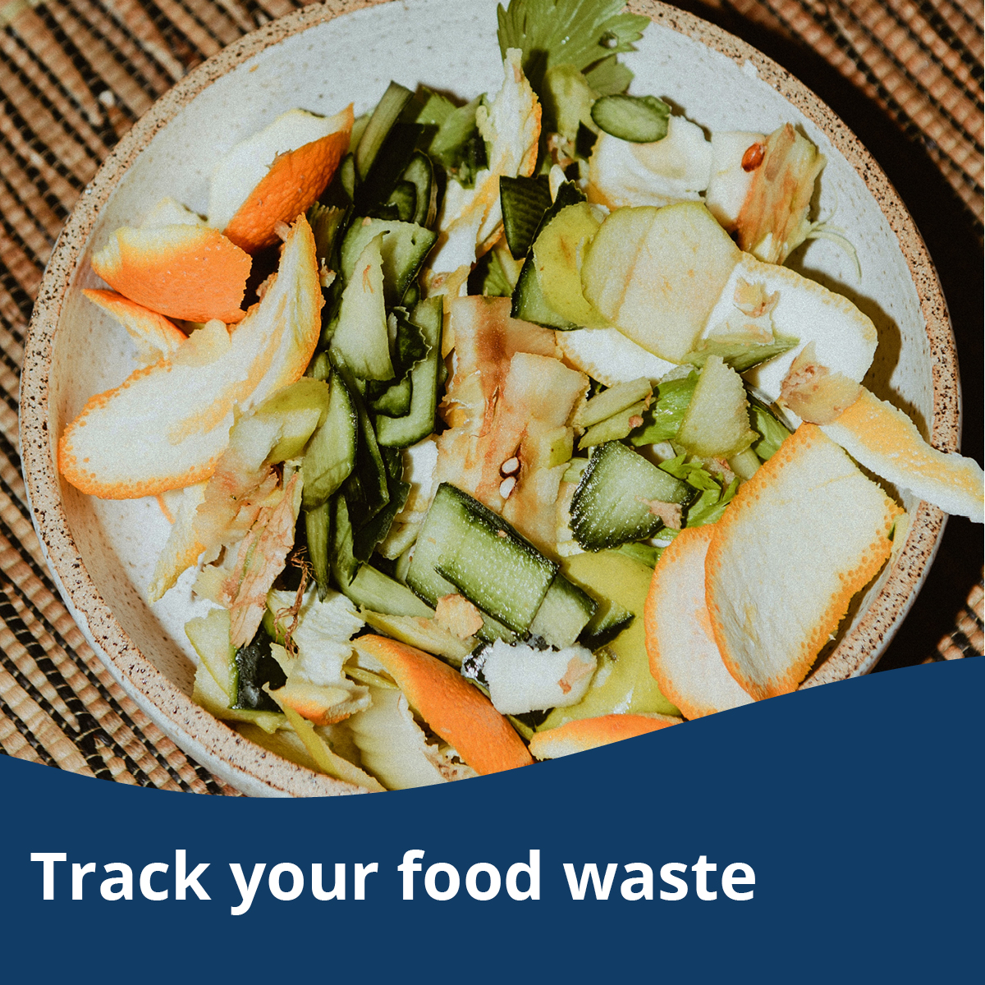
To use images and graphics: right click on the image and select Save as Picture or download graphics at stopfoodwaste.ecochallenge.org/about/resources
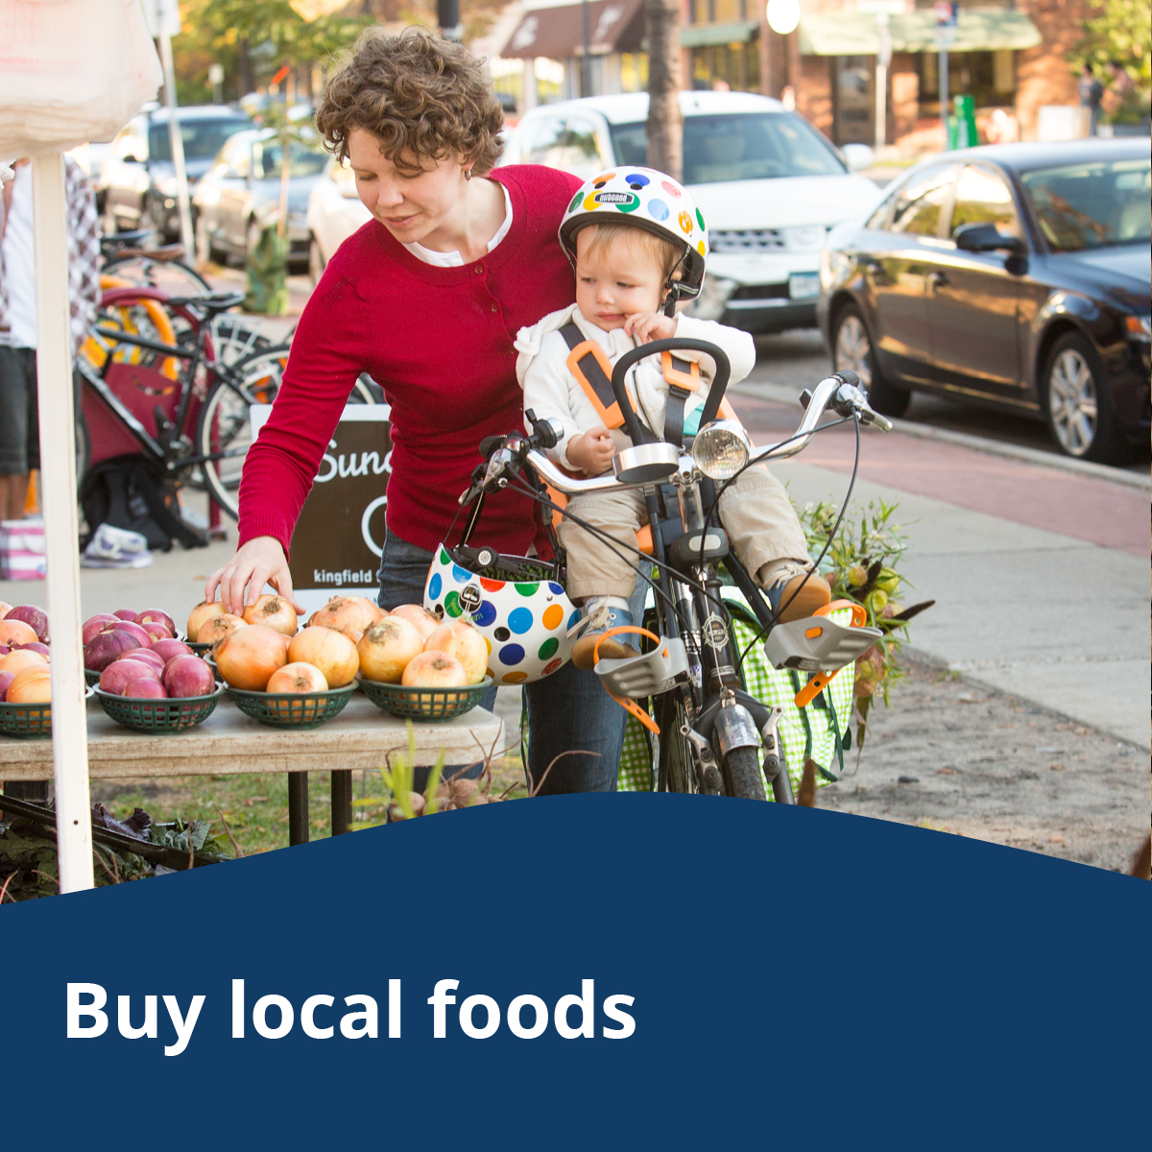
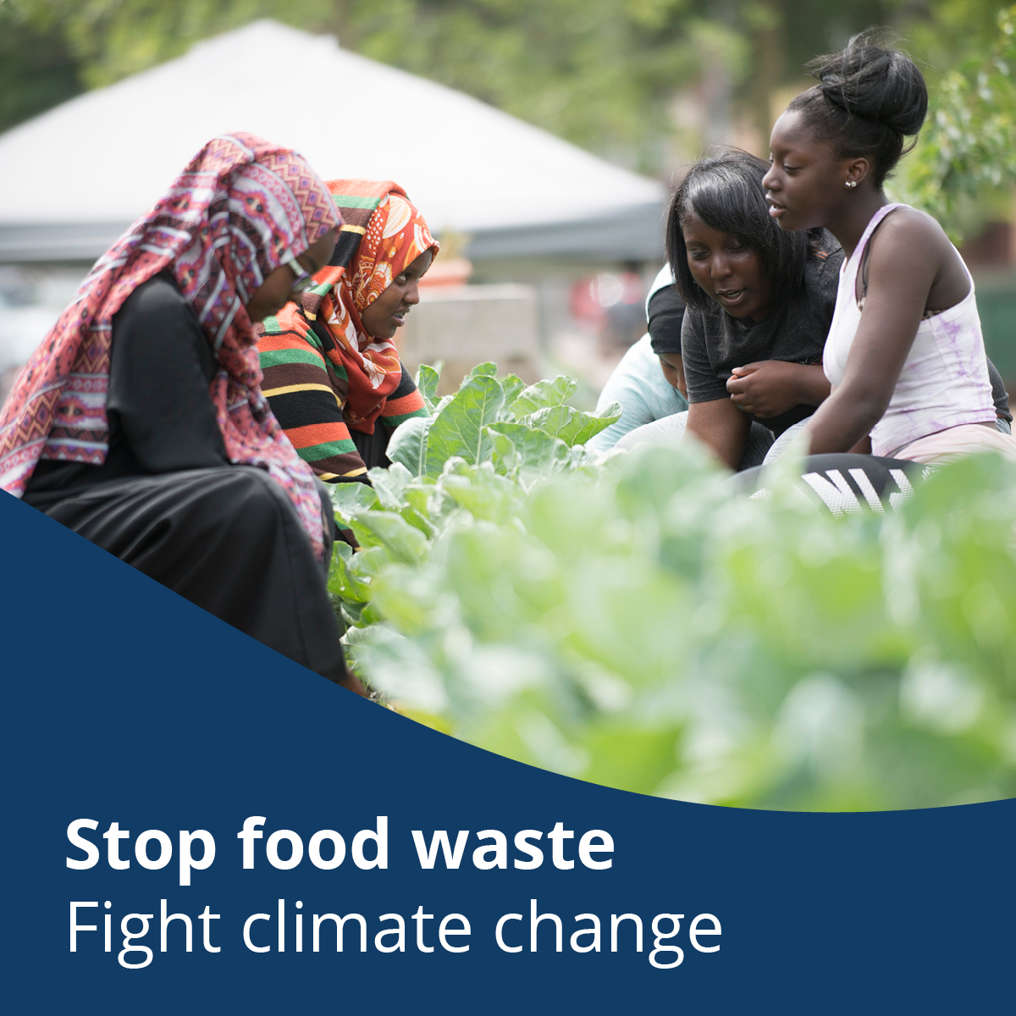
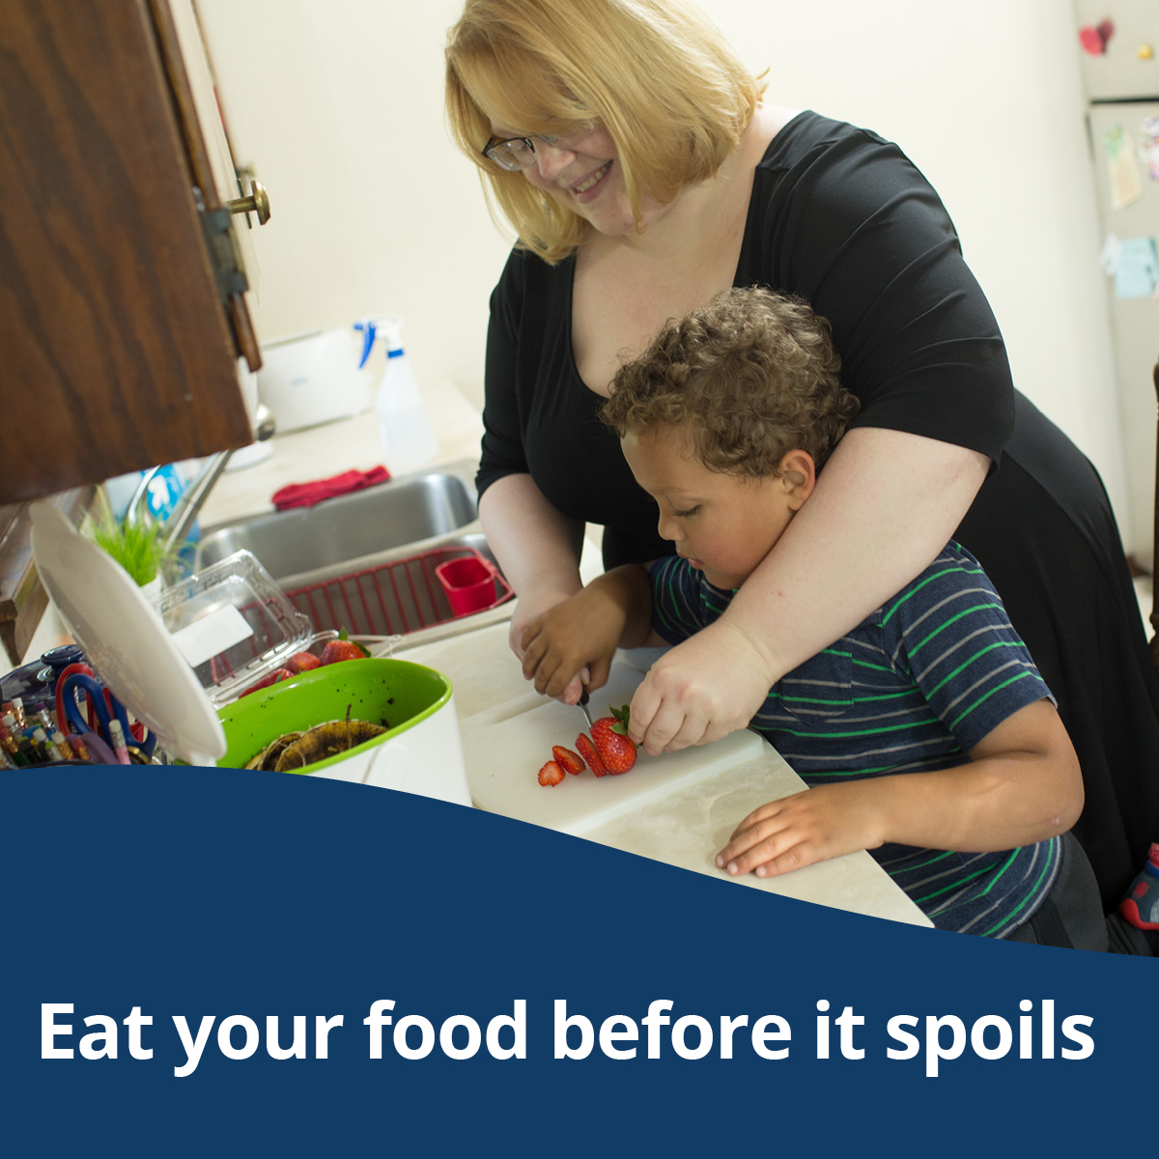

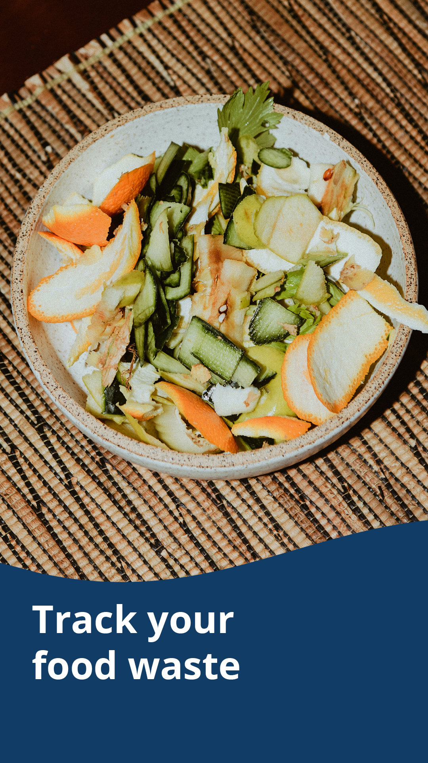
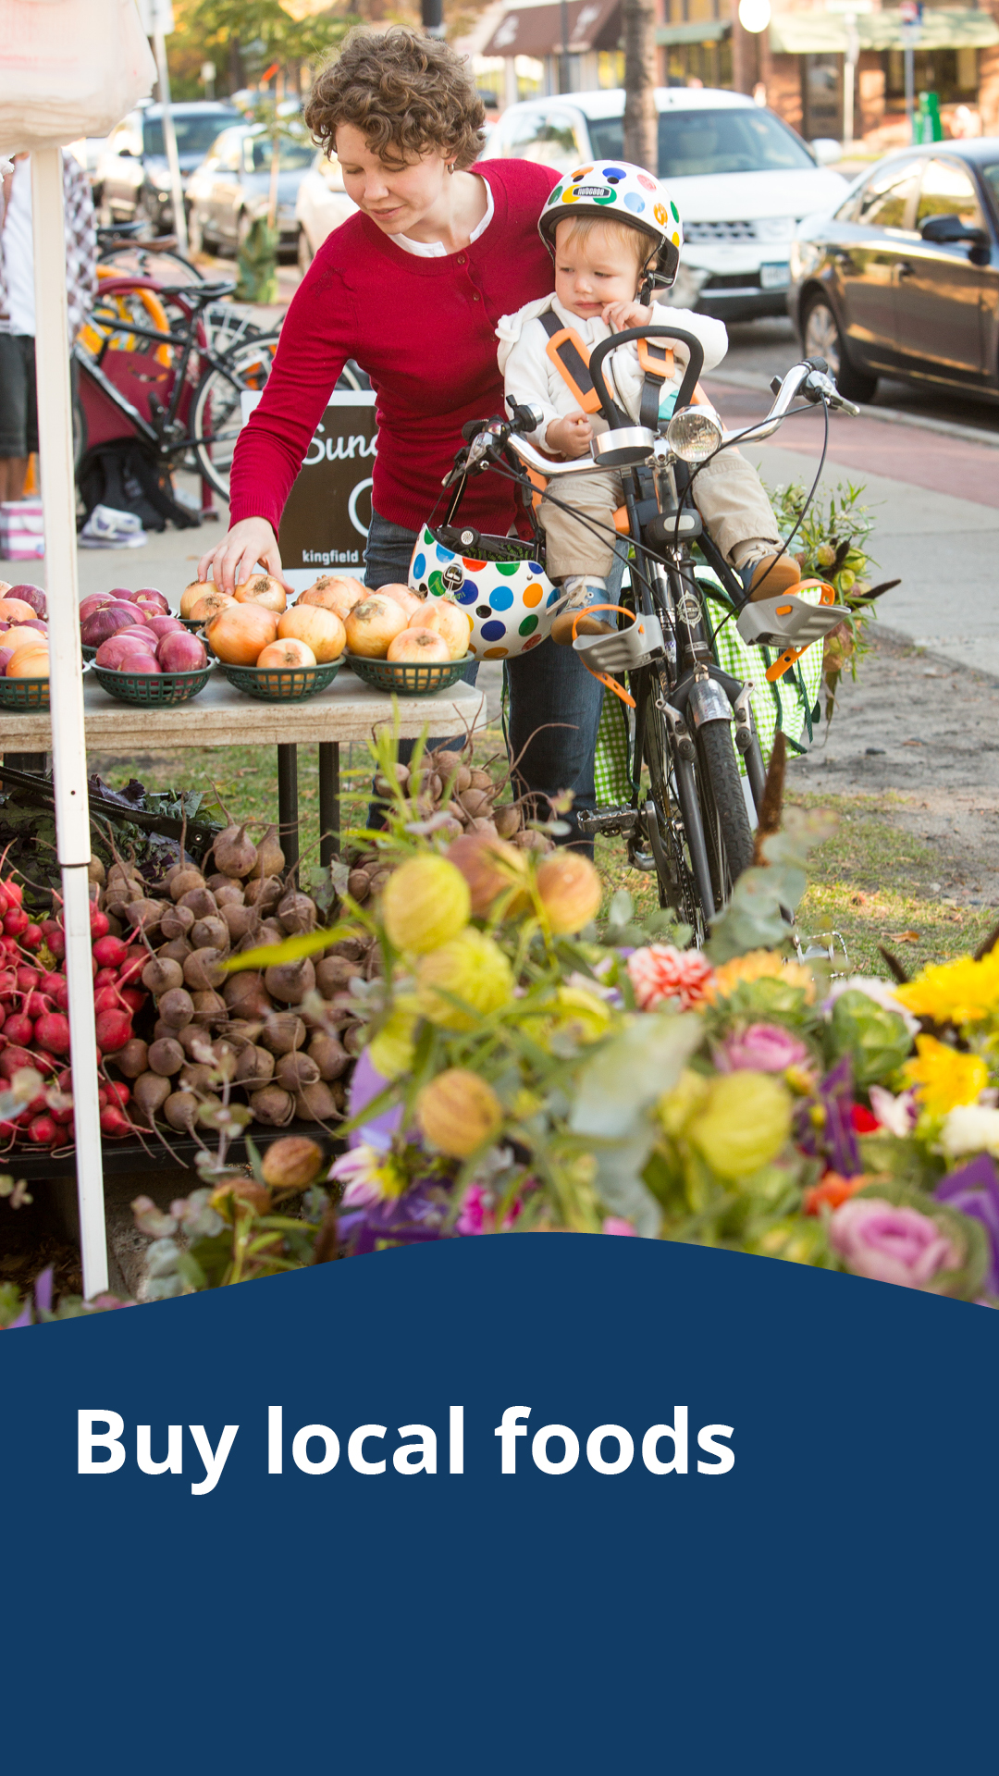
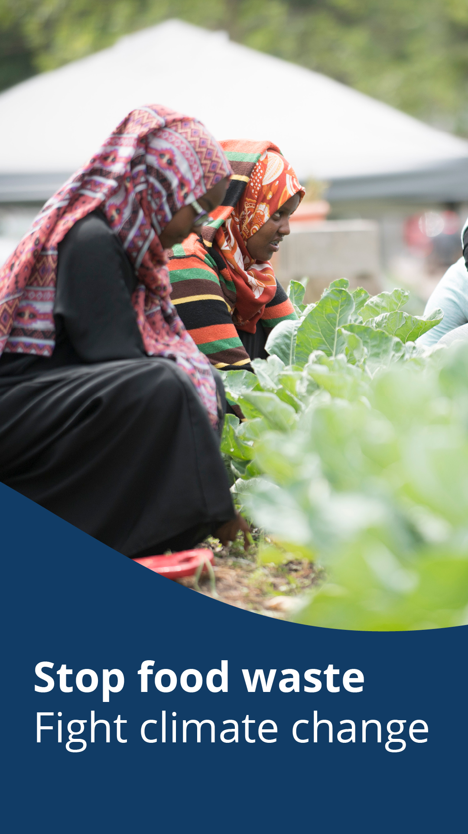
Instagram story graphics
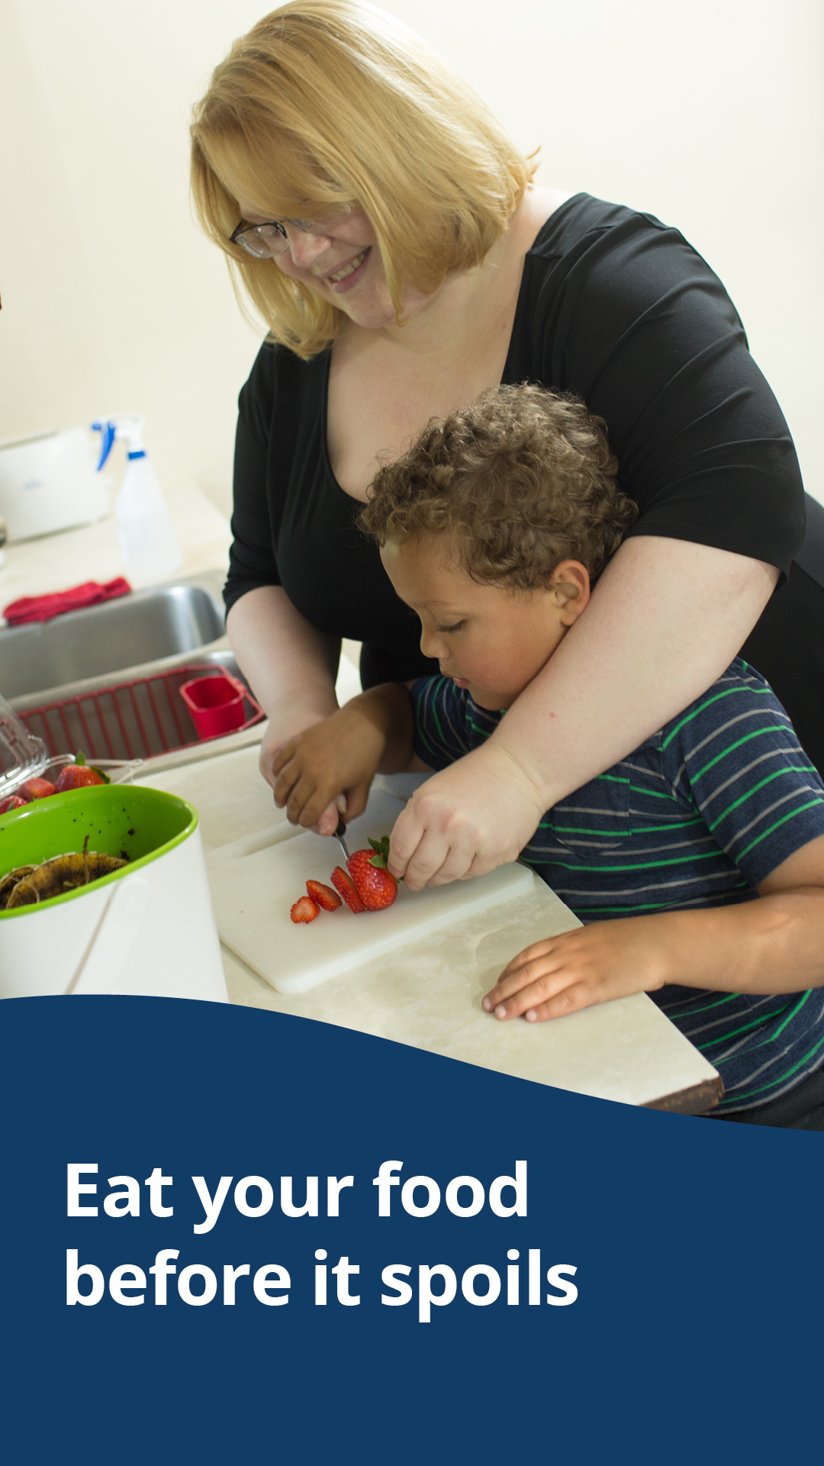

Message group three: Stop food waste. Feed your family.

Facebook:
Spend time making memories with your family, not making food that goes to waste. By involving kids in meal planning, learning about food and food waste, and buying and preparing the right amount for your household, you can stretch your budget further, teach your kids to love food, and ensure that everyone has enough to eat. Stop food waste. Feed your family. Take the Stop Food Waste Challenge. Sign up by July 31. stopfoodwaste.ecochallenge.org

Twitter:
Spend time making memories with family, not making food that goes to waste. By buying and preparing the right amount, you can stretch your budget further and teach your kids to love food. Stop food waste. Feed your family. Sign up by July 31 stopfoodwaste.ecochallenge.org #StopFoodWaste

Instagram:
Spend time making memories with your family, not making food that goes to waste. By involving kids in meal planning, learning about food and food waste, and buying and preparing the right amount for your household, you can stretch your budget further, teach your kids to love food, and ensure that everyone has enough to eat. Stop food waste. Feed your family. Take the Stop Food Waste Challenge. Sign up by July 31. #StopFoodWaste

Carousel of graphics:
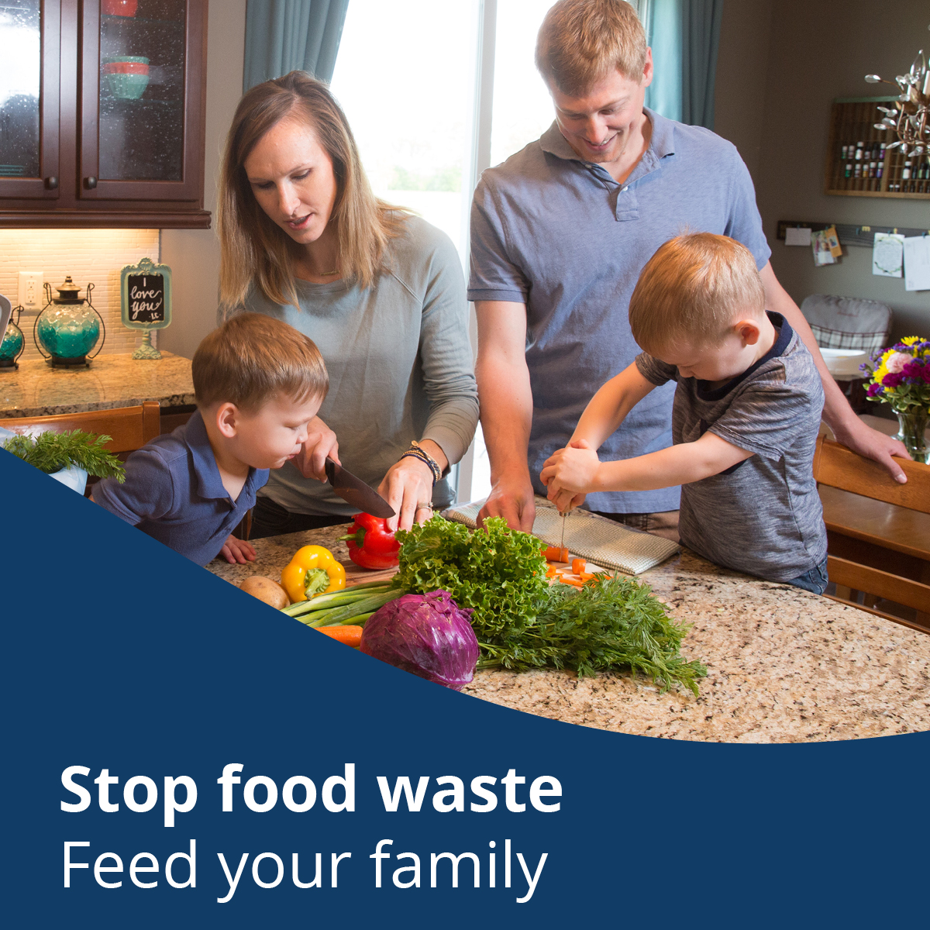
To use images and graphics: right click on the image and select Save as Picture or download graphics at stopfoodwaste.ecochallenge.org/about/resources

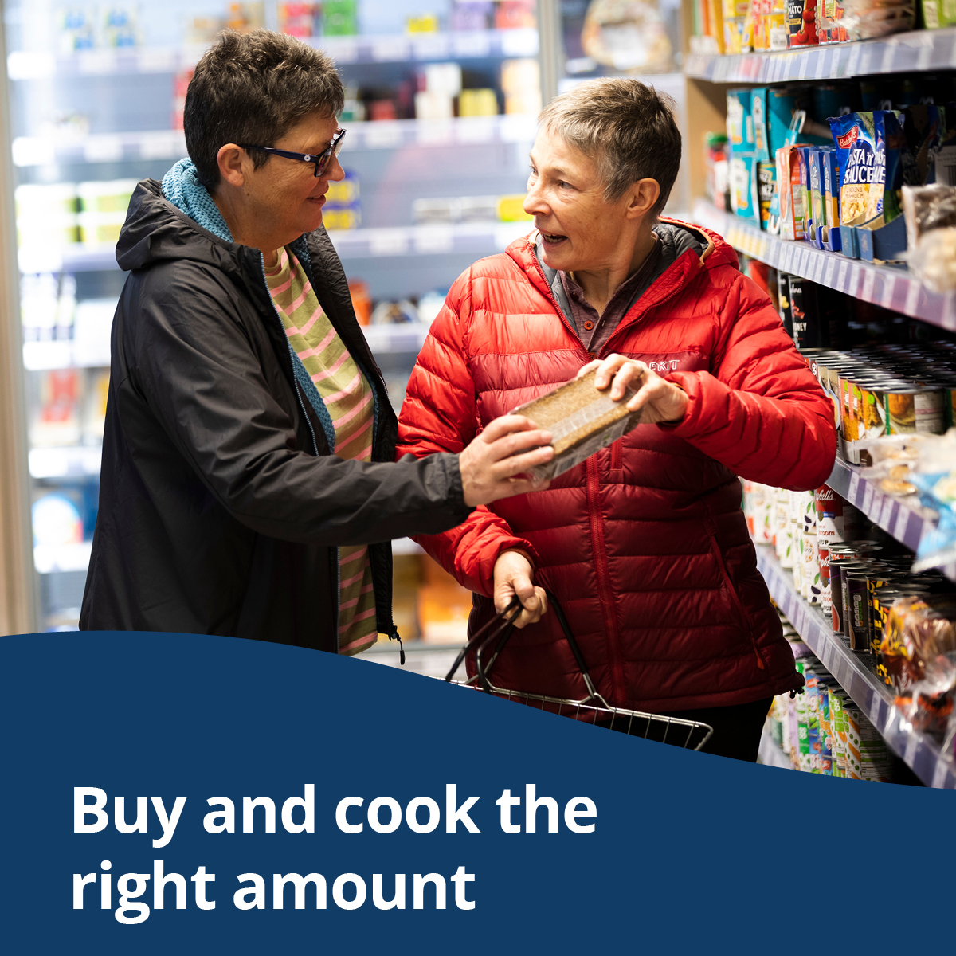

Instagram story graphics
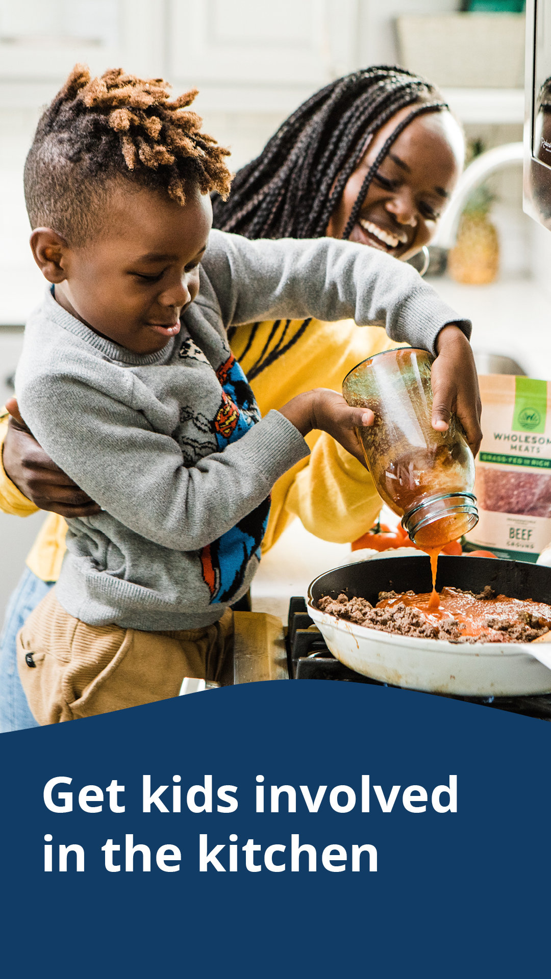
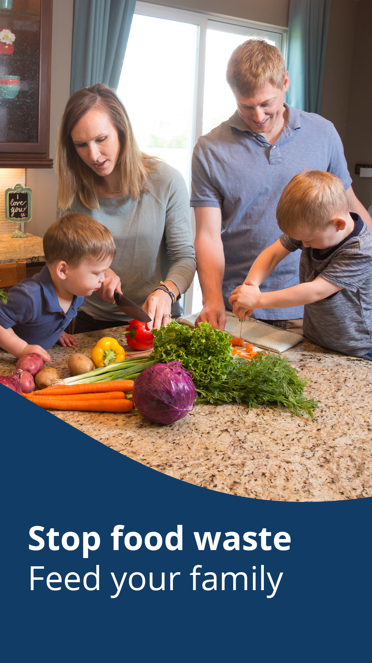
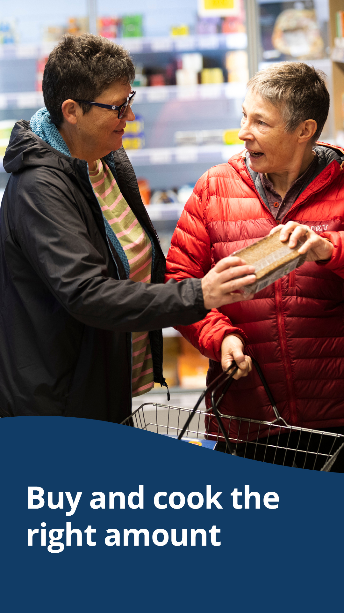

Message group four: Stop food waste. Become a better cook.

Facebook:
Get creative with your groceries before they spoil in your fridge. By using up leftovers, modifying your recipes to use up what you have, and learning new techniques to keep your food fresh for longer, you’ll make mealtime more exciting and be a better cook in no time. Stop food waste. Become a better cook. Take the Stop Food Waste Challenge. Sign up by July 31. stopfoodwaste.ecochallenge.org

Twitter:
Get creative with your groceries before they spoil in your fridge. By using up leftovers and learning new techniques to keep food fresh for longer, you’ll be a better cook in no time. Stop food waste. Become a better cook. Sign up by July 31. stopfoodwaste.ecochallenge.org #StopFoodWaste

Instagram:
Get creative with your groceries before they spoil in your fridge. By using up leftovers, modifying your recipes to use up what you have, and learning new techniques to keep your food fresh for longer, you’ll make mealtime more exciting and be a better cook in no time. Stop food waste. Become a better cook. Take the Stop Food Waste Challenge. Sign up by July 31. #StopFoodWaste

Carousel of graphics:
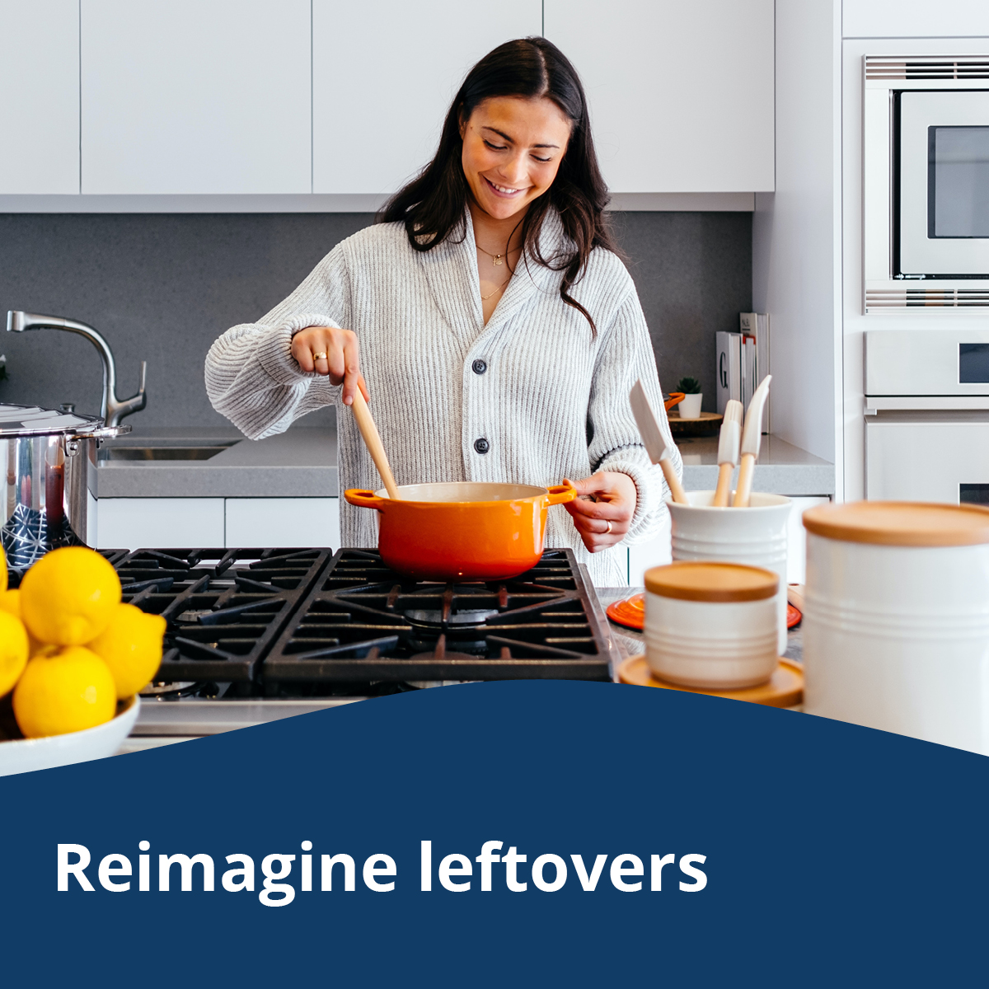
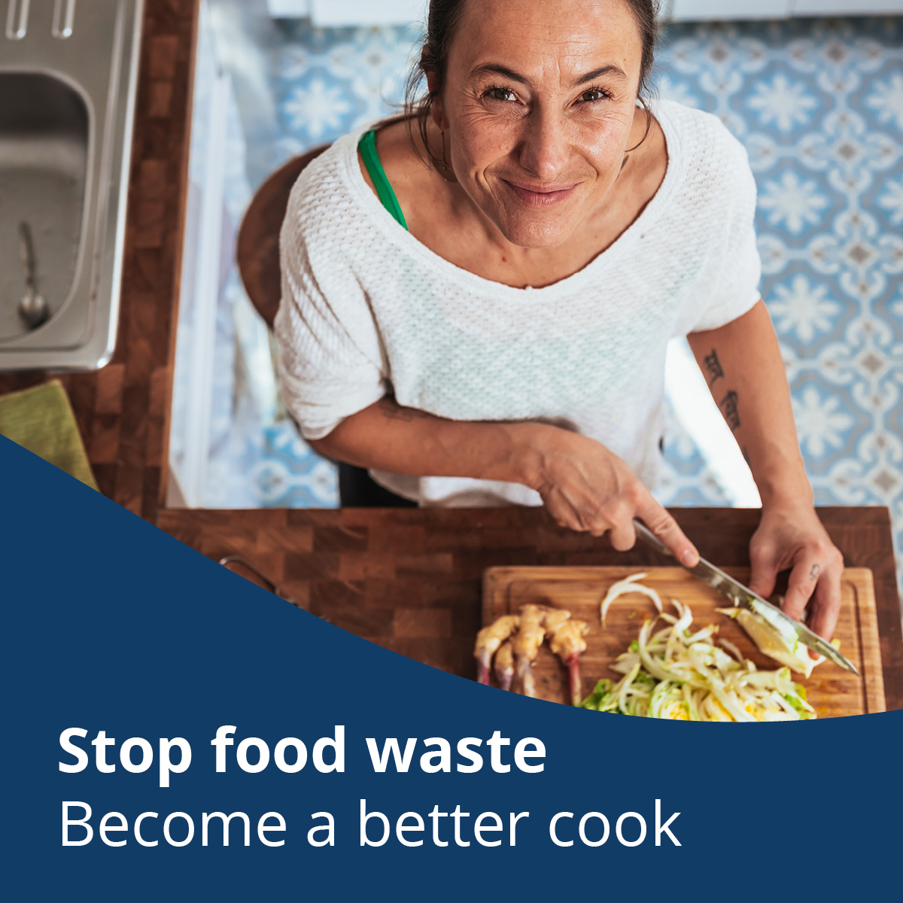
To use images and graphics: right click on the image and select Save as Picture or download graphics at stopfoodwaste.ecochallenge.org/about/resources
.

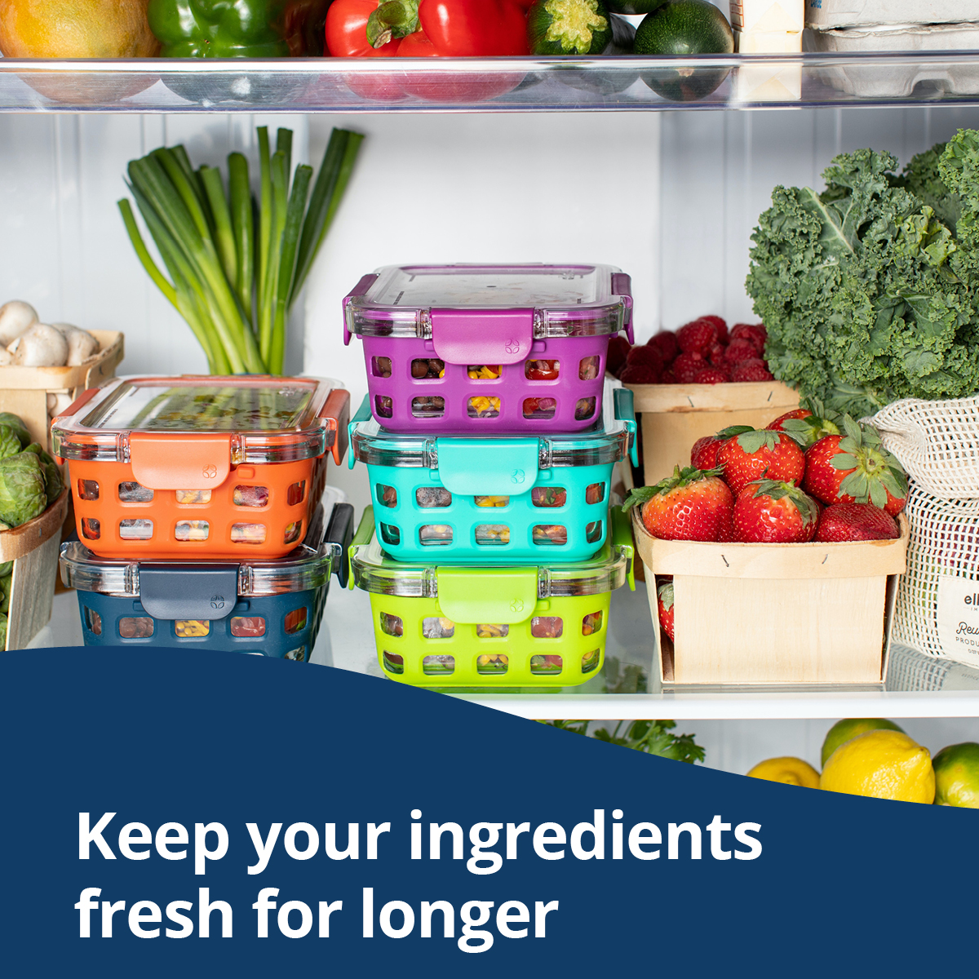

Instagram story graphics
