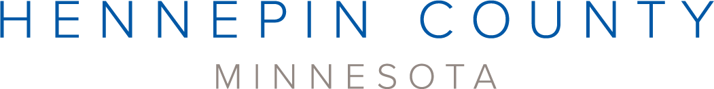

Community Recycling Ambassadors media kit

About the Community Recycling Ambassadors program
To help residents take action for the environment, Hennepin County offers a Community Recycling Ambassador program. During a six-week course, Community Recycling Ambassador volunteers learn about waste prevention, recycling, and composting from industry experts. They then commit to volunteering 30 hours to inspire others in their communities to reduce waste, recycle more, and compost. Hennepin County is holding one round of the Community Recycling Ambassador training in 2024 in the spring. See below for class dates and application details.

Help spread the word
Please share the promotional messaging with the communities you work with. You can download campaign assets below.
- Use the sample newsletter article to share on your organization’s website or in your newsletters. These are editable so you can customize the length or message.
- Use the sample social media posts to share through your social media channels. These are editable so you can customize the message and website.
- Follow and reshare messages posted on the Hennepin County Environment and Energy social media channels: Hennepin Environment on Facebook, Hennepin Environment on Instagram, and @hennepinenviro on Twitter
- Share the information and resources available at hennepin.us/recycling-ambassadors

Upcoming Community Recycling Ambassador trainings

Spring 2024 class
The spring 2024 class will be held every Thursday from February 15 through March 21 from 6 to 8 p.m. The class will take place virtually via Zoom.
The application for the spring class will open on Monday, January 22 and close on Sunday, February 4.
Before applying, please ensure that you meet the following requirements:
- You are 18 years of age or older
- You live, work, or go to school within Hennepin County
- You are available for all six class sessions
- You can commit to 30 hours of volunteering after the class completes
- You have access to internet and a computer or similar device to attend class virtually
Visit the website to learn more about the program and apply.

Contact
For more information about the Community Recycling Ambassador program, contact Kaitlin Keller, Waste Reduction and Recycling Specialist, at kaitlin.keller@hennepin.us.

Promotional resources
Use the sample newsletter article and social media posts below to promote the program.

Become a Community Recycling Ambassador
If you are looking for ways to volunteer in your community, consider becoming a Hennepin County Community Recycling Ambassador!
Community Recycling Ambassadors are trained on waste prevention, recycling and composting, and effective communication skills through a six-week course, with one class each week, taught by industry experts and community leaders. This training program is free to participants.
Once training is complete, participants commit to 30 hours of volunteering putting their skills to work on projects and activities that minimize waste and provide waste reduction, recycling and composting education.

Apply for the spring 2024 class
The spring 2024 class will be held every Thursday from February 15 through March 21 from 6 to 8 p.m. The class will take place virtually via Zoom.
The application for the spring class will open on Monday, January 22 and close on Sunday, February 4.
Before applying, please ensure that you meet the following requirements:
- You are 18 years of age or older
- You live, work, or go to school within Hennepin County
- You are available for all six class sessions
- You can commit to 30 hours of volunteering after the class completes
- You have access to internet and a computer or similar device to attend class virtually
Visit the website to learn more about the program and apply.

Social media posts
To use images and graphics: right click on image and select Save as Picture.

Post 1 – sign up to be notified of upcoming classes
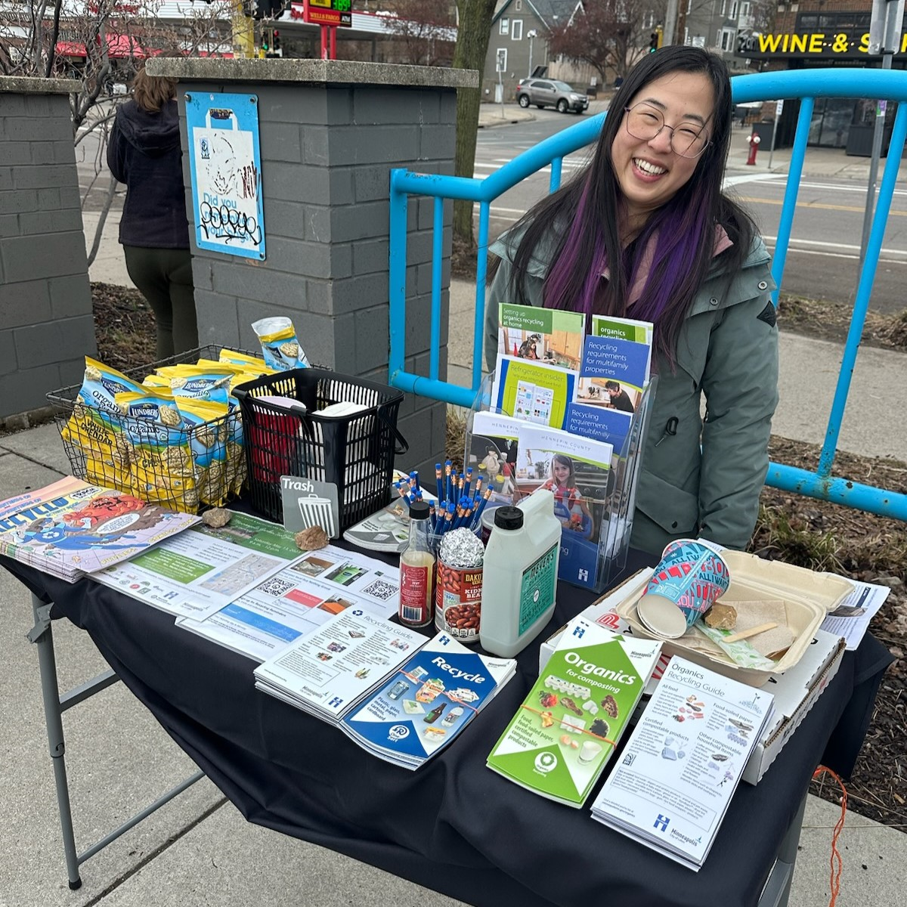
Facebook: If you are looking for ways to volunteer in your community, consider becoming a Community Recycling Ambassador! The application for the spring class will open on Monday, January 22. Learn more about the program and sign up to be notified when the application is open: hennepin.us/recycling-ambassadors
X/Twitter: If you are looking for ways to volunteer in your community, consider becoming a Community Recycling Ambassador! The application for the spring class will open on January 22. Sign up to be notified: hennepin.us/recycling-ambassadors #Volunteer #WasteReduction #Recycling #Composting
Instagram: If you are looking for ways to volunteer in your community, consider becoming a Community Recycling Ambassador! The application for the spring class will open on Monday, January 22. Learn more about the program and sign up to be notified when the application is open at the link in our bio. #Volunteer #WasteReduction #Recycling #Composting
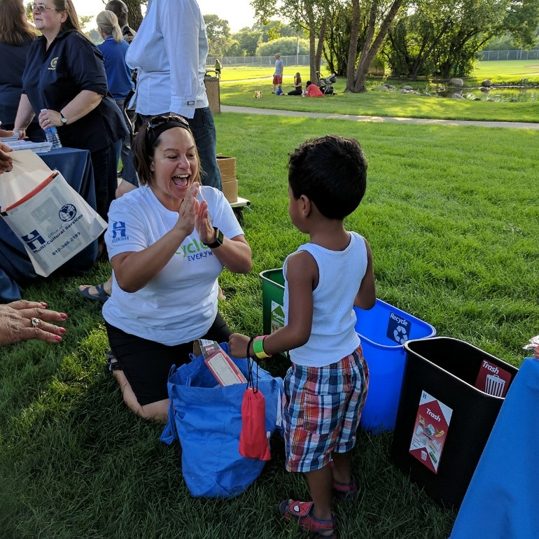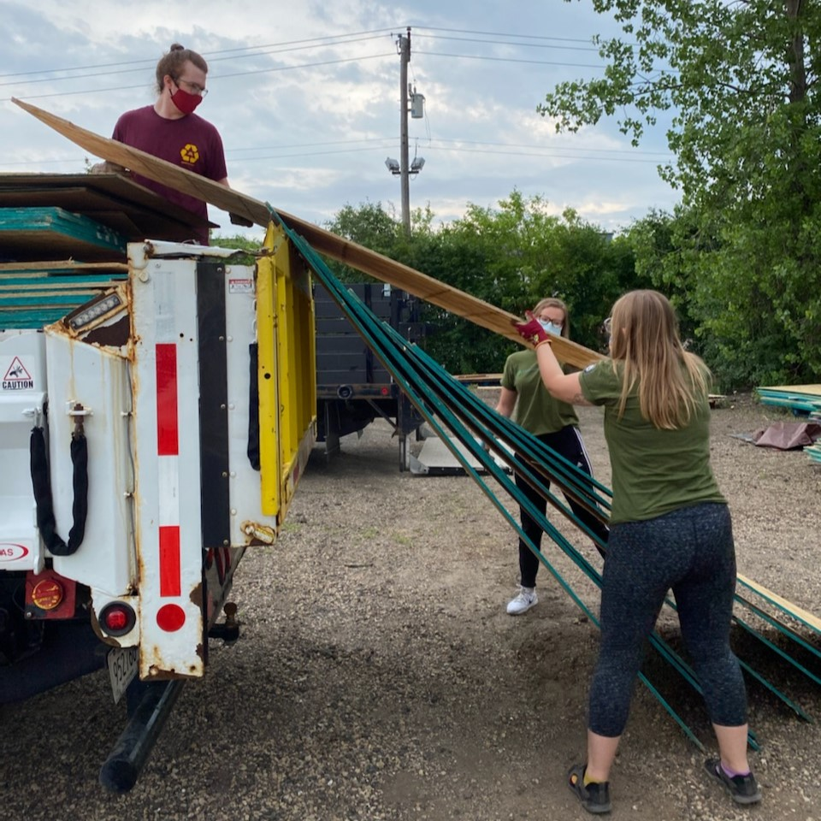

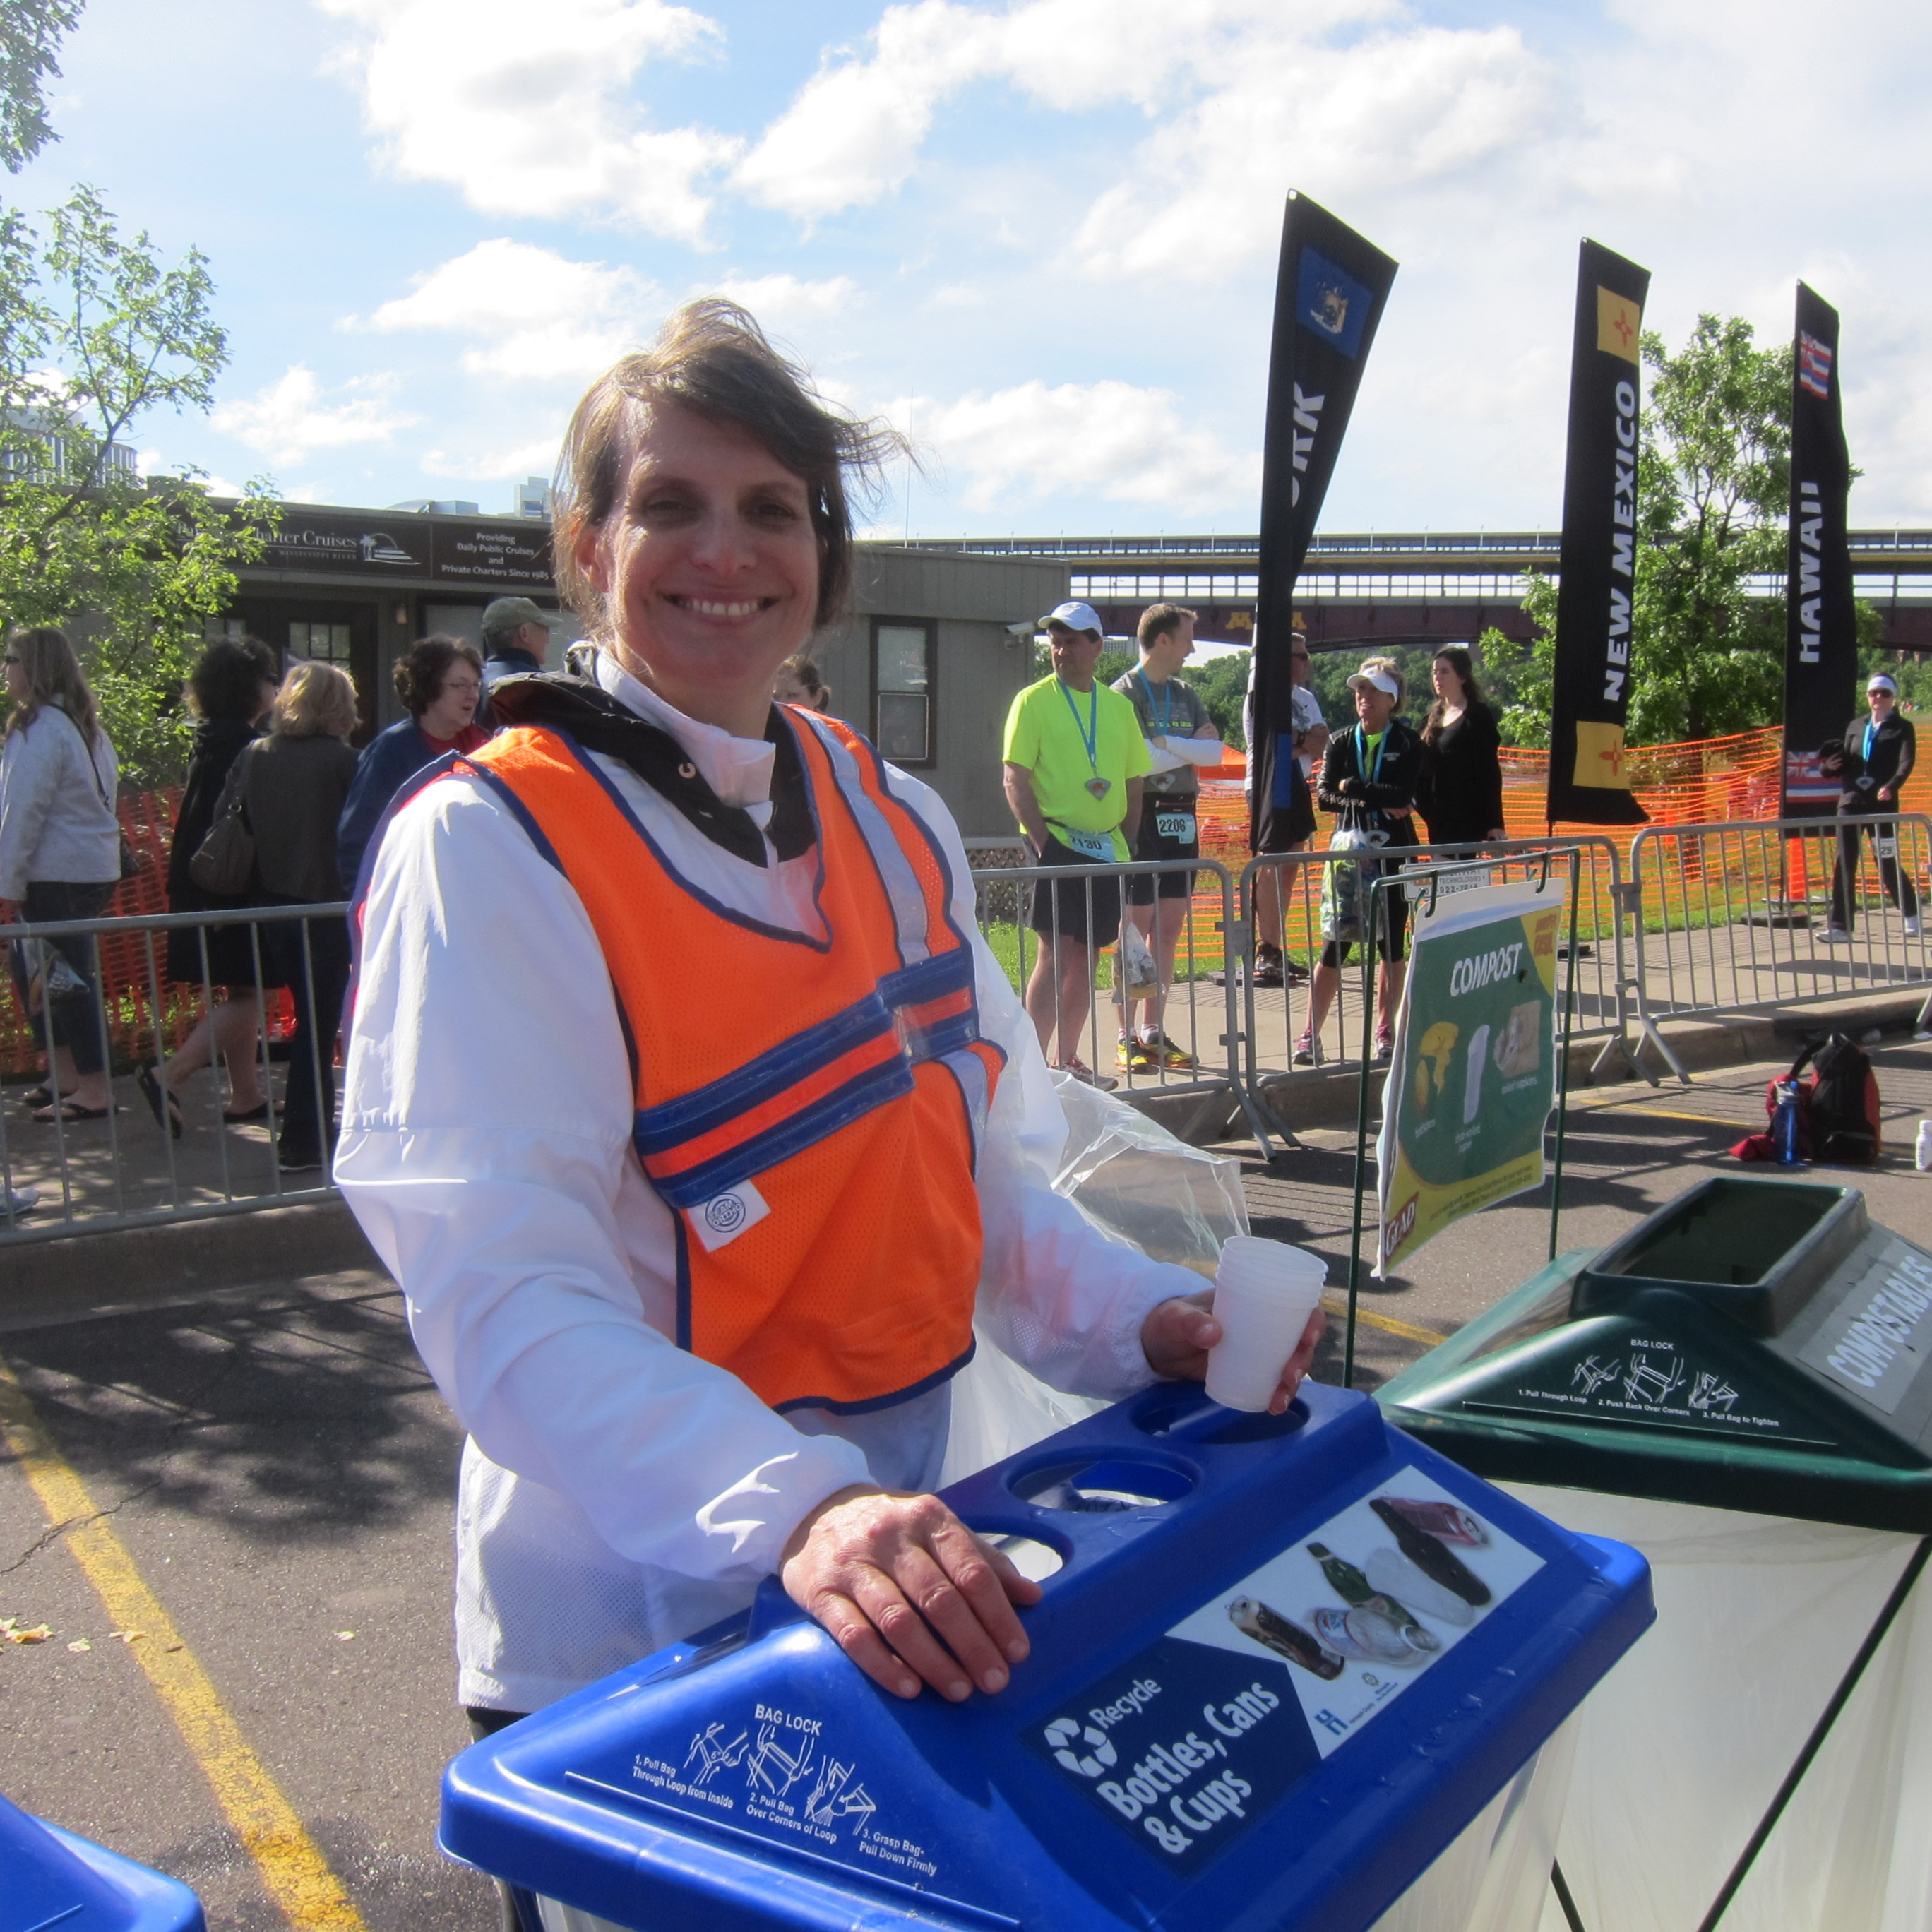
Post 2 – apply!
Facebook: Community Recycling Ambassadors are friendly sources of information on waste prevention, recycling, and composting. Volunteers put their skills to work on projects that minimize waste and educate their community about waste reduction, recycling, and composting. Are you ready to get involved? The application for the spring class closes on February 4. Apply now! hennepin.us/recycling-ambassadors
X/Twitter: Community Recycling Ambassadors are friendly sources of information on waste prevention, recycling, and composting. Are you ready to get involved? The application for the spring class closes on February 4. Apply now! hennepin.us/recycling-ambassadors #Volunteer #WasteReduction #Recycling
Instagram: Community Recycling Ambassadors are friendly sources of information on waste prevention, recycling, and composting. Volunteers put their skills to work on projects that minimize waste and educate their community about waste reduction, recycling, and composting. Are you ready to get involved? The application for the spring class closes on February 4. Apply now at the link in our bio. #Volunteer #WasteReduction #Recycling #Composting
