Setting up Digital Signature – “Click to Sign”
These instructions are for setting up a digital signature in Windows 7 / Adobe Acrobat XI Pro.
This type of signature is for internal forms signed by a worker.
After the form is signed the signature will look similar to this:
- Open a form that has eSignature enabled.

- Click on the Red Tab by the signature line:

- You will get a pop-up message to Add Digital ID.
Select “A new digital ID I want to create now”
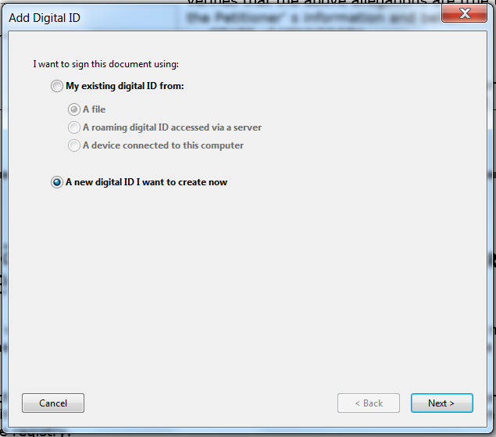

- You will get a message asking where to store your digital ID.
Select “New PJCS#12 digital ID file” and click Next.
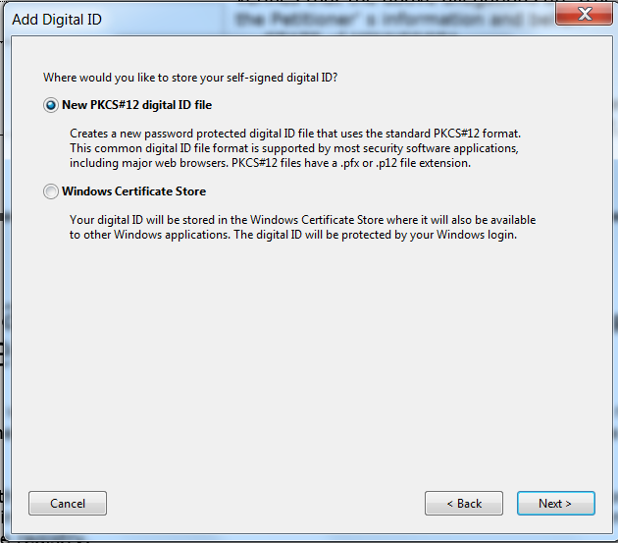

- Enter your name, unit, organization (i.e., Hennepin County) and Hennepin County email and click Finish.
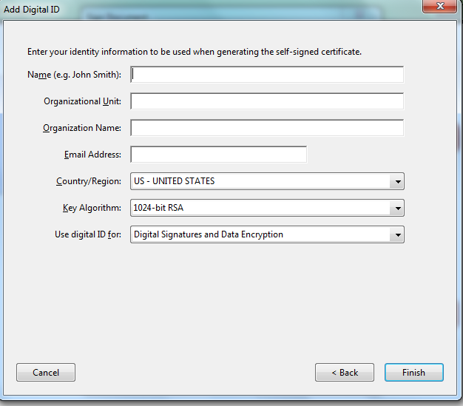
- Enter a password and confirm the password. Click Finish.
Important Note: You must remember this password for future use, or you will need to re-do the process.
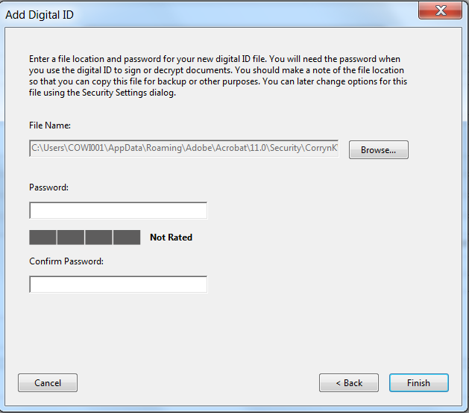
- You can now enter your password and click Sign. The document will then be signed.
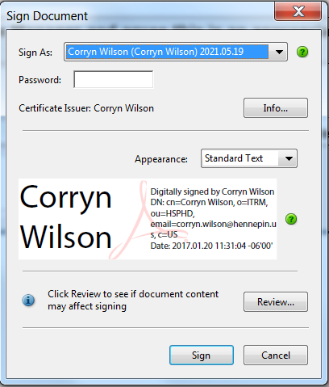

- Going forward, when you sign a form, you will just enter your password and click sign.

