Emerald ash borer media kit

About emerald ash borer
Ash trees are a common urban landscaping tree – there are more than 1 million ash trees in yards, parks and streets in Hennepin County. That’s about 15 percent of the tree canopy. All ash trees in the county that aren’t being treated are likely infested with emerald ash borer (EAB), an invasive tree pest from Asia that kills ash trees.
The emerald ash borer has been discovered in most cities and is presumed to be in all cities in Hennepin County. It’s likely that every non-treated ash tree in the county will be infested soon. It can take several years for an ash tree to show symptoms from emerald ash borer, so even a tree that appears healthy may be in the early stages of being infested.
There are two options for managing ash trees on your property: preserve them by using an insecticide treatment or remove and dispose of them.
More information about EAB for residents can be found at Hennepin.us/ashtrees

Funding for removals
In early 2024 Hennepin County was awarded 10 million dollars in funding from the U.S. Forest Service to remove diseased trees, plant trees, educate residents, and support businesses and workforce development. Work on this project will begin in spring 2024 and continue through January 31, 2029. Hennepin County will help homeowners with low incomes get trees removed and replaced on their properties. Applications will be accepted from residents beginning in June 2024.
Visit beheardhennepin.org/urban-community-forestry to stay up to date on this grant project, subscribe for updates, and find application materials.

Resources to promote emerald ash borer
Ways to educate the public about emerald ash borer:
- Use the sample newsletter article to share on your organization’s website or in your newsletters. These are editable so you can customize the length or message.
- Use the sample social media posts to share through your social media channels. These are editable so you can customize the message and website.
- Share the Emerald ash borer brochure (PDF), Ash tree identification card (PDF), and Decision guide for managing ash trees (PDF).Printed copies can be ordered from environmentalresources.hennepin.us/items
- Share this GIF: Spread of emerald ash borer image (GIF)
- Follow and reshare messages posted on the Hennepin County Environment and Energy social media channels: Hennepin Environment on Facebook, Hennepin Environment on Instagram, and @hennepinenviro on Twitter.
- Share the information and resources available at hennepin.us/ashtrees
- Send people who are interested in the urban and community forestry work Hennepin County is doing to beheardhennepin.org/urban-community-forestry

Contact
Dustin Ellis, Hennepin County Environment and Energy Forestry Supervisor, dustin.ellis@hennepin.us
Angie Ziobro, Hennepin County Environment and Energy communications, angie.ziobro@hennepin.us

Sample newsletter article

Deciding how to manage ash trees from the threat of emerald ash borer
Ash trees are a common urban landscaping tree – there are more than 1 million ash trees in yards, parks, forests and streets in Hennepin County. That’s about 15 percent of the tree canopy. All ash trees in the county that aren’t being treated will likely infested with emerald ash borer soon. Emerald ash borer is an invasive tree pest from Asia that kills ash trees.
Take the following steps to decide how to manage ash trees on your property from the threat of emerald ash borer:
- Identify and inventory ash trees: figure out if you have ash trees, how many you have, and where they are located
- Determine if your ash trees are worth saving: they should be healthy, at least 30 inches in circumference or 10 inches in diameter at chest height, show no or few signs of emerald ash borer infestation, in a good location, and valuable to the property owner. Treatment should begin immediately.
- Work with a certified arborist to treat trees that are worth saving: use a trunk injection of a non-neonicotinoid insecticide every two to three years in late spring; cost is typically $100 to $300 per treatment, depending on the size of the tree.
- Monitor and make a plan for removal for trees that aren’t being treated: monitor your trees for signs of emerald ash borer, work with a certified arborist to remove your trees when necessary and consider planting a tree or two to replace any you remove.
Learn more about emerald ash borer, how to identify ash trees, signs of emerald ash borer infestation, and tips for hiring a certified arborist at hennepin.us/ashtrees.

Social media posts

The threat of emerald ash borer
Media resource to use: GIF: spread of emerald ash borer in Hennepin County

Facebook:
There are over 1 million ash trees in Hennepin County, and 100 percent of them are threatened by the emerald ash borer. Since emerald ash borer was first found in Minneapolis in 2010, it has spread and is now presumed to be in all cities in Hennepin County. It’s likely that every non-treated ash tree in the county will be infested soon. Learn how to identify ash trees and options for managing your trees at www.hennepin.us/ashtrees

Twitter:
There are over 1 million ash trees in Hennepin County, and 100 percent of them are threatened by emerald ash borer. Learn more at www.hennepin.us/ashtrees
#EmeraldAshBorer #EAB #AshBorer #InvasiveSpecies #ActOnAsh

Instagram
There are over 1 million ash trees in Hennepin County, and 100 percent of them are threatened by the emerald ash borer. Since emerald ash borer was first found in Minneapolis in 2010, it has spread and is now presumed to be in all cities in Hennepin County. It’s likely that every non-treated ash tree in the county will be infested soon. Do you have a plan for your ash trees?
#EmeraldAshBorer #EABAwareness #InvasiveSpeciesAlert

Identifying ash trees
Images: Ash trees, ash tree identification card image

Facebook:
Identifying and taking an inventory of your ash trees is the first step in deciding how to manage your trees from the threat of emerald ash borer. Learn how to identify ash trees and your options for managing them at www.hennepin.us/ashtrees

Twitter:
Identifying and inventorying your ash trees is the first step in preparing for emerald ash borer. Find out more at www.hennepin.us/ashtrees
#EmeraldAshBorer #EAB #AshBorer #InvasiveSpecies #ActOnAsh

Instagram:
Identifying and taking an inventory of your ash trees is the first step in deciding how to manage your trees from the threat of emerald ash borer. Do you have any ash trees in your yard?
#EmeraldAshBorer #EABAwareness #InvasiveSpeciesAlert

Decision guide for managing ash trees
Image: Ash tree decision guide

Facebook:
Emerald ash borer, an invasive tree pest that attacks and kills ash trees, is the biggest current threat to our tree canopy. Most residents live within 15 miles of an infested ash tree, which means you should be taking steps now to determine if you have ash trees on your property and how you are going to manage them. Use our decision guide for managing ash trees to help you figure out what you are going to do. Link to https://www.hennepin.us/-/media/hennepinus/residents/environment/documents/ash-tree-decision-guide.pdf

Twitter:
Use our decision guide for managing ash trees to help you prepare for the threat of emerald ash borer. Link to https://www.hennepin.us/-/media/hennepinus/residents/environment/documents/ash-tree-decision-guide.pdf

Images and other media

EAB spread GIF
GIF: spread of emerald ash borer in Hennepin County

Ash tree identification card image
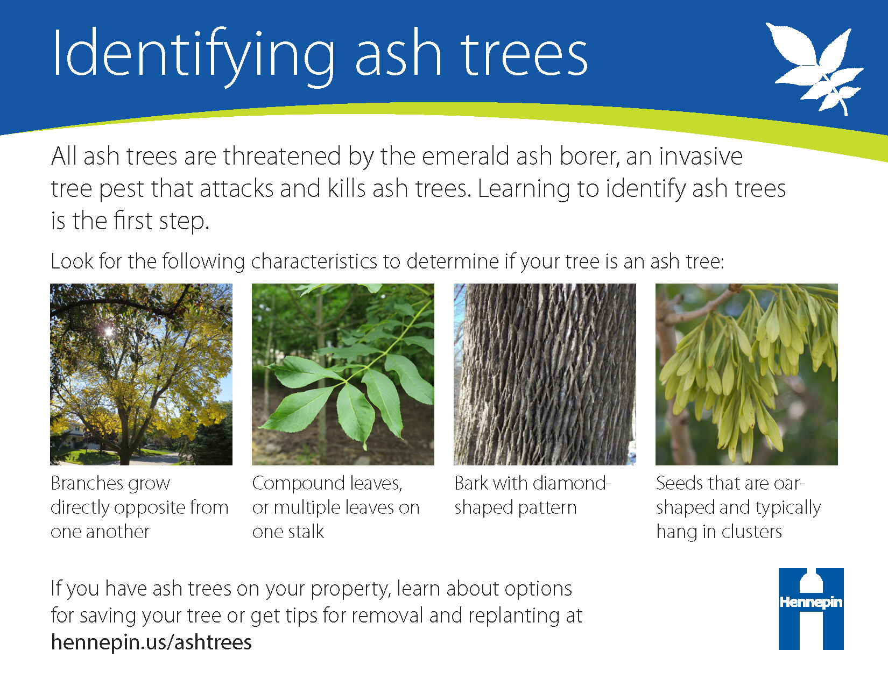

Ash tree decision guide image
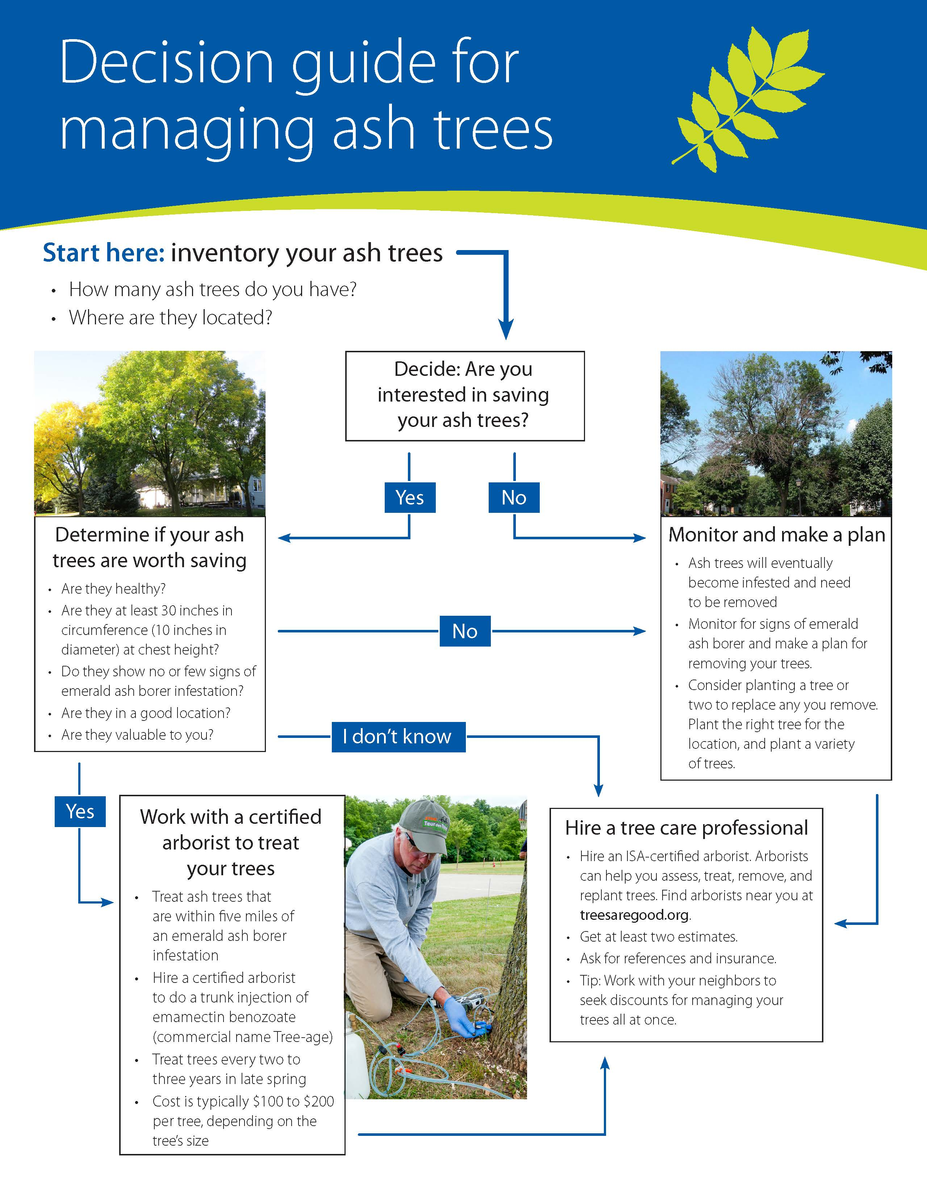

Ash trees
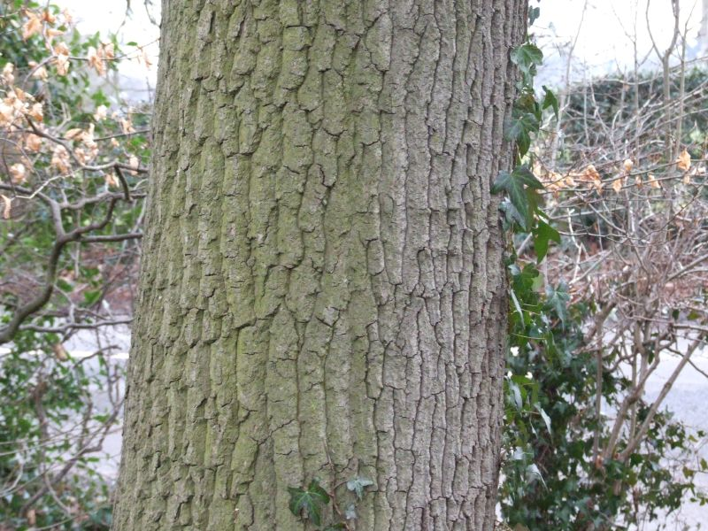
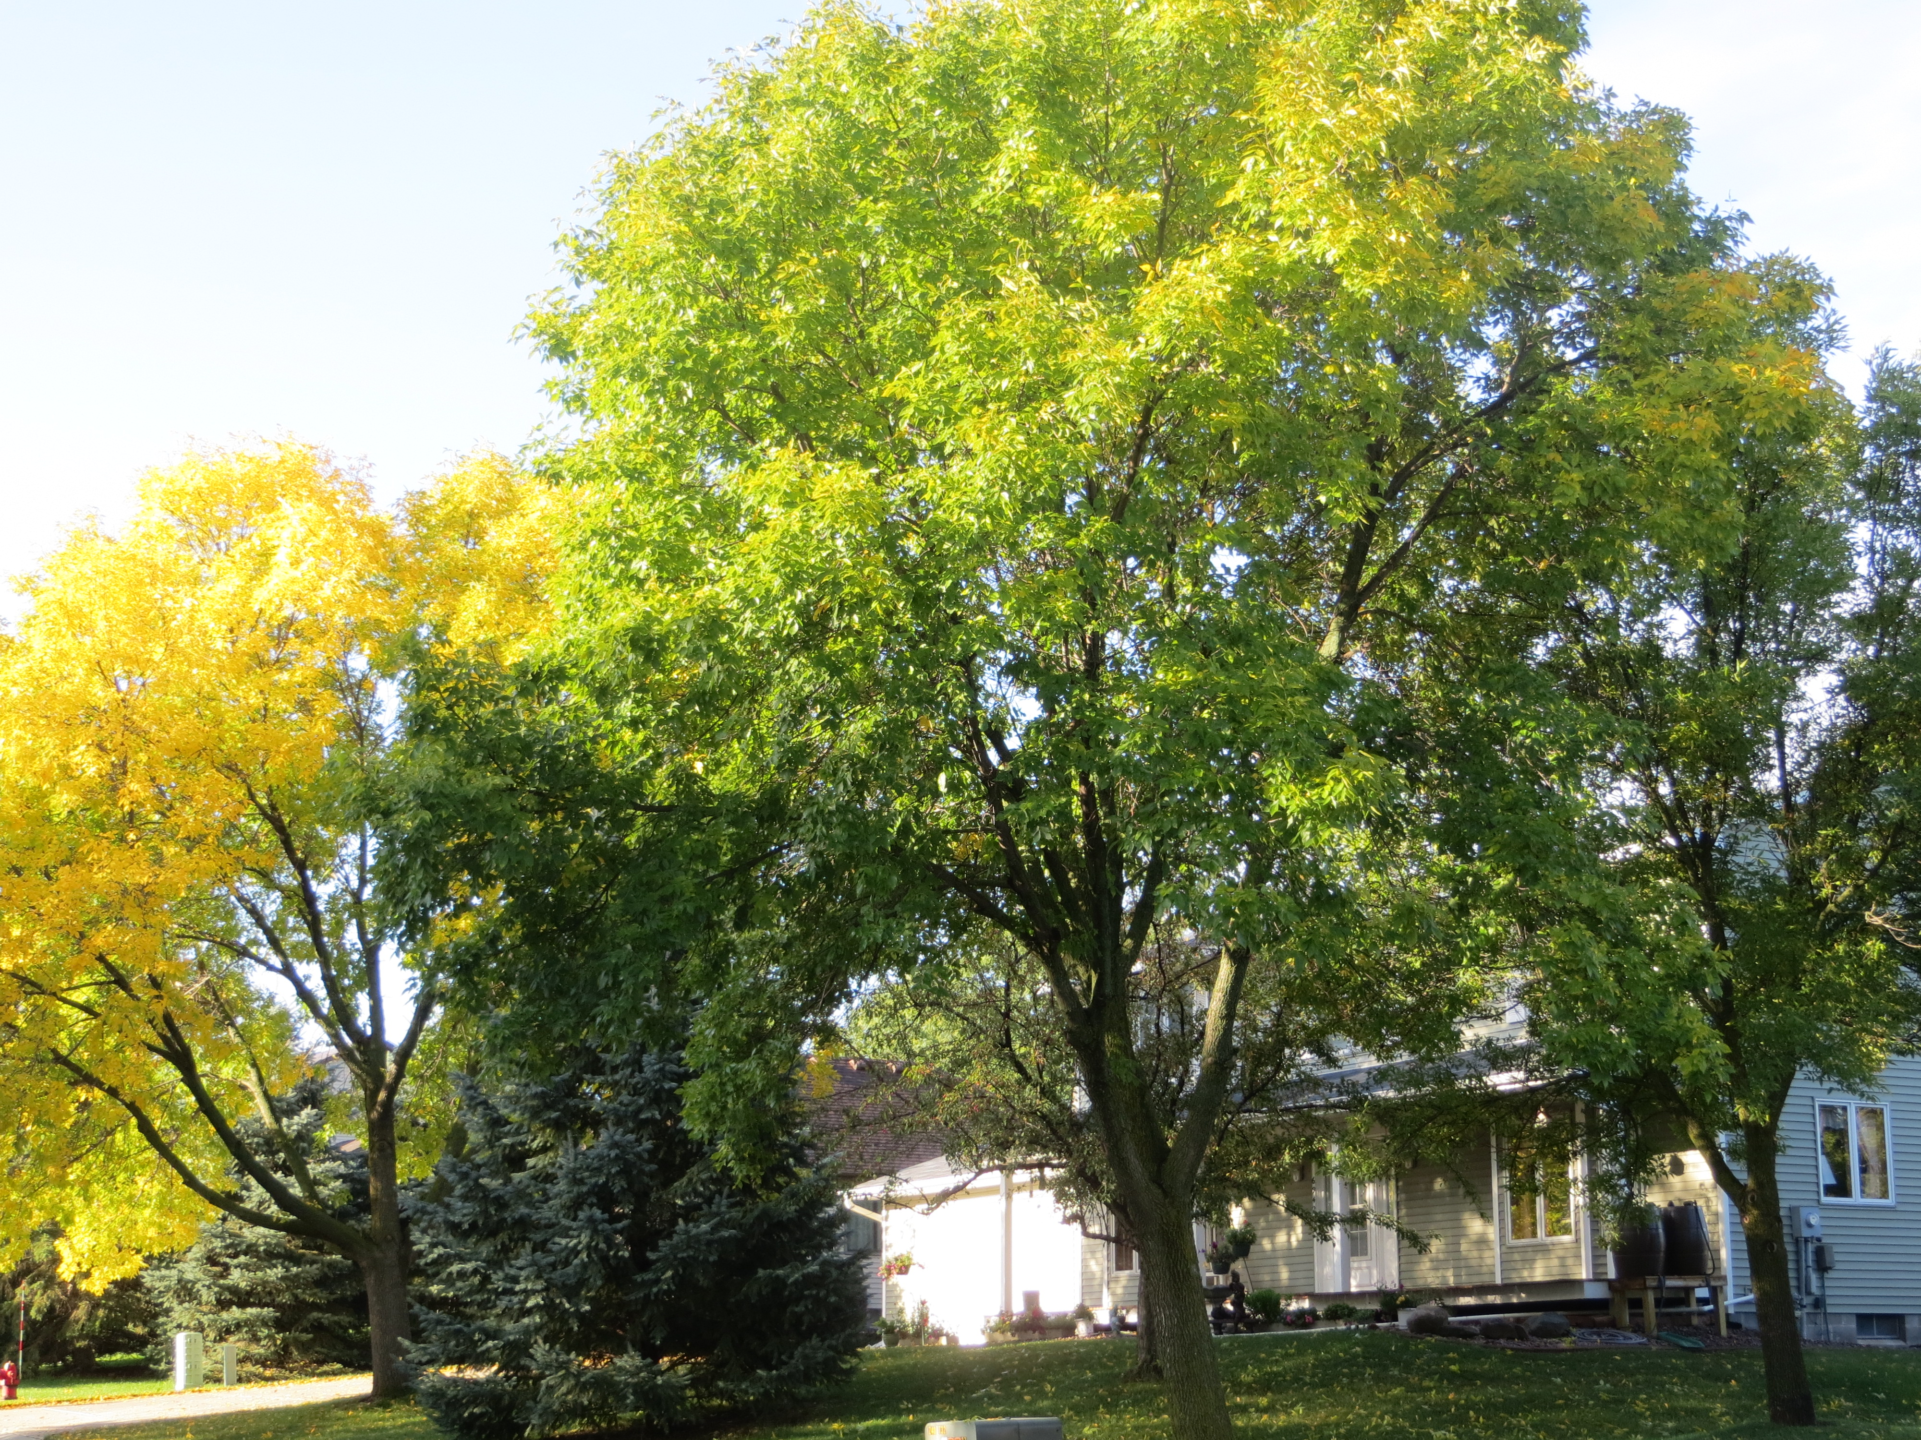
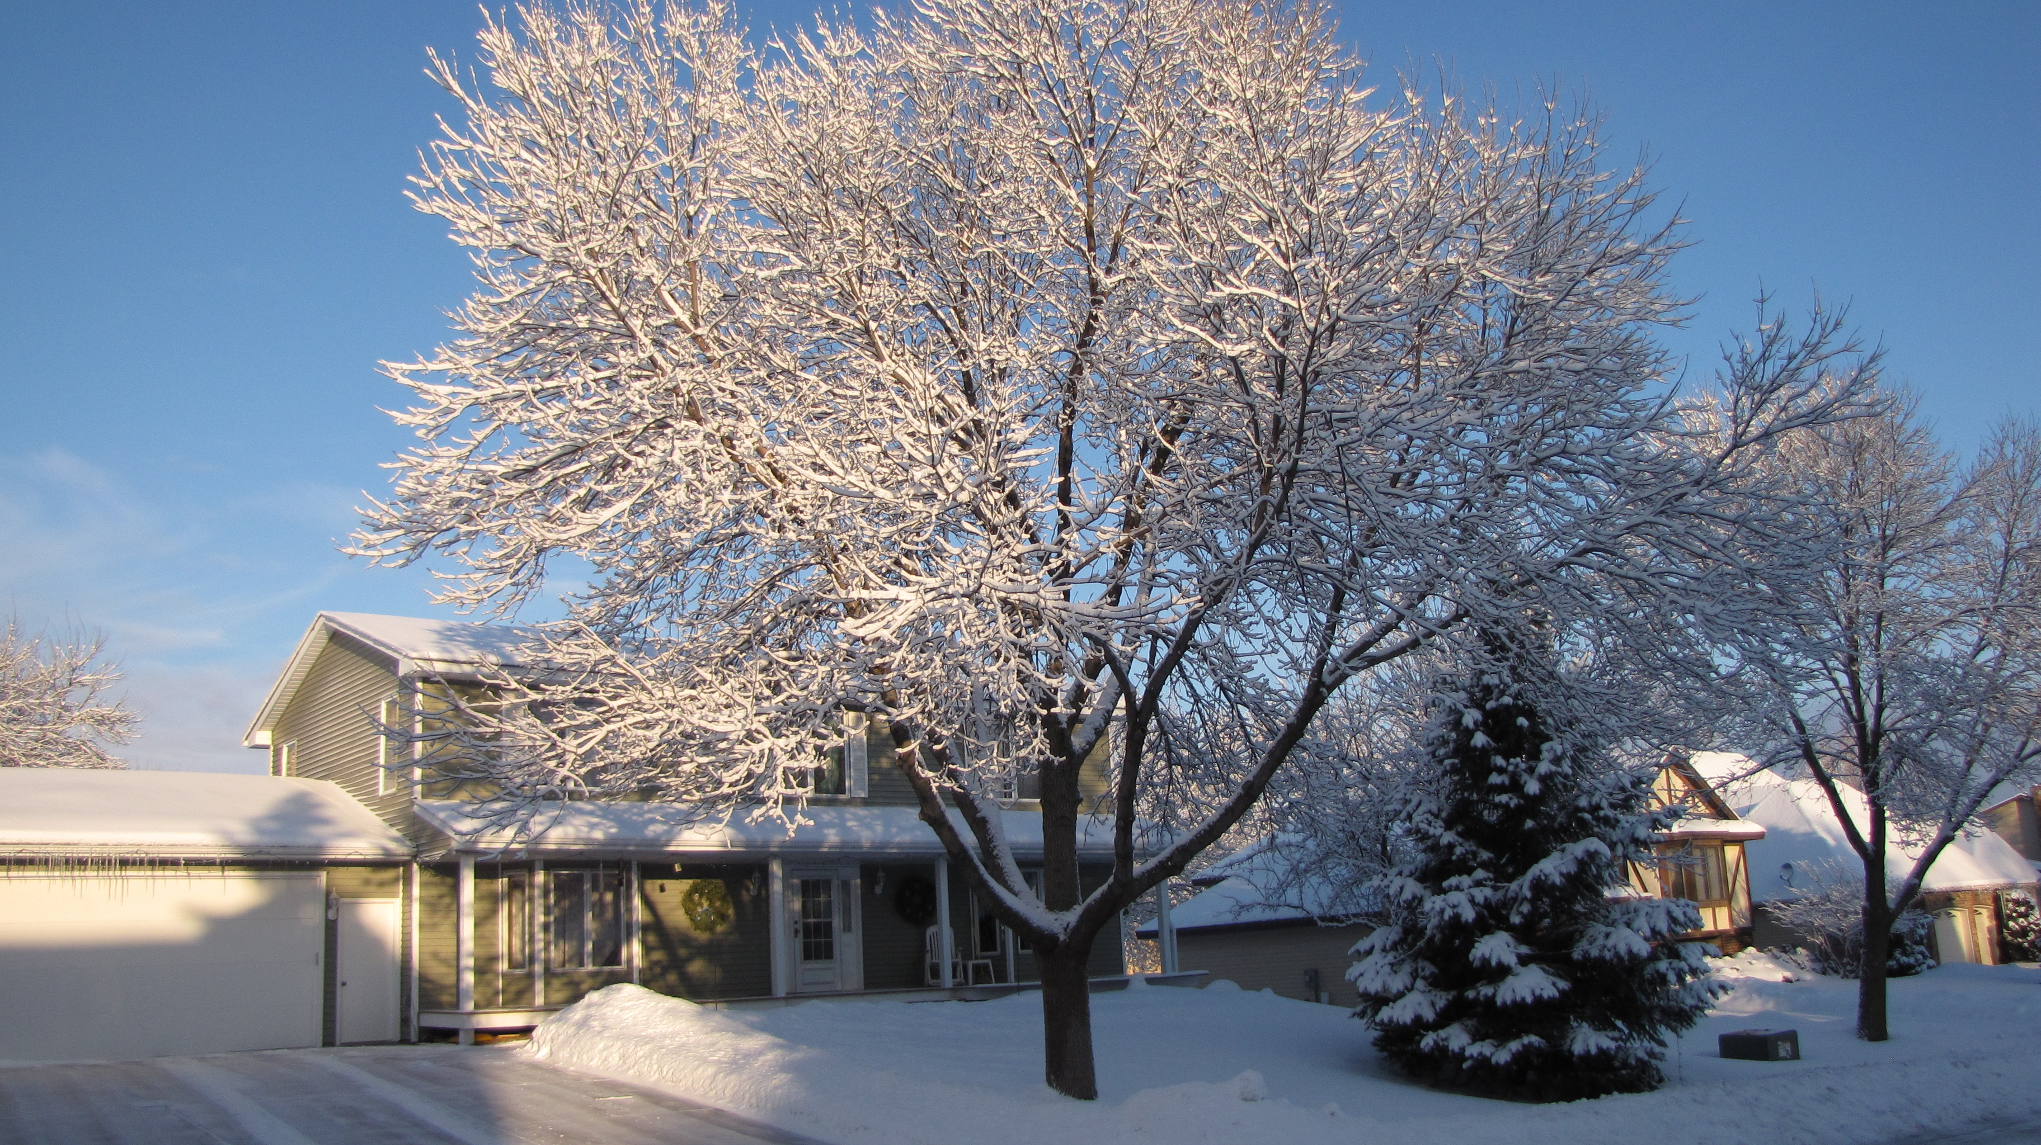

Ash trees with signs of emerald ash borer infestation
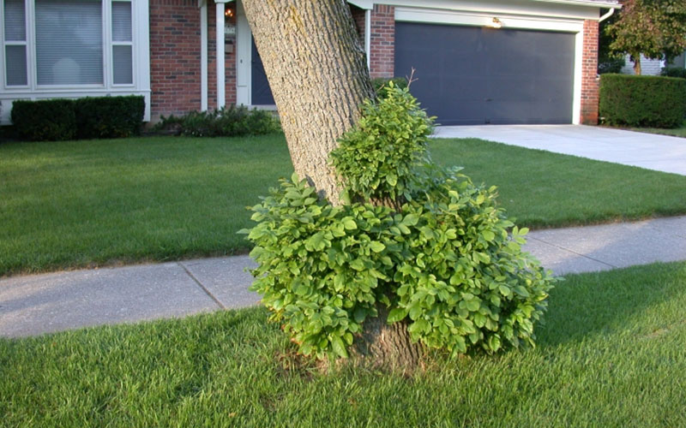
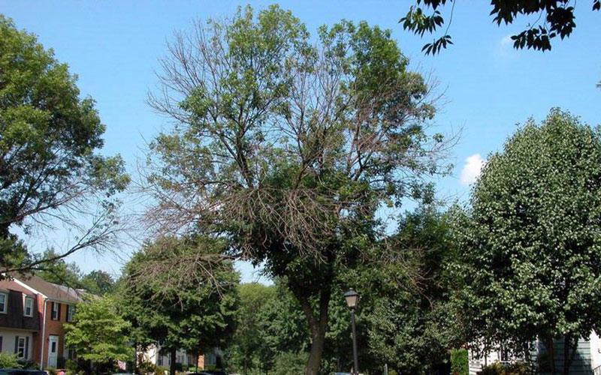
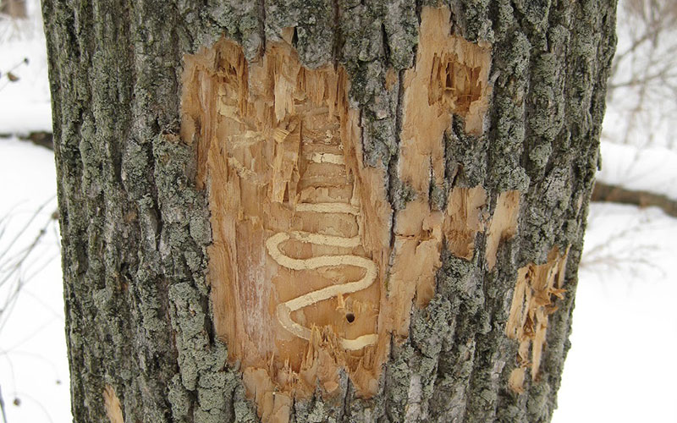

Ash tree treatment for emerald ash borer
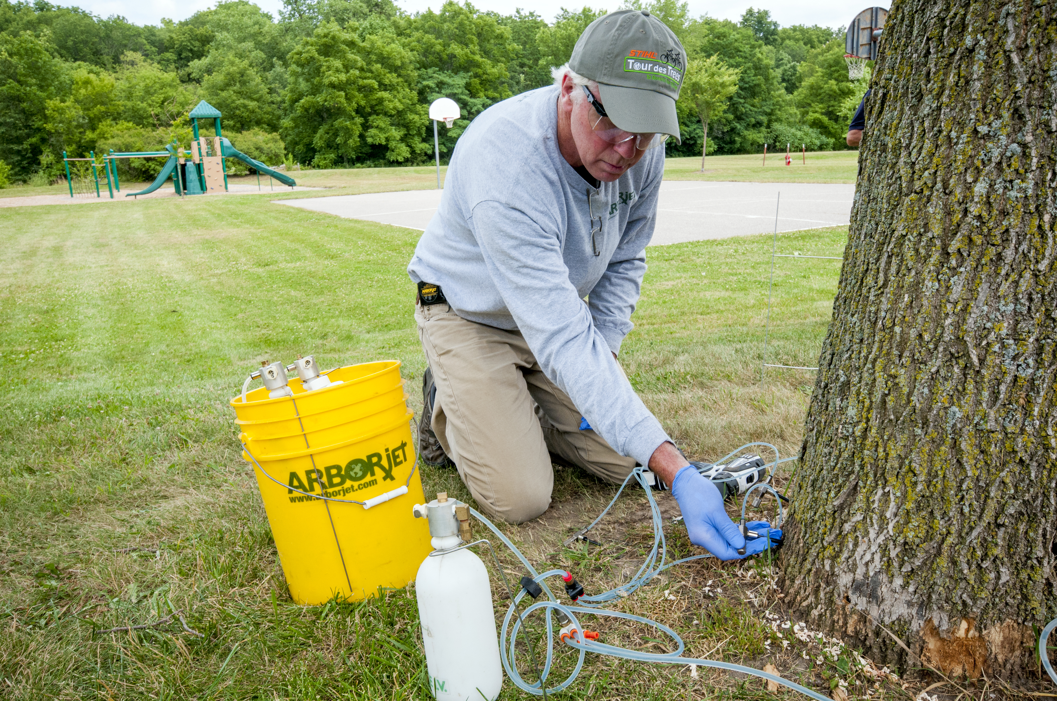

Emerald ash borer
Credit this photo to: Pennsylvania Department of Conservation and Natural Resources
