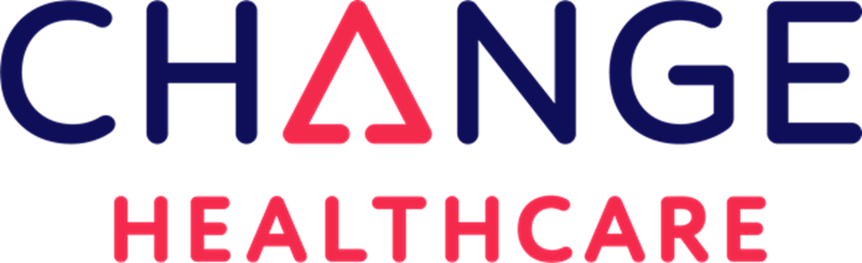

If you have a medical problem that makes you unable to work, or have a child in a special education program, you may be eligible for Social Security Disability or Supplemental Security Income.

For us to help, you must:
Be a Minnesota Resident
Be receiving cash benefits through
GA, GAMC, GRH, MFIP, MSA
Have a medical condition that has kept or will keep you from working for over a year or have an IEP or other well documented treatment for a child’s learning or physical disability
***To shorten your wait time and ensure we have adequate staff to help you, please call first to make an appointment at (612) 872- 2080 x 100 We will let you know if we can help and outline the application process for you.

