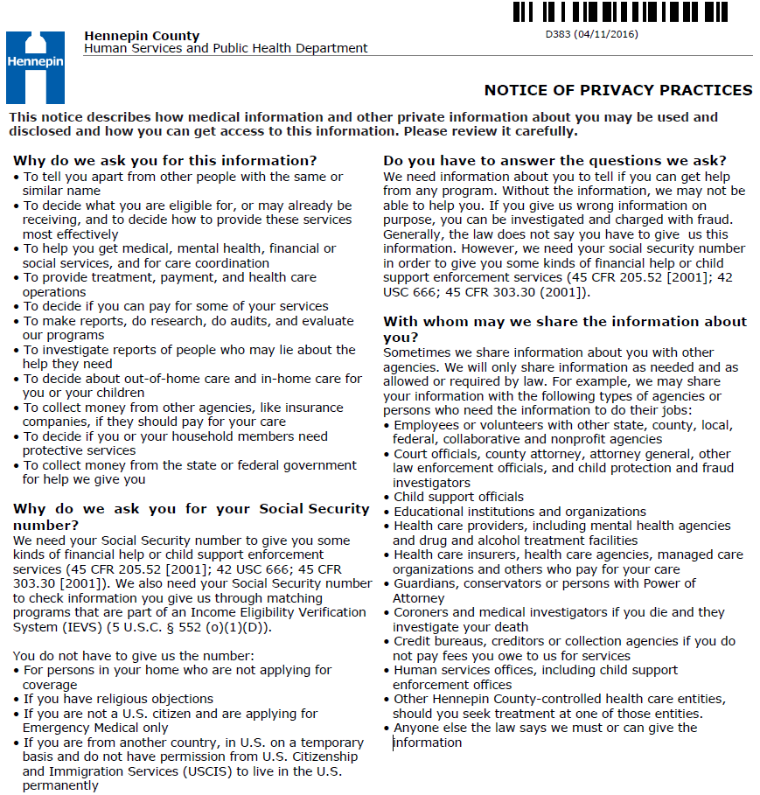

Page 1 of 2 Client Name____________________________ Case Number__________________

