MEC2 Screens: Quick Reference Guide for ESPs
Getting started - Employment Counselors are granted access to MEC2. This system contains all information regarding a participants Child Care Assistance case. Employment Counselors can view the current status of any Child Care Assistance case for families they work with. Information on how to request access to MEC2 can be found on the MFIP & DWP Employment Service web site under Policies and Procedures/ESP Requests for Access to DHS/HC Data Systems. Additional MEC2 on-line training is available by DHS through Trainlink.
How to find a case
Select Case Overview and enter MAXIS/MEC2 case number on MEC2 Home Screen.
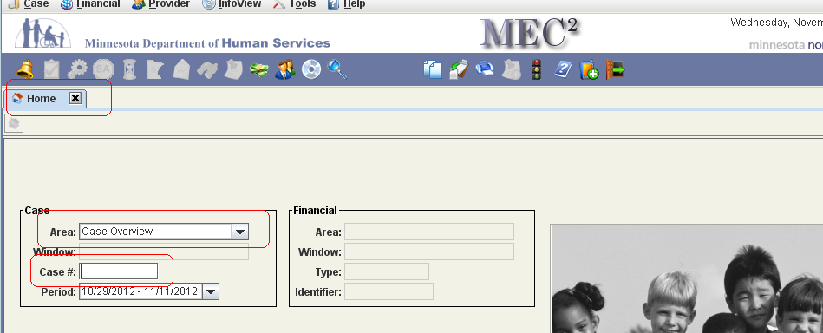
The Overview Screen includes the following information:
Status, Redetermination due date, MFIP, DWP, and Child Care program information. 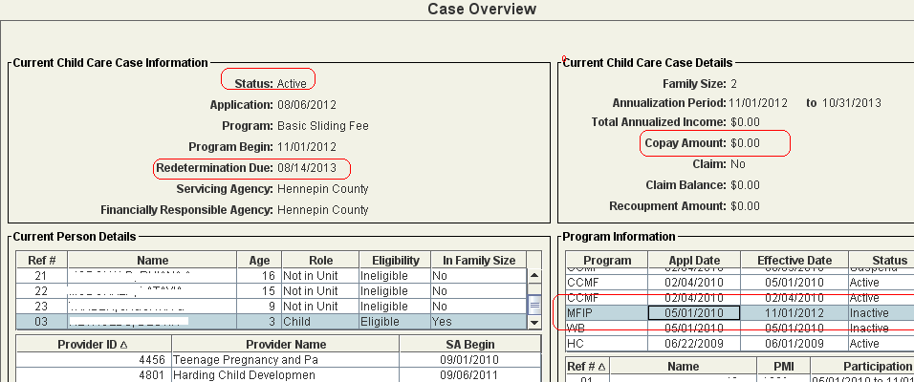
To view a Service Authorization select and the biweekly period you are interested in. If a Service Authorization exists it will include:
The child care provider’s name, the child in care, the amount of care authorized, and the Copay amount.
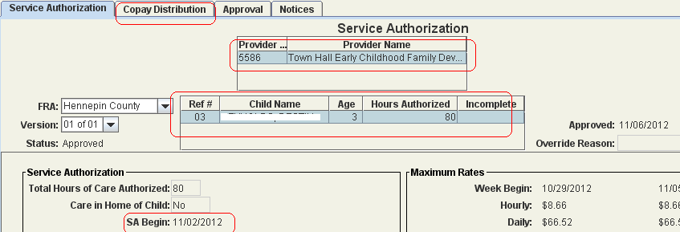
To view notices generated to either the client or the provider select and the date range that applies. A list of notices will display. Click view comments to view the content of the notice you are interested in.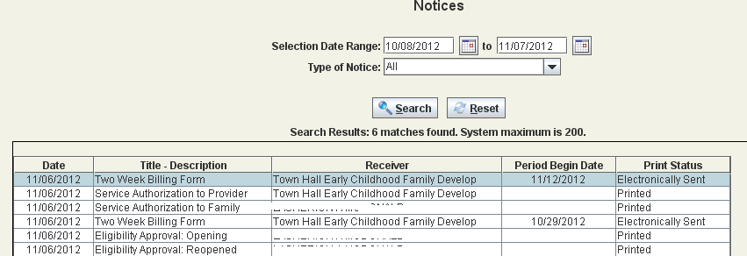
To view case notes select and scroll to the case note needed.
