

Trash or cash food waste campaign media kit

About the Trash or Cash campaign
Forty percent of all food in America is wasted. For a family for four, that wasted food could add up to $2,500 year or more. Wasting food also wastes the water, fertilizer, land, and labor needed to get that food from the fields to your table and creates harmful methane emissions when it breaks down in landfills.
Trash or Cash is a public education campaign that uses a game show theme to increase awareness of the problem of wasted food and offers easy, everyday solutions that help people save money.

Resources to promote the Trash or Cash campaign
Ways to share the Trash or Cash campaign educate the public about wasted food:
- Use the sample newsletter articles to share on your organization’s website or in your newsletters. These are editable so you can customize the length or message.
- Use the sample social media posts to share through your social media channels. These are editable so you can customize the message and website.
- Encourage your audience to visit trashorcash.org and to sign up for Fridge Check Friday emails.
- Share the following resources. Printed copies can be ordered from www.hennepin.us/environmental-resources
  - Fridge check guide (PDF)
  - Fruit and veggies storage guide (PDF)
  - Eat First Labels (PDF)
- Follow and reshare messages posted on the Hennepin County Environment and Energy social media channels: Hennepin Environment on Facebook, Hennepin Environment on Instagram, and @hennepinenviro on Twitter. Use the hashtags: #StopFoodWaste #SaveMoney
- Share the videos: game show series (YouTube) and chef tip series (YouTube)

Contact
Jenny Kedward, food waste prevention specialist, jenny.kedward@hennepin.us
Alisa Reckinger, communications specialist, alisa.reckinger@hennepin.us

Sample newsletter articles

Article 1: General campaign promotion

Time to choose what you like more: Cash or Trash
If you won in cash the amount of money you spent on food you threw away last year, you’d be thrilled. Nearly 40% of all food in America is wasted – much of it coming from our homes. An average family of four loses more than $2,500 to wasted food every year!
Simply buying food you’ll eat and eating the food you have can make a big impact. Protect your paycheck and our planet. Learn more and sign up for Fridge Check Friday reminders at trashorcash.org.
Suggested graphic: stop throwing away money
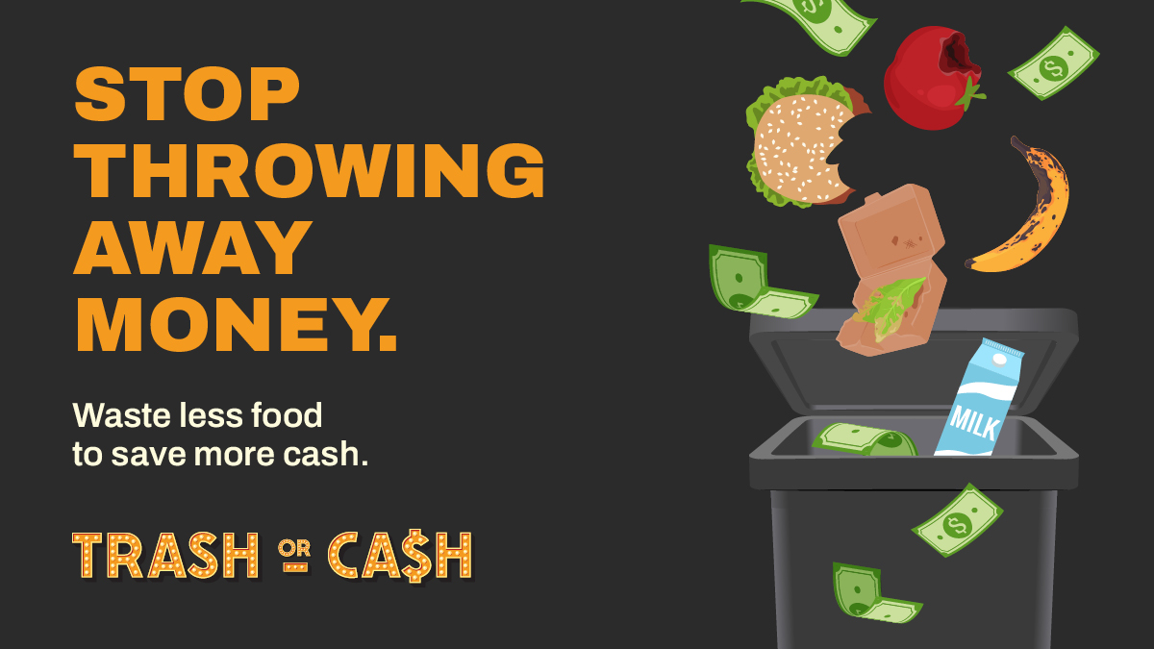

Article 2: Campaign and Fridge Check Friday promotion

Choose cash over trash by wasting less food
When you waste food, you waste money. We toss nearly 40% of food in the U.S. For a family of four, that can add up to more than $2,500 in wasted food every year!
It’s not just a waste of money. Wasting food also wastes the water, fertilizer, land, and labor needed to get that food from the fields to your table.
Hennepin County’s Trash or Cash campaign aims to help you put more money in your pocket by wasting less food. The campaign uses a game show theme and partnerships with local chefs to help you learn better habits for buying food you’ll eat and eating the food you have.
Sign up for Fridge Check Friday emails to get weekly reminders to use up your food before it goes bad plus snack-sized kitchen hacks to help you get the most out of your groceries.
Suggested graphic: wasted food is a waste of money
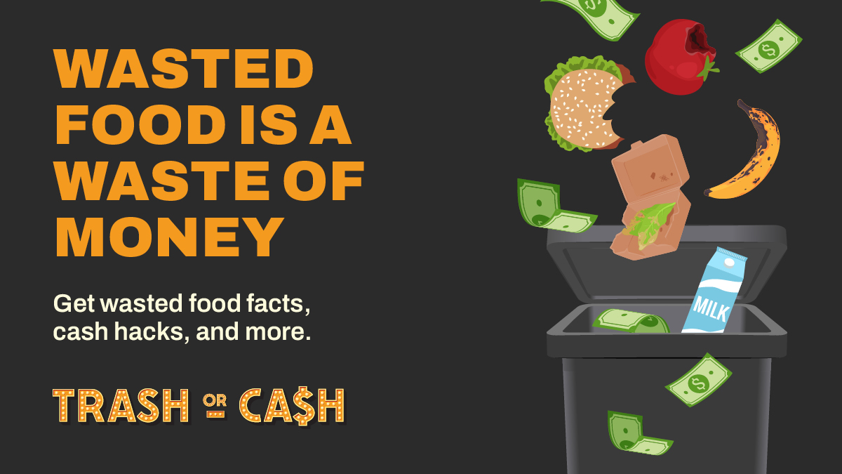

Article 3: Fridge Check Guide and Fridge Check Friday promotion

Kitchen reality check
Wasting food is a waste of money. While no one likes wasting food, we often don’t realize how much uneaten leftovers or spoiled fruit adds up.
That’s why simply tracking what food goes to waste and why can have the greatest impact on your kitchen habits.
Use the new Fridge Check Guide (PDF) to understand what food you’re throwing away and why. The guide also has a Use It Up list to help you make a plan for ingredients and leftovers that need to get eaten quickly.
Want more helpful tips to help you waste less food and put more money in your pocket? Sign up for Fridge Check Friday emails! You’ll get weekly reminders to use up your food before it goes bad plus snack-sized kitchen hacks to help you get the most out of your groceries.
Suggested photo: Woman standing in front of open fridge holding containers of food

Article 4: Kitchen cash hacks

Kitchen cash hacks to help you save cash
Everyone's already playing Trash or Cash, whether we know it or not. That’s because when you throw away food, you throw away money.
The amount of food we waste is like buying 5 bags of food at the grocery store and leaving 2 behind. That adds up to roughly 97 meals wasted per person each year in Hennepin County.
Master the skills you need to prevent wasted food, and you can’t lose! Simple changes in how you plan, store, and cook can have a big impact. Get started by trying these kitchen cash hacks:
- If you’re new to meal planning, keep it doable by planning 3 meals each week and including a leftovers night.
- Produce sold by weight, such as grapes, potatoes, and bananas, means you can take just the amount you need.
- Create an "Eat First" area in the fridge to keep track of what needs to be used right away.
- Store food the same way you found it in the grocery store. If it was chilled, keep it in the fridge. If not, it’s ok to keep on the counter.
- Know some go-to meals that use up extra bits of fruits and veggies – think smoothies, soup, omelets, and stir fries.
- Freeze meals in portions you will want later. Use ice cube trays to freeze small amounts of ingredients like tomato paste, herbs in olive oil, or coconut milk.
Get weekly tips by signing up for Fridge Check Friday reminders at trashorcash.org.
Suggested photo: Inside of a fridge with at eat first basket on the top shelf
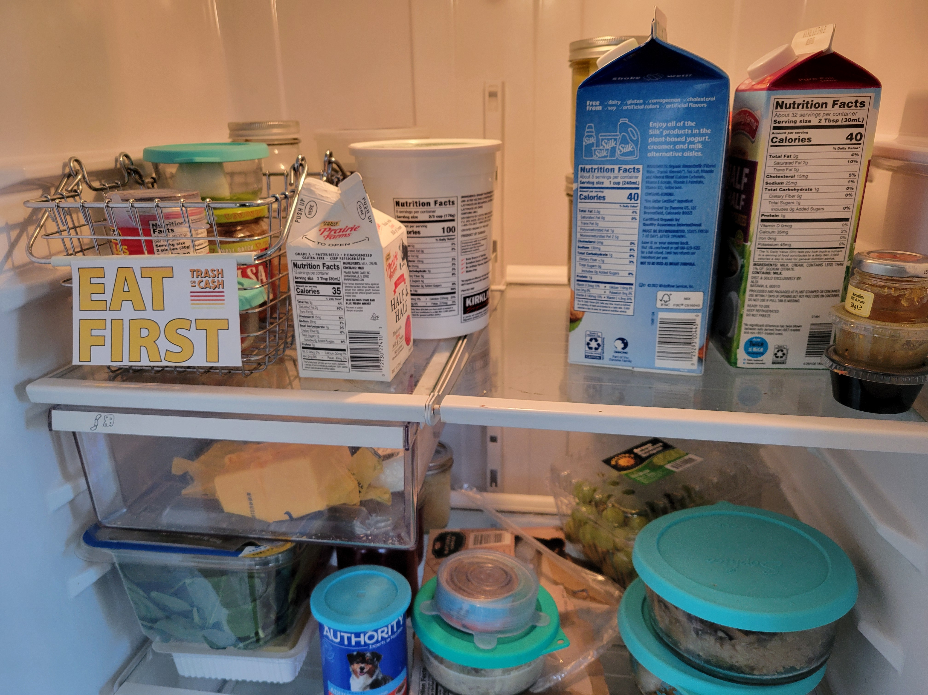

Social media posts
Suggested hashtags: #StopFoodWaste #SaveMoney
To use images and graphics: right click on image and select save picture as, alt text for you to use is included with the pictures and graphics

Post 1: Choose what you like more – Trash or Cash
Instagram:
When you throw away food, you’re throwing away money. Time to choose what you like more: Trash or Cash. If you won in cash the amount of money you spent on food you threw away last year, you’d be thrilled. Well, now’s your big chance.
See how much money is on the table for you and master the skills you need to prevent food waste at trashorcash.org
#StopFoodWaste #SaveMoney
Facebook:
When you throw away food, you’re throwing away money. Time to choose what you like more: Trash or Cash. If you won in cash the amount of money you spent on food you threw away last year, you’d be thrilled. Well, now’s your big chance.
See how much money is on the table for you and master the skills you need to prevent food waste at trashorcash.org
X:
When you throw away food, you’re throwing away money. Time to choose what you like more: Trash or Cash. See how much money is on the table for you and master the skills you need to prevent food waste at trashorcash.org #StopFoodWaste #SaveMoney
Suggested graphics (square and story):
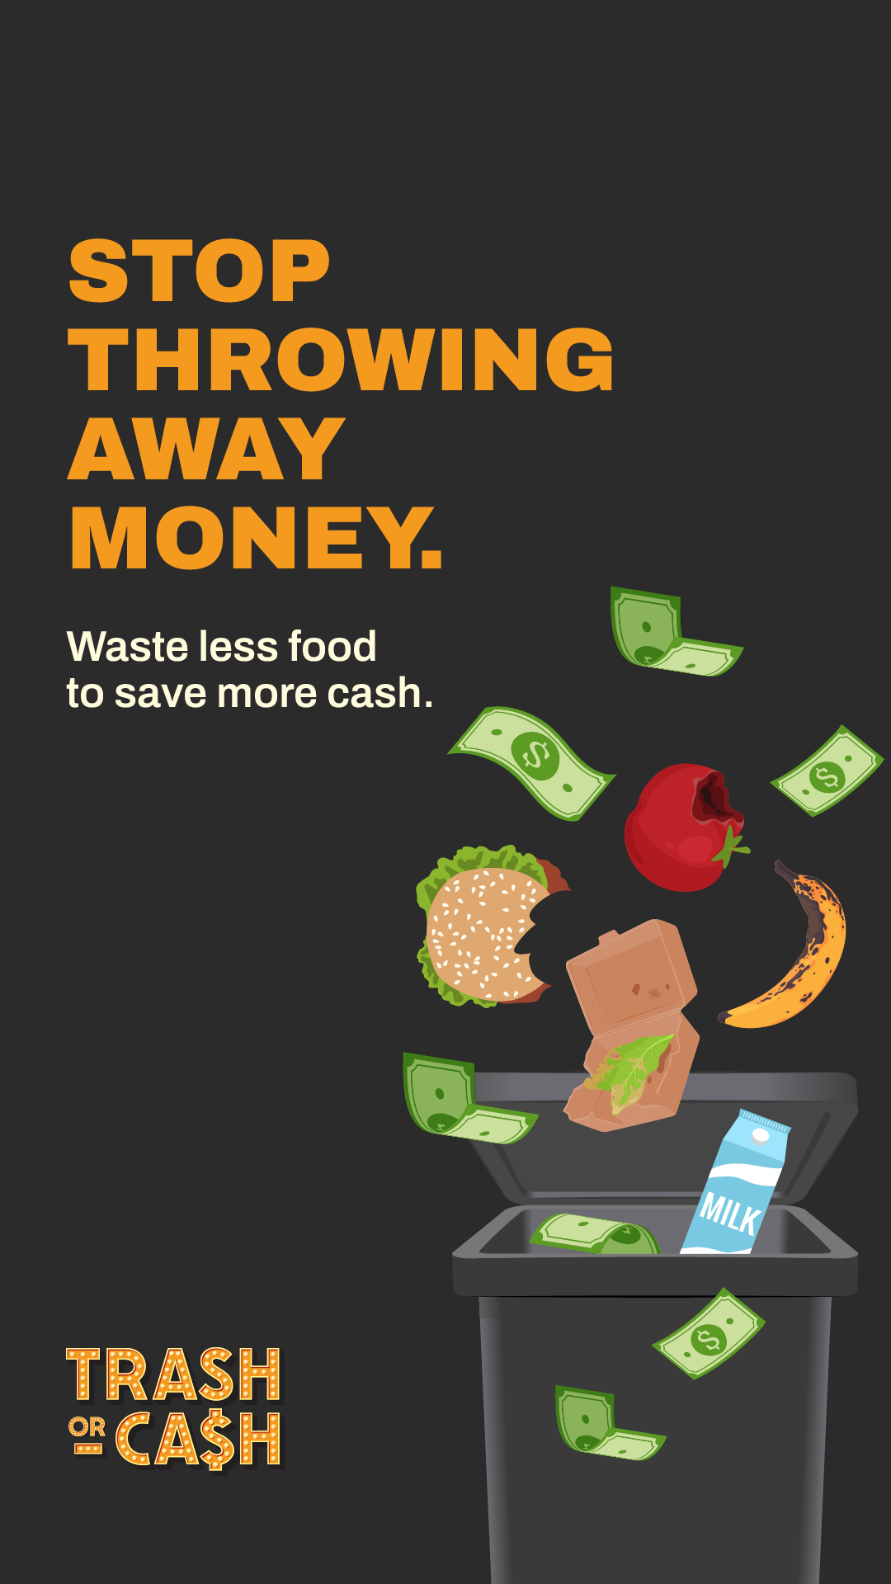
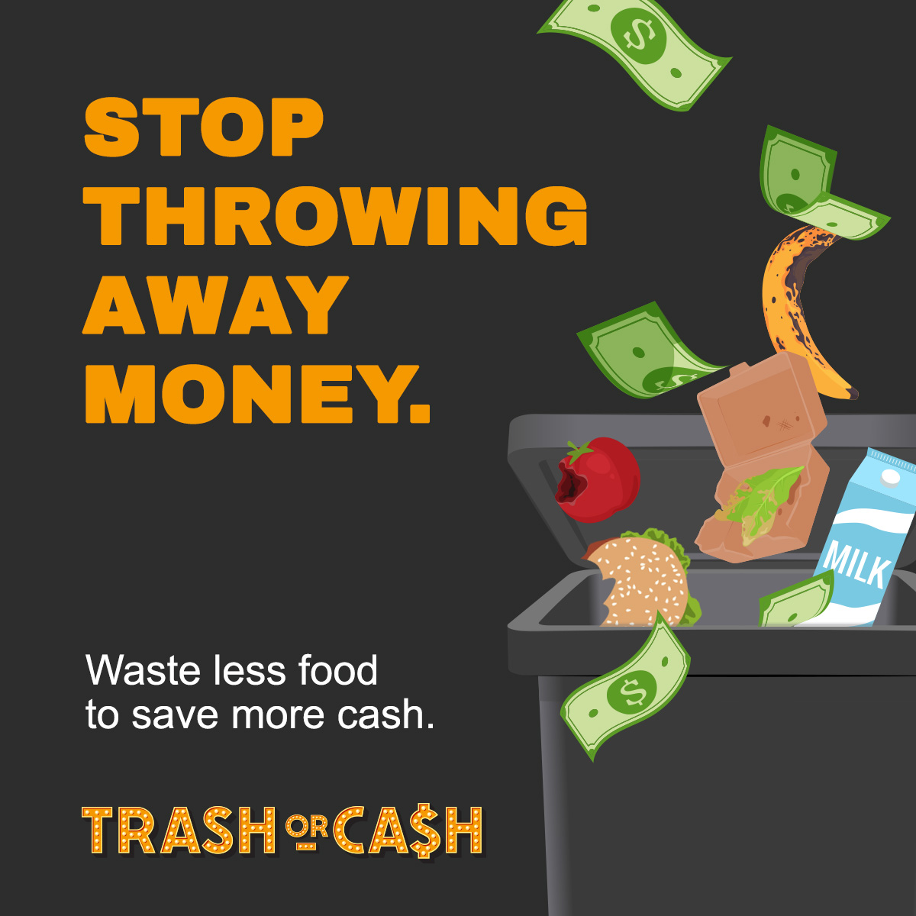

Post 2: Wasted food is wasted money
Instagram:
When you waste food, you waste money. We toss nearly 40% of food in the U.S. For a family of four, that can add up to more than $2,500 in wasted food every year!
It’s not just a waste of money. Wasting food also wastes the water, fertilizer, land, and labor needed to get that food from the fields to your table. Stop wasting and start saving at trashorcash.org
#StopFoodWaste #SaveMoney
Facebook:
When you waste food, you waste money. We toss nearly 40% of food in the U.S. For a family of four, that can add up to more than $2,500 in wasted food every year!
It’s not just a waste of money. Wasting food also wastes the water, fertilizer, land, and labor needed to get that food from the fields to your table. Stop wasting and start saving at trashorcash.org
X:
When you waste food, you waste money. We toss nearly 40% of food in the U.S. For a family of four, that can add up to more than $2,500 in wasted food every year! Stop wasting and start saving at trashorcash.org #StopFoodWaste #SaveMoney
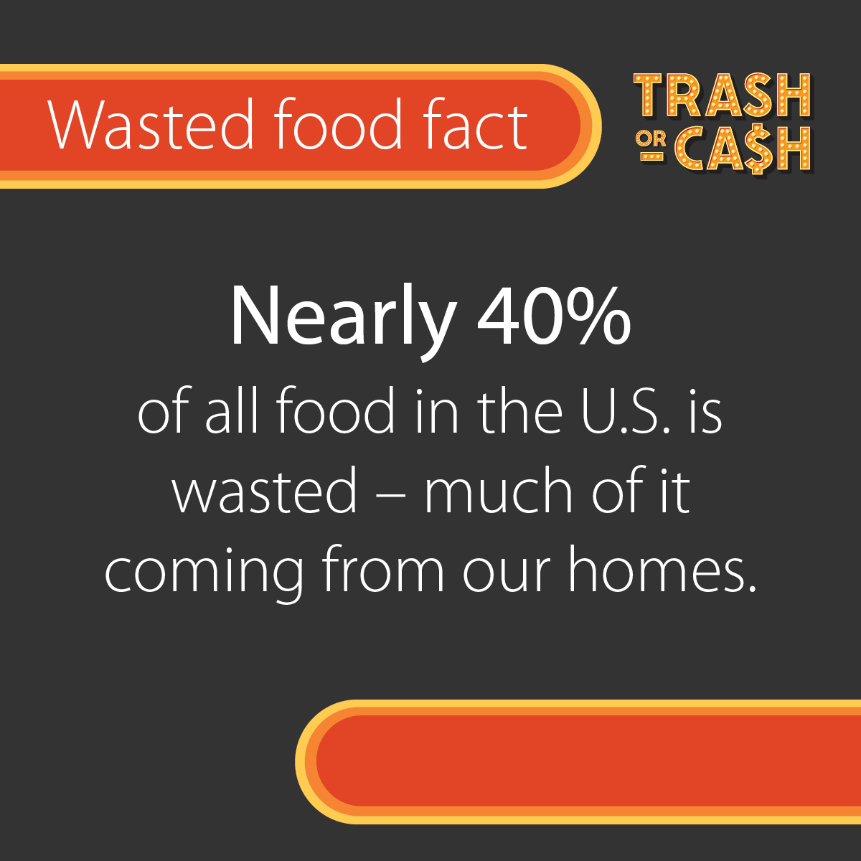
Suggested graphics (square and story):
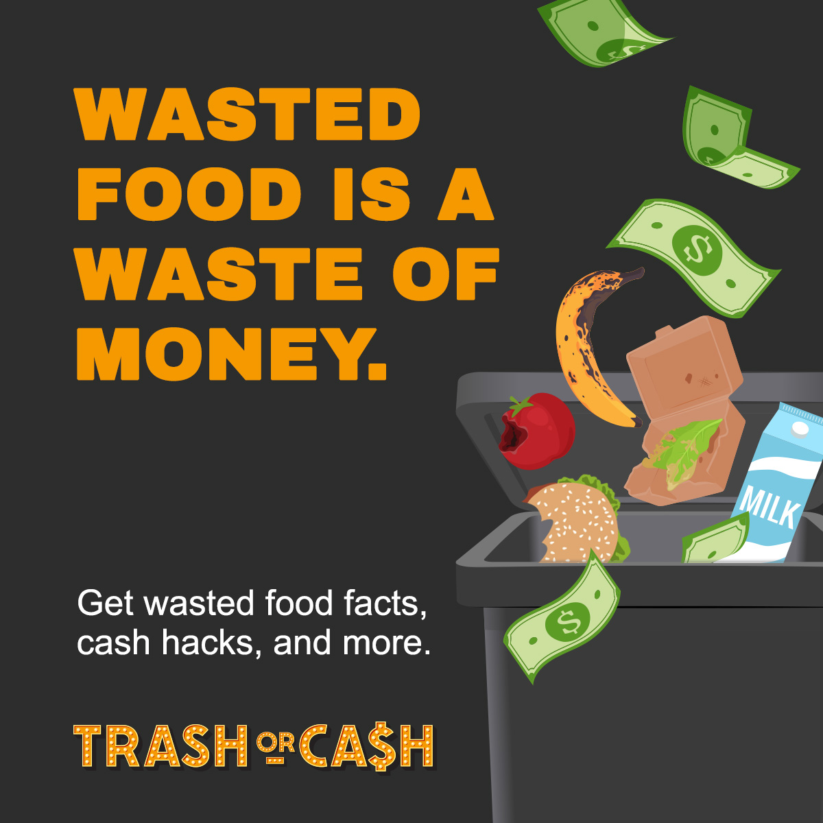
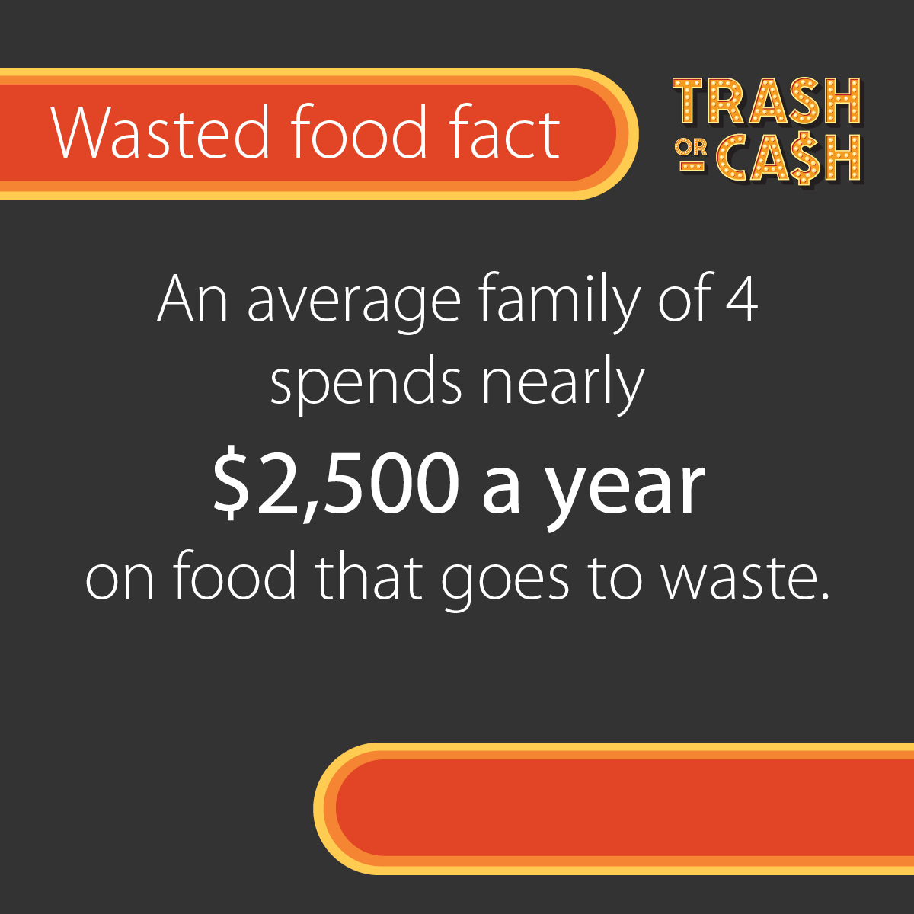

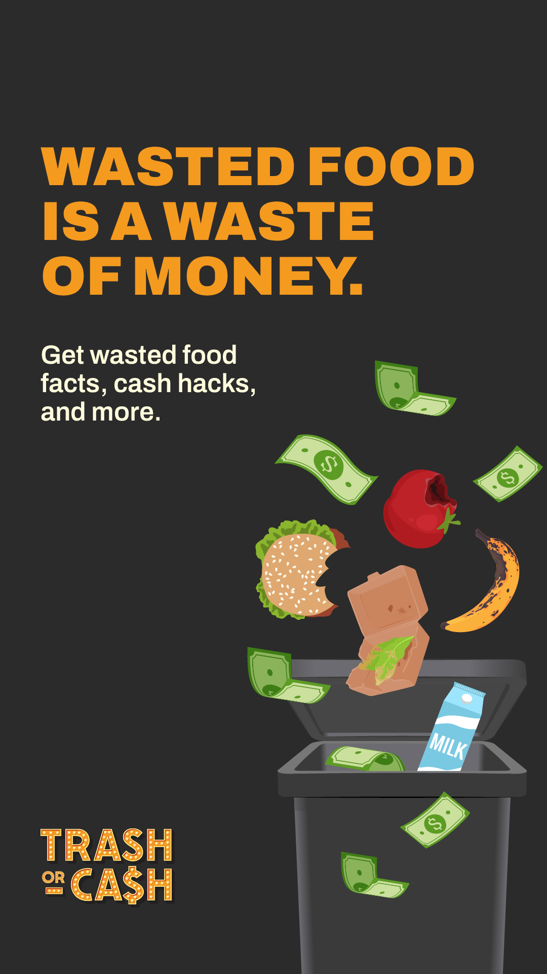
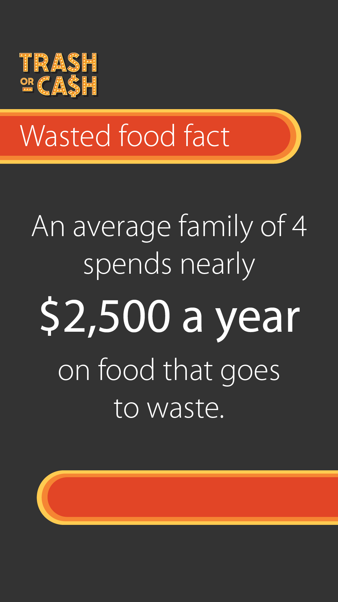
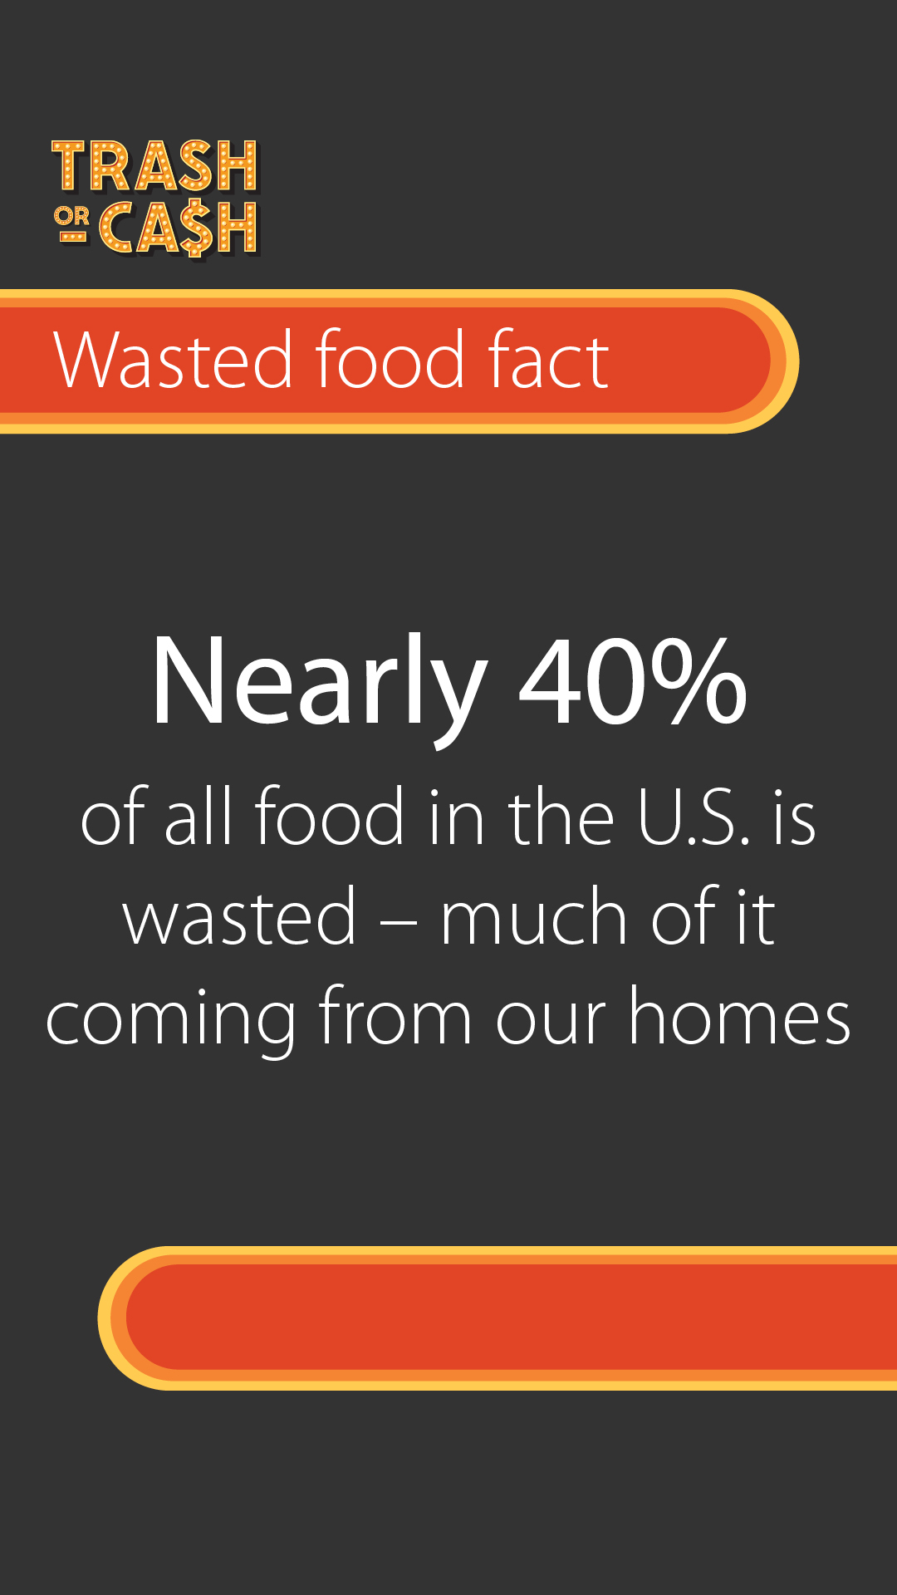

Post 3: Fridge Check Friday
Instagram:
It’s Fridge Check Friday! Haven’t heard of it? Fridge Check Friday is your weekly reminder to check your fridge before you go shopping and to use your food before it goes bad.
Sign up for weekly reminders plus snack-sized kitchen hacks to help you get the most out of your groceries trashorcash.org
#StopFoodWaste #SaveMoney
Facebook:
It’s Fridge Check Friday! Haven’t heard of it? Fridge Check Friday is your weekly reminder to check your fridge before you go shopping and to use your food before it goes bad.
Sign up for weekly reminders plus snack-sized kitchen hacks to help you get the most out of your groceries trashorcash.org/#fridge-check-friday
X:
It’s Fridge Check Friday! Haven’t heard of it? Fridge Check Friday is your weekly reminder to check your fridge before you go shopping and to use your food before it goes bad. Sign up now trashorcash.org/#fridge-check-friday #StopFoodWaste #SaveMoney
Suggested graphics (square and story):
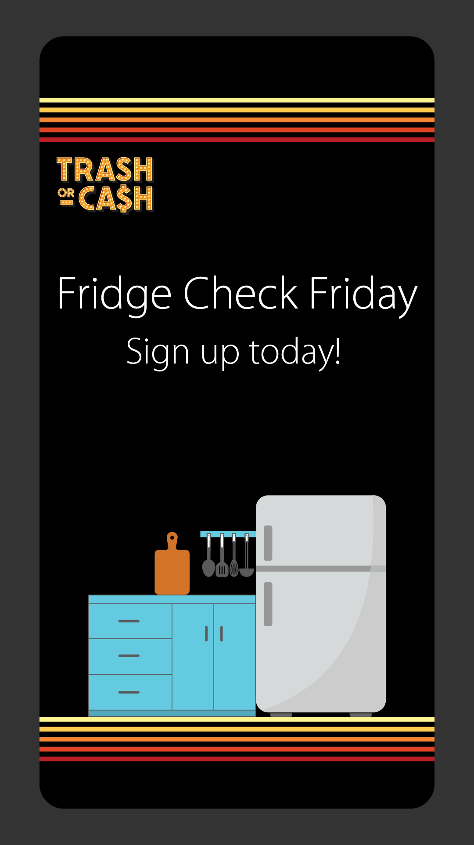


Post 4: Kitchen cash hacks
Instagram:
Wasted food is wasted money. About half of all food waste happens at home. For a family of 4, that can add up to over $2,500 a year spent on food that just goes to waste. Choose cash over trash by making simple changes to how you plan, store, and cook. Get started by trying these kitchen cash hacks, and learn more at trashorcash.org.
#StopFoodWaste #SaveMoney
Facebook:
Wasted food is wasted money. About half of all food waste happens at home. For a family of 4, that can add up to over $2,500 a year spent on food that just goes to waste. Choose cash over trash by making simple changes to how you plan, store, and cook. Get started by trying these kitchen cash hacks, and learn more at trashorcash.org.
X:
Wasted food is wasted money. About half of all food waste happens at home. Choose cash over trash by making simple changes to how you plan, store, and cook. Get started by trying these kitchen cash hacks, and learn more at trashorcash.org. #StopFoodWaste #SaveMoney
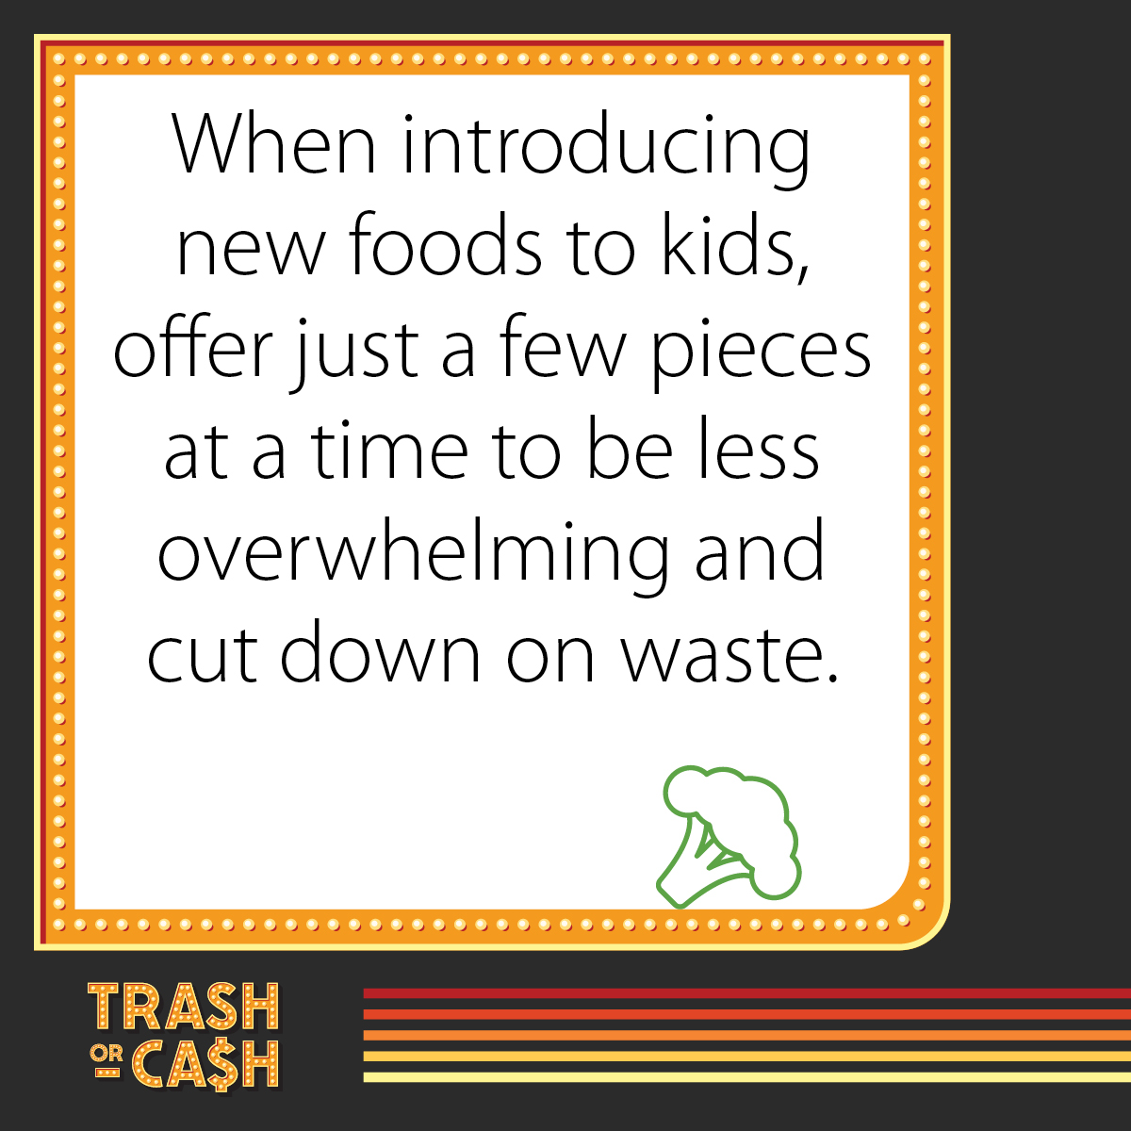
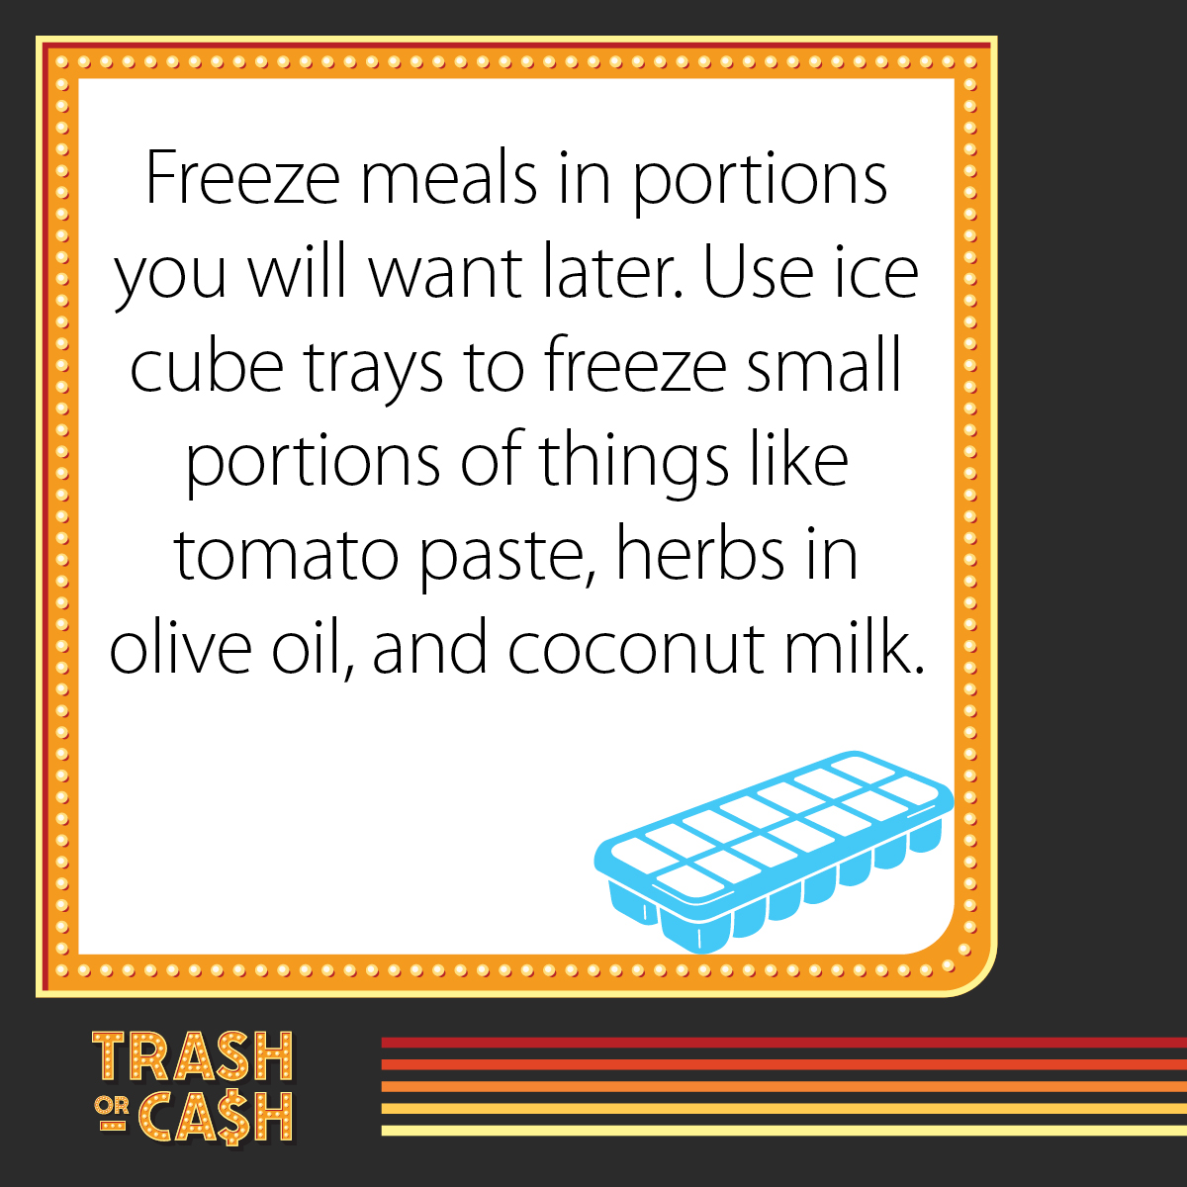
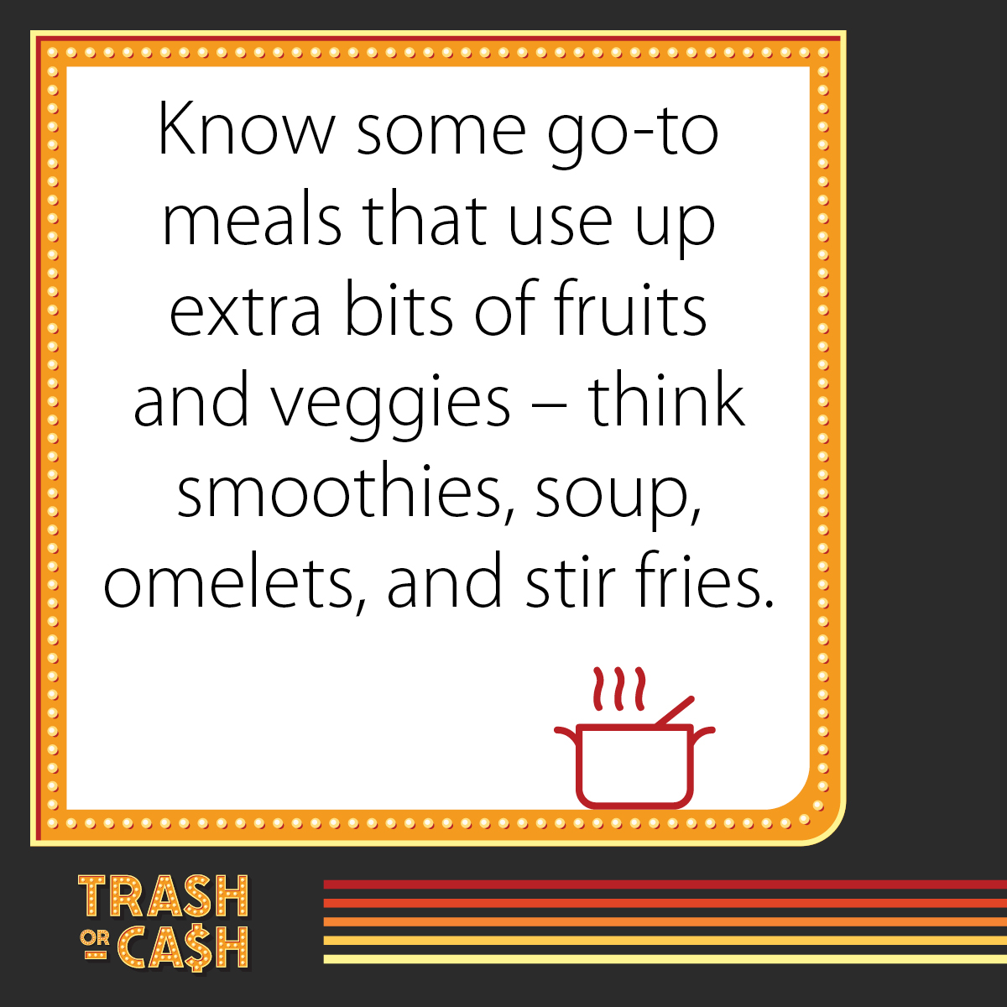
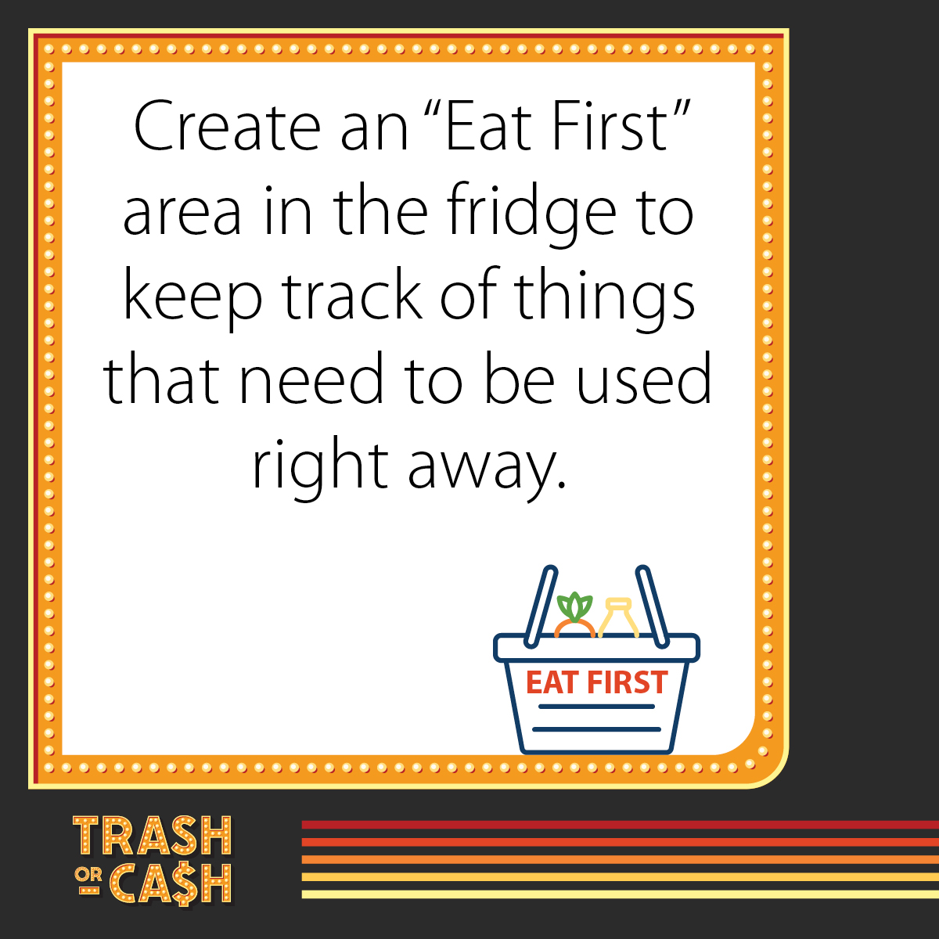
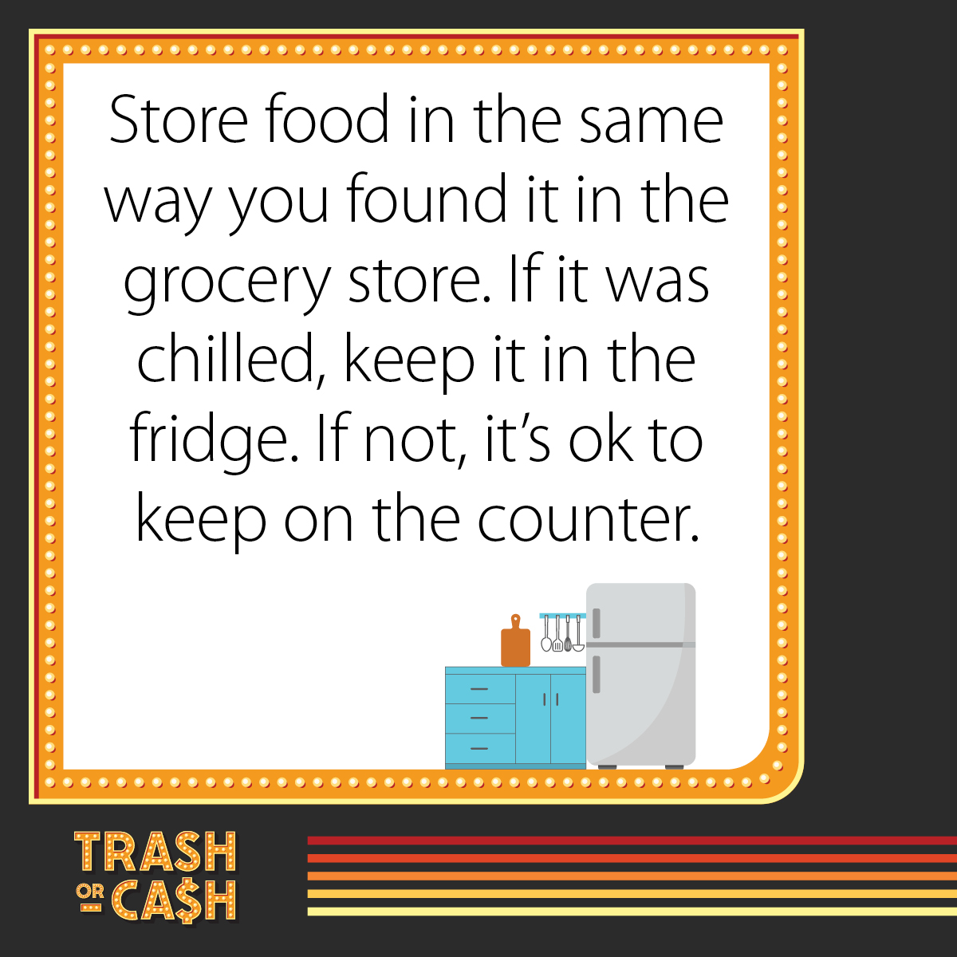
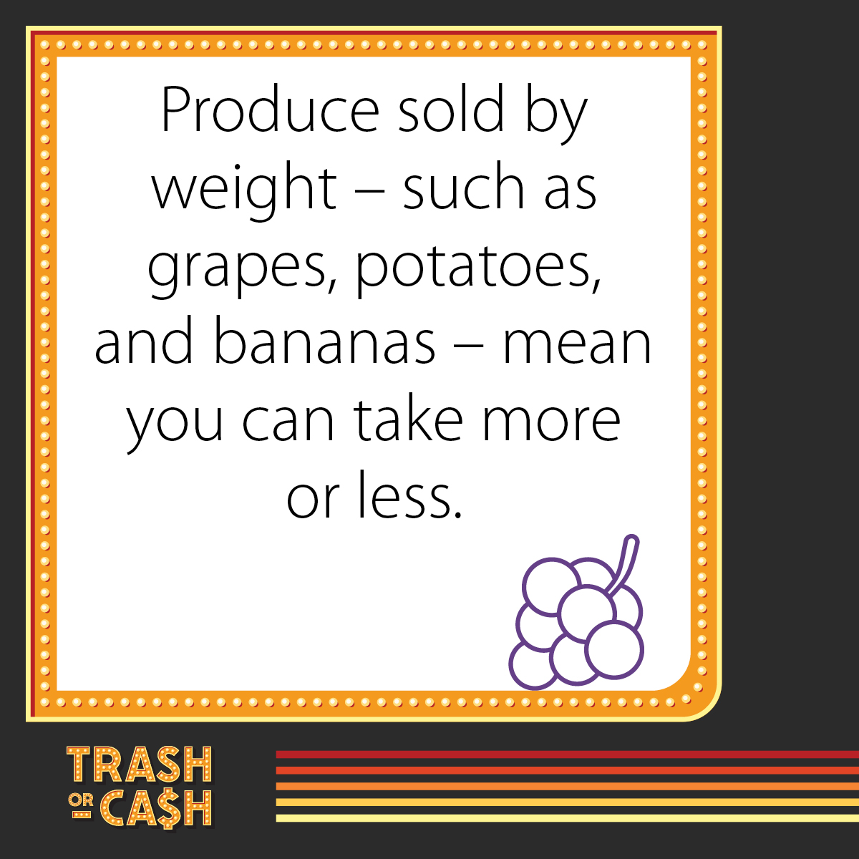
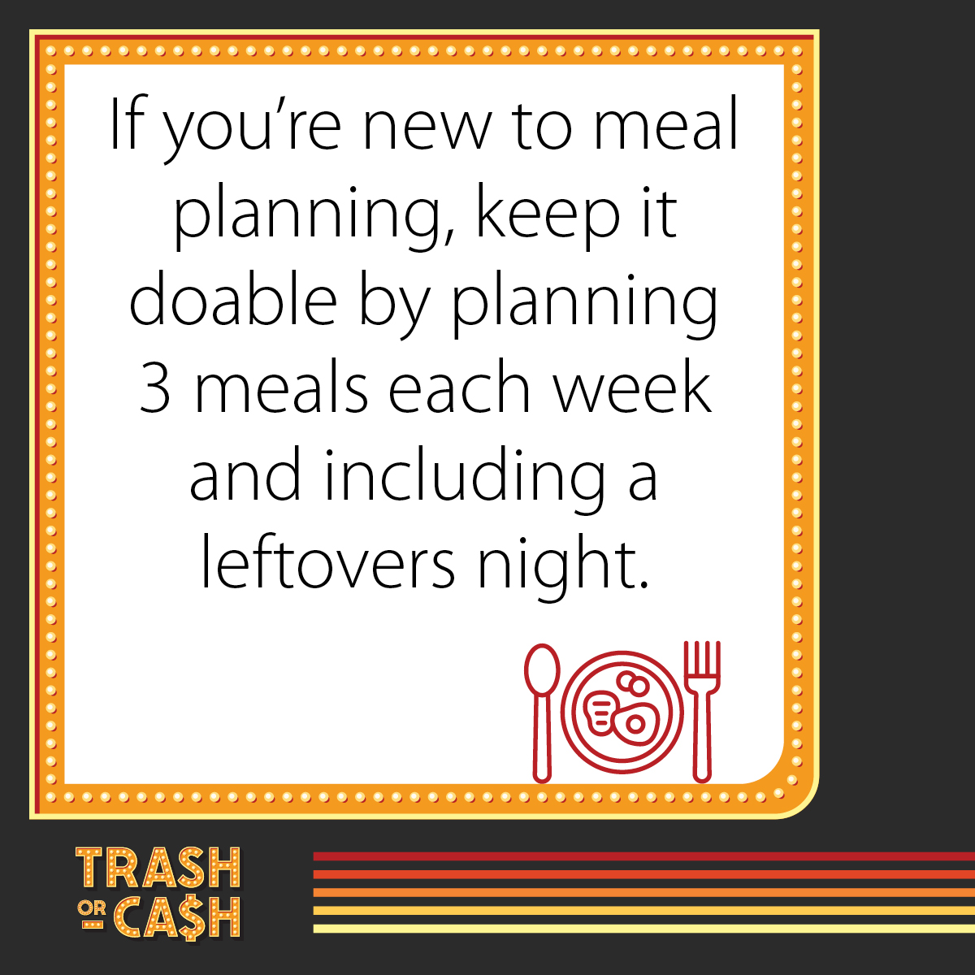
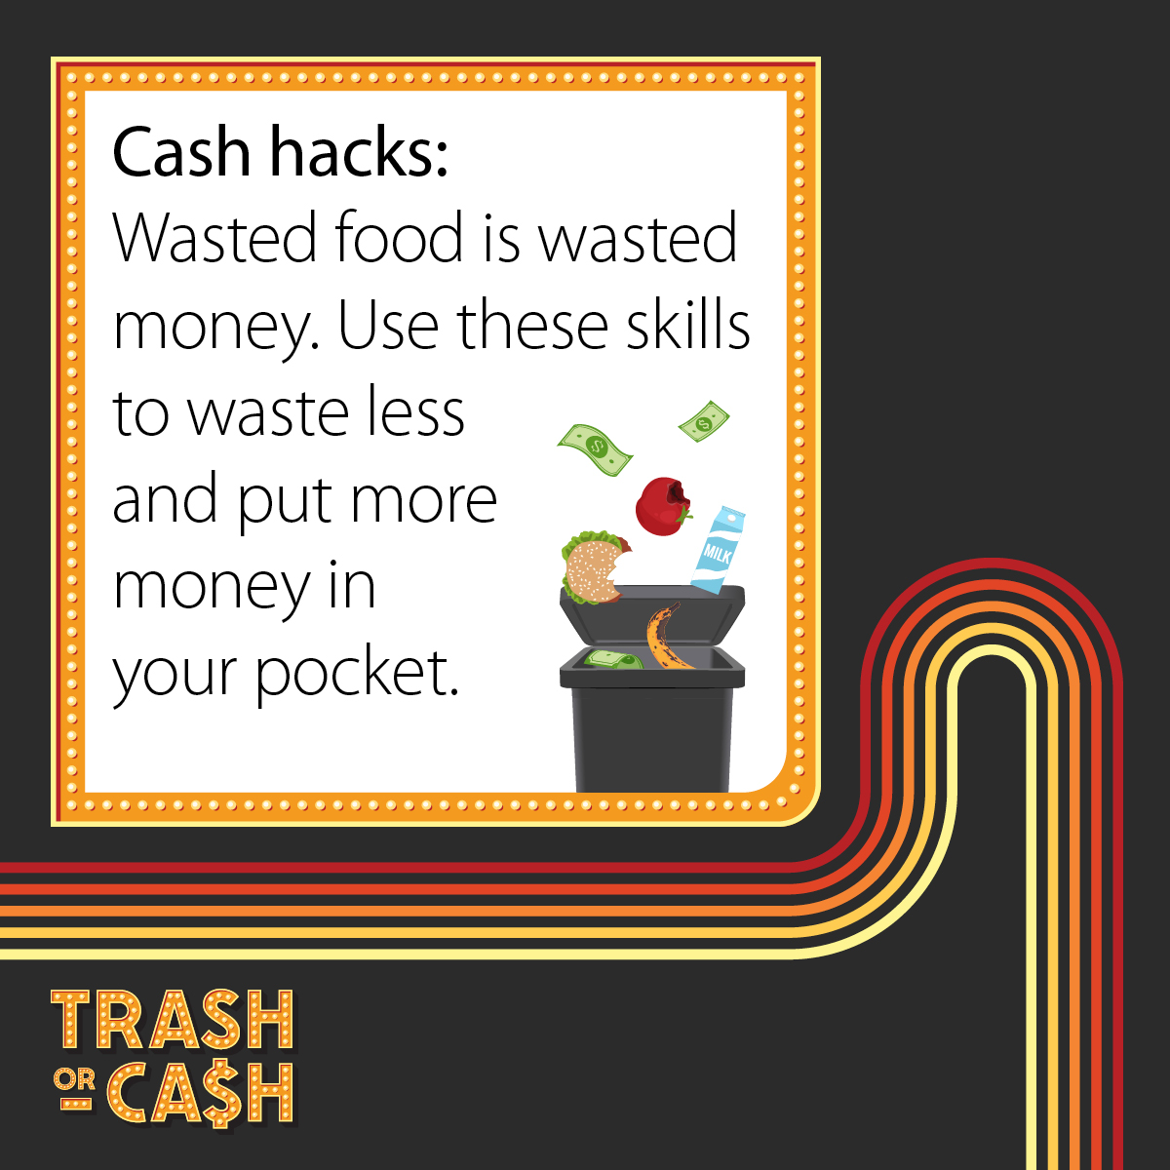
Suggested graphics (square and story):

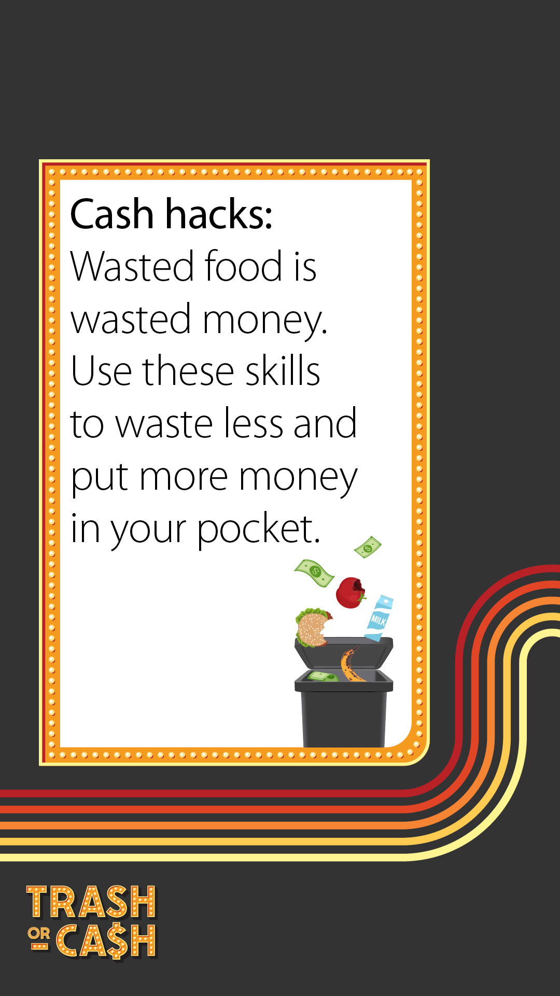
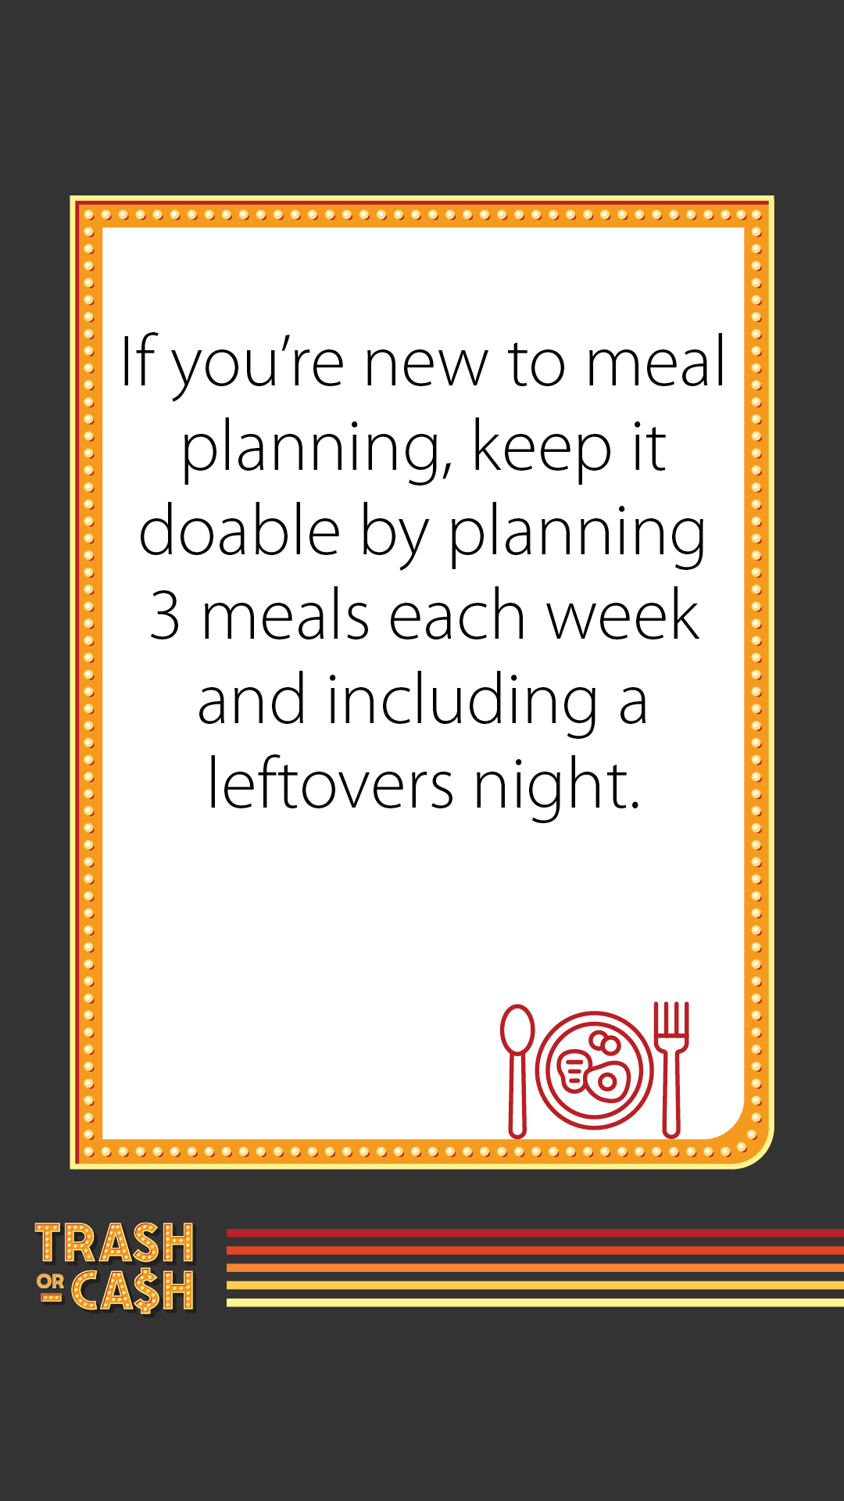
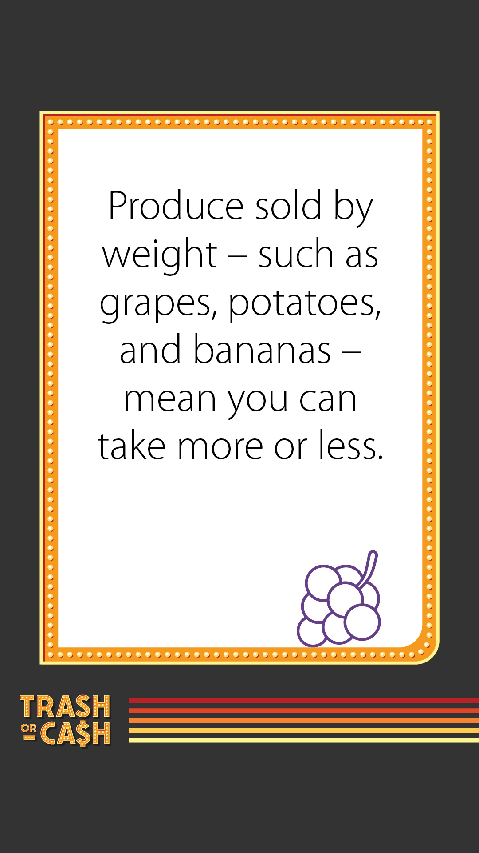
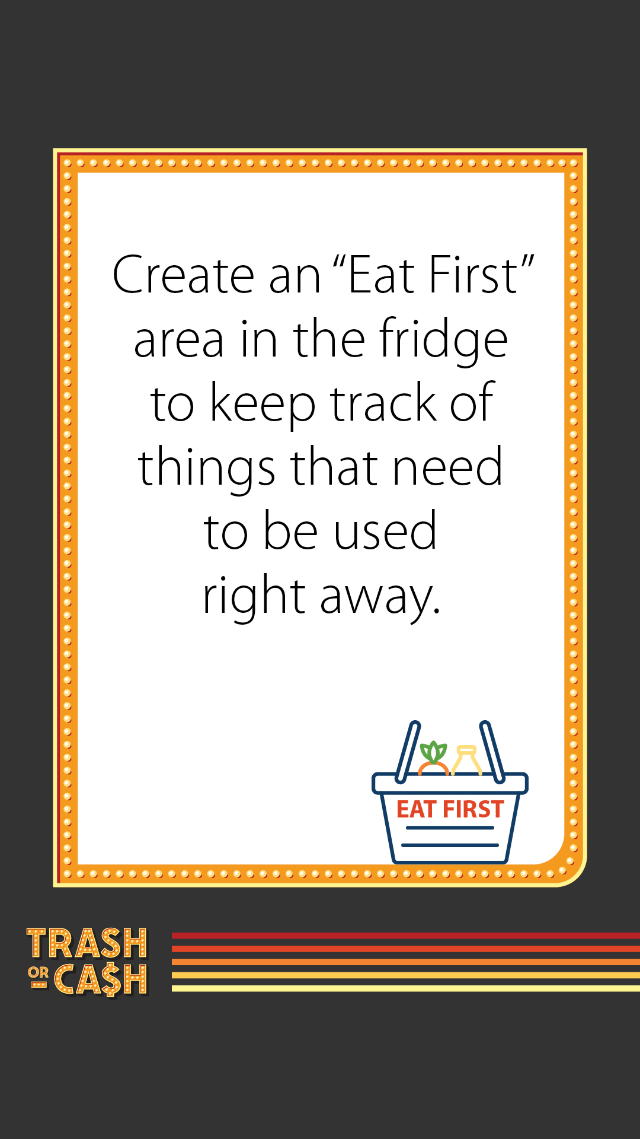
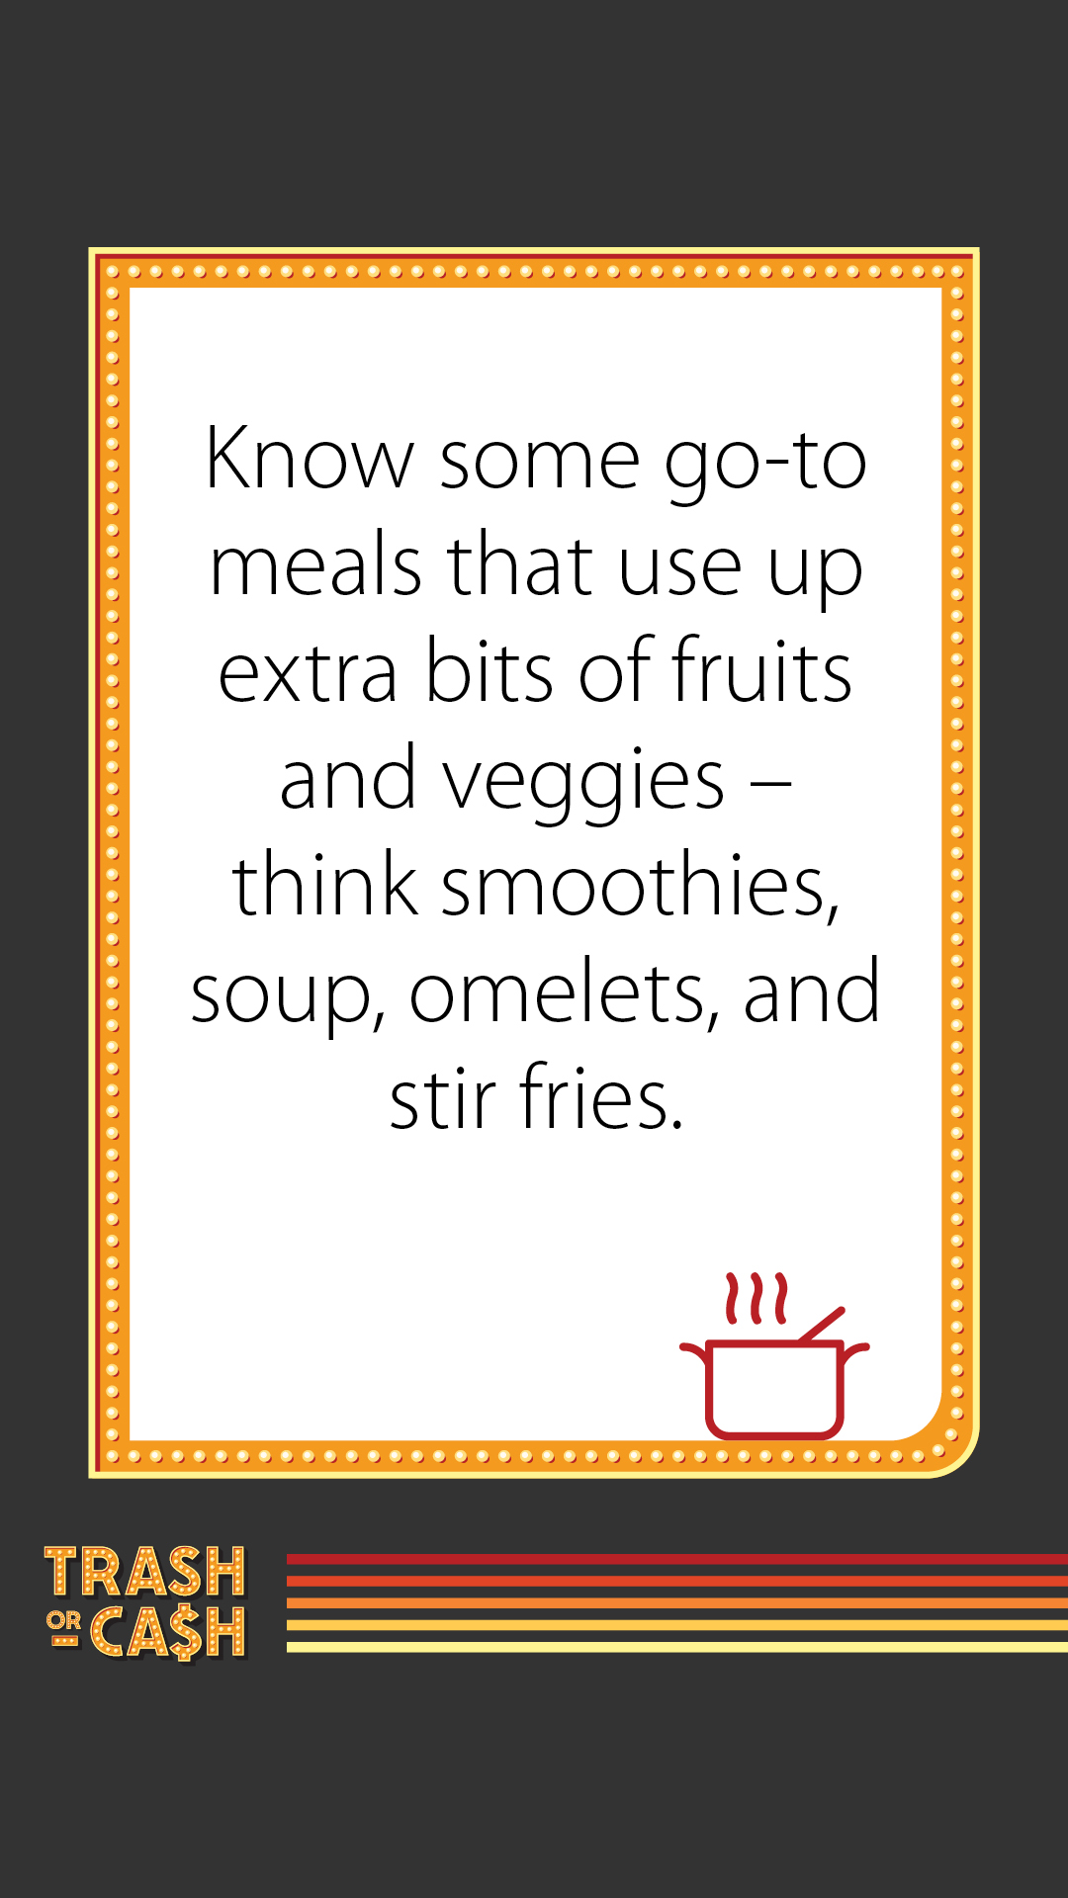
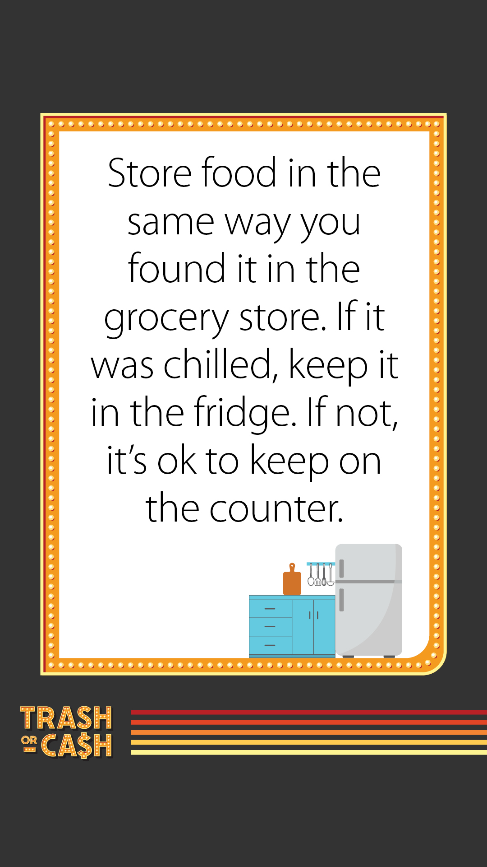
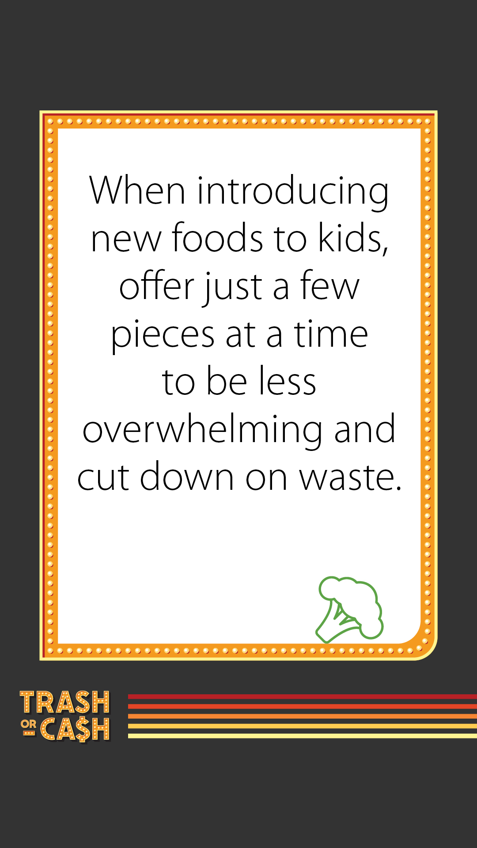
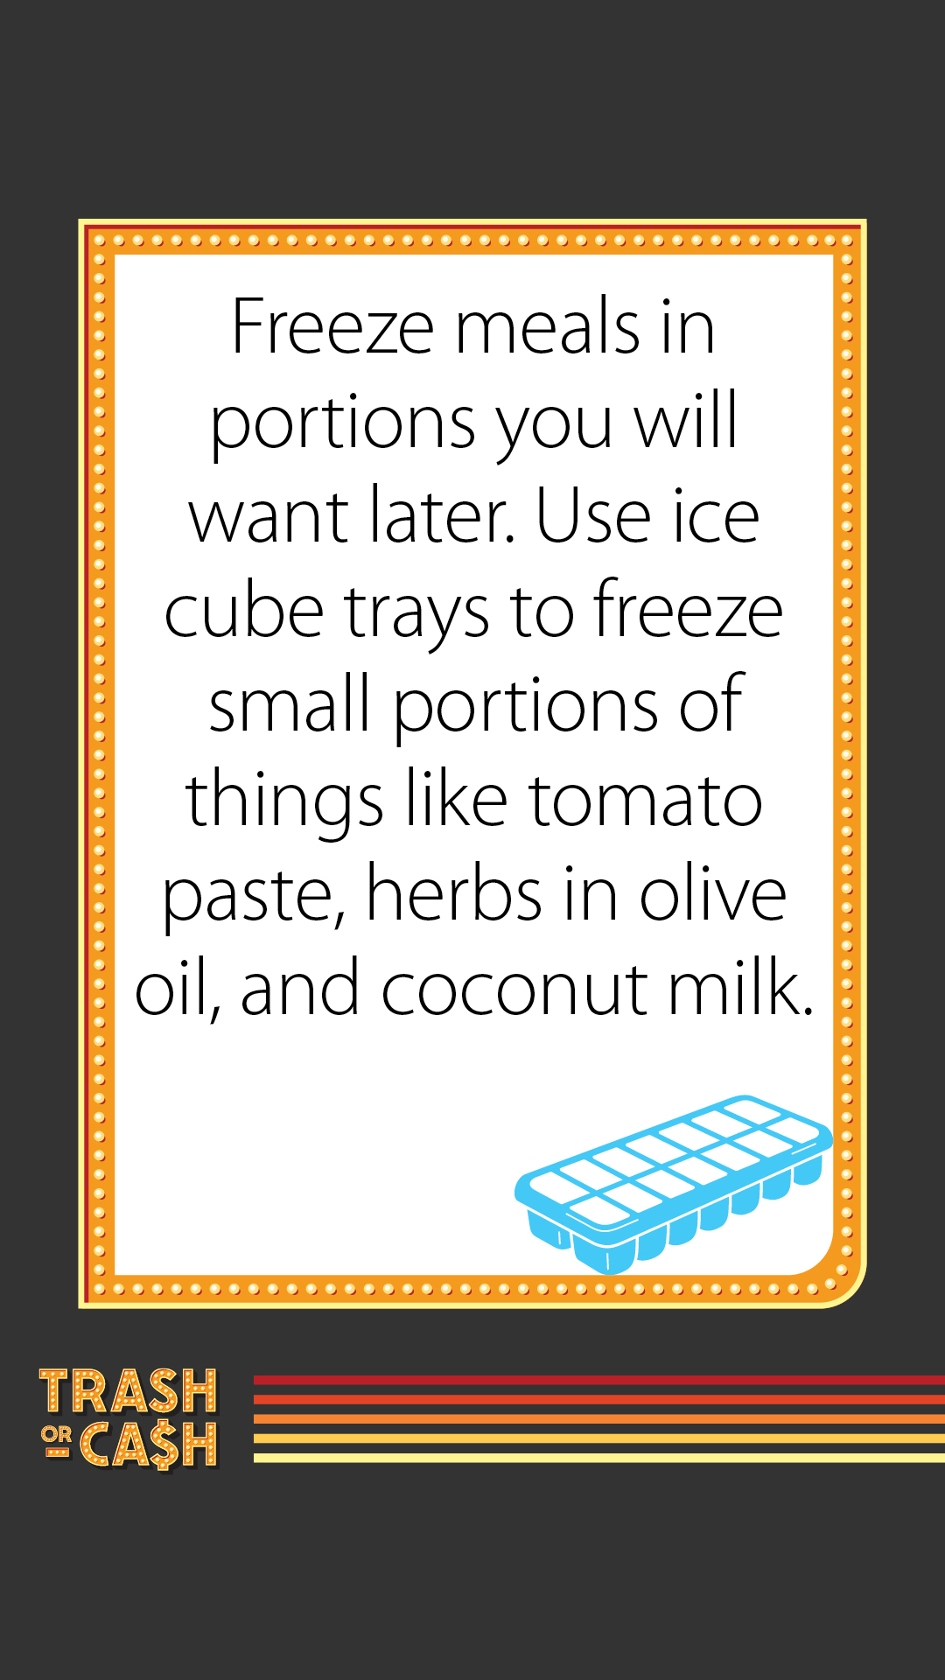

Post 5: Kitchen reality check
Facebook:
Wasting food is a waste of money. While no one likes wasting food, we often don’t realize how much uneaten leftovers or spoiled fruit adds up. That’s why simply tracking what food goes to waste and why can have the greatest impact on your kitchen habits.
Use the Fridge Check Guide to understand what food you’re throwing away and why and create a Use it Up list for leftovers that need to get eaten quickly. Get the guide: https://trashorcash.org/#resources
X:
Wasting food is a waste of money. While no one likes wasting food, we often don’t realize how much it adds up. Use the Fridge Check Guide to understand what food you’re throwing away and why and make a plan for your leftovers: https://trashorcash.org/#resources #StopFoodWaste #SaveMoney

Videos
The Trash or Cash campaign includes two series of videos: game show series (YouTube) and chef tip series (YouTube). If you are interested in video files (mp4) to share on your channels, please contact jenny.kedward@hennepin.us or alisa.reckinger@hennepin.us.

Game show series

Trash or Cash game show: Bulkamania
Link: https://youtu.be/5KTcY-xjI_A?si=p3l2UXbA-dyS8k9O
Description: Do you buy more food at 50% off or just the amount you need? Remember, wasted food is wasted money. Learn how you can choose cash over trash by wasting less food at trashorcash.org.

Trash or Cash game show: Contain your excitement
Link: https://youtu.be/eDWkaEyxSWU?si=qXmdjjHt_pmxRrTX
Description: How much money can you make by properly storing your leftovers to eat later? Remember, wasted food is wasted money. Learn how you can choose cash over trash by wasting less food at trashorcash.org.

Trash or Cash game show: Date the save
Link: https://youtu.be/1tDFlWXddHE?si=fsZHvpYWL2v2YGMD
Description: Choose the best date to eat or freeze food to keep your money from going to waste. Remember, wasted food is wasted money. Learn how you can choose cash over trash by wasting less food at trashorcash.org.

Chef tips series

Carrie McCabe-Johnston (Nightingale) on using up fruit and vegetable scraps
Link: https://youtu.be/h_pz87_aXgA?si=c6spH8_TO5b4m7DV
Description: Carrie McCabe-Johnston, chef and owner of Nightingale in Minneapolis, shares her tips for saving money by wasting less food. This includes using fruit or vegetable scraps to infuse flavor into vinegars or oils. Learn how you can choose cash over trash by wasting less food at trashorcash.org.

Lachelle Cunningham (Chelles’ Kitchen Catering) on running an efficient kitchen
Link: https://youtu.be/ZdPFRzwpDOM?si=ykRsJlBmCRfb2vnD
Description: Lachelle Cunningham, chef and owner of Chelles’ Kitchen Catering, shares her tips for saving money by wasting less food. She says that the essential concepts for planning to reduce food waste – being planful, mindful, and efficient – are the same whether you’re running a food business or cooking at home. Learn how you can choose cash over trash by wasting less food at trashorcash.org.

David Fhima (Maison Margaux, Fhima’s, Mother Dough) on tracking food waste
Link: https://youtu.be/sQGcZaRi2HU?si=FULrpvOLltdhA56e
Description: David Fhima, chef and restauranteur with Maison Margaux, Fhima’s, Mother Dough, and more in Minneapolis, thinks everyone should have a place at home to write down what food they throw away. Understanding the problem is the first step in finding ways save money by wasting less food. Learn how you can choose cash over trash by wasting less food at trashorcash.org.

Yia Vang (Union Hmong Kitchen, Vinai) on the cost of wasted food
Link: https://youtu.be/cK4fWliVJ4o?si=t0U0NmF0GcRpoII6
Description: Yia Vang, owner and chef with Union Hmong Kitchen and Vinai in Minneapolis, explains that every time we throw away a little bit of food, it adds up. A couple cents here and a couple cents here adds up to thousands of dollars a year being thrown out. Learn how you can choose cash over trash by wasting less food at trashorcash.org.

Yia Vang (Union Hmong Kitchen, Vinai) on being flexible with recipes
Link: https://youtu.be/wSc1Yfq2Zqc?si=QTO86oL6971-Raug
Description: Yia Vang, owner and chef with Union Hmong Kitchen and Vinai in Minneapolis, encourages home cooks to think about the recipes they plan on making and how they could change some items out to buy fewer and more low-cost ingredients. Learn how you can choose cash over trash by wasting less food at trashorcash.org.

Vincent Francoual (Chloe by Vincent) on being creative in the kitchen
Link: https://youtu.be/ejkGQcXTIFI?si=mxs_KejgtIJ6gCfv
Description: Vincent Francoul, owner and chef with Chloe by Vincent in Minneapolis, says you have to be smart about how you use and reuse food. It takes a bit of creativity, but it’s not that complicated. Learn how you can choose cash over trash by wasting less food at trashorcash.org.

