

Sustainable landscaping media kit

About sustainable landscaping and pollinator-friendly habitat
Residents can protect pollinators and improve water quality in their own backyards with sustainable landscaping practices. These practices include planting native plants, limiting pesticide and herbicide use, incorporating water sources into landscapes, and planting a variety of trees and shrubs. Sustainable landscaping provides critical habitat for the variety of pollinators in Minnesota, including insects like bees and butterflies, birds, and bats.

Resources to promote sustainable landscaping
Ways to educate the public about sustainable landscaping:
- Use the sample newsletter articles and social media posts to share with your audiences. These are editable so you can customize the length or message.
- Share this resource about creating habitat for bees, butterflies, and other pollinators:
  - English: Creating habitat for Minnesota pollinators (PDF)
  - Spanish: Cómo crear el hábitat para los polinizadores de Minnesota (PDF)
  - Printed copies can be ordered from hennepin.us/environmental-resources
- Share stories about sustainable landscaping for water quality from Clean Water MN: cleanwatermn.org and resources, literature, and workshops from Blue Thumb: bluethumb.org
- Download these media kits for more resources about protecting habitat:
  - Actions to protect water quality media kit (DOCX)
  - Providing habitat for birds and bats media kit (DOCX)
  - Land protection and restoration media kit (DOCX)
- Follow and reshare messages posted on our social media channels: Hennepin Environment on Facebook, Hennepin Environment on Instagram, and @hennepinenviro on X/Twitter.

Contact
For more information about sustainable landscaping, contact:
Emily McDonald, Environmental Educator, emily.mcdonald@hennepin.us

Sample newsletter article – Helping pollinators (short version - 259 words)

Helping pollinators threatened by habitat loss and climate change
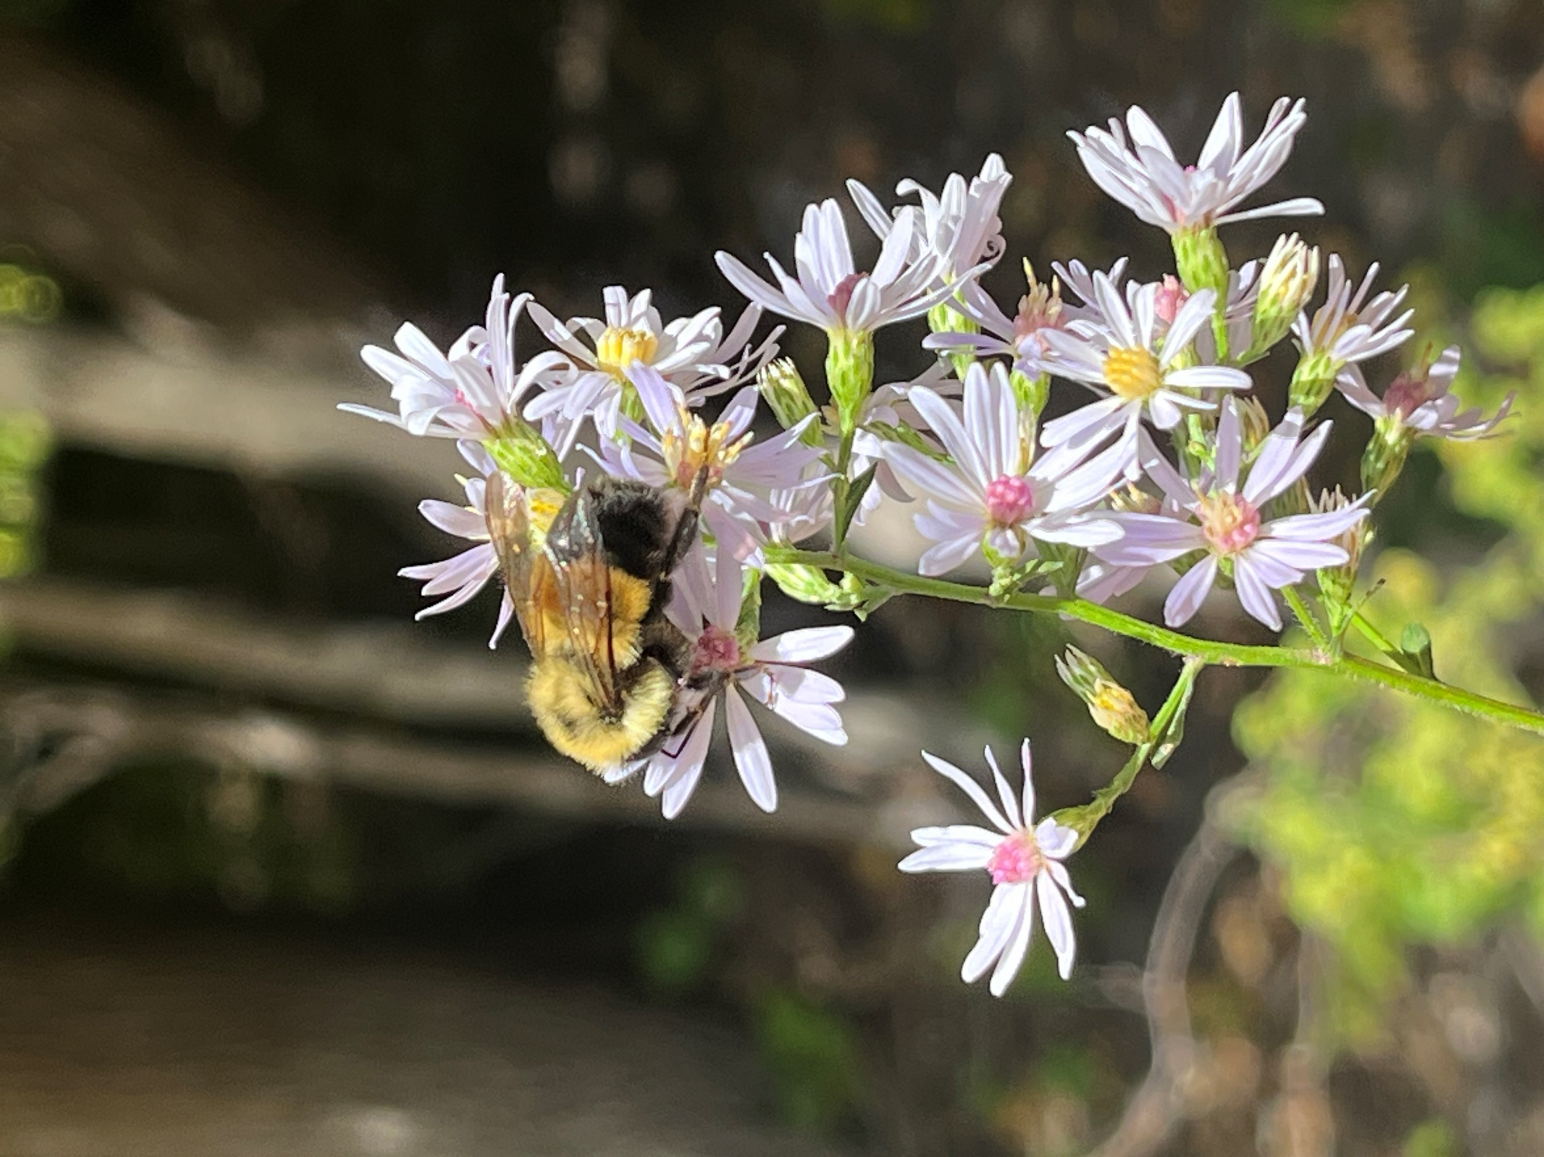
We rely on pollinators including native bees, butterflies, and birds to pollinate fruits and vegetables like apples, tomatoes, pumpkins, and strawberries. Pollination is also critical to produce oils, fibers, biofuels, and dairy and meat products.
There are thousands of native pollinators in Minnesota, including over 400 species of bees.

The threats to pollinators
Butterflies, bees, and other pollinators are in serious decline from habitat loss, climate change impacts, disease, parasites, and pesticide use. Several of Minnesota’s insect pollinators have been listed as threatened and endangered.

Gardening for pollinators
Here are some tips and tricks to get you started on your pollinator-friendly yard:
- Plant a bee lawn: Provide habitat for pollinators by replacing your turfgrass with low-growing native plants.
- Think variety: Grow a variety of native plants that flower throughout the year. This will provide diverse food sources for a variety of pollinators.
- Leave your gardens messy: Last year’s plants, leaves, seedheads and stems provide important overwintering and nesting habitat.
- Avoid chemicals: Reduce or eliminate your use of pesticides and herbicides. Never use pesticides or herbicides if rain is in the forecast over the next two days.
- Remove pavement: Replace pavement and asphalt with plants to help reduce temperature stressors on pollinators. This will also have added benefits for water quality!
- Plant a tree: Plant a tree (or trees!) in your yard to have big impacts. Trees help capture carbon, provide shade to reduce energy use needed for cooling, and increase your property value.
Use the plant finder from Blue Thumb to search for plants based on color, bloom months, light, soil moisture requirements, and more!

Sample newsletter article – Helping pollinators (long version - 422 words)

Helping pollinators threatened by habitat loss and climate change
We rely on pollinators including native bees, butterflies, and birds to pollinate fruits and vegetables like apples, tomatoes, pumpkins, and strawberries. Pollination is also critical to produce oils, fibers, biofuels, and dairy and meat products.
There are thousands of native pollinators in Minnesota, including over 400 species of bees.

The threats to pollinators
Butterflies, bees, and other pollinators are in serious decline from habitat loss, climate change impacts, disease, parasites, and pesticide use. Several of Minnesota’s insect pollinators have been listed as threatened and endangered.
You can help Minnesota’s pollinators in your yard or garden. Planting native plants results in a beautiful, low-maintenance yard and garden that provides habitat, pollen, and nectar for Minnesota’s pollinators as well as captures carbon to help fight climate change.

Gardening for pollinators
If you have a garden (even a small garden) you can help pollinators by transforming it into a place they can find shelter and food. Here are some tips and tricks to get you started:
- Plant a bee lawn: Provide habitat for pollinators (and cut down on yard work!) by replacing your turfgrass with low-growing native plants. Plants that are commonly used include fine fescue, self-heal, and creeping thyme. These plants provide food for pollinators while being inexpensive to plant and maintain.
- Think variety: Grow a variety of native plants that flower throughout the year. This will provide diverse food sources for a variety of pollinators.
- Leave your gardens messy: Last year’s plants, leaves, seedheads and stems provide important overwintering and nesting habitat.
- Avoid chemicals: Reduce or eliminate your use of pesticides and herbicides. Never use pesticides or herbicides if rain is in the forecast over the next two days.
- Remove pavement: Replace pavement and asphalt with plants to help reduce temperature stressors on pollinators. This will also have added benefits for water quality!
- Plant a tree: Plant a tree (or trees!) in your yard to have big impacts. Trees help capture carbon, provide shade to reduce energy use needed for cooling, and increase your property value.

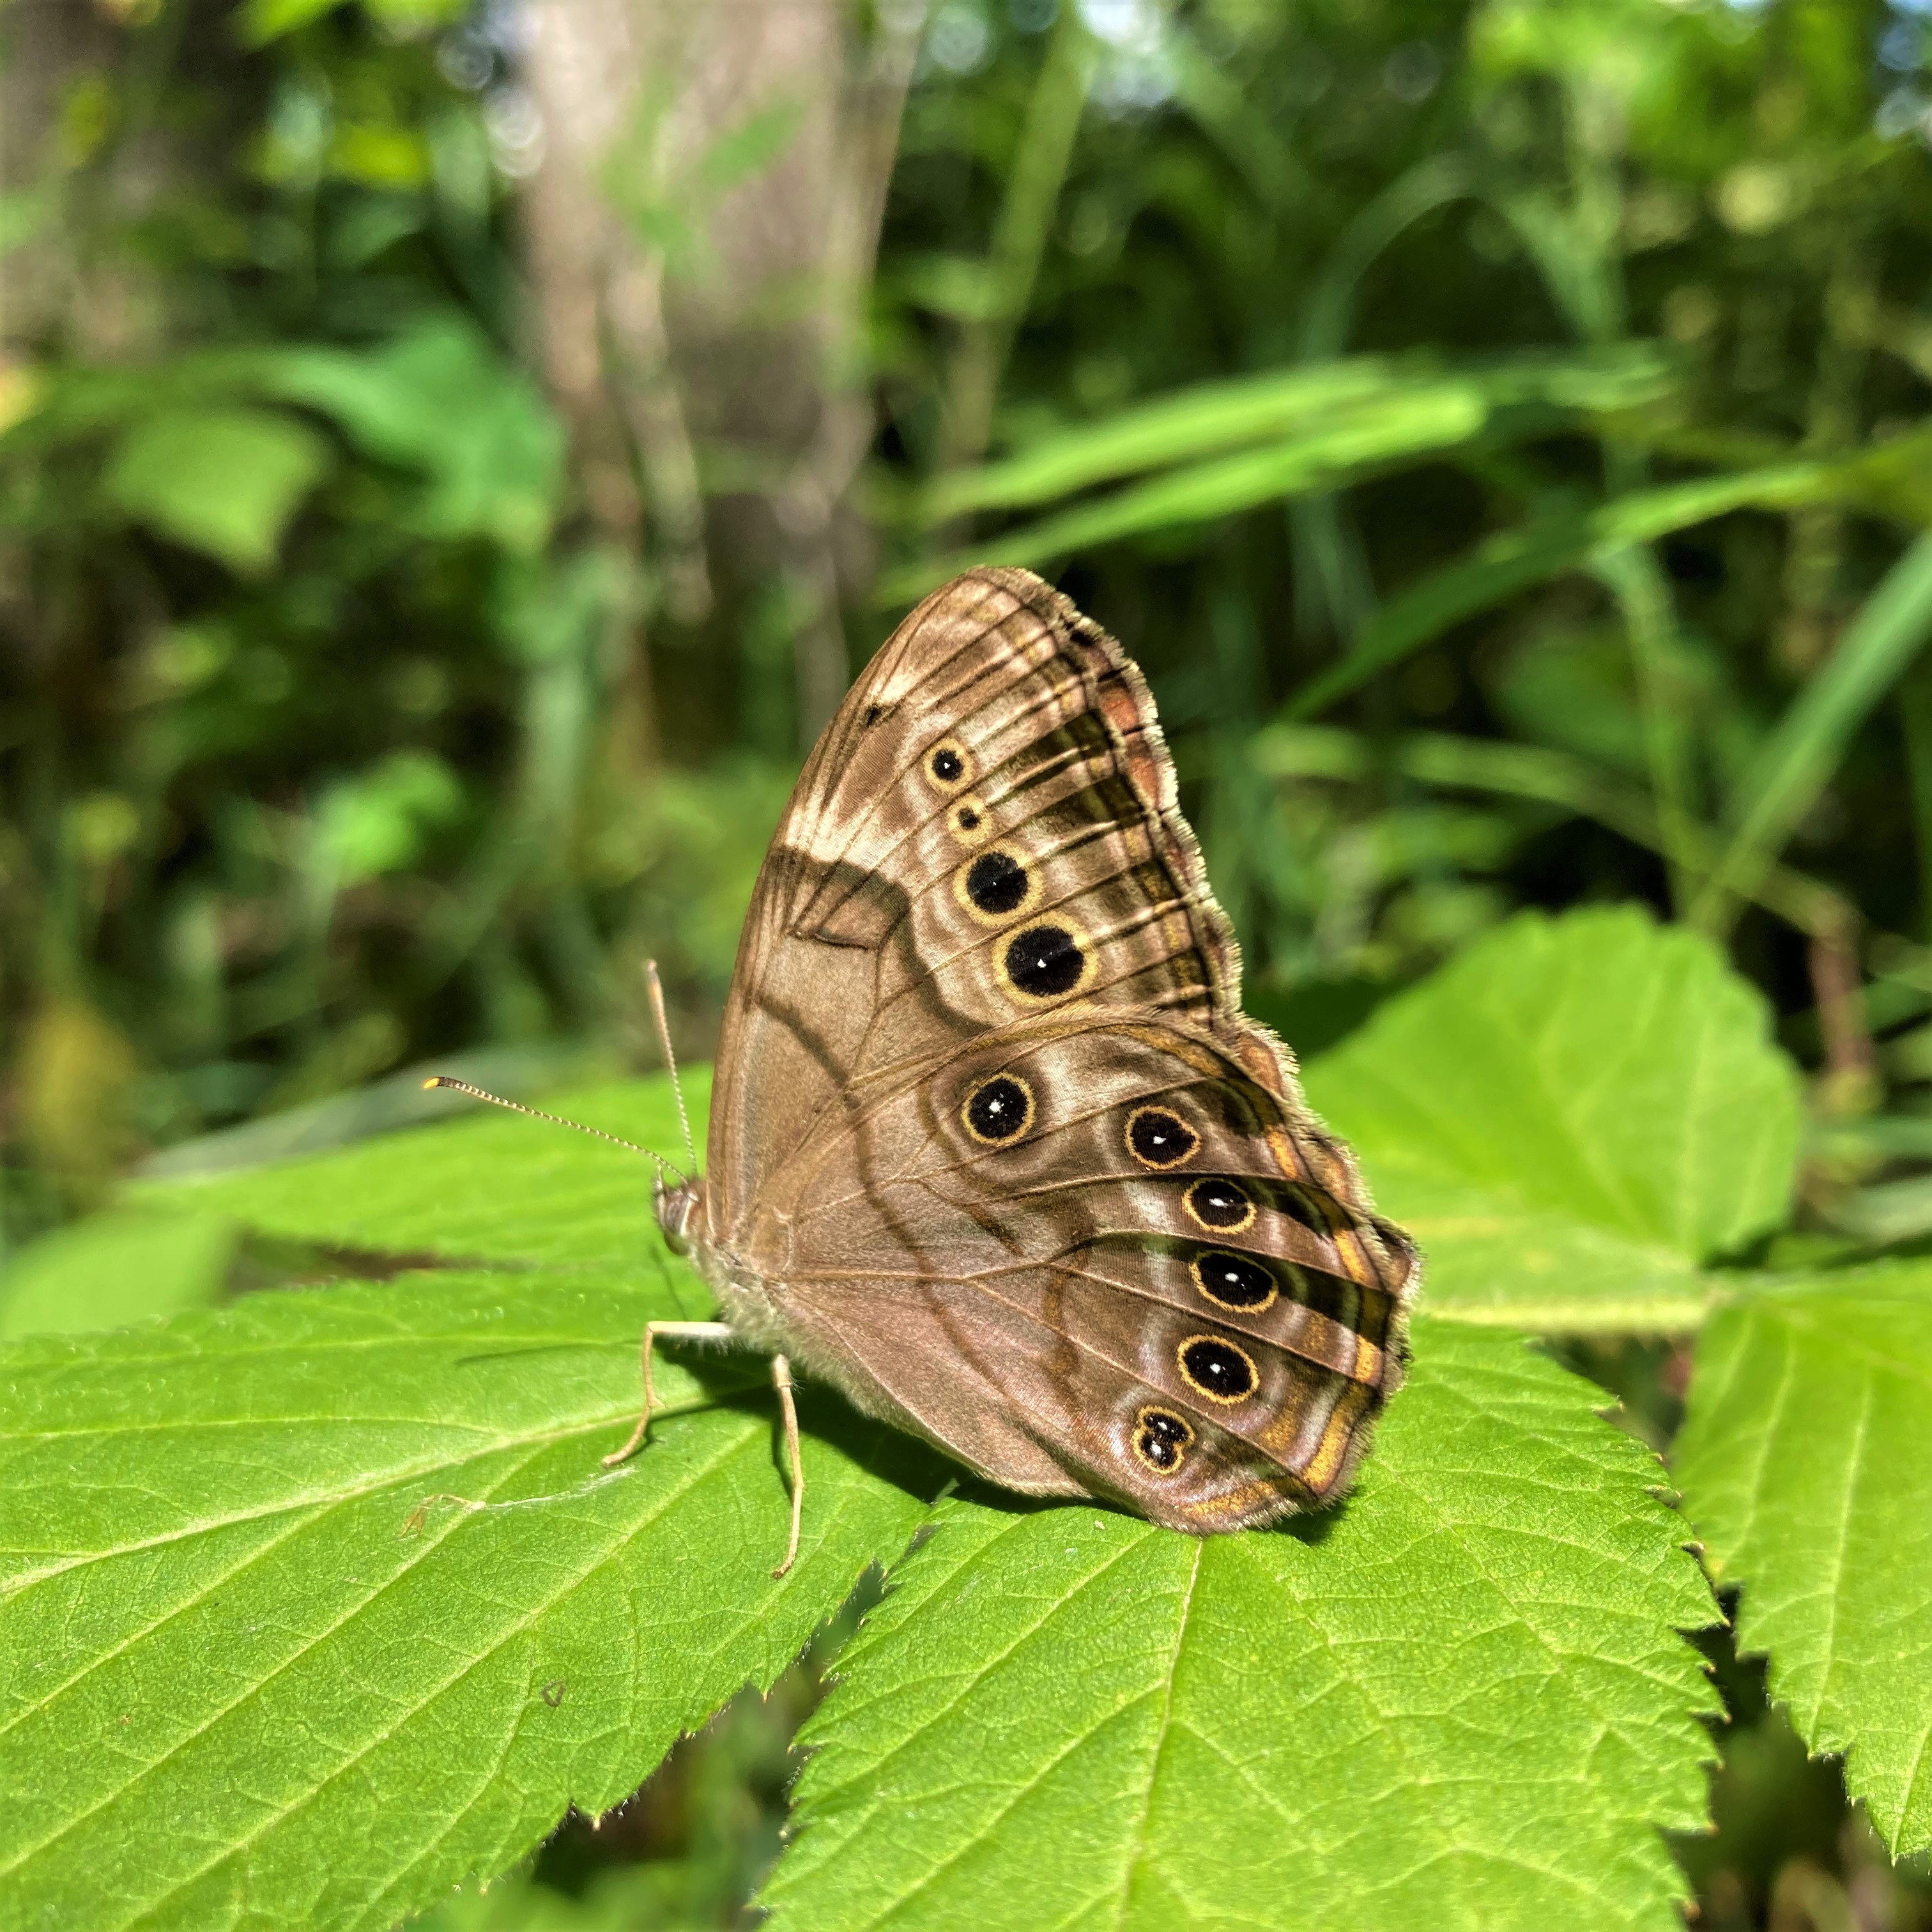
Resources to help you take action
- Blue Thumb has a plant finder tool and offers resilient yards and pollinator workshops.
- The Minnesota Department of Natural Resources has a list of native plant suppliers, landscapers, and restoration consultants.
- Lawns to Legumes offers cost-share grants to help cover the costs of planting pollinator-friendly yards. Learn more and apply online.
- The Minnesota Board of Soil and Water Resources has residential pollinator resources and customizable pollinator garden templates.

Sample newsletter article – Improving habitat (448 words)

How to create habitat for pollinators in your yard and garden
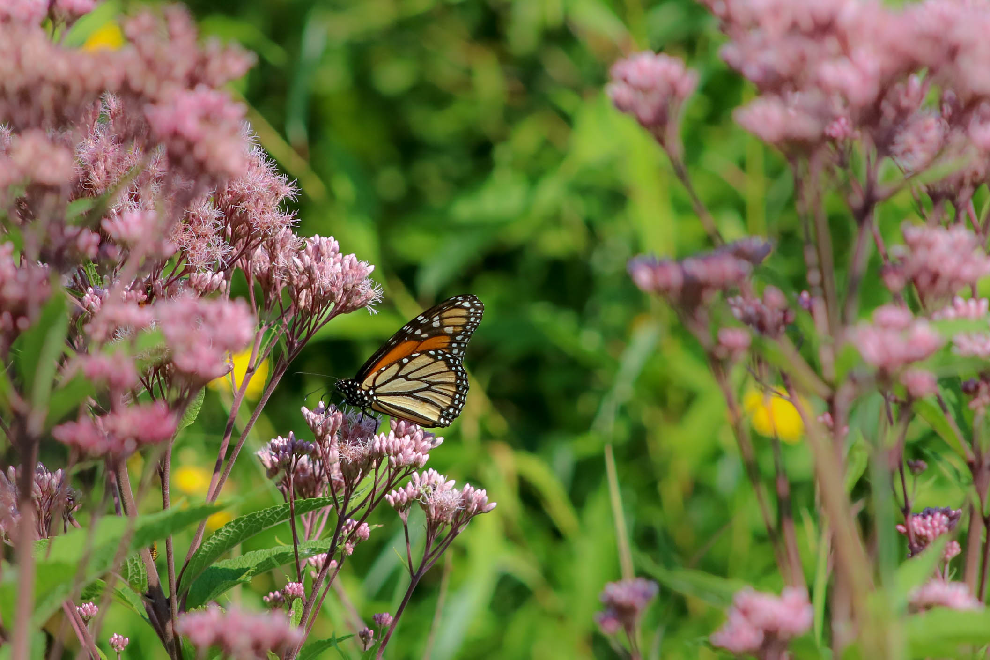
Protect pollinators and improve water quality in your own backyard with sustainable landscaping practices. These practices include planting native plants, limiting pesticide and herbicide use, incorporating water sources into your landscape, and planting a variety of trees and shrubs.

Plant native, pollinator-friendly plants
Using plants native to Minnesota provides sustainable habitat for wildlife and pollinators. Choose a diverse array of plants that bloom at different times of the year to ensure a continuous source of nectar and pollen for pollinators.
For example, in Minnesota, all varieties of milkweed are critical host plants for monarch butterflies. Monarchs lay their eggs exclusively on milkweed, and it serves as a host plant for their caterpillars. Consider adding this flower to your garden! Use the advanced search option on the plant finder tool to find other high value pollinator plants.

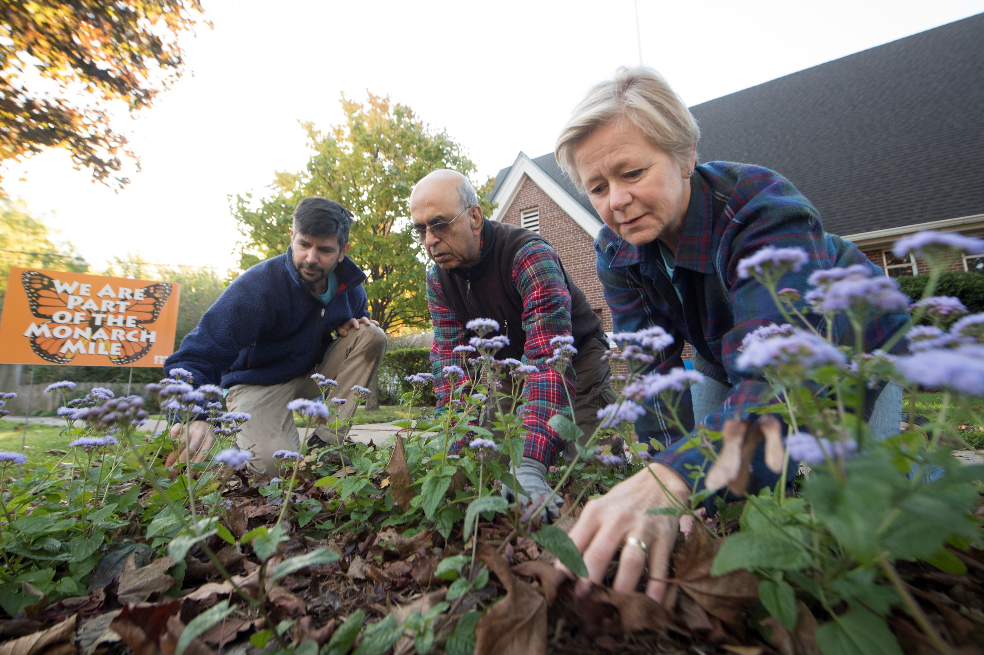
Provide nesting sites
Invite pollinators to visit your garden by providing safe places for them to rest or spend the night. You can incorporate nesting sites for native animals, such as birdhouses, bat boxes, and brush piles into your garden design or install nesting sites for native bees and insects, such as bee hotels, to encourage their presence in your garden. You can also leave dead wood and fallen leaves in a corner of your yard to provide habitat for solitary bees and other beneficial insects.

Limit pesticide and herbicide use
Minimize or eliminate the use of pesticides and herbicides in your garden and yard. Excessive use of these chemicals can harm pollinators through contaminated nectar and pollen. Instead, explore natural alternatives for pest control, such as introducing beneficial insects or using integrated pest management practices that minimize chemical usage while promoting healthy ecosystems.

Incorporate water sources
Installing birdbaths, ponds, or other small water features can be highly beneficial for native wildlife. These water sources provide hydration opportunities for various species, including birds, insects, and small mammals. Ensure these water sources are clean, especially during dry periods.

Plant trees
Trees like oaks, willows, and maples provide habitat and food sources for various pollinators. Incorporating trees into your landscape can benefit both insects and birds. Design your garden with various layers including tall trees, shrubs, and groundcover. This mimics natural ecosystems and provides homes for different wildlife species.
Each spring, Hennepin County sells seedling trees to property owners to restore and improve woodland areas and increase wildlife habitat. The bareroot trees range in size from 6 inches to 2 feet tall. Trees can create shelterbelts, provide visual screens, and offer shade that increases home energy efficiency. Trees also protect water quality, prevent soil erosion, and improve wildlife habitat. Learn more at hennepin.us/trees.

Sample newsletter article – Rain gardens (360 words)

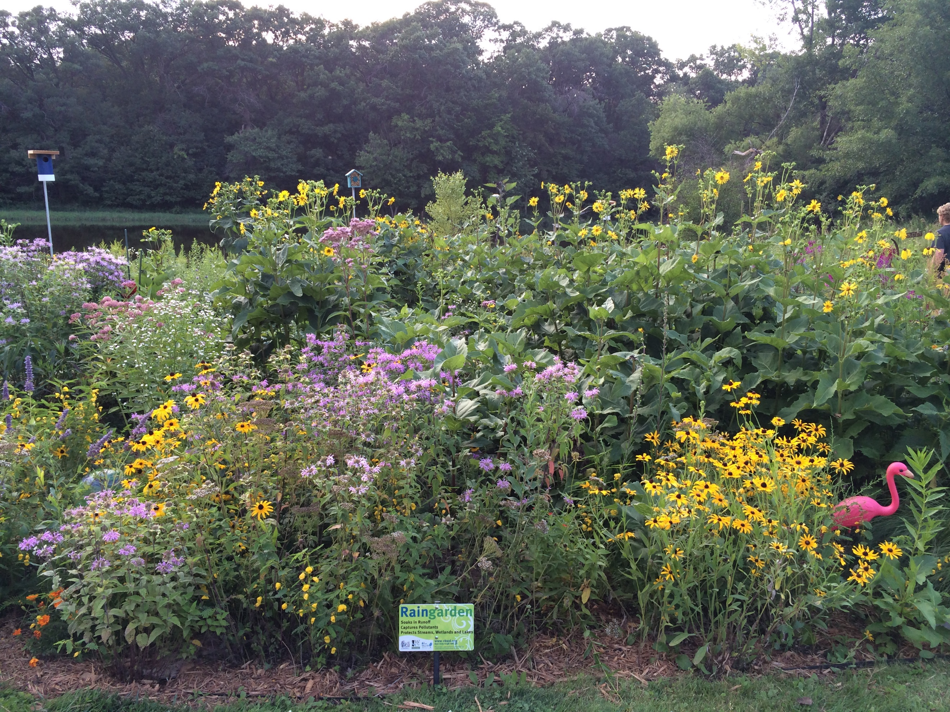
Rain gardens: what are they and why are they important?
When it rains, the stormwater that runs off driveways, lawns, houses, and parking lots can carry pollutants like oil, paint, and chemicals down storm drains and into nearby lakes, streams, and rivers. Homeowners can install a special kind of garden, called a rain garden, to infiltrate water into the ground rather than run off into storm drains.
A rain garden is a garden with a shallow depression designed to catch rainwater and keep runoff from entering nearby water sources. These gardens are filled with deep-rooted plants that can tolerate flooding and drought conditions. The plants and soil in a rain garden absorb pollutants and filter sediment as the water infiltrates into the ground. The gardens are designed to tolerate periods of wet and saturated soils, holding water for 24 to 48 hours.
Rain gardens also provide beautiful landscaping and habitat for birds and butterflies. By soaking up rain where it falls, they slow stormwater runoff, help prevent erosion, and remove pollutants. This improves water quality and helps alleviate localized flooding problems.
Rain gardens will require some maintenance. The garden will need regular watering and weeding, especially during the first season until the plants are established, then periodic weeding in the following years. As with any other perennial garden, plants need to be cut back in the spring, and plants may need to be divided every few years. Sediment and debris that flows into the garden with the rainwater should be removed when necessary.
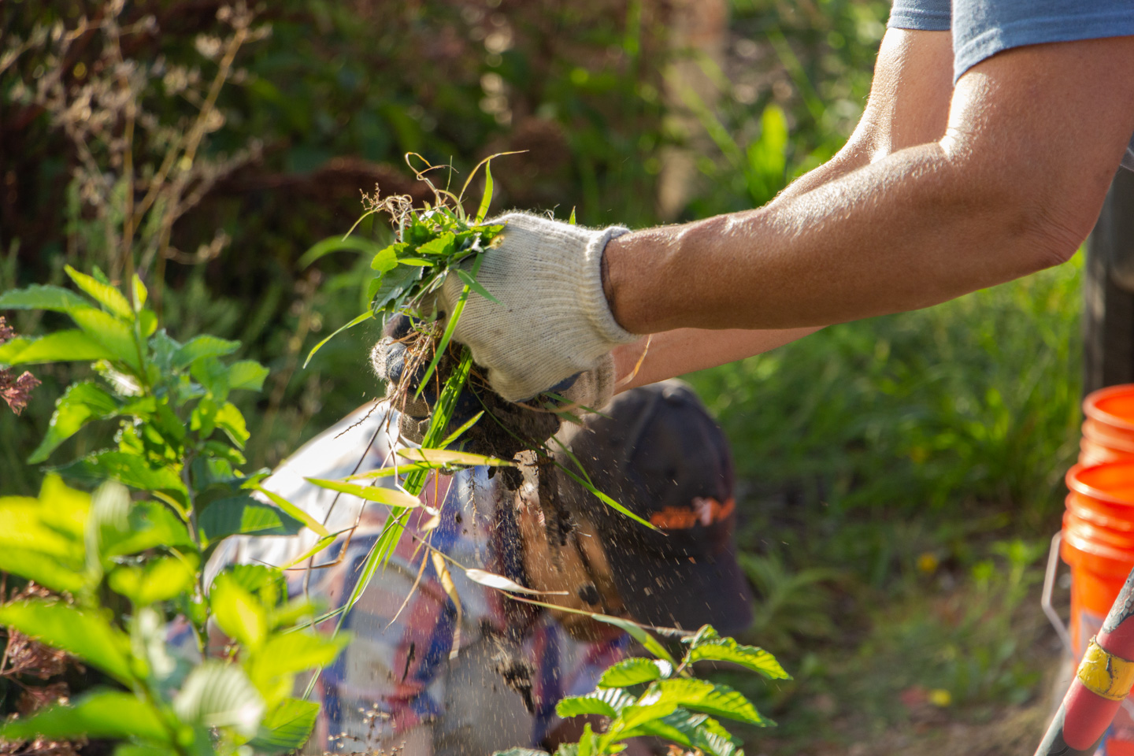
Rain gardens require some expertise to ensure they are designed and constructed properly. There are many resources available to those interested in creating a rain garden:
- Metro Blooms (metroblooms.org) offers workshops to teach homeowners how to design and install rain gardens.
- Blue Thumb (bluethumb.org) has examples of rain garden projects, a video of how to build a rain garden, project cost calculator, and a comprehensive guide on designing and installing rain gardens.
- Many landscape designers, services and nurseries have staff who are knowledgeable on rain garden design and installation.
For more information on rain gardens and other actions you can take to protect water quality, visit hennepin.us/protect-natural-resources.

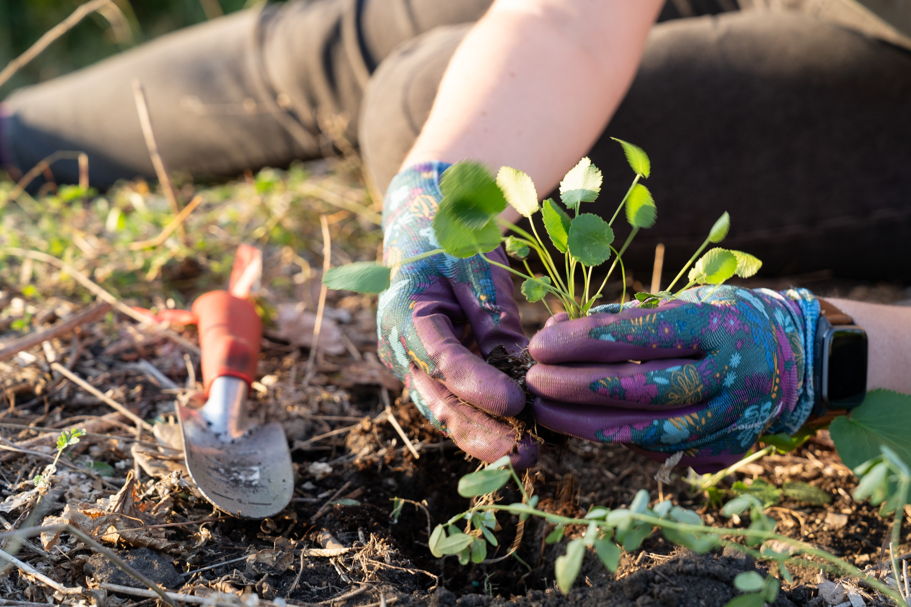
Sample newsletter article – Blue Thumb Partnership (229 words)

Plant your gardens to support a resilient, pollinator-friendly yard!
When planning your gardens, don’t forget to plant for clean water and pollinators! By using proper yard design and planting pollinator-friendly plants, our yards can help filter rainwater where it falls rather than flowing straight to our water bodies and picking up pollutants along the way. Native plants in yards have many benefits, like supporting pollinators and native ecosystems, being resilient during flooding and drought, enhancing soil health, providing food for wildlife, and stabilizing land to reduce erosion… just to name a few!
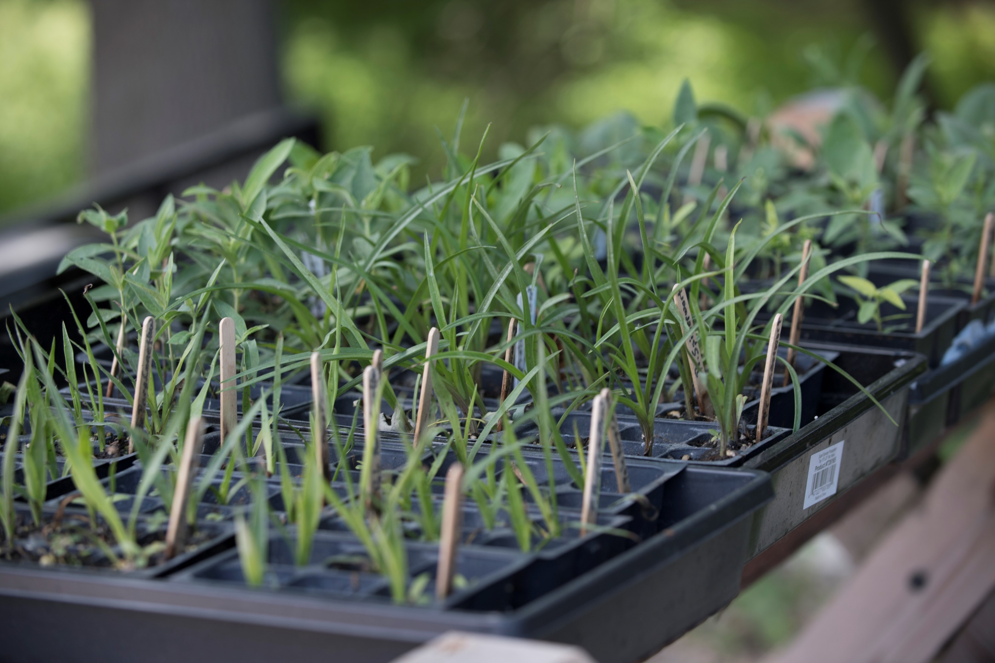
While planning native gardens may sound daunting at first, there are a lot of resources to help you along the way. Blue Thumb is one organization that provides resources and workshops to help people plant for clean water.
Check out these resources from Blue Thumb:
- Where can I buy native plants? Read Blue Thumb’s article on native plant sales.
- Can I get financial support for creating pollinator habitats? Yes! All Minnesota residents are eligible to apply for Lawns to Legumes cost-share funding of up to $400.
- Where can I learn more about planting for clean water? Blue Thumb hosts workshops and online learning events throughout the year.
- What kind of plants should I use? Look at Blue Thumb’s plant finder to find plants that fit your aesthetic and are suited to the environmental conditions of your yard.

Social media posts
Suggested hashtags: #Pollinators #NativePlants #Bees #SustainableLandscaping #CleanWater #PollinatorFriendly
To use images and graphics: right click on image and select save picture as, alt text for you to use is included with the pictures and graphics

Post 1: Helping pollinators
Facebook: We rely on pollinators including native bees, butterflies, and birds to pollinate fruits and vegetables like apples, tomatoes, pumpkins, and strawberries. You can help Minnesota’s pollinators in your yard or garden by planting native pollinator-friendly plants, replacing grass with low-maintenance plants, planting a tree, and eliminating pesticides. Learn how: hennepin.us/climate-action/what-we-can-do/helping-pollinators
Twitter/X: You can help Minnesota’s pollinators in your yard by planting native pollinator-friendly plants, replacing grass with low-maintenance plants, planting a tree, and eliminating pesticides. Learn how: hennepin.us/climate-action/what-we-can-do/helping-pollinators #Pollinators #NativePlants #Bees #SustainableLandscaping
Instagram: We rely on pollinators including native bees, butterflies, and birds to pollinate fruits and vegetables like apples, tomatoes, pumpkins, and strawberries. You can help Minnesota’s pollinators in your yard or garden by planting native pollinator-friendly plants, replacing grass with low-maintenance plants, planting a tree, and eliminating pesticides. Learn how at the link in our bio. #Pollinators #NativePlants #Bees #SustainableLandscaping
Images:
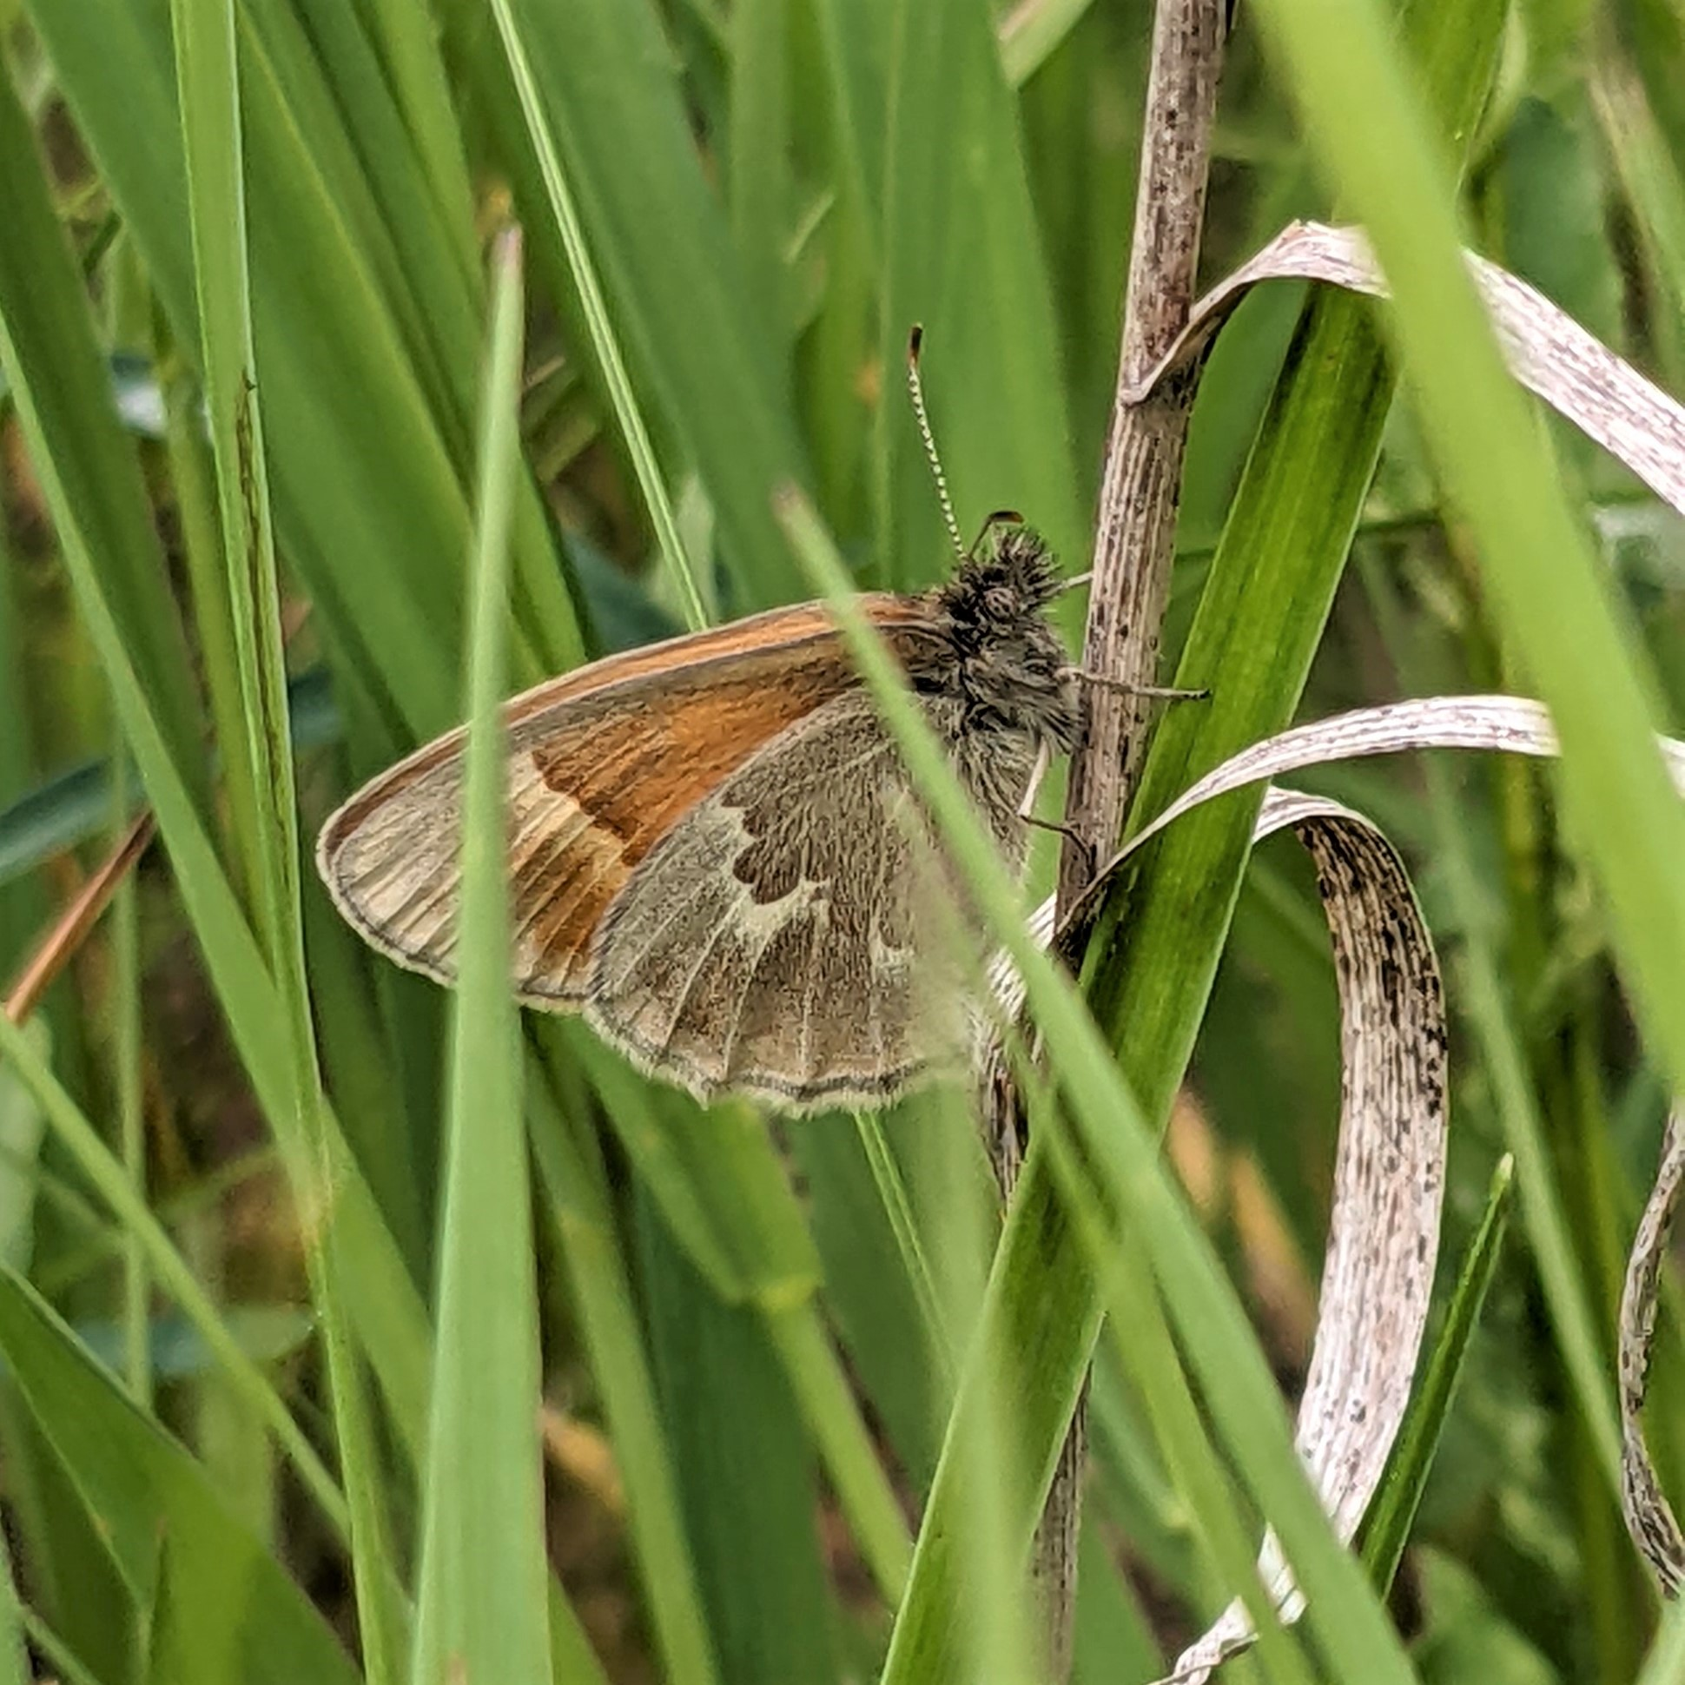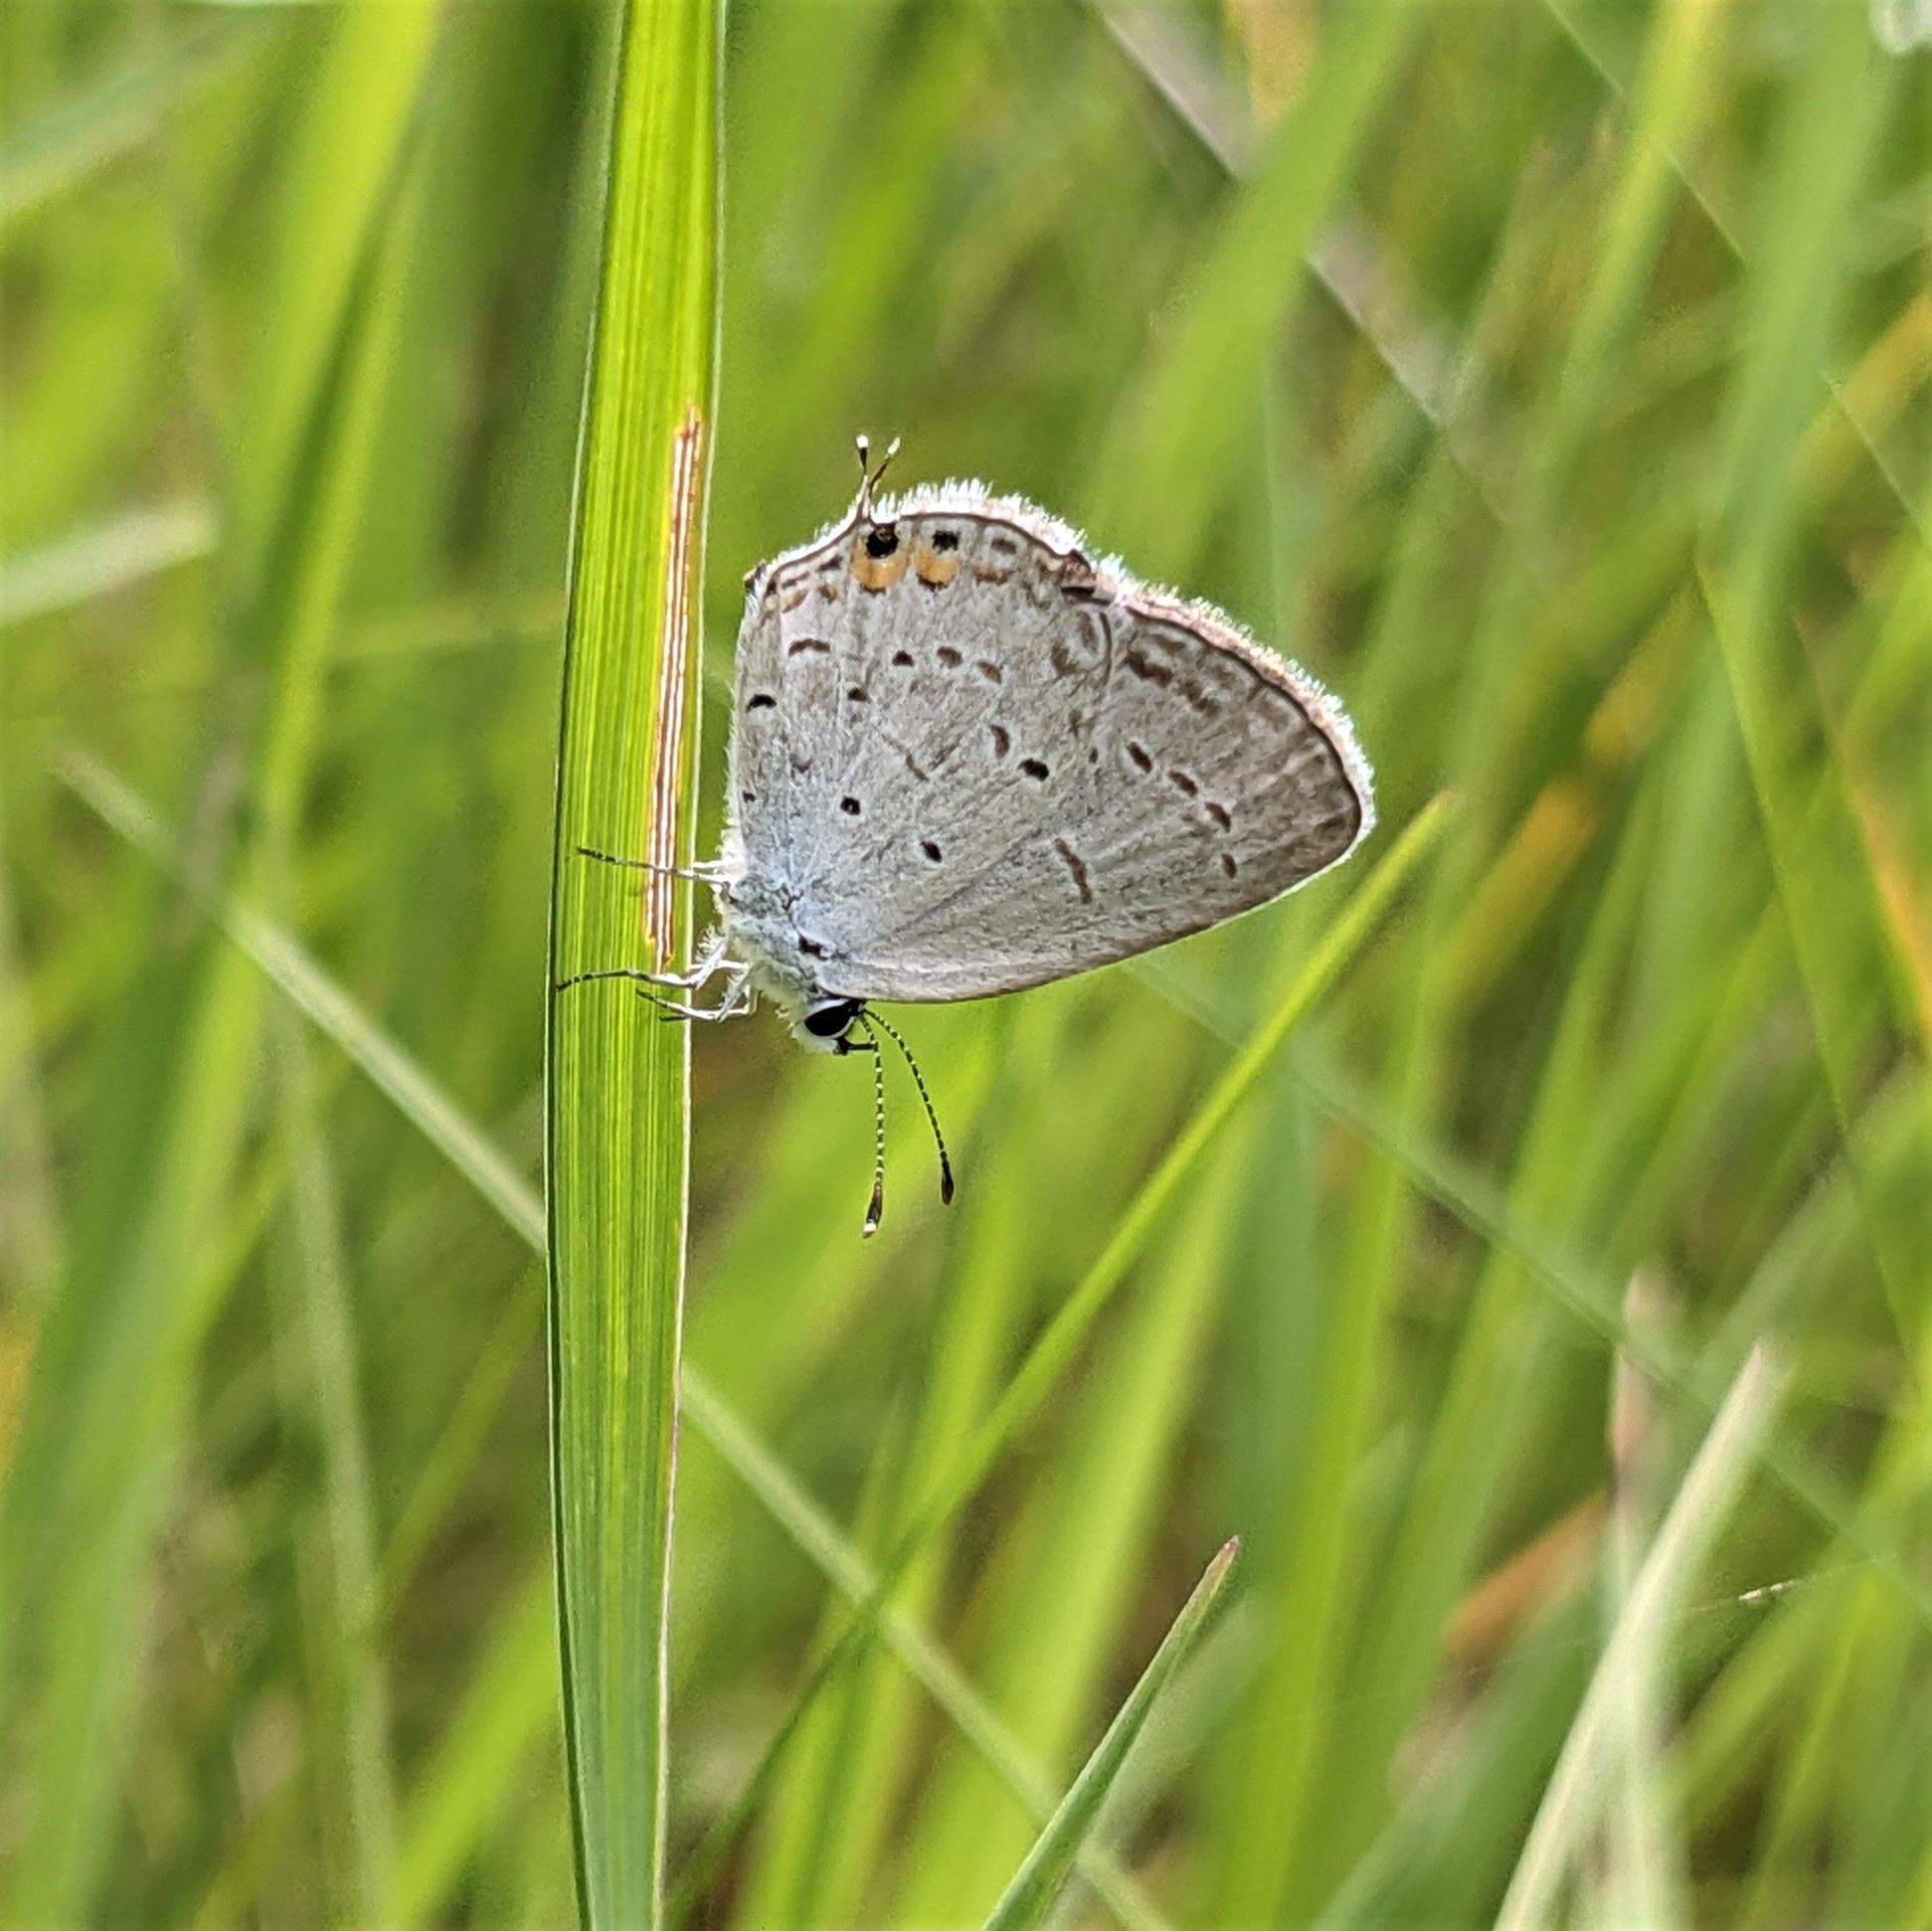
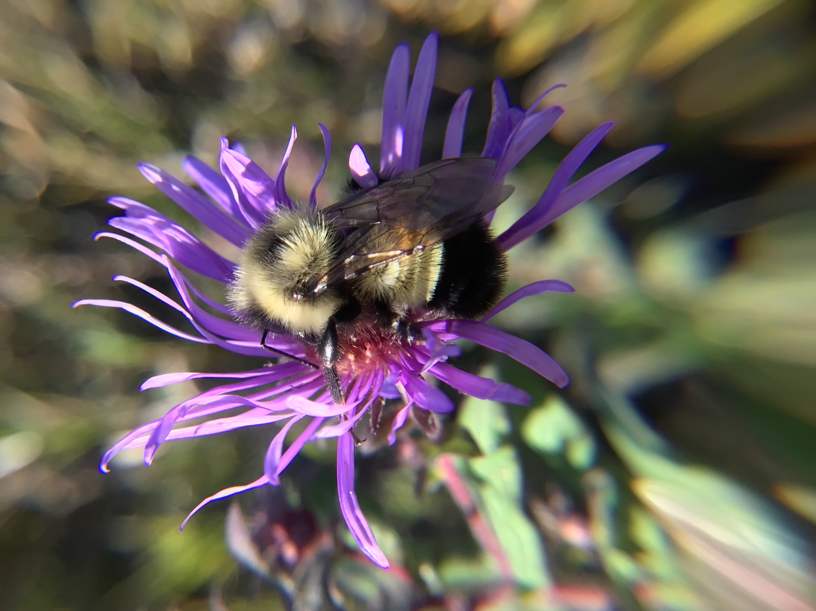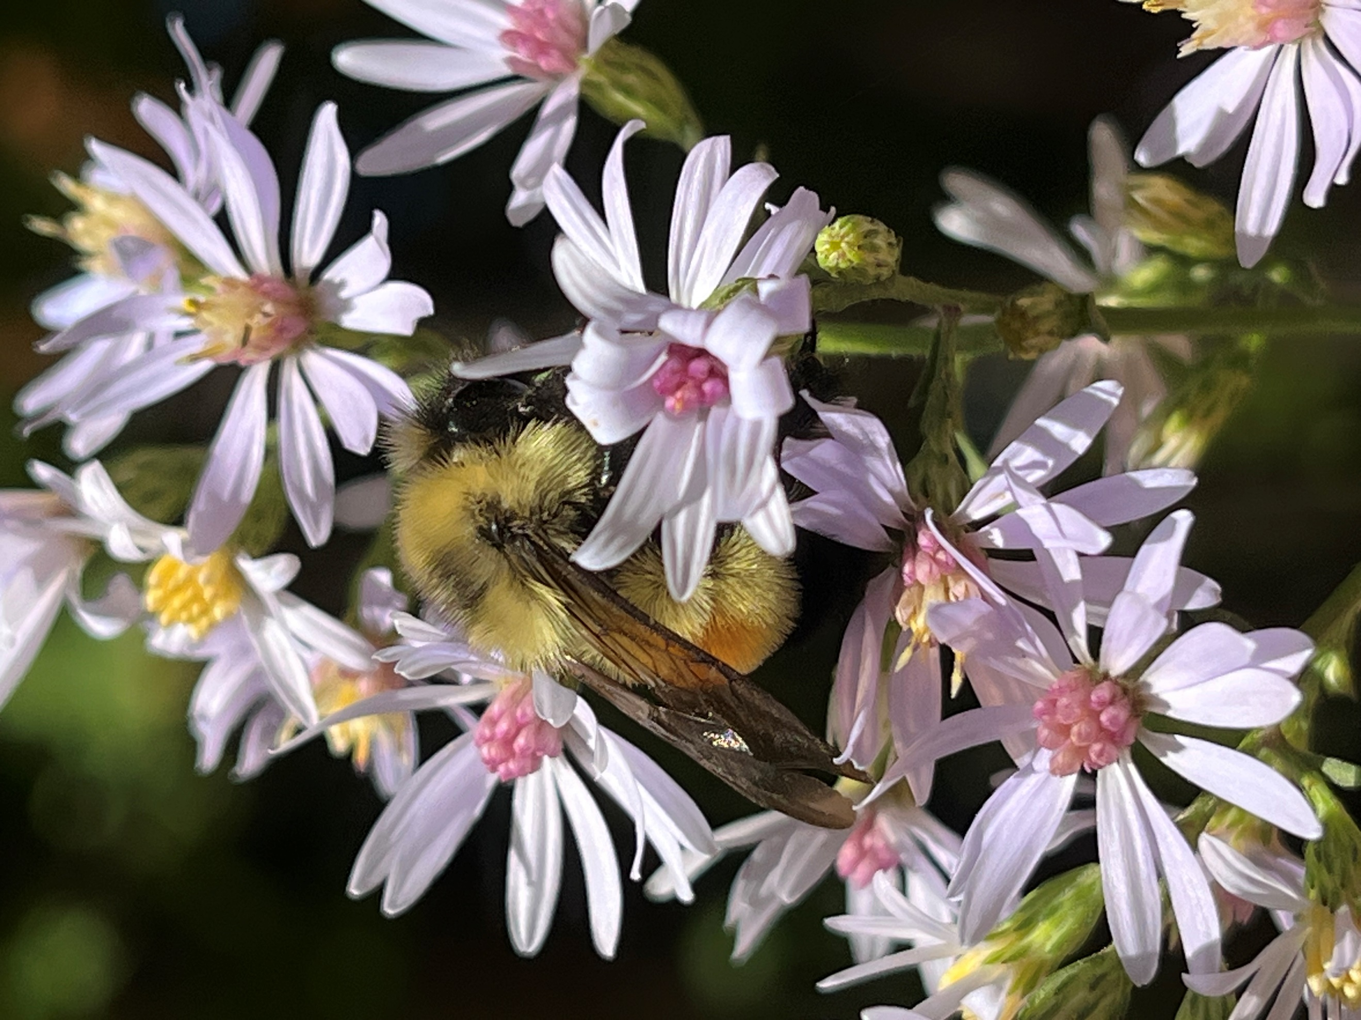

Post 2: Rain gardens
Facebook: Rain gardens help protect lakes and rivers by slowing the flow of water and allowing it to infiltrate into the ground rather than running off into storm drains that flow directly into lakes and streams. The native plants used in rain gardens also provide habitat for birds and butterflies. For more information on rain gardens and other actions you can take to protect water quality, visit hennepin.us/protect-natural-resources.
Twitter/X: Rain gardens help protect lakes and rivers by slowing the flow of water and allowing it to infiltrate into the ground. Learn about rain gardens and other actions you can take to protect water quality at hennepin.us/protect-natural-resources #NativePlants #SustainableLandscaping
Instagram: Rain gardens help protect lakes and rivers by slowing the flow of water and allowing it to infiltrate into the ground rather than running off into storm drains that flow directly into lakes and streams. The native plants used in rain gardens also provide habitat for birds and butterflies. Learn more about rain gardens and other actions you can take to protect water quality at the link in our bio. #NativePlants #SustainableLandscaping
Image:
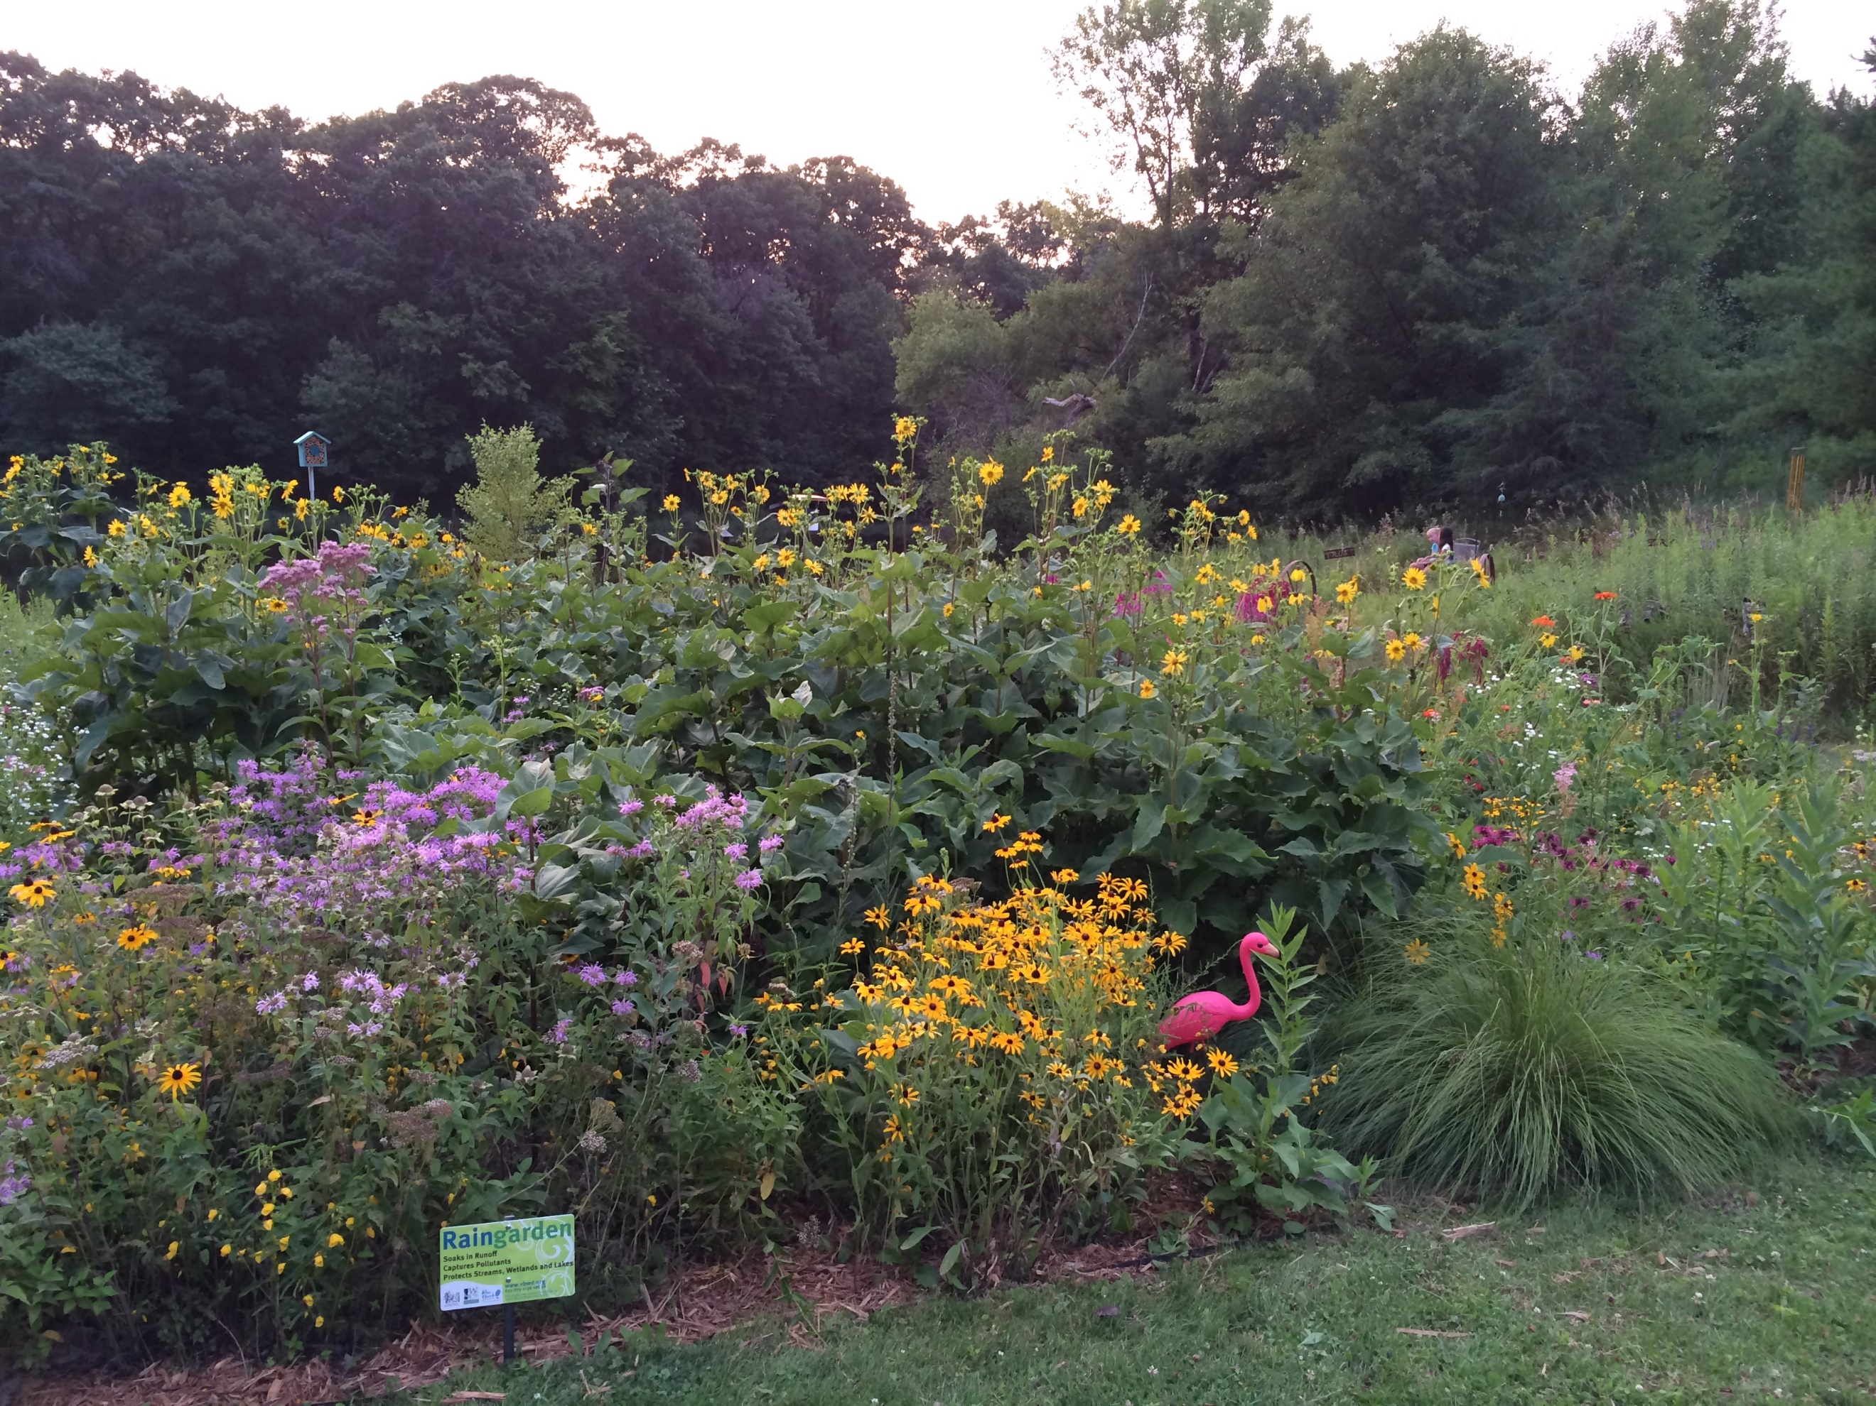

Post 3: Blue Thumb
Facebook: Native plants in yards have many benefits like supporting pollinators and native ecosystems, being resilient during flooding and drought, enhancing soil health, providing food for wildlife, and stabilizing land to reduce erosion, just to name a few! While planning native gardens may sound daunting at first, there are a lot of resources to help you along the way. Learn more at bluethumb.org.
Twitter/X: Native plants in yards have many benefits like supporting pollinators and native ecosystems, being resilient during flooding and drought, enhancing soil health, and providing food for wildlife. Learn more at bluethumb.org. #CleanWater #PollinatorFriendly #NativePlants
Instagram: Native plants in yards have many benefits like supporting pollinators and native ecosystems, being resilient during flooding and drought, enhancing soil health, providing food for wildlife, and stabilizing land to reduce erosion, just to name a few! While planning native gardens may sound daunting at first, there are a lot of resources to help you along the way. Learn more at bluethumb.org. #CleanWater #PollinatorFriendly #NativePlants
Image:
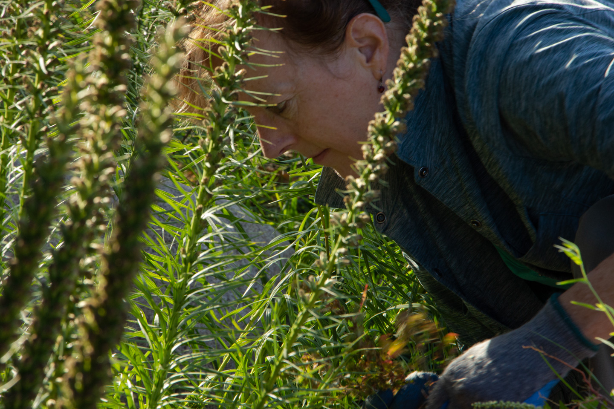

Post 4: Plant sales
Facebook: Are you looking to buy native plants this spring? Check out Blue Thumb’s resource for upcoming sales and links to native plant nurseries. bluethumb.org/spring-native-plant-sales-in-minnesota
Twitter/X: Are you looking to buy native plants this spring? Check out Blue Thumb’s resource for upcoming sales and links to native plant nurseries. bluethumb.org/spring-native-plant-sales-in-minnesota #CleanWater #PollinatorFriendly #NativePlants
Instagram: Are you looking to buy native plants this spring? Check out Blue Thumb’s resource for upcoming sales and links to native plant nurseries at the link in our bio. #CleanWater #PollinatorFriendly #NativePlants
Image:

Post 5: Lawns to Legumes
Facebook: Are you interested in protecting pollinators like the rusty patched bumble bee and the monarch butterfly? Lawns to Legumes offers cost-share grants of up to $400 to help cover the costs of planting pollinator-friendly yards. Learn more and apply at bluethumb.org/lawns-to-legumes
Twitter/X: Are you interested in protecting pollinators like the rusty patched bumble bee and the monarch butterfly? Lawns to Legumes offers grants of up to $400 to help plant pollinator-friendly yards. Apply at bluethumb.org/lawns-to-legumes #CleanWater #PollinatorFriendly #NativePlants
Instagram: Are you interested in protecting pollinators like the rusty patched bumble bee and the monarch butterfly? Lawns to Legumes offers cost-share grants of up to $400 to help cover the costs of planting pollinator-friendly yards. Learn more and apply at the link in our bio. #CleanWater #PollinatorFriendly #NativePlants
Images:
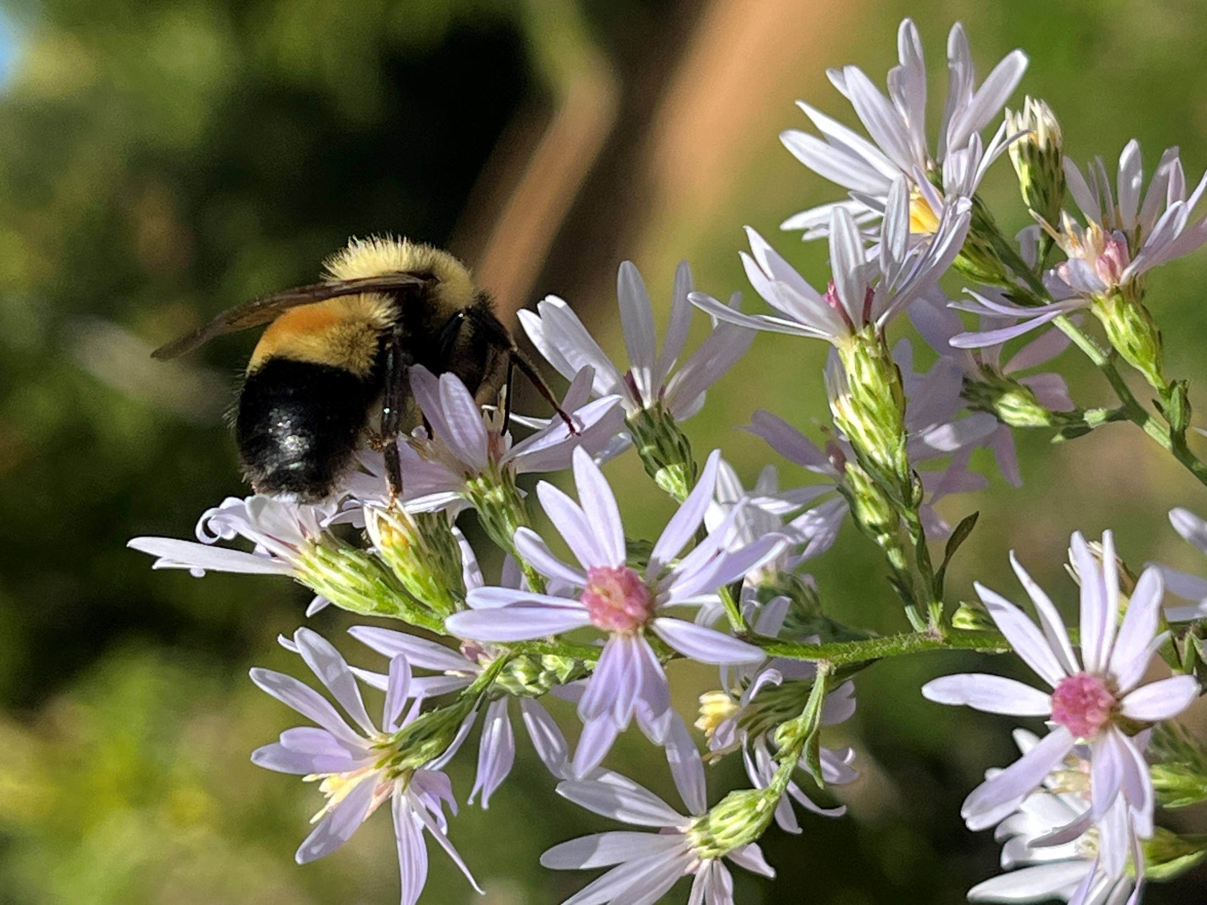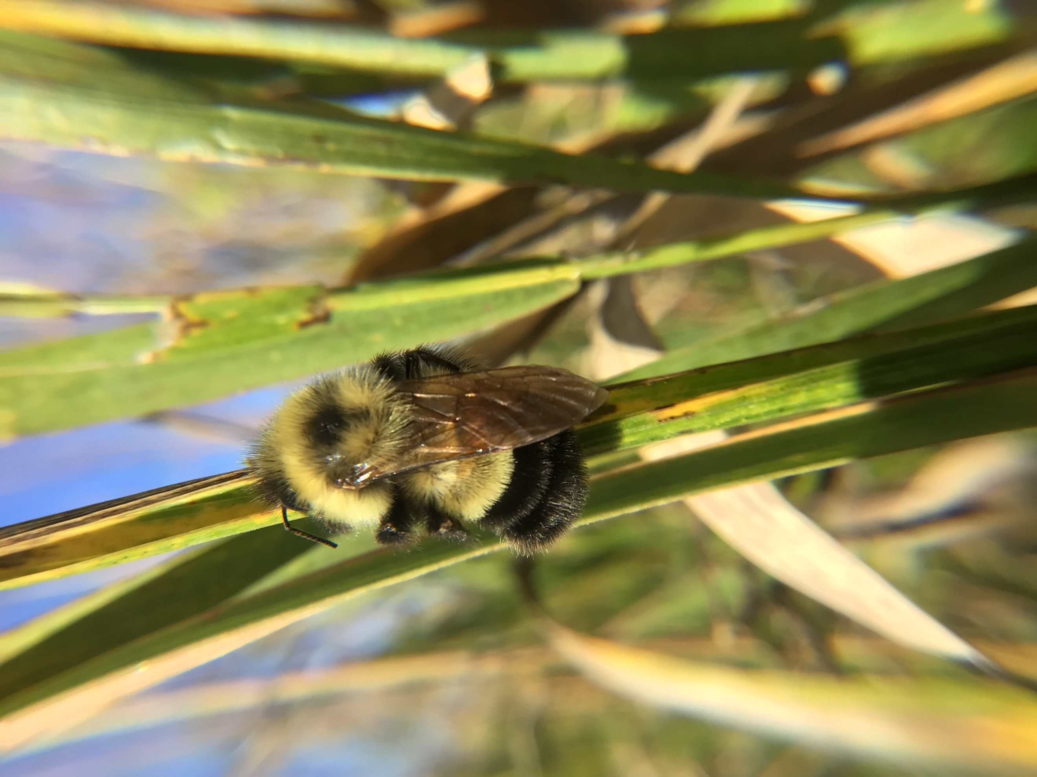

Post 6: Plant Finder
Facebook: Choosing the right plants for an outdoor space that have environmental benefits can be confusing, but using the online resource, Plant Finder, from Blue Thumb makes it easier by allowing you to search for plants based on color, bloom months, light, soil moisture requirements, and more!
Twitter/X: Use Blue Thumb’s online Plant Finder to help choose the right plants for your yard or garden. Search for plants based on color, bloom months, light, soil moisture requirements, and more! bluethumb.org/plants #PollinatorFriendly #NativePlants
Instagram: Choosing the right plants for an outdoor space that have environmental benefits can be confusing, but using Blue Thumb’s online Plant Finder makes it easier by allowing you to search for plants based on color, bloom months, light, soil moisture requirements, and more! Access the Plant Finder at the link in our bio. #PollinatorFriendly #NativePlants
Image:

