Recycle smart: know what goes in your recycling cart media kit

About recycle smart

With shifting markets and policy changes, many people have wondered what happens to their recycling and what they can do to best support recycling. The best thing you can do to support recycling is to avoid “wish-cycling” and recycle the right things.

Resources to promote recycling the right things
Ways to educate the public about recycling:
- Use the sample newsletter article to share on your organization’s website or in your newsletters. These are editable so you can customize the length or message.
- Use the sample social media posts to share through your social media channels. These are editable so you can customize the message and website.
- Share the recycling guide (PDF). Printed copies can be ordered from https://environmentalresources.hennepin.us/items
- Encourage residents to order resources to improve recycling at home https://environmentalresources.hennepin.us/residents
- Follow and reshare messages posted on the Hennepin County Environment and Energy social media channels: Hennepin Environment on Facebook, Hennepin Environment on Instagram, and @hennepinenviro on Twitter
- Share the information and resources available at www.hennepin.us/recycling

Contact
For more information about this topic, contact:
- Kaitlin Steinberg, residential recycling coordinator, kaitlin.steinberg@hennepin.us
- Alisa Reckinger, communications and outreach specialist, alisa.reckinger@hennein.us

Sample newsletter article – short

Recycle smart: know what goes in your recycling cart
At some point, we’ve all probably put something in our recycling cart that we weren’t sure was actually recyclable. This is sometimes called “wish-cycling.”
Although you may want to recycle everything, the best thing you can do to support recycling is to only recycle the items accepted in your program. These items can be sorted properly at recycling facilities and made into new products.

Know what goes in your recycling cart
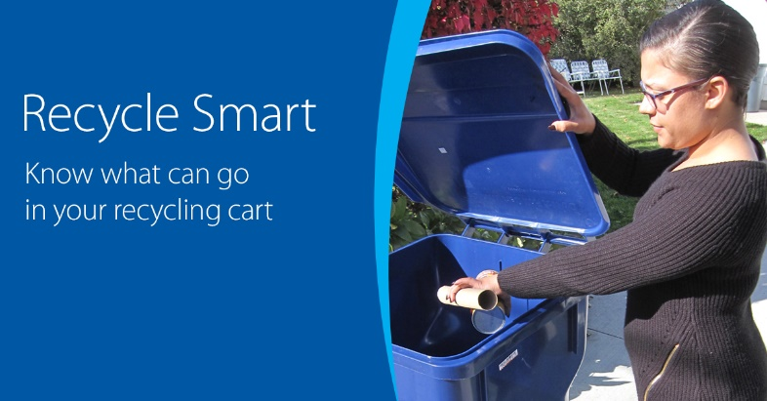
Start with the basics of what can be recycled. This includes:
- Paper: mail, office papers, magazine, newspapers
- Boxes: cardboard boxes, cereal and cracker boxes, shoe boxes, toiletry boxes
- Cartons: milk cartons, juice boxes, broth cartons
- Glass: food and beverage bottles and jars
- Plastic bottles and jugs: soda bottles, milk jugs, shampoo bottles
- Plastic cups and containers: yogurt cups, clear cups, cottage cheese containers, produce containers
- Metal: food and beverage cans

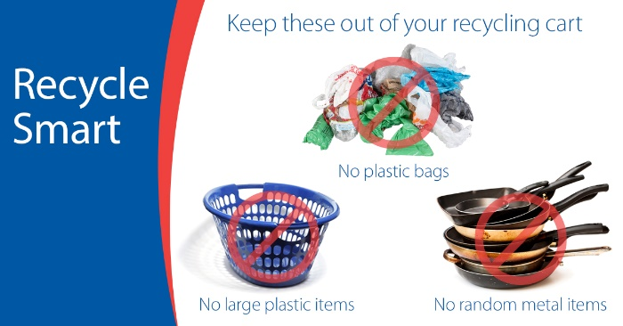
Keep these items out of your recycling cart
The following items can damage equipment at recycling facilities, harm employees at recycling facilities, or do not have strong markets to be turned into new products.
You can still recycle some of these items at drop-off locations. And for all of these items, think about ways you could avoid them – purchase high-quality items, buy used items, and find durable, reusable, or compostable alternatives.
Items that are important to leave out of your recycling cart include:
- Plastic bags
- Large plastic items
- Random metal items
- Single-use plastic utensils and straws
- Paper plates, cups, and takeout containers
- Propane tanks
- Cords and string lights
- Electronics and batteries
- Needles and sharps
Visit hennepin.us/recycling for the recycling guide of items that are accepted throughout Hennepin County and more information on the most important items to keep out of your recycling cart.

Sample newsletter article – long

Recycle smart: know what goes in your recycling cart
At some point, we’ve all probably put something in our recycling cart that we weren’t sure was actually recyclable. This is sometimes called “wish-cycling.”
Although you may want to recycle everything, the best thing you can do to support recycling is to only recycle the items accepted in your program. These items can be sorted properly at recycling facilities and made into new products.

Know what goes in your recycling cart
Start with the basics of what can be recycled. This includes:
- Paper: mail, office papers, magazine, newspapers
- Boxes: cardboard boxes, cereal and cracker boxes, shoe boxes, toiletry boxes
- Cartons: milk cartons, juice boxes, broth cartons
- Glass: food and beverage bottles and jars
- Plastic bottles and jugs: soda bottles, milk jugs, shampoo bottles
- Plastic cups and containers: yogurt cups, clear cups, cottage cheese containers, produce containers
- Metal: food and beverage cans

Keep these items out of your recycling cart
These items can damage equipment at recycling facilities, harm employees at recycling facilities, or do not have strong markets to be turned into new products.
You can still recycle some of these items at drop-off locations. And for all of these items, think about ways you could avoid them – purchase high-quality items, buy used items, and find durable, reusable, or compostable alternatives.
- Plastic bags and film: These items get tangled in the equipment at recycling sorting facilities and interfere with the recycling process. Bring to a retail drop-off to be recycled.
- Large plastic items: Plastic lawn furniture, laundry baskets, storage tubs, and plastic toys are difficult to sort at recycling facilities and there aren’t good markets for recycling them.
- Random metal items: Pots, pans, pipes, hangers, tools, and other random metal items can damage equipment and harm workers at recycling sorting facilities. All metal can be recycled, just not in your recycling cart at home – bring these items to a scrap metal recycler.
- Batteries: These are too small to be sorted at recycling facilities, and certain batteries can cause fires. Batteries should be recycled at places like the county drop-off facilities.
- Bags of recyclables: Don’t put your recycling in bags in your recycling cart. Recyclers can’t tell what’s in the bag, so your items might not get recycled. Place recycling loose in your cart.
- Paper cups and plates and plastic utensils and straws: These items are often contaminated with food, are difficult to sort at recycling facilities, and don’t have good recycling markets. Avoid them by using reusable options.
Visit hennepin.us/recycling for the recycling guide of items that are accepted throughout Hennepin County and more information on the most important items to keep out of your recycling cart.

Social media posts
Suggested hashtags: #recyclesmart #recycling #hennepinrecycles #hennepinzerowaste
To use images and graphics: right click on image and select save picture as

Recycle Smart – Keep these items out of your recycling cart
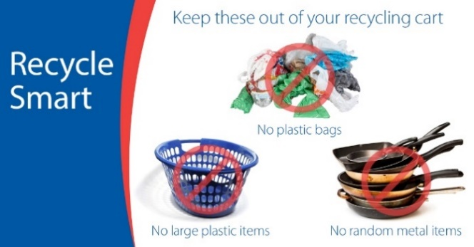
Facebook: The best thing you can do to support recycling is to recycle the right stuff:
- Know what’s ok to put in your recycling cart.
- Keep out stuff that’s not accepted or that you’re not sure about.
Learn more at www.hennepin.us/recycling #recyclesmart
Twitter: The best thing you can do to support recycling is to recycle the right stuff. Learn more at www.hennepin.us/recycling #recyclesmart

Recycle Smart – Keep plastic bags out of your recycling cart
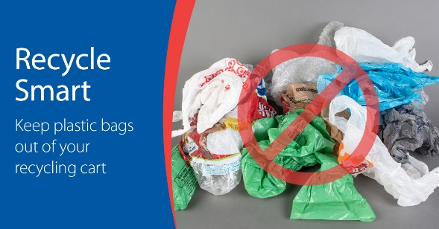
Facebook: Plastic bags and wrap get tangled in the equipment at recycling sorting facilities. Bring plastic bags to a retail drop-off to be recycled or avoid plastic bags altogether by choosing reusable bags. Find options at www.hennepin.us/green-disposal-guide/items/plastic-bags-wrap
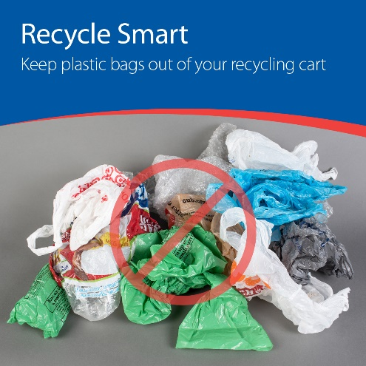
Instagram: Plastic bags and wrap get tangled in the equipment at recycling sorting facilities. Bring plastic bags to a retail drop-off to be recycled or avoid plastic bags altogether by choosing reusable bags. #recyclesmart #recycling
Twitter: Plastic bags and wrap don’t belong in your recycling cart! Find drop-off recycling options at www.hennepin.us/green-disposal-guide/items/plastic-bags-wrap #recyclesmart

Recycle Smart – Don’t put your recycling in bags in your recycling cart
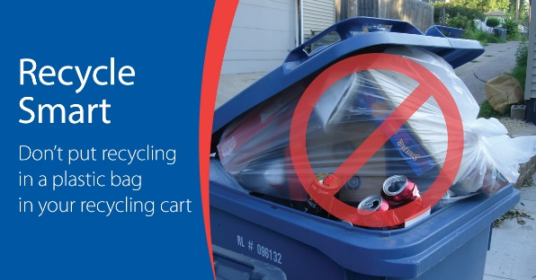
Facebook: Don't put your recycling in bags in your recycling cart. Recyclers can't tell what's in the bag, so your items might not get recycled. Place recycling loose in your cart. Use an unlined bin or reusable bag to collect recycling in your home. Learn more at www.hennepin.us/recycling
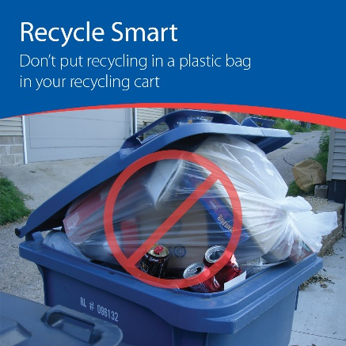
Instagram: Don't put your recycling in bags in your recycling cart. Recyclers can't tell what's in the bag, so your items might not get recycled. Place recycling loose in your cart. Use an unlined bin or reusable bag to collect recycling in your home. #recyclesmart #recycling
Twitter: Don't put your recycling in bags in your recycling cart. Recyclers can't tell what's in the bag, so your items might not get recycled. Learn more at www.hennepin/recycling #recyclesmart

Recycle Smart – Keep random metal items out of your recycling cart
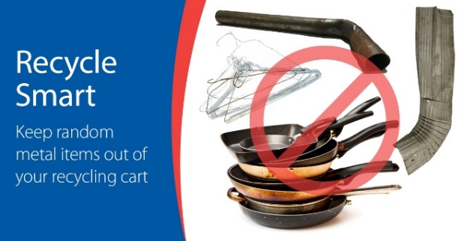
Facebook: Pots, pans, pipes, hangers, tools, and other random metal items can damage equipment and harm workers at recycling sorting facilities. All metal can be recycled, just not in your recycling cart at home – bring these items to a scrap metal recycler. Find options at https://www.hennepin.us/green-disposal-guide/items/scrap-metal
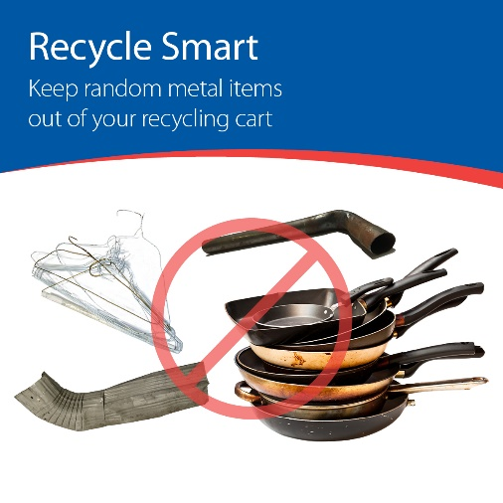
Instagram: Pots, pans, pipes, hangers, tools, and other random metal items can damage equipment and harm workers at recycling sorting facilities. All metal can be recycled, just not in your recycling cart at home – bring these items to a scrap metal recycler. #recyclesmart #recycling
Twitter: Pots, pans, pipes, hangers, tools, and other random metal items can damage equipment and harm workers at recycling sorting facilities. All metal can be recycled, just not in your recycling cart at home. Find options at https://www.hennepin.us/green-disposal-guide/items/scrap-metal #recyclesmart

Recycle Smart – Keep large plastic items out of your recycling cart (laundry baskets, buckets, tubs)
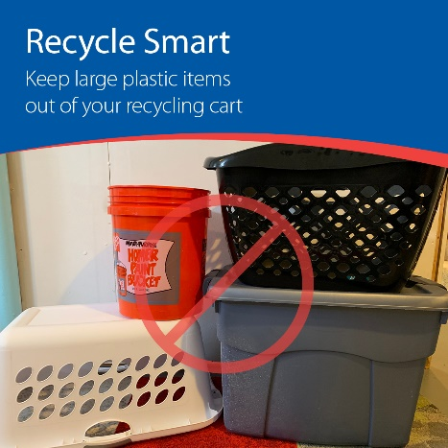
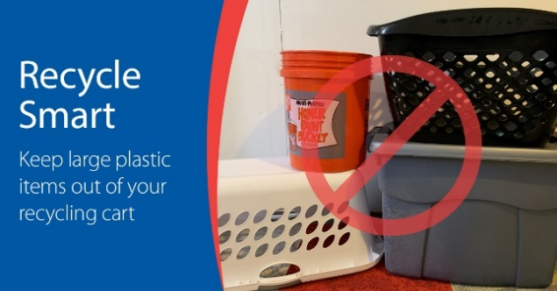
Facebook: Plastic laundry baskets, buckets, storage tubs and other large plastic items are difficult to sort at recycling facilities, and there aren’t good markets for recycling them. Purchase high-quality items, use them for as long as possible, and look for donation opportunities if they're still in good shape when you're ready to get rid of them. Learn more at www.hennepin.us/recycling
Instagram: Plastic laundry baskets, buckets, storage tubs and other large plastic items are difficult to sort at recycling facilities, and there aren’t good markets for recycling them. Purchase high-quality items, use them for as long as possible, and look for donation opportunities if they're still in good shape when you're ready to get rid of them. #recyclesmart #recycling
Twitter: Large plastic items are difficult to sort at recycling facilities and don’t have good recycling markets. Keep them out of your recycling cart. Learn more at www.hennepin.us/recycling #recyclesmart

Recycle Smart – Keep large plastic items out of your recycling cart (lawn furniture and toys)
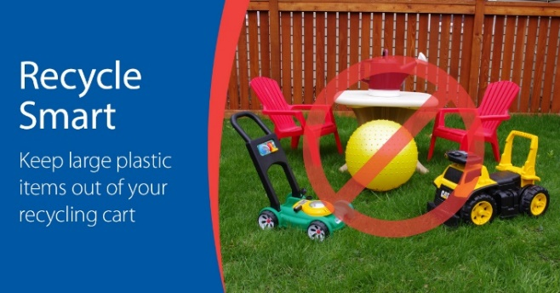
Facebook: Plastic lawn furniture, toys, and other large plastic items are difficult to sort at recycling facilities, and there aren’t good markets for recycling them. Purchase high-quality items, use them for as long as possible, and look for donation opportunities if they're still in good shape when you're ready to get rid of them. Learn more at www.hennepin.us/recycling
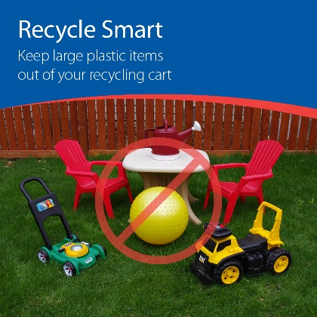
Instagram: Plastic lawn furniture, toys, and other large plastic items are difficult to sort at recycling facilities, and there aren’t good markets for recycling them. Purchase high-quality items, use them for as long as possible, and look for donation opportunities if they're still in good shape when you're ready to get rid of them. #recyclesmart #recycling #donate
Twitter: Large plastic items are difficult to sort at recycling facilities and don’t have good recycling markets. Keep them out of your recycling cart. Learn more at www.hennepin.us/recycling #recyclesmart

Recycle Smart – Keep batteries out of your recycling cart
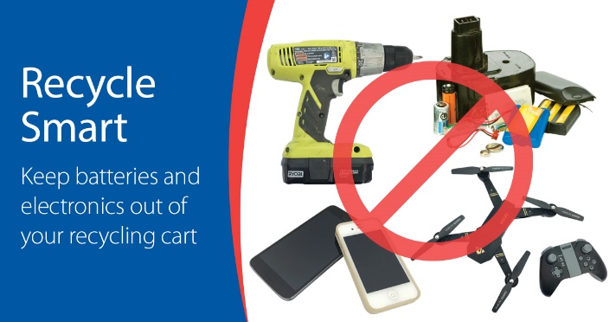
Facebook: Batteries are too small to be sorted at recycling facilities, and certain batteries can cause fires. Batteries should be recycled at places like the Hennepin County Drop-off Facilities. Remove and recycle the batteries from electronics and toys or bring in the entire device if you cannot remove the batteries. Find options at www.hennepin.us/batteryrecycling
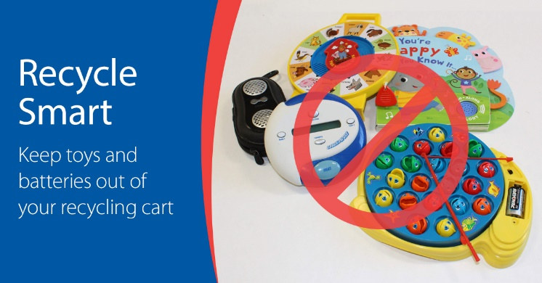
Optional additional message: Single-use alkaline batteries such as AA, AAA, C, D etc. can be put in the trash. To make it simple, we accept all types of household batteries at Hennepin County drop-off facilities.
Instagram: Batteries are too small to be sorted at recycling facilities, and certain batteries can cause fires. Batteries should be recycled at places like the Hennepin County Drop-off Facilities. Remove and recycle the batteries from electronics and toys or bring in the entire device if you cannot remove the batteries. #recyclesmart #recycling
Twitter: Batteries are too small to be sorted at recycling facilities, and certain batteries can cause fires. Batteries and electronics that contain batteries should be recycled at places like the county drop-off facilities. Find options at www.hennepin.us/batteryrecycling #recyclesmart
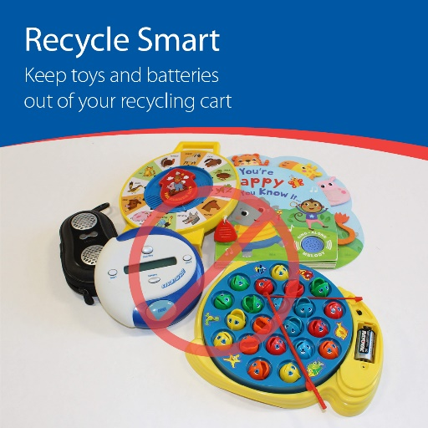
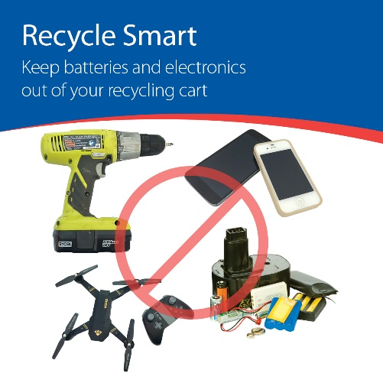

Recycle Smart – Keep paper cups and plates and plastic utensils and straws out of your recycling cart
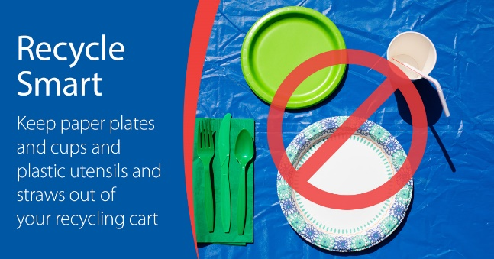
Facebook: Paper cups and plates and plastic utensils and straws are often contaminated with food, are difficult to sort at recycling facilities, and don’t have good recycling markets. Avoid them by using reusable options.
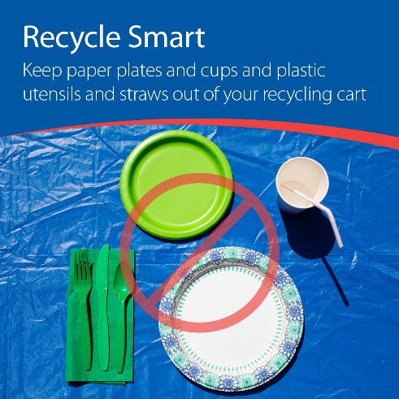
Instagram: Paper cups and plates and plastic utensils and straws are often contaminated with food, are difficult to sort at recycling facilities, and don’t have good recycling markets. Avoid them by using reusable options. #recyclesmart #choosetoreuse
Twitter: Paper cups and plates and plastic utensils and straws are often contaminated with food, are difficult to sort at recycling facilities, and don’t have good recycling markets. Avoid them by using reusable options. #recyclesmart #choosetoreuse

Recycle Smart – Keep single-use plastic utensils and straws out of your recycling cart
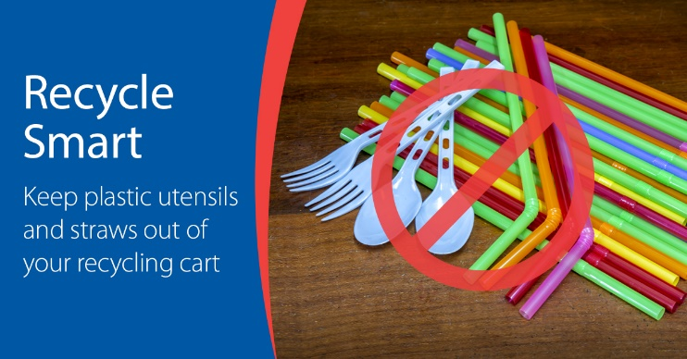
Facebook: Plastic utensils and straws are too small and difficult to sort at recycling facilities, and there aren’t good recycling markets for them. Avoid them by choosing reusable options or refusing them when you can.
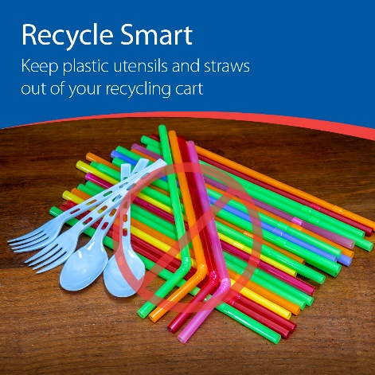
Instagram: Paper cups and plates and plastic utensils and straws are often contaminated with food, are difficult to sort at recycling facilities, and don’t have good recycling markets. Avoid them by using reusable options. #recyclesmart #choosetoreuse
Twitter: Paper cups and plates and plastic utensils and straws are often contaminated with food, are difficult to sort at recycling facilities, and don’t have good recycling markets. Avoid them by using reusable options. #recyclesmart #choosetoreuse

Recycle Smart – Keep paper plates and cups out of your recycling cart
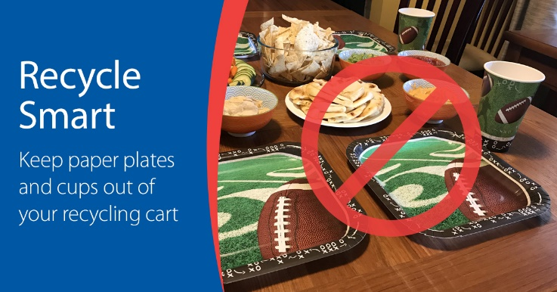
Facebook: Paper cups and plates can’t be recycled because they are often lined with plastic or contaminated with food. Avoid them by choosing reusable cups, mugs and plates.
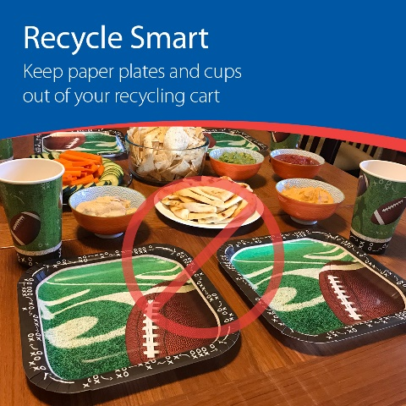
Instagram: Paper cups and plates can’t be recycled because they are often lined with plastic or contaminated with food. Avoid them by choosing reusable cups, mugs and plates. #recyclesmart #choosetoreuse
Twitter: Paper cups and plates can’t be recycled because they are often lined with plastic or contaminated with food. Avoid them by choosing reusable cups, mugs and plates. #recyclesmart #choosetoreuse

Recycle Smart – Keep paper takeout containers out of your recycling cart
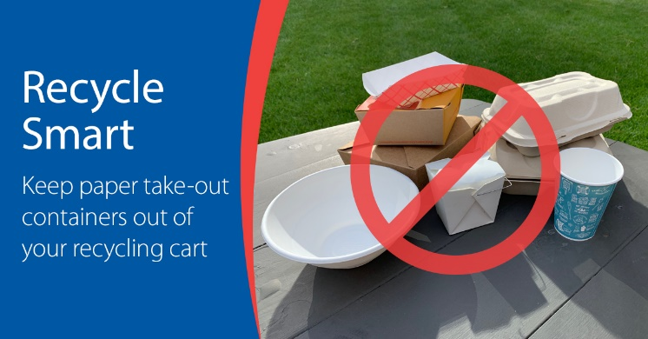
Facebook: Paper takeout containers can’t be recycled because they are often contaminated with food and many are lined with plastic. Check to see if they are BPI-certified compostable and accepted in the organics recycling. Avoid them by bring reusable cups and containers, opting to dine in, or choosing businesses that offer reusable takeout containers.
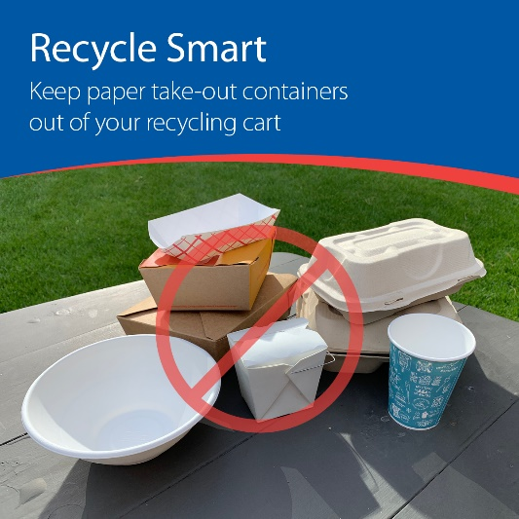
Instagram: Paper takeout containers can’t be recycled because they are often contaminated with food and some are lined with plastic. Check to see if they are BPI-certified compostable and accepted in the organics recycling. Avoid them by bring reusable cups and containers, opting to dine in, or choosing businesses that offer reusable takeout containers. #recyclesmart #choosetoreuse
Twitter: Paper takeout containers can’t be recycled because they are often contaminated with food and some are lined with plastic. Avoid them by bring reusable cups and containers, opting to dine in, or choosing businesses that offer reusable takeout containers. #recyclesmart

Recycle Smart – Keep cords, hoses, and string lights out of your recycling cart
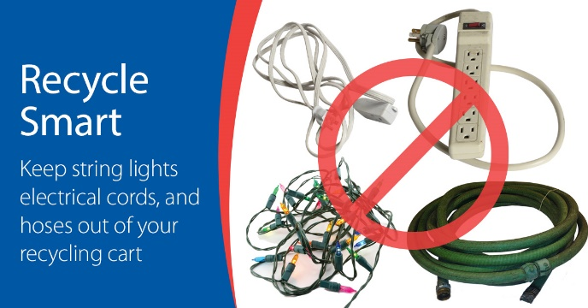
Facebook: Keep “tanglers” like cords, hoses and string lights out of your recycling bin. As the name suggests, these items get tangled in the equipment at recycling facilities. You can recycle cords and string lights at Hennepin County drop-off facilities. Old hoses can go in the trash. Learn more on the Green Disposal Guide www.hennepin.us/green-disposal-guide.
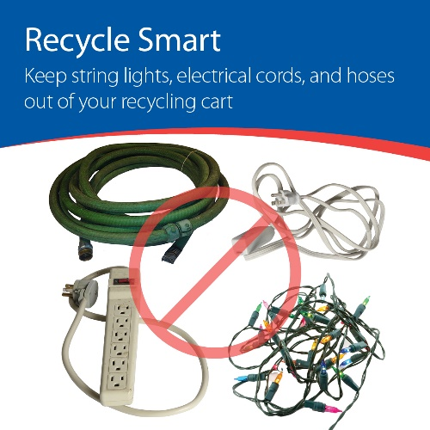
Instagram: Keep “tanglers” like cords, hoses and string lights out of your recycling bin. As the name suggests, these items get tangled in the equipment at recycling facilities. You can recycle cords and string lights at Hennepin County drop-off facilities. Old hoses can go in the trash. #recyclesmart #recycling
Twitter: Keep “tanglers” like cords, hoses and string lights out of your recycling bin - these items get tangled in the equipment at recycling facilities. Recycle cords and string lights at Hennepin County drop-off facilities. Put old hoses in the trash. Learn more www.hennepin.us/green-disposal-guide

Recycle Smart – Keep cylinders and tanks out of your recycling cart
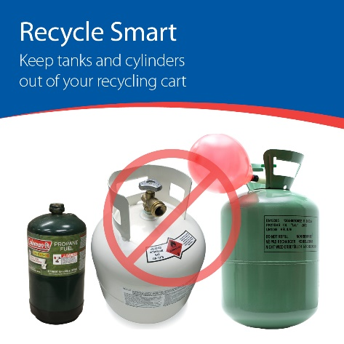
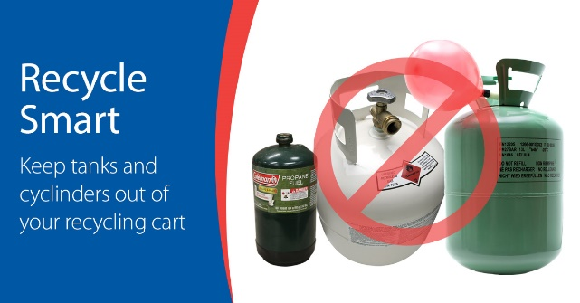
Facebook: Tanks and cylinders contain a compressed gas that makes them explosive and potential fire hazards. It is illegal to put propane tanks, helium tanks, and other pressurized cylinders in your household recycling or trash. Properly dispose of all pressurized cylinders; find options on the Green Disposal Guide https://www.hennepin.us/green-disposal-guide/search#term=tanks&page=0
Instagram: Cylinders and tanks contain a compressed gas that makes them explosive and potential fire hazards. It is illegal to put propane tanks, helium tanks, and other pressurized cylinders in your household recycling or trash. Properly dispose of all pressurized cylinders. #recyclesmart
Twitter: Cylinders and tanks contain a compressed gas that makes them explosive and potential fire hazards. It is illegal to put pressurized cylinders and tanks in your household recycling or trash. Properly dispose of all pressurized cylinders; find options https://www.hennepin.us/green-disposal-guide/search#term=tanks&page=0

Recycle Smart – Keep needles and sharps out of your recycling cart
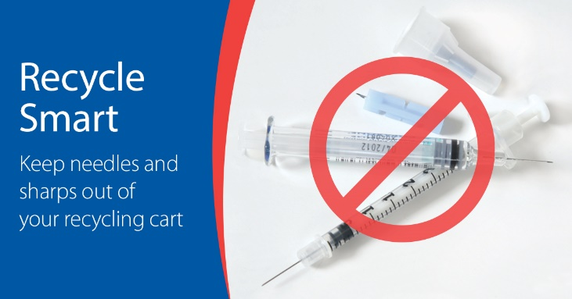
Facebook: Needles and sharps should be managed and disposed of safely to prevent injury and disease transmission from needle-sticks. They should never be placed in your recycling cart. Learn about disposal options on the Green Disposal Guide https://www.hennepin.us/green-disposal-guide/items/needles-sharps
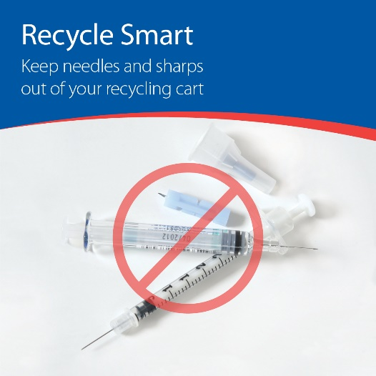
Instagram: Needles and sharps should be managed and disposed of safely to prevent injury and disease transmission from needle-sticks. They should never be placed in your recycling cart. Options include checking with your healthcare provider, destroying at home, using a mail-in program, or bringing to a Hennepin County drop-off facility. #recyclesmart
Twitter: Needles and sharps should be managed and disposed of safely to prevent injury and disease transmission from needle-sticks. They should never be placed in your recycling cart. Learn about disposal options on the Green Disposal Guide www.hennepin.us/green-disposal-guide/items/needles-sharps #recyclesmart

