Media kit resources on safely disposing of medicines

About medicine disposal
Safely dispose of unused medicines at one of the medicine drop boxes in Hennepin County. Drop boxes are operated in partnership with Hennepin County or by independent pharmacies.
- Print a medicine disposal program flyer (PDF)

Properly disposing of unused medicines is important

Prevent abuse or poisoning
Storing unused medicines in the home poses safety and health threats.
- Prescription drug abuse is a growing problem, especially among teens.
- Accidental poisonings from medicines are also on the rise. Learn more on the MN Poison Control System's website.
- If you believe that you or someone you know has been poisoned: call Poison Help at 1-800-222-1222 for further instructions.

Protect the environment
Medicines flushed down the drain or disposed of in the trash can contaminate bodies of water, harm wildlife and end up in drinking water supplies.

What happens to medicines after they are dropped off?
After medicines have been collected, they are transported to an incinerator, where they will be destroyed. Incineration is the preferred method of medicine destruction for environmental safety and abuse prevention.
Hennepin County does not provide service to pick up medicines directly from your home. If someone contacts you offering this service, please call your local law enforcement agency.

Resources to promote medicine disposal
- Use the sample newsletter article to share on your organization’s website or in your newsletters. These are editable so you can customize the length or message.
- Use the sample social media posts to share through your social media channels. These are editable so you can customize the message and website.
- Share the medicine disposal program flyer (PDF). Printed copies can be ordered from https://environmentalresources.hennepin.us/items
- Follow and reshare messages posted on the Hennepin County Environment and Energy social media channels: Hennepin Environment on Facebook, Hennepin Environment on Instagram, and @hennepinenviro on Twitter.
- Share the information and resources available at www.hennepin.us/medicine

Sample newsletter article

Drop boxes available for safe medicine disposal
Unwanted or unused medicines should be brought to a medicine drop box for safe and proper disposal. More than 60 medicine drop boxes are available throughout the county for free, safe, and secure disposal of medicines. Find the medicine drop box closest to you.
Properly disposing of unwanted medicines is important to prevent abuse or poisoning and protect the environment. Misuse of and addiction to prescription drugs is at a crisis level in the United States, and medicines flushed down the drain or disposed of in the trash can contaminate bodies of water, harm wildlife and end up in drinking water supplies.

Safe medicine storage
Approximately 2 million Americans misused prescription pain relievers for the first time during 2016, according to the 2017 National Survey on Drug Use and Health. In the Twin Cities metro area, overdose deaths increased 40% from 2019 to 2020 according to the Minnesota Department of Health. Learn how to safely store medications in your home.

Social media content
Facebook:
Medicines flushed down the drain or disposed of in the trash can contaminate bodies of water, harm wildlife and end up in drinking water supplies. Find a medicine drop box near you to properly dispose of unused or unneeded medicine at www.hennepin.us/medicine.
Properly disposing of unwanted medicines is important to prevent abuse or poisoning and protect the environment. Find a medicine drop box to dispose of unused medicine at www.hennepin.us/medicine.
Misuse of and addiction to prescription drugs is at a crisis level in the United States. It's important to do your part to prevent your medicines from being used improperly. Find a medicine drop box near you at www.hennepin.us/medicine
There are over 60 medicine drop boxes in Hennepin County that are available for free, safe and secure disposal of medicines. Find the closest drop box to your home or work here: www.hennepin.us/medicine
Twitter:
Find a medicine drop box near you to properly dispose of unused or unneeded medicine at www.hennepin.us/medicine. #medicine #medicinedisposal #hennepincounty #mn #minnesota
Storing unused medicines in the home poses safety and health threats. Learn to properly dispose of medicine at www.hennepin.us/medicine #medicine #medicinedisposal #hennepincounty #mn #minnesota
Misuse of and addiction to prescription drugs is at a crisis level in the United States. It's important to do your part to prevent your medicines from being used improperly. Find a medicine drop box near you at www.hennepin.us/medicine #medicine #medicinedisposal #hennepincounty #mn #minnesota
There are over 60 medicine drop boxes in Hennepin County that are available for free, safe and secure disposal of medicines. Find the closest drop box to your home or work here: www.hennepin.us/medicine #medicine #medicinedisposal #hennepincounty #mn #minnesota
Instagram:
Misuse of and addiction to prescription drugs is at a crisis level in the United States. It's important to do your part to prevent your medicines from being used improperly. Find a medicine drop box near you at hennepin.us/medicine #medicine #medicinedisposal #hennepincounty #mn #minnesota
There are over 60 medicine drop boxes in Hennepin County that are available for free, safe and secure disposal of medicines. Find the closest drop box to you at hennepin.us/medicine
#medicine #medicinedisposal #hennepincounty #mn #minnesota

Images

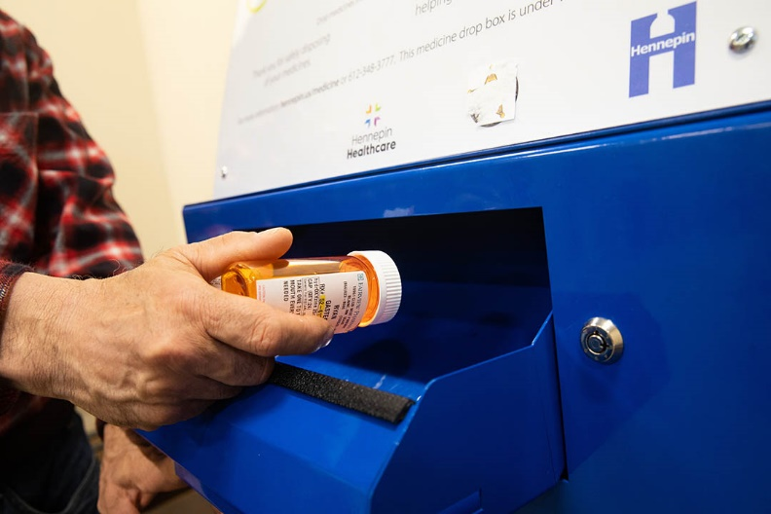
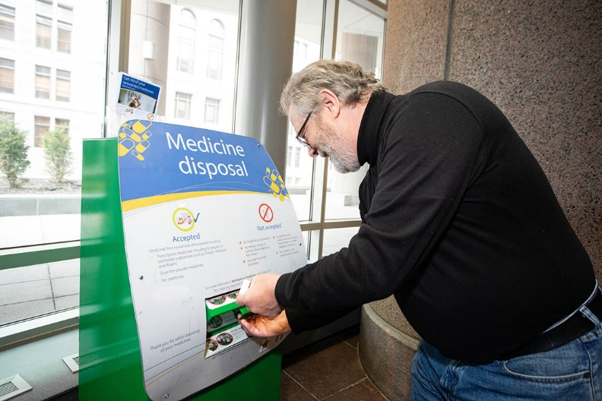
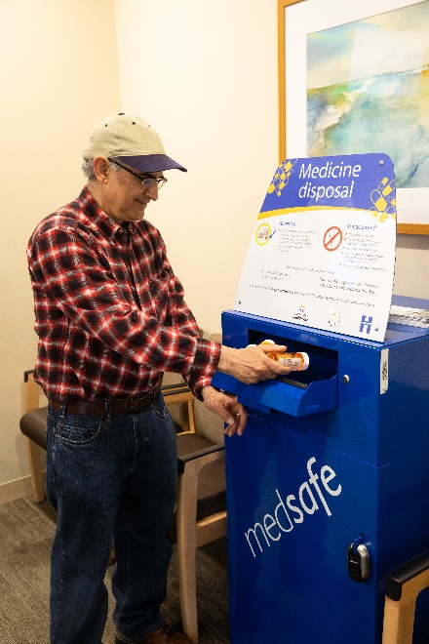

Contact
For more information about medicine disposal contact:
Ryan Gastecki, Medicine disposal program manager, 612.235.0749, ryan.gastecki@hennepin.us
Angie Ziobro, Hennepin County Environment and Energy communications, 612.348.9850, angela.ziobro@hennepin.us

Sample newsletter article

Title

Subhead
Include the article text and embed relevant images and graphics. Add alt text to images and include alt text for images for partners to use.
Use subheads, bullet points, etc. to break up the text. Include links to the program website or other important resources.
Optional: Include both a long and short newsletter article

Social media posts
Suggested hashtags: insert suggested hashtags related to this topic
To use images and graphics: right click on image and select save picture as, alt text for you to use is included with the pictures and graphics

Post 1:
Include post text and suggested image, graphic, link, video, or other media. Add alt text to images and include suggested alt text for partners to use. Alternative option is to include images and graphics separately after the social media posts.
Include separate posts for Facebook/NextDoor, Twitter, and Instagram, or make text short enough for Twitter.

Post 2:

