Eco-friendly holiday disposal media kit

About eco-friendly holiday disposal:

The holidays generate a lot of waste and knowing what is recyclable, compostable, or trash can be challenging! This guide provides resources to help educate people about disposing of holiday items after the season is over.

Resources to promote eco-friendly holiday disposal:
Ways to educate the public about being eco-friendly during the holidays:
- Use the sample newsletter article to share on your organization’s website or in your newsletters. These are editable so you can customize the length or message.
- Use the sample social media posts to share through your social media channels. These are editable so you can customize the message and website.
- Share these resources:
  - Green Disposal Guide (hennepin.us/green-disposal-guide)
  - Hennepin County drop-off facilities (hennepin.us/dropoffs)
  - Yard and tree waste disposal (hennepin.us/yardwaste)
- Follow and reshare messages posted on the Hennepin County Environment and Energy social media channels: Hennepin Environment on Facebook, Hennepin Environment on Instagram, and @hennepinenviro on Twitter

Contact
For more information about eco-friendly holiday disposal, contact:
Environmental Education and Outreach Team, environment@hennepin.us

Sample newsletter article

Holiday disposal guide
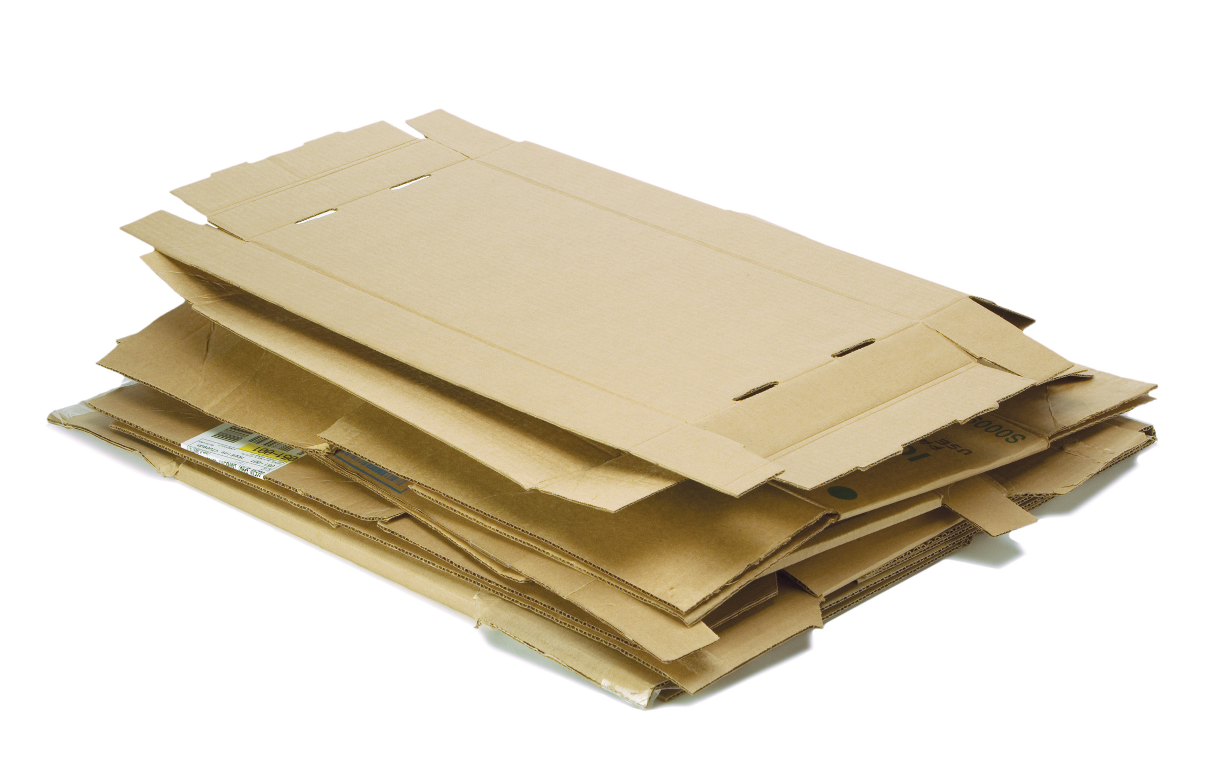
Between packaging from deliveries, decorations, gift wrap, and more, the holiday season is a time when we often have a lot of stuff to get rid of. To make sure you recycle and reuse as much as you can, review the holiday disposal guide tips below for the best way to get rid of common holiday items.

Recycle at home

Boxes
This includes cardboard boxes, boxes from deliveries, shoe boxes, electronics boxes, and gift boxes. Empty and flatten boxes before putting them in the recycling. If you have a lot of boxes, check with your hauler to see if they can be placed alongside your recycling cart. Cardboard is also accepted at Hennepin County drop-off facilities.

Paper
You can recycle packing paper, cards, and envelopes made of plain paper, and newspaper, Kraft paper, or other plain paper used as gift wrap.
Flatten paper before recycling to ensure it gets properly sorted with the paper at the recycling facility.

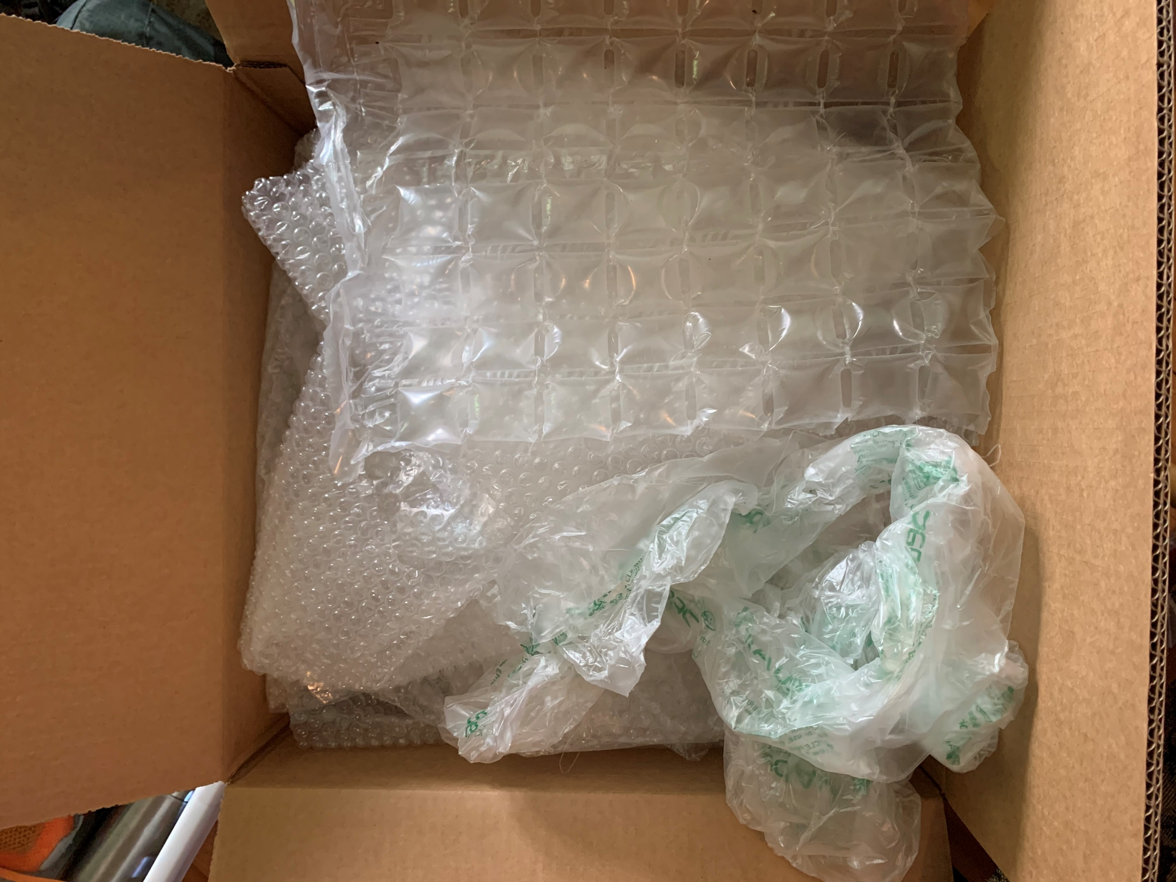
Bring to a drop-off for recycling

Plastic bags, film, and bubble wrap
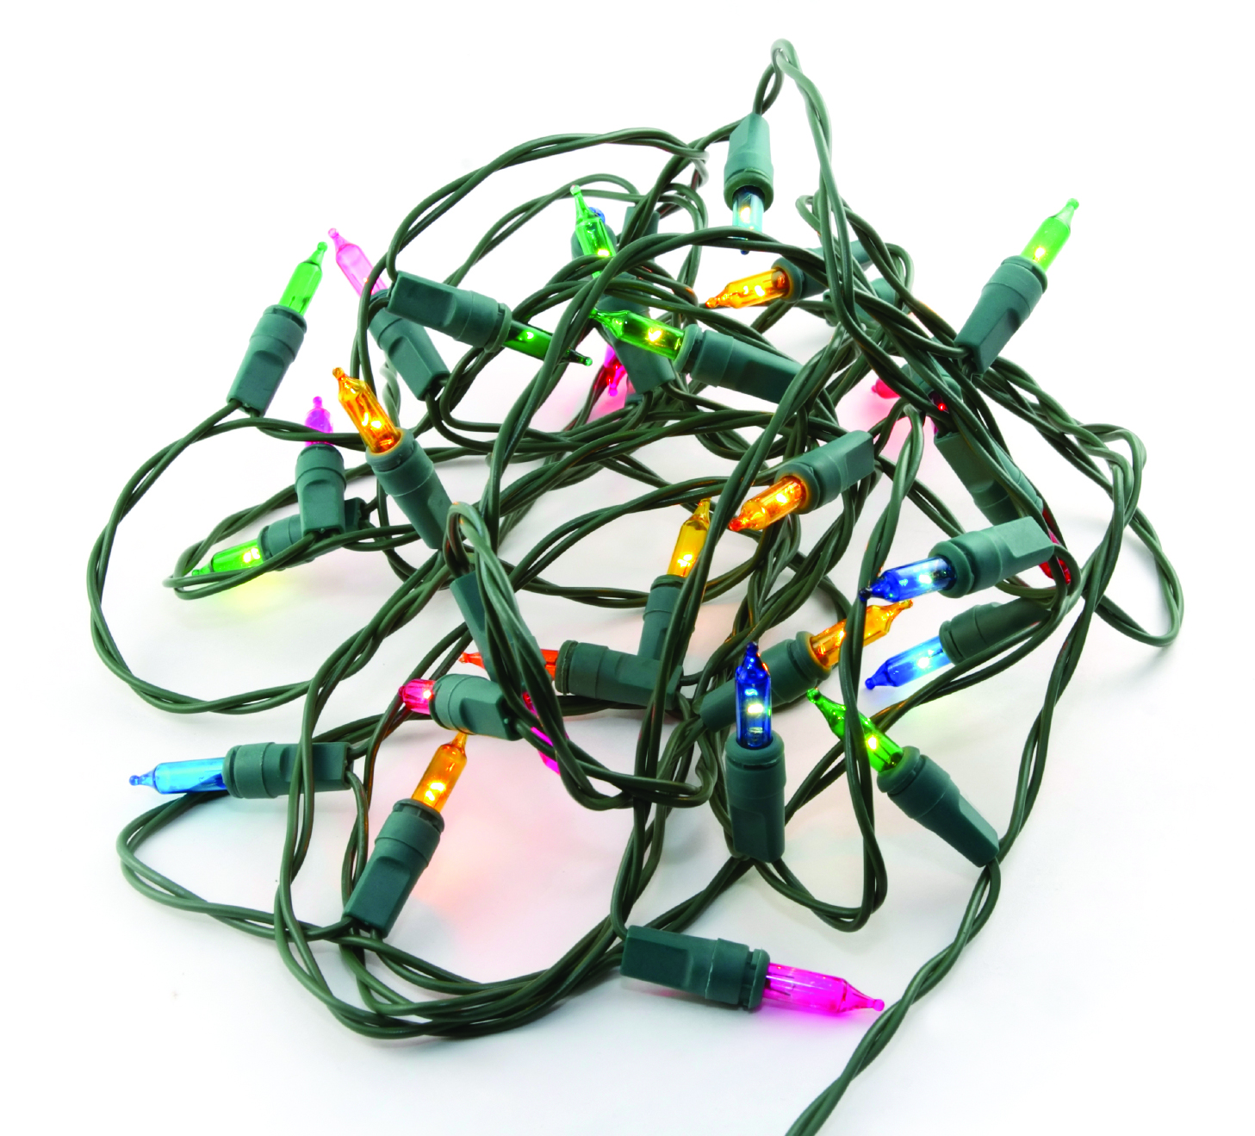
Deliveries can come with a lot of plastic packaging. You can bring shipping envelopes made entirely of plastic, plastic film, air pillows, and bubble wrap to a drop-off for recycling. Plastic bags and film must be clean and dry, and plastic air pillows should be deflated. Some retail and grocery stores have collection containers, and these items are accepted at Hennepin County drop-off facilities.

String lights, electronics, and batteries
It’s common this time of year to have things like string lights that no longer work, electronics that you are upgrading, or items with batteries that you need to get rid of. These items are accepted at Hennepin County drop-off facilities for recycling or proper disposal. Find options for disposing of common household items on the Green Disposal Guide.

Special pick-up or yard waste site

Real Christmas trees, wreaths, and greenery
Check with your hauler or city as many offer special pickup options after the holidays. Or take these items to a yard waste site. Remove everything, including lights, ornaments, and tinsel, before disposing.
If wreaths and greenery are not accepted by your hauler, put them in a plastic bag and put in the trash. Unless you know your tree and greenery was grown in Minnesota, the Minnesota Department of Agriculture says you shouldn’t leave them in your backyard because of concerns about pests. Learn more about best practices for holiday greenery.

Trash

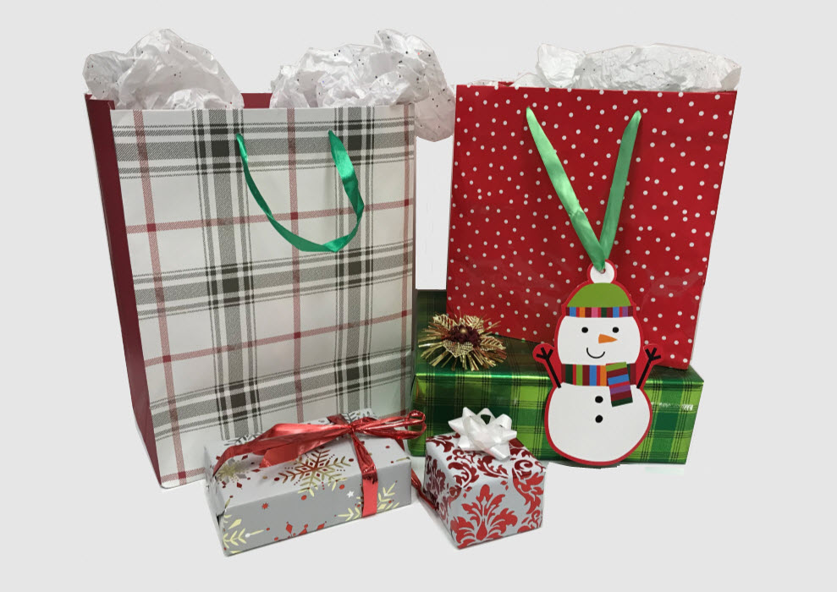
Gift wrap and decorations
Many items commonly used to decorate gifts go in the trash. This includes:
- Glossy, shiny, or glittery wrapping paper
- Tissue paper
- Bows and ribbons
- Cards that have glitter, foil, or plastic adornments
- Cards printed on photo paper
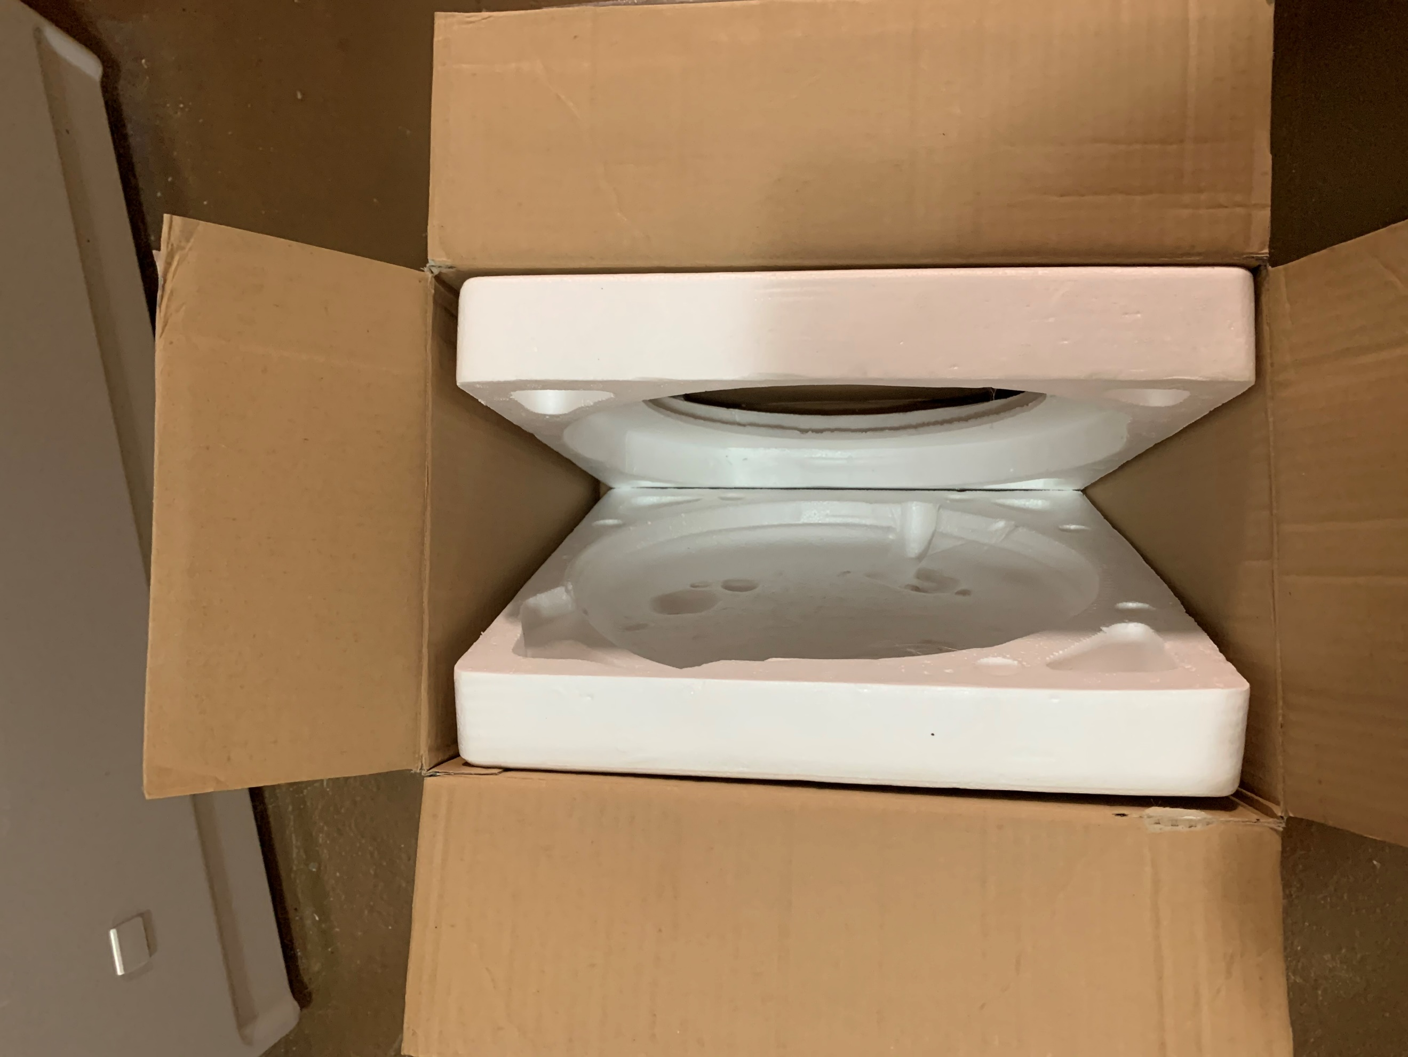
As you clean up during the holidays, items like gift bags, gift boxes, ribbons, and bows are great to save and reuse next year!

Packing materials
StyrofoamTM is not recyclable. Reuse StyrofoamTM for future packaging and mailing needs or put it in the trash. Shipping envelopes made of multiple materials (such as paper and bubble wrap) go in the trash.

Trees, wreaths, and greenery with flocking or glitter
Trees, wreathes, and other greenery that has flocking (a covering of artificial snow), glitter, or other decorations that cannot be removed should go in the trash. Artificial trees and wreaths should be saved for reuse or look for options to give them away or donate them.

Social media graphics
Below is a series of graphics about eco-friendly holiday disposal to use in social media posts. To use images and graphics: right click on image and select Save as Picture.
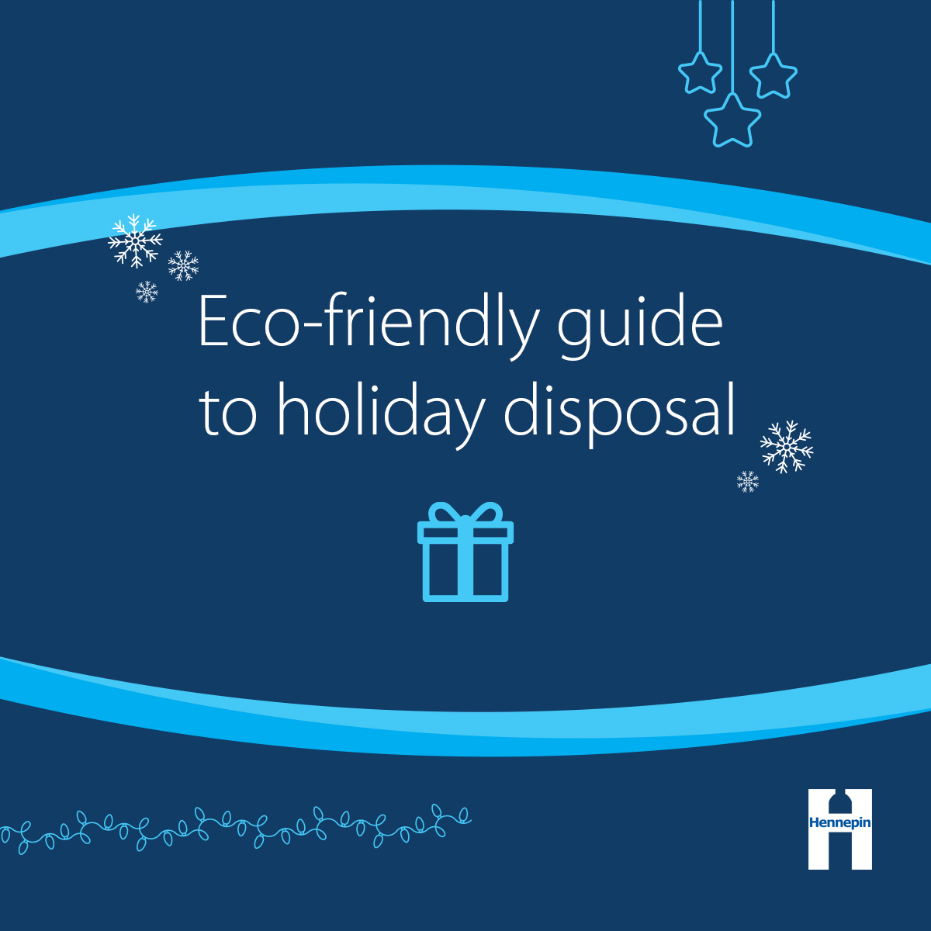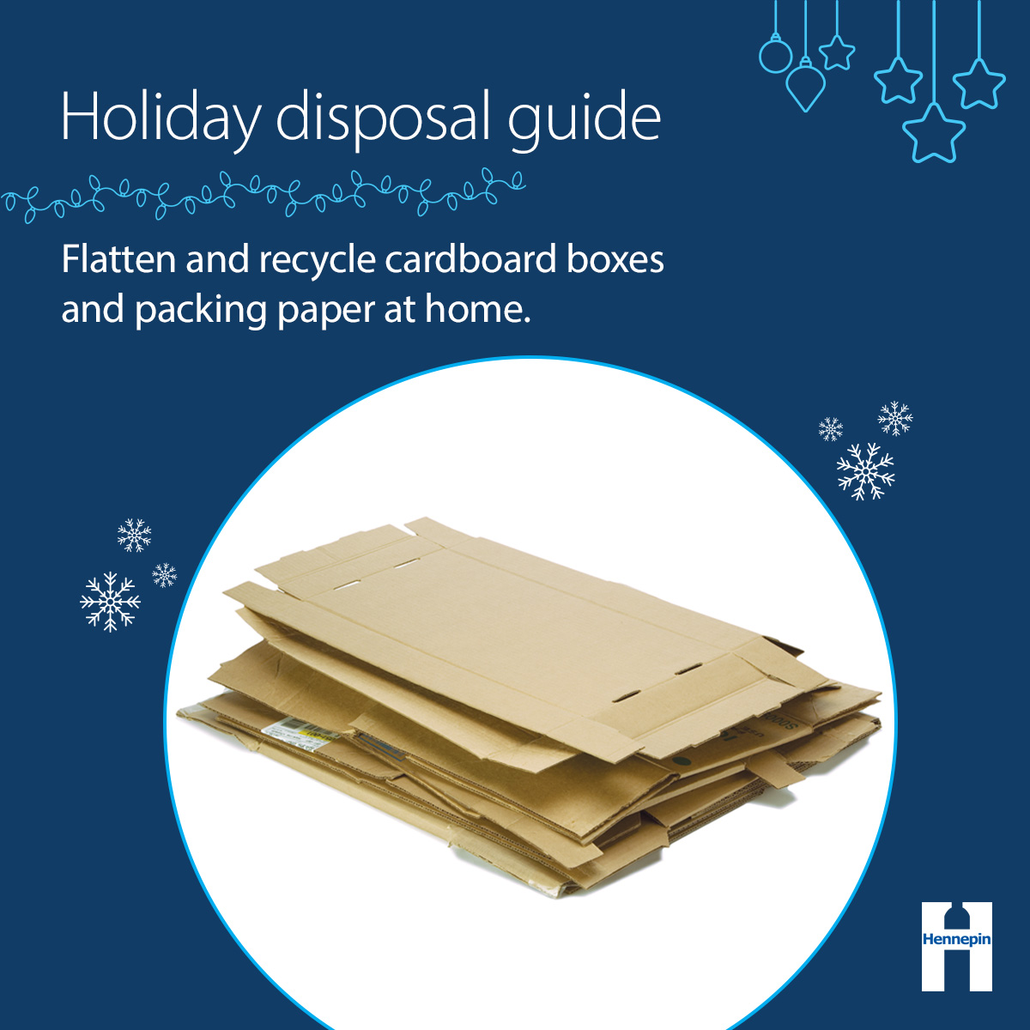
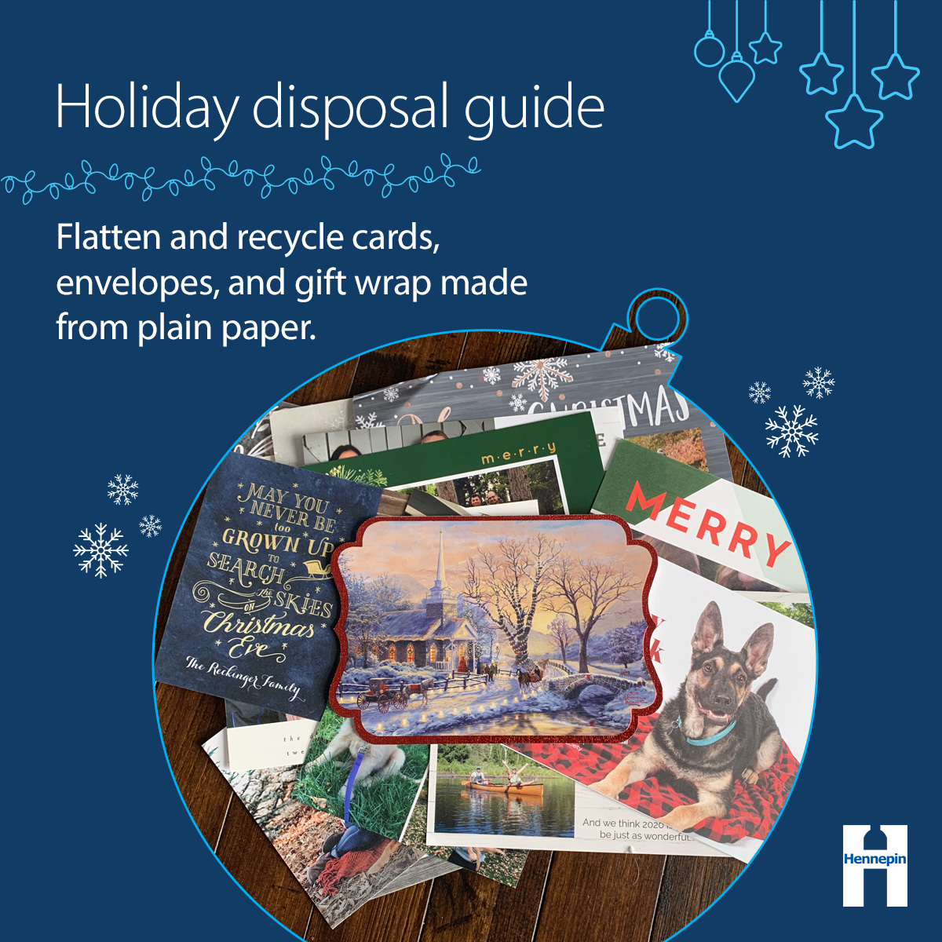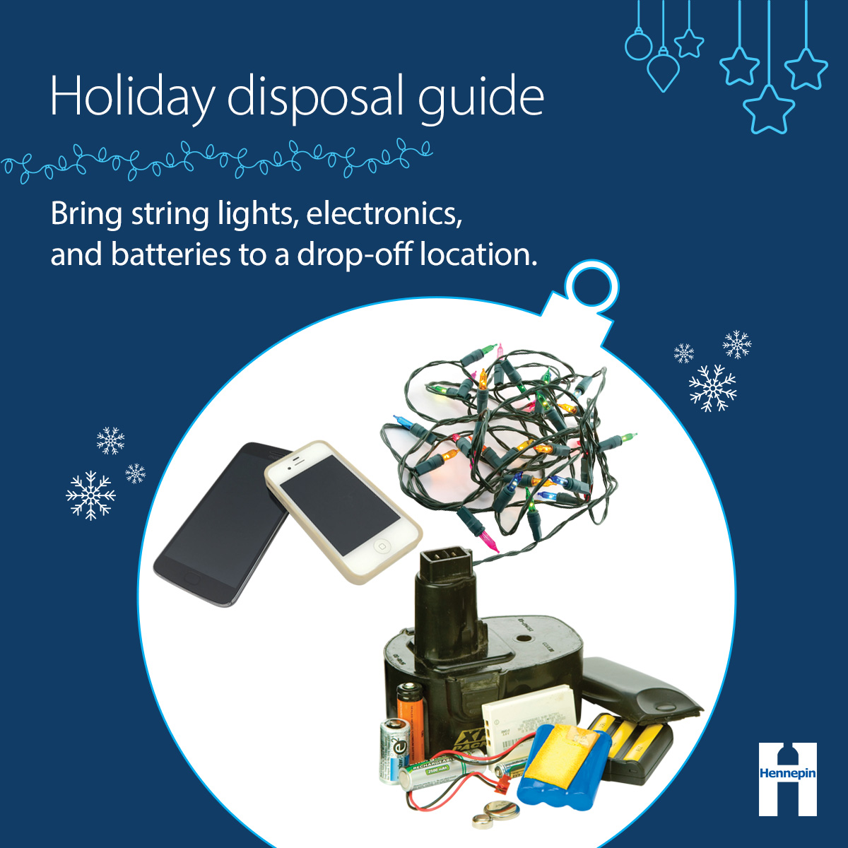
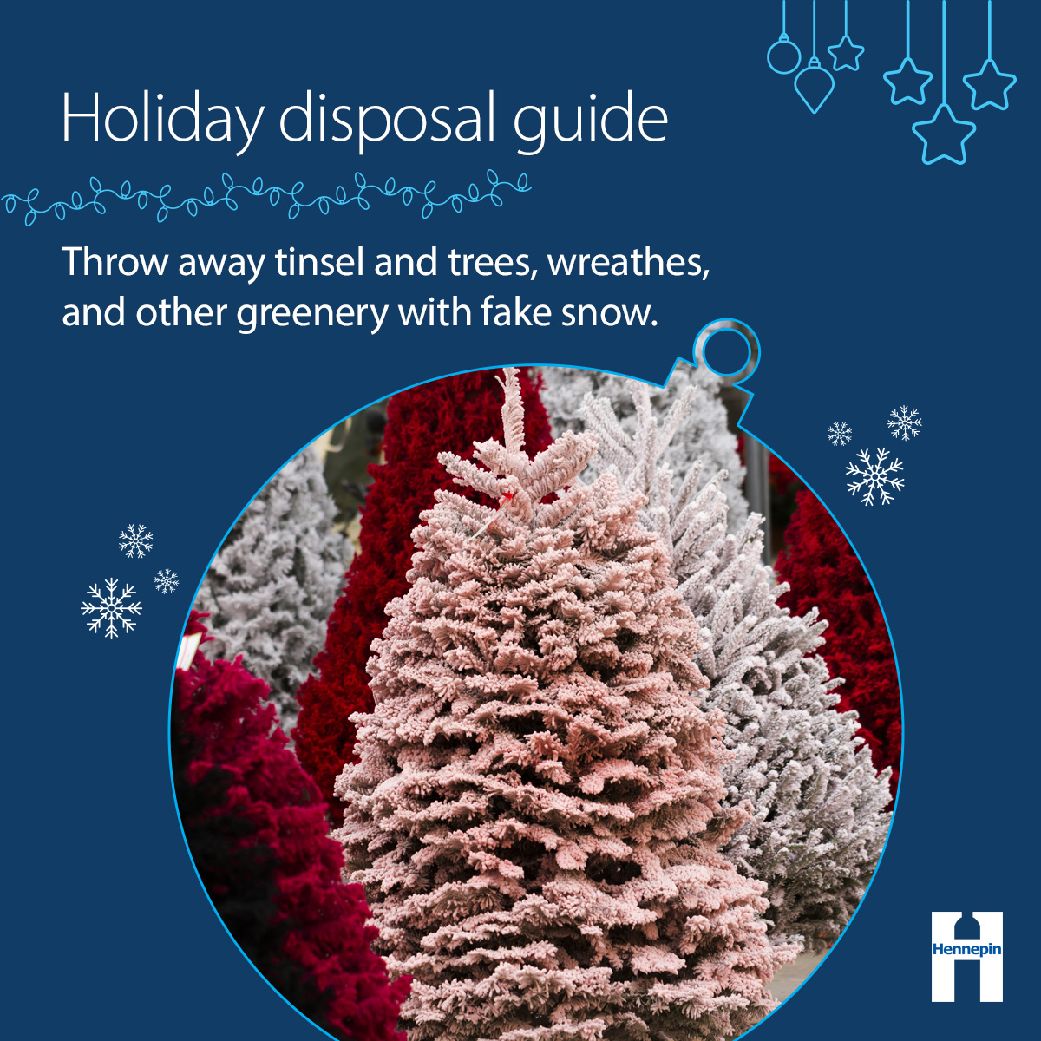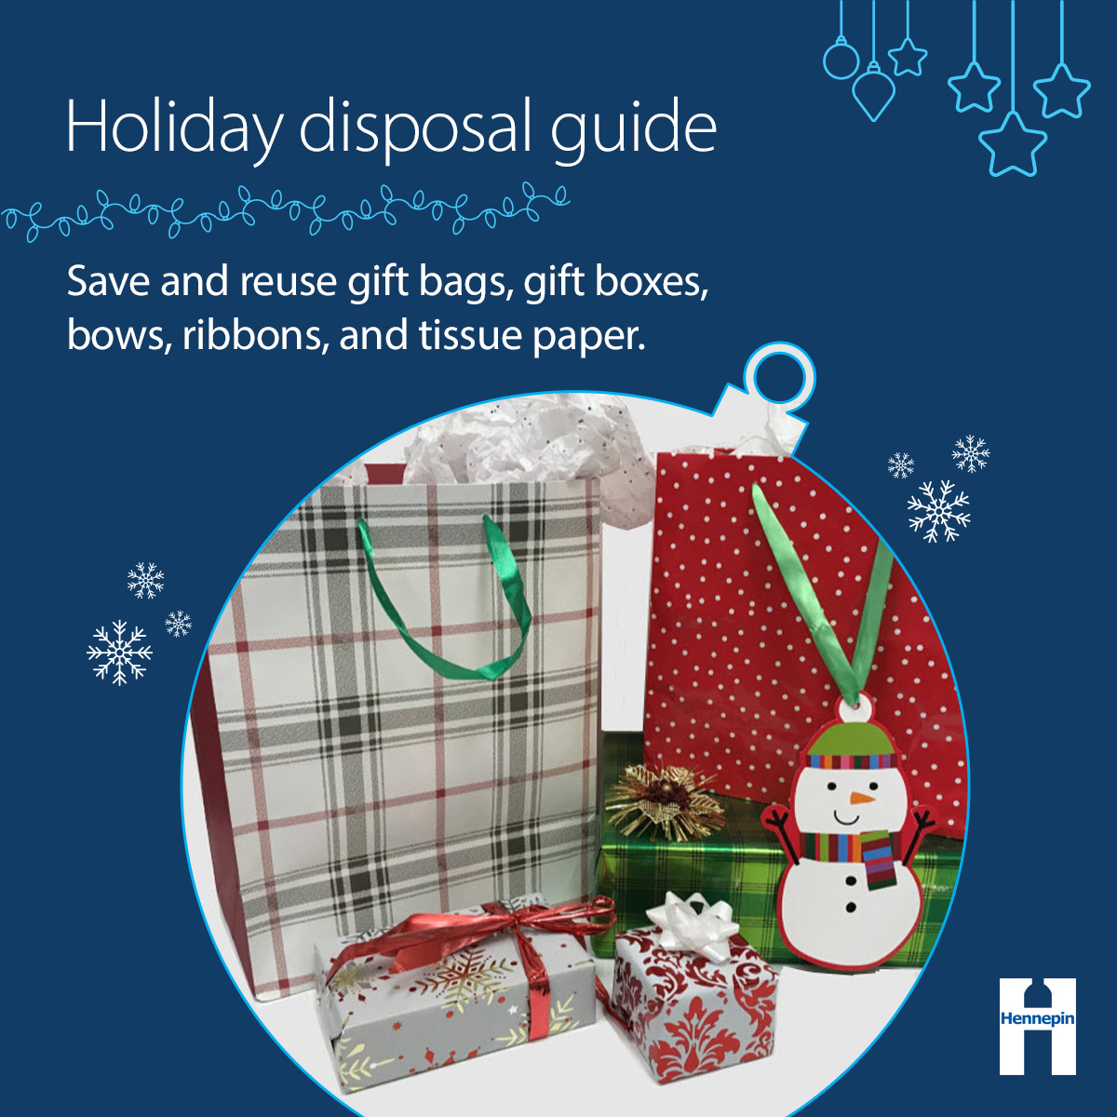
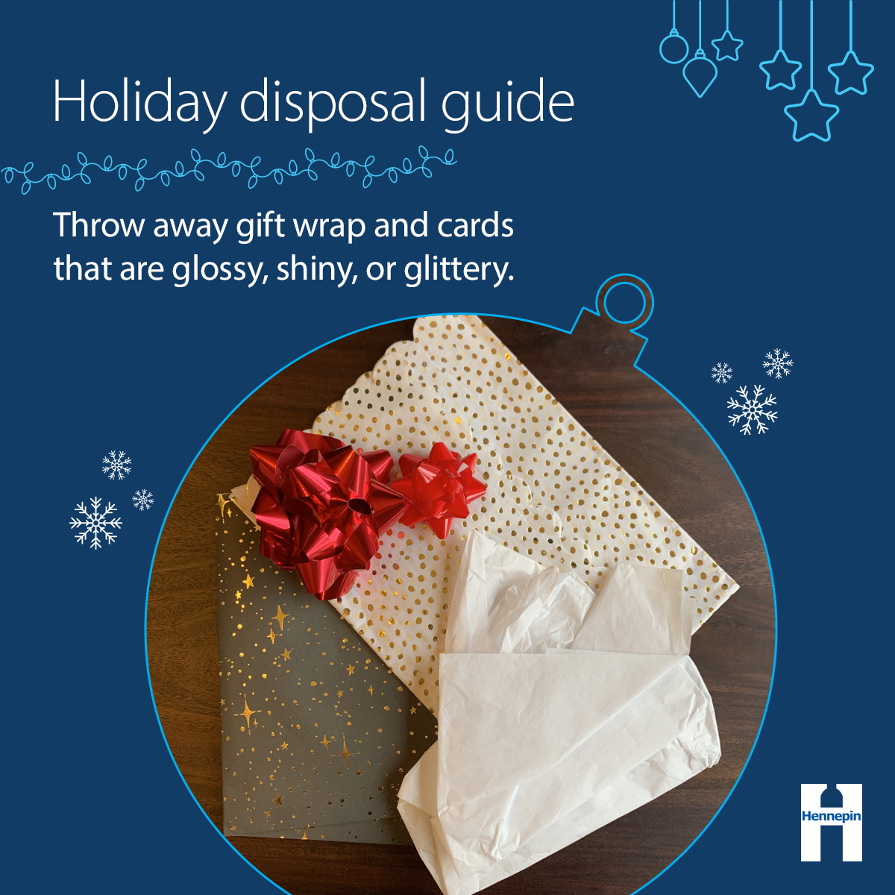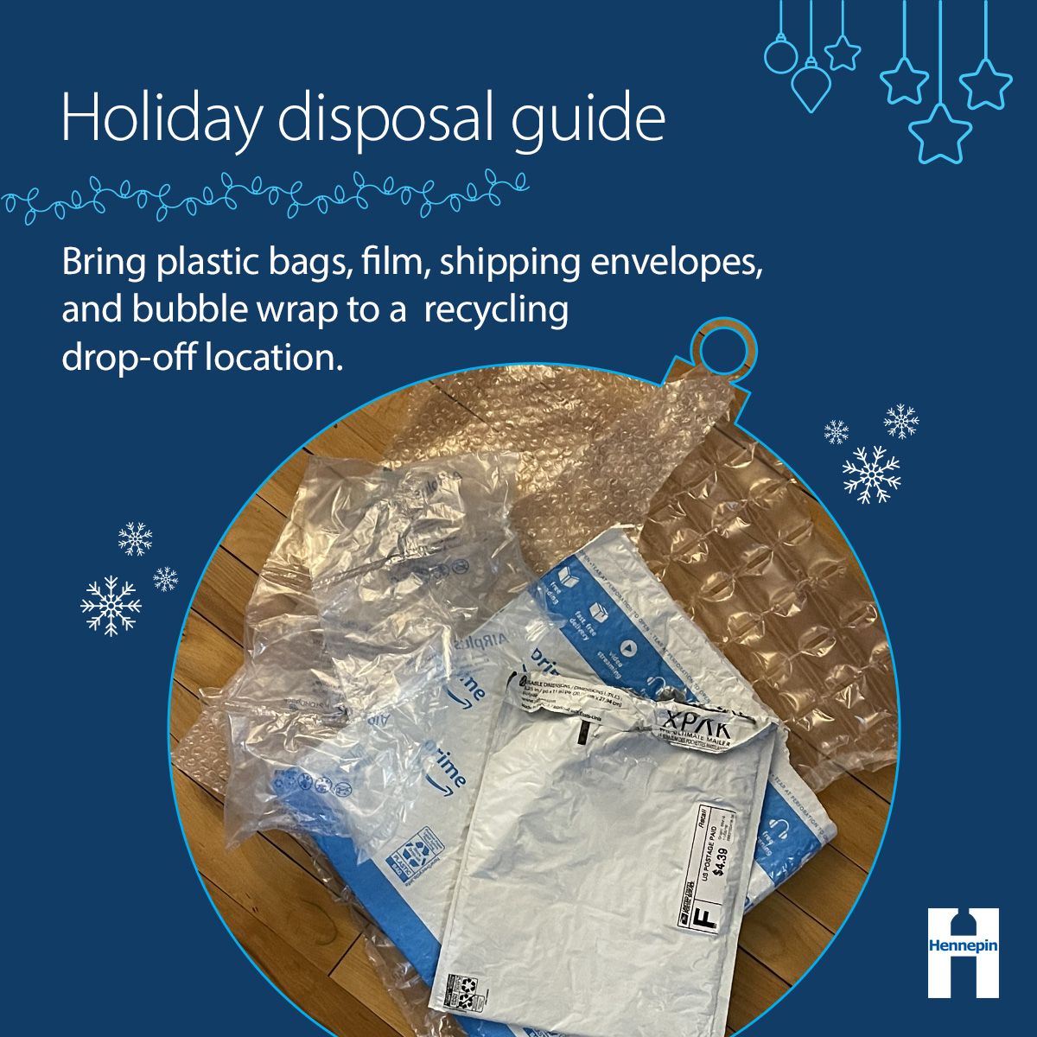
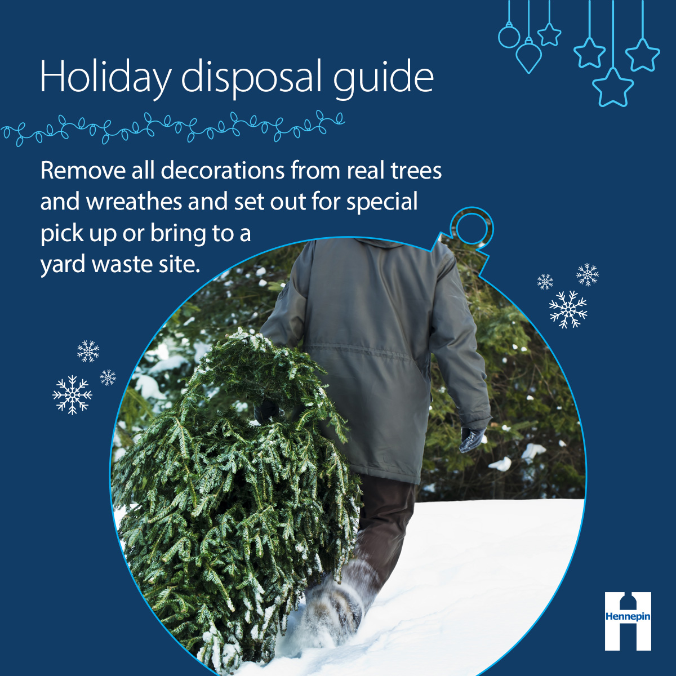

Social media posts
Suggested hashtags: #LowWaste #Recycle #Reuse #Holiday
To use images and graphics: right click on the image and select Save as Picture.

Post 1: Carousel of graphics
Facebook: Between packaging from deliveries, decorations, gift wrap, and more, the holiday season is a time when we often have a lot of stuff to get rid of. Review these tips to make sure you recycle and reuse as much as you can!
Twitter/X: Between packaging from deliveries, decorations, gift wrap, and more, the holiday season is a time when we often have a lot of stuff to get rid of. Review these tips to make sure you recycle and reuse as much as you can! #LowWaste #Recycle #Holiday
Instagram: Between packaging from deliveries, decorations, gift wrap, and more, the holiday season is a time when we often have a lot of stuff to get rid of. Review these tips to make sure you recycle and reuse as much as you can! #LowWaste #Recycle #Holiday
<< select series of images from social media graphics above>>

Post 2: Cardboard and paper
Facebook: As you clean up from the holidays, follow these tips for the best way to get rid of common holiday items like cardboard! You can flatten and recycle cardboard boxes as well as cards, envelopes, and gift wrap made from plain paper at home.
Twitter/X: As you clean up from the holidays, follow these tips for the best way to get rid of common holiday items like cardboard! You can flatten and recycle cardboard boxes as well as cards, envelopes, and gift wrap made from plain paper at home. #Recycle #Holiday
Instagram: As you clean up from the holidays, follow these tips for the best way to get rid of common holiday items like cardboard! You can flatten and recycle cardboard boxes as well as cards, envelopes, and gift wrap made from plain paper at home. #Recycle #Holiday
Alt text (top image): Folded and stacked cardboard boxes. Holiday disposal guide: Flatten and recycle cardboard boxes and packing paper at home.
Alt text (bottom image): Stack of holiday cards. Holiday disposal guide: Flatten and recycle cards, envelopes, and gift wrap made from plain paper.

Post 3: Electronics and string lights
Facebook: It’s common this time of year to have things like string lights that no longer work, electronics that you are upgrading, or items with batteries that you need to get rid of. These items are accepted at Hennepin County drop-off facilities for recycling or proper disposal. hennepin.us/dropoffs
Twitter/X: It’s common this time of year to have things like string lights that no longer work, electronics that you are upgrading, or items with batteries that you need to get rid of. These items are accepted at Hennepin County drop-off facilities for recycling or proper disposal. hennepin.us/dropoffs #Recycle #Holiday
Instagram: It’s common this time of year to have things like string lights that no longer work, electronics that you are upgrading, or items with batteries that you need to get rid of. These items are accepted at Hennepin County drop-off facilities for recycling or proper disposal. #Recycle #Holiday
Alt text: String lights and old electronics. Holiday disposal guide: Bring string lights, electronics, and batteries to a drop-off location.

Post 4: Artificial trees and flocking
Facebook: The holiday season is a time when we often have a lot of stuff to get rid of. Trees, wreathes, and other greenery with fake snow, glitter, or other decorations that cannot be removed should go in the trash. Artificial trees and wreaths should be saved and reused.
Twitter/X: The holiday season is a time when we often have a lot of stuff to get rid of. Trees, wreathes, and other greenery with fake snow, glitter, or other decorations that cannot be removed should go in the trash. Artificial trees and wreaths should be saved and reused. #LowWaste #Holiday
Instagram: The holiday season is a time when we often have a lot of stuff to get rid of. Trees, wreathes, and other greenery with fake snow, glitter, or other decorations that cannot be removed should go in the trash. Artificial trees and wreaths should be saved and reused. #LowWaste #Holiday
Alt text: Christmas tree with fake snow. Holiday disposal guide: Throw away tinsel and trees, wreaths, and other greenery with fake snow.

Post 5: Gift bags and boxes
Facebook: As you clean up during the holidays, items like gift bags, gift boxes, ribbons, and bows are great to save and reuse next year!
Twitter/X: As you clean up during the holidays, items like gift bags, gift boxes, ribbons, and bows are great to save and reuse next year! #Reuse #Holiday
Instagram: As you clean up during the holidays, items like gift bags, gift boxes, ribbons, and bows are great to save and reuse next year! #Reuse #Holiday
Alt text: Colorful gift bags and boxes. Holiday disposal guide: Save and reuse gift bags, gift boxes, bows, ribbons, and tissue paper.

Post 6: Glossy/shiny paper, glitter, tissue paper
Facebook: Unfortunately, many items commonly used to decorate gifts this holiday season go in the trash if they cannot be reused. This includes glossy, shiny, or glittery wrapping paper, tissue paper, bows and ribbons, cards that have glitter, foil, or plastic adornments, and cards printed on photo paper.
Twitter/X: Unfortunately, many items commonly used to decorate gifts this holiday season go in the trash if they cannot be reused. This includes glossy, shiny, or glittery wrapping paper, tissue paper, bows and ribbons, cards that have glitter, foil, or plastic adornments, and cards printed on photo paper. #Reuse #Holiday
Instagram: Unfortunately, many items commonly used to decorate gifts this holiday season go in the trash if they cannot be reused. This includes glossy, shiny, or glittery wrapping paper, tissue paper, bows and ribbons, cards that have glitter, foil, or plastic adornments, and cards printed on photo paper. #Reuse #Holiday
Alt text: Tissue paper and glittery paper. Holiday disposal guide: Throw away gift wrap and cards that are glossy, shiny, or glittery.

Post 7: Plastic film
Facebook: The holiday season is a time when we often have a lot of stuff to get rid of including packaging from deliveries. Shipping envelopes made entirely of plastic and plastic film, air pillows, bags, and bubble wrap can be brought to a drop-off location for recycling. hennepin.us/dropoffs
Twitter/X: The holiday season is a time when we often have a lot of stuff to get rid of including packaging from deliveries. Shipping envelopes made entirely of plastic and plastic film, air pillows, bags, and bubble wrap can be brought to a drop-off location for recycling. hennepin.us/dropoffs #Recycle #Holiday
Instagram: The holiday season is a time when we often have a lot of stuff to get rid of including packaging from deliveries. Shipping envelopes made entirely of plastic and plastic film, air pillows, bags, and bubble wrap can be brought to a drop-off location for recycling. #Recycle #Holiday
Alt text: Plastic packaging and bubble wrap. Holiday disposal guide: Bring plastic bags, shipping envelopes, and bubble wrap to a recycling drop-off location.

Post 8: Real trees
Facebook: Real trees can be brought to a yard waste site or set out for special pick up. Check with your hauler or city as many offer special pickup options after the holidays. Remember to remove everything, including lights, ornaments, and tinsel, before disposing. hennepin.us/yardwaste
Twitter/X: Real trees can be brought to a yard waste site or set out for special pick up. Check with your hauler or city as many offer special pickup options after the holidays. Remember to remove everything, including lights, ornaments, and tinsel, before disposing. hennepin.us/yardwaste #LowWaste #Holiday
Instagram: Real trees can be brought to a yard waste site or set out for special pick up. Check with your hauler or city as many offer special pickup options after the holidays. Remember to remove everything, including lights, ornaments, and tinsel, before disposing. #LowWaste #Holiday
Alt text: Man dragging tree through the snow. Holiday disposal guide: Remove all decorations from real trees and wreathes and set out for special pick up or bring to a yard waste site.

