Providing habitat for birds and bats media kit

About providing habitat for birds and bats
The 300 bird species and at least seven bat species that call Hennepin County home play a vital role in our ecosystems. Birds spread seeds, pollinate flowers and trees, and create places for other animals to nest. Bats control pests and provide fertilizer. Birds and bats also give us entertainment, inspiration, and connections to nature! Unfortunately, bird and bat populations are threatened by habitat loss, cat predation, collisions with buildings and cars, pesticides, plastics, diseases, and climate change.

Resources to promote providing habitat for birds and bats
Ways to educate the public about birds and bats:
- Use the sample newsletter articles to share on your organization’s website or in your newsletters. These are editable so you can customize the length or message.
- Use the sample social media posts to share through your social media channels. These are editable so you can customize the message and website.
- Share the resources below. Order printed copies from environmentalresources.hennepin.us/items
  - Providing habitat for the birds in your backyard (PDF)
  - Supporting native backyard bird populations (PDF)
  - Building and maintaining your bat house (PDF)
- Follow and reshare messages posted on the Hennepin County Environment and Energy social media channels: Hennepin Environment on Facebook, Hennepin Environment on Instagram, and @hennepinenviro on Twitter.
- Share the information and resources available at hennepin.us/protect-natural-resources

Contact
Nicole Witzel, Wildlife Biologist, nicole.witzel@hennepin.us
Emily McDonald, Environmental Educator, emily.mcdonald@hennepin.us

Sample newsletter article – Flying friends pledge

Take the pledge to protect birds and bats
The 300 bird species and at least seven bat species that call Hennepin County home play a vital role in our ecosystems. Birds spread seeds, pollinate flowers and trees, and create places for other animals to nest. Bats control pests and provide fertilizer. Birds and bats also give us entertainment, inspiration, and connections to nature!
Unfortunately, bird and bat populations are threatened by habitat loss, cat predation, collisions with buildings and cars, pesticides, plastics, diseases, and climate change. The good news: there are many actions we can take to work against these threats and help our flying friends!

Take action to protect birds and bats
Pledge to take the following actions to help our flying friends:
Plant native vegetation to provide shelter and habitat
Provide a variety of appropriate food sources
Offer clean water sources year-round
Install and maintain a bird or bat house
Limit the use of lawn chemicals and pesticides
Keep household cats indoors
Close window blinds and turn off outside lights during bird migration (late March to early June and mid-August to November) and bat swarming season (August to October)
Place stickers or decals on windows to prevent birds from hitting them
Take a bird or bat walk to discover the flying friends that live in our neighborhood
Teach a friend or family member about being bird and bat friendly
Contact the Wildlife Rehabilitation Center of Minnesota (wrcmn.org) to report an injured bird or bat
Record bird nest or bat box observations through the NestWatch app at nestwatch.org
Use iNaturalist (inaturalist.org) or eBird (ebird.org) to document the wildlife in your neighborhood. Share your lists at @hennepin_biomonitoring or #hennepin_biomonitoring

Sample newsletter article – Bird houses

Provide habitat for the birds in your backyard
Providing high quality habitat, including safe places for birds to nest, is one of the best ways we can support Minnesota’s native bird populations. Loss of trees for shelter and food is a leading cause of the decline in many bird populations.
In urban, suburban, and even rural areas, suitable nesting cavities may be scarce. We tend to remove dead and dying trees for our own safety, but this means there are fewer places for birds to nest. You can help the birds in your area by creating temporary brush piles or installing nest boxes in your yard.

Build a bird house
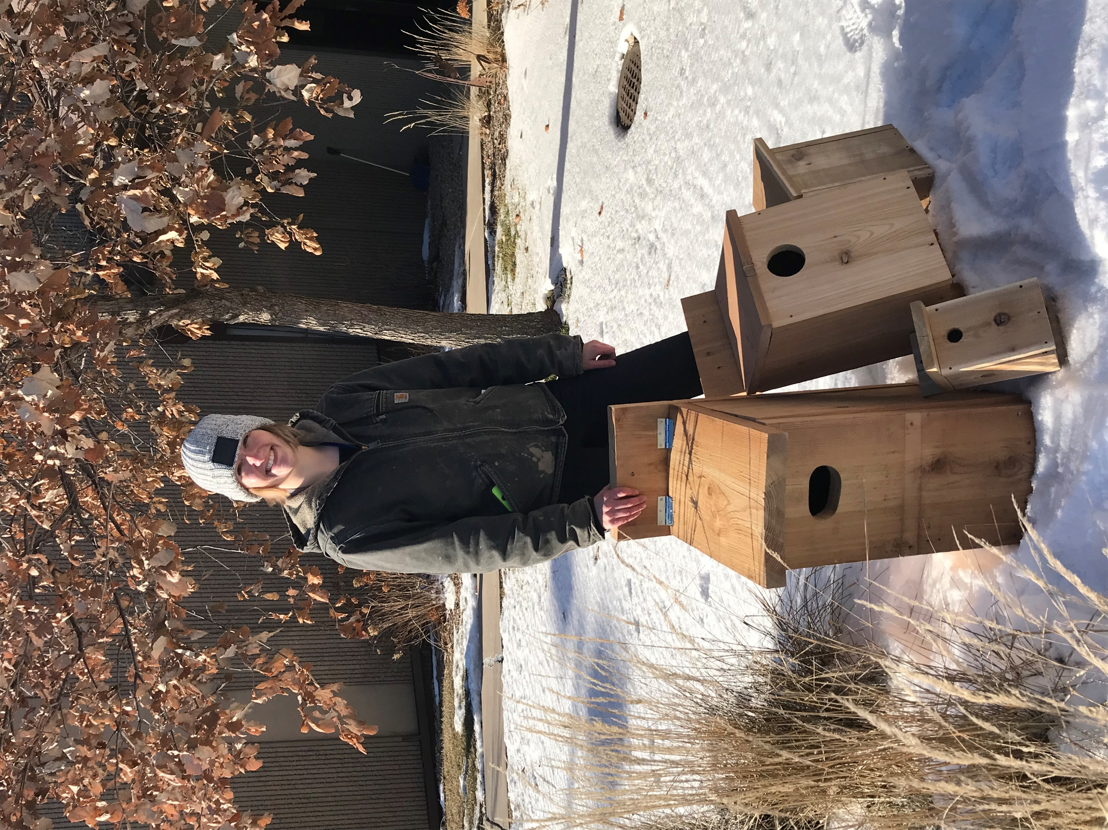
When you think of a nest box, you may be thinking of a traditional bird house that looks like a miniature of your own house with a perch on the front. In reality, nest boxes for birds are more often shaped like wooden boxes, platforms, or cones. Each box must be created with a specific bird species in mind
Bird houses should be made of untreated wood, preferably cedar, and galvanized screws for construction. Thick walls, ventilation holes, a sloped roof, recessed floor, and drainage holes keep the house warm and dry.
Visit the Cornell Lab of Ornithology’s NestWatch (nestwatch.org) to download nest box plans. Their site includes plans, installation requirements, and other tips for creating the ideal nest box.

Place your bird house
Place your nest boxes by mid-March to allow migrating birds a chance to use them. Don’t be discouraged if birds don’t use the nest box right away. Sometimes it can take several seasons for them to find the home you’ve built for them. Rest assured, breeding pairs will often use a nest box for years once they find the perfect spot.
Do not place your nest box near anywhere that pesticides or herbicides are used. These chemicals can reduce the supply of food for hungry nestlings and harm both parents and their chicks.

Clean and maintain your bird house
Once you have a nest box established, it needs minimal but very important maintenance. Over time, a buildup of nesting material and fecal matter can overtake a nest box. Unclean nests can also harbor parasites that can spread to other birds.
To keep your nest box in good working condition, remove the material and scrub the inside with mild detergent and water at the end of the season. Replace any parts of the house that are damaged or rotting and make sure the nest box is well-secured and ready for next season.

Pledge to protect birds
There are many ways you can protect birds throughout the year:
- If they don’t pose a safety concern, leave dead trees and brush standing.
- Provide water and multiple different food sources using bird feeders and make sure they are cleaned regularly to prevent disease.
- Make windows more visible to birds with curtains, screens, and other markings to prevent window strikes.
- Turn off lights that you’re not using, especially at night and during bird migration.
- Don’t use pesticides. They can poison or kill birds or their food source.
- Keep your cats indoors. Cats are one of the most common causes of bird casualties, particularly young birds.
- Contact the Wildlife Rehabilitation Center of Minnesota (wrcmn.org) for advice on what to do with an injured bird, or any other wildlife.
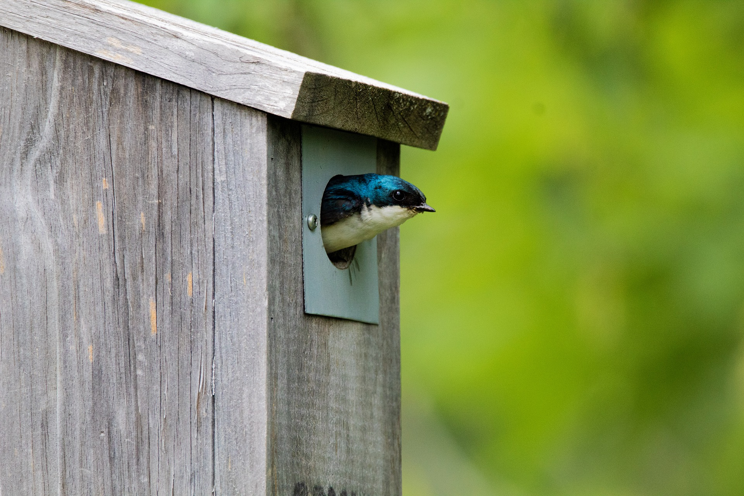
Tree swallow. Photo credit: Vinny Simard

Sample newsletter article – Bird baths

Provide a water source for your backyard birds
Providing quality habitat for birds is about more than providing them safe places to build their nests. Birds need water and food sources nearby, especially during the breeding season. Bird baths can be an excellent way to provide fresh, clean drinking and bathing water to backyard birds.
Here are some ways you can encourage birds to use your bird bath:
- Place your bird bath close to shrubs and bird feeders that provide food and cover.
- Add a water feature to attract birds and keep breeding insects at bay.
- Add a heater in the winter to enjoy visiting birds all year.
- Add pebbles or stones to your bird bath for birds to perch on.
If you don’t yet have a bird bath but would like one, repurpose a shallow dish or plant tray! Place it on the ground or on a stump and add a few stones to weigh it down. Fill it with about an inch of water and wait for the birds to show up for a bath!

How to maintain your bird bath
It is essential to keep your bird baths clean to prevent the spread of pests and disease.
Dirty bird baths can be dangerous to your feathered friends and can also create an insect problem for you. The stagnant water of a neglected bird bath may cause poisonous algae to grow and can encourage insects like gnats and mosquitoes to breed. Dirty bird baths can also be contaminated by fecal matter and rotting food, becoming a breeding ground for harmful bacteria.
Keep birds safe and healthy by regularly cleaning and maintaining your bird bath. Here’s some tips from the National Audubon Society (audubon.org) for keeping your bird bath fresh and clean:
- Empty your bird bath and rinse it well every other day before refilling.
- Fill your bird bath with about an inch of water.
- Periodically, use a solution of one part vinegar to nine parts water to scrub your bird bath thoroughly inside and out. Rinse well before adding fresh water.
- Never use detergents or chemicals to clean your bird bath as this can remove important oils from bird feathers.
- Monitor the base of your bird bath for mold and clean as needed.
- The frequency of deep cleaning your bird bath may vary depending on the number of birds visiting and the time of the year, but generally every few weeks is recommended.
Bird baths can sometimes spread dangerous or fatal bird diseases. Help slow the spread of these diseases by following guidance from the Minnesota Department of Natural Resources. To minimize the risk to our feathered friends, clean your bird baths more frequently or remove them for a while if disease spread is high.
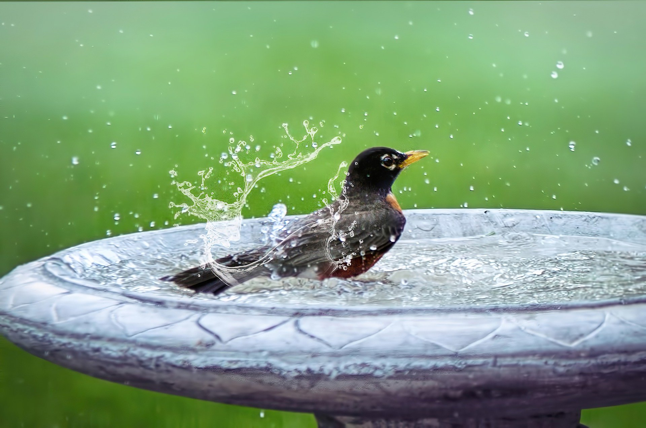
American robin. Photo credit: Jill Wellington
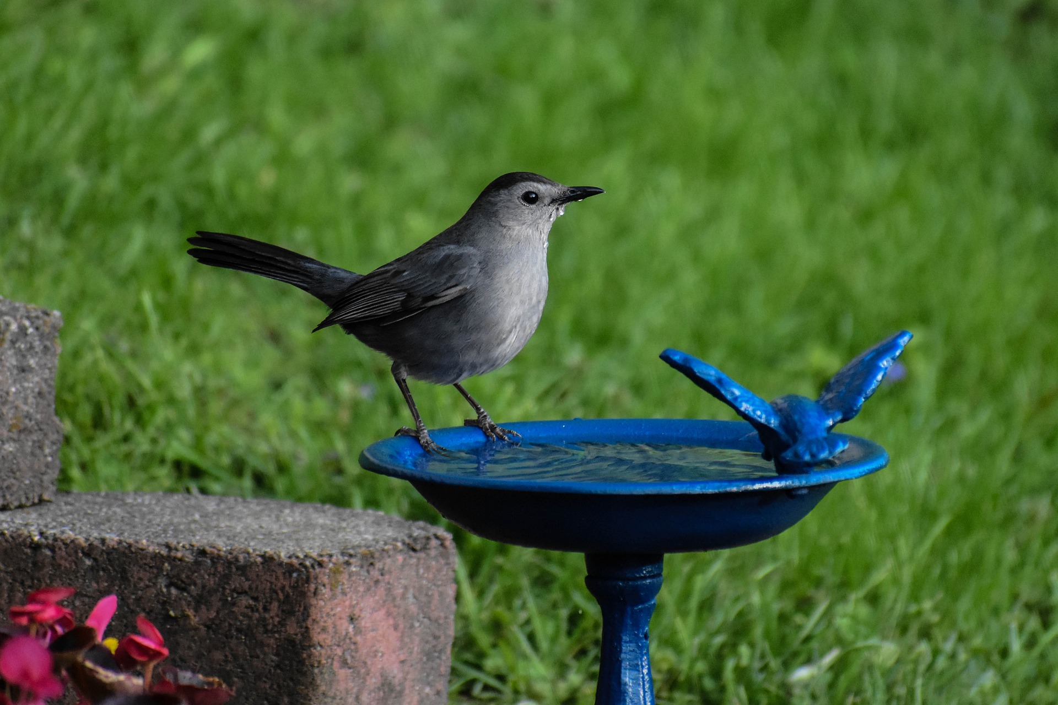
Gray catbird. Photo credit: Jack Bulmer

Sample newsletter article – Bird feeders

Provide a food source for your backyard birds
Providing quality habitat for birds is about more than providing them safe places to build their nests. Birds need water and food sources nearby, especially during the breeding season.
There are several different types of bird feeders, including suet feeders, house feeders, tube feeders, and hummingbird feeders, which will each attract different bird species.
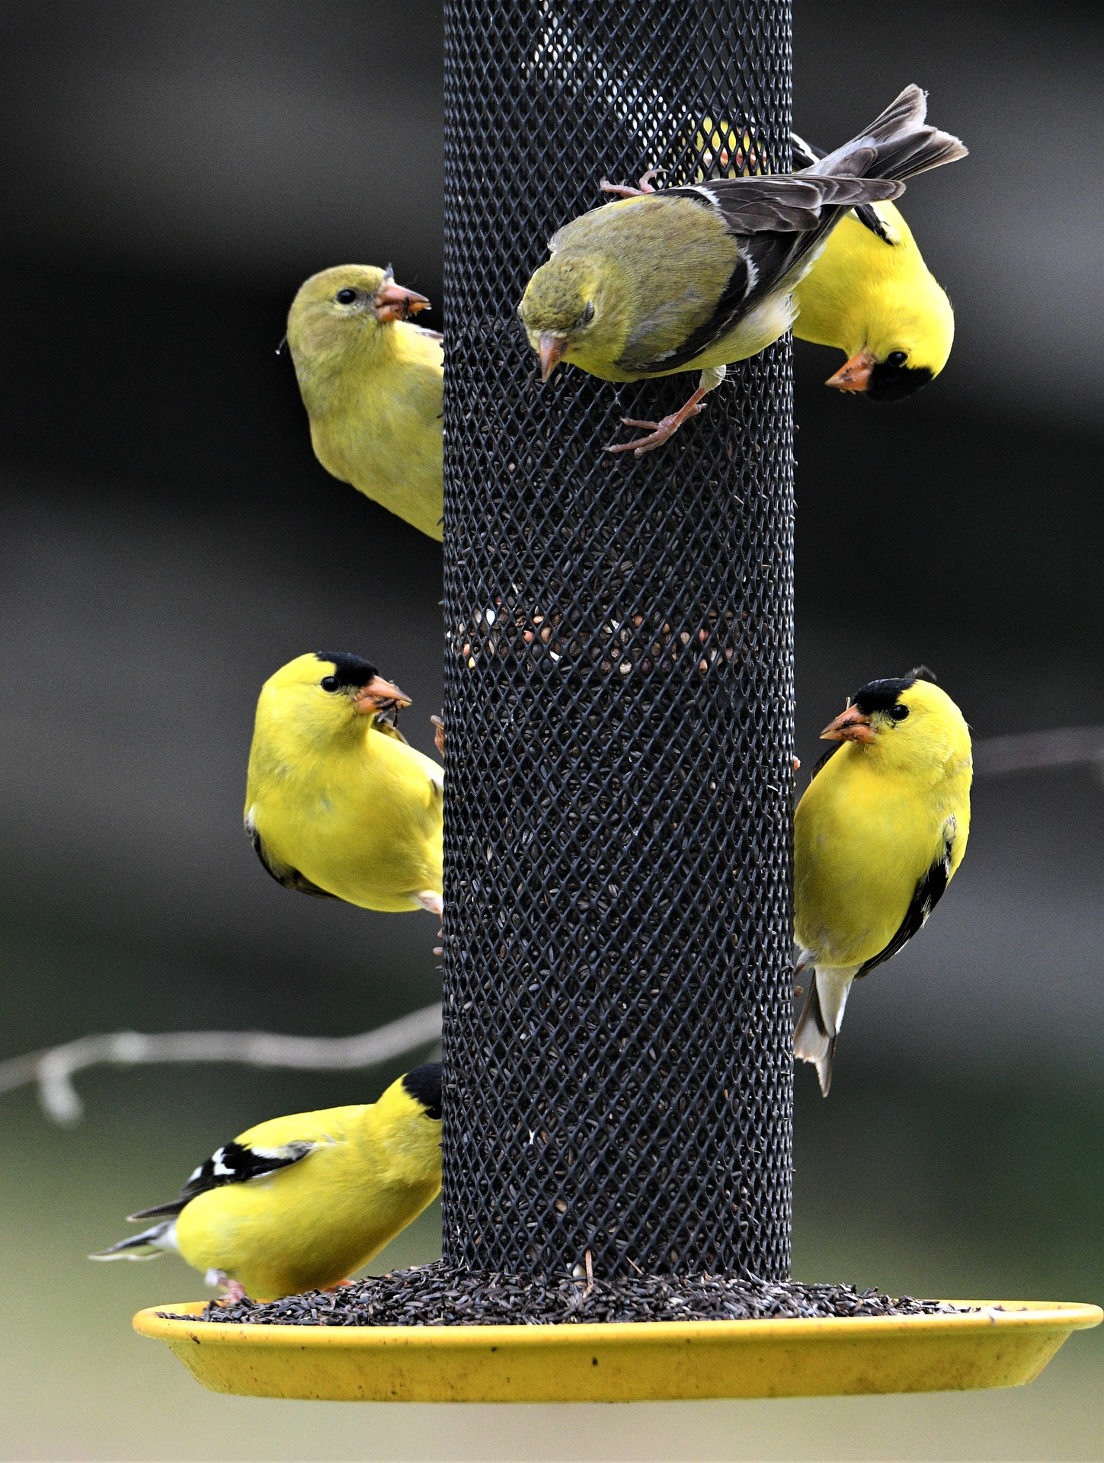
Bird feeders can spread bacteria and viruses, and damp bird food can expose birds to mold that can be fatal. Keep your feeders and bird food clean by:
Goldfinch. Photo credit: Veronika Andrews
- Cleaning your feeders once every two weeks with a solution of one part bleach to nine parts water. Rinse thoroughly and allow the feeders to dry before refilling.
- Avoiding platform feeders since these can hold feces and are very difficult to clean.
- Using feeders that keep your bird food out of the elements.
- Not using suet during hot weather. It can turn rancid and melt, dripping all over your yard and feeders.
- Keeping your bird food in sealed containers to prevent it from getting wet or infested with pests.
- Cleaning the ground under your feeders to prevent a buildup of food and feces, which can become moldy and attract unwanted animals.
- Cleaning hummingbird feeders every few days to prevent mold and fermentation of sugars, which can be deadly.
To prevent the spread of chronic wasting disease among deer, residents of Hennepin County are prohibited from feeding deer. To prevent access to bird food, hang all bird feeders at least six feet off the ground.

Provide a nutritious blend
Bird feeders are a staple of any wildlife lover’s yard, but it’s important to do your research to be sure that you’re providing a healthy, nutritious mix to your visitors.
Fruit: Apples are enjoyed by robins, gray catbirds, blue jays, and northern cardinals. Orange halves are enjoyed by orioles, red-bellied woodpeckers, and red-headed woodpeckers, and grape jelly is loved by gray catbirds and robins.
Millet mix is a favorite of mourning doves, chipping sparrows, and indigo buntings.
Peanuts are loved by chickadees, nuthatches, woodpeckers, and blue jays.
Mealworms are a great source of protein for bluebirds, robins, wrens, warblers, gray catbirds, chipping sparrows, northern cardinals, indigo buntings, rose-breasted grosbeaks, and Baltimore orioles.
Black oil sunflower seeds are enjoyed by cardinals, blue jays, chickadees, rose-breasted grosbeaks, house finches, and purple finches.
Suet is a staple of woodpeckers, nuthatches, chickadees, and wrens.
Nectar is great for hummingbirds, warblers, nuthatches, orioles, and woodpeckers. Put out hummingbird feeders by May 1. Never use nectars with any kind of dye. This can be deadly for hummingbirds.

Other bird feeding tips
- Offer a diversity of foods in different sized and shaped bird feeders.
- Place bird feeders in clusters in an open area to attract the most variety of bird species.
- Place bird feeders ten feet or more from shrubs or other cover where cats and other predators could hide.
- Place feeders at different heights to attract different species.
- Use baffles to discourage squirrels and raccoons from accessing feeders.
- Plant native fruit and nut-bearing trees and shrubs that provide food for native birds.
- Do not feed ducks bread or other processed foods. Instead, offer peas, cracked corn, oats, lettuce, or earthworms.
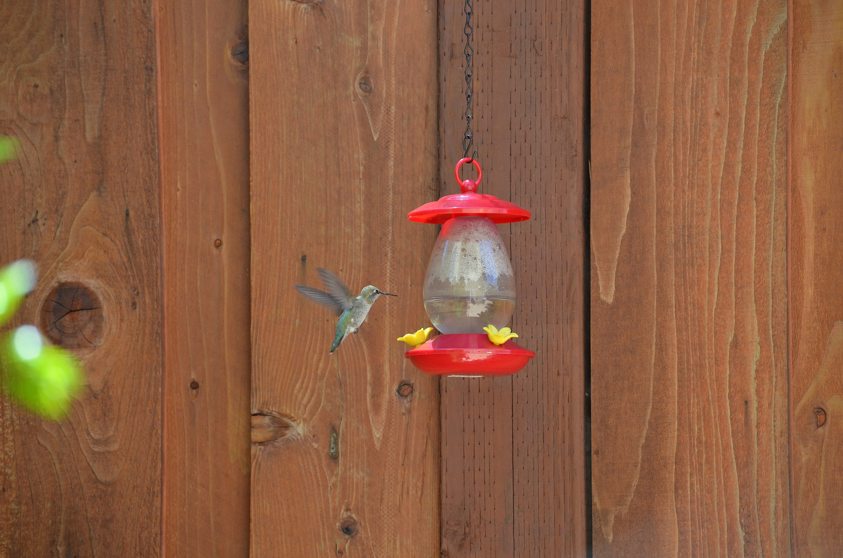
Ruby-throated hummingbird. Photo credit: Cristina Moidel

Sample newsletter article – Bat houses

Building and maintaining your bat house
In Minnesota, we have eight different bat species:

- Big brown bat
- Little brown myotis
- Silver-haired bat
- Eastern red bat
- Hoary bat
- Northern long-eared bat
- Tri-colored bat
- Evening bat

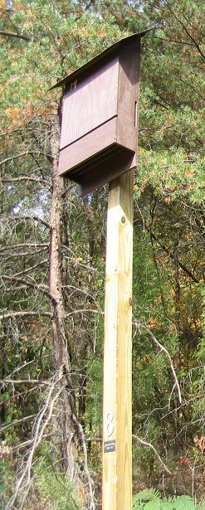
Bats are an important part of our ecosystem and eat up to half of their body weight in insects every night. Not only do they eat the mosquitoes that would otherwise munch on you, but they are also extremely important to agricultural production by reducing crop damage caused by insects.
Photo credit: Quadell

Build a bat house
Many species of bats are dependent on dead and dying woody vegetation for shelter. Some like to squeeze into the narrow gap between peeling bark, while others prefer hollow trees. We often remove dead or dying trees for our own safety, leaving bats with no safe places to roost as they migrate, settle, and raise their young.
To give our flying friends a safe place to stay, consider building a bat house! The best current bat house designs are the four-chamber nursery bat house and the rocket box. The plans for both houses can be found on Bat Conservation International’s website (batcon.org).
Do not paint or stain your bat house. Painting it can make it too hot or too cold for the bats inside. Be sure to seal all the seams to make sure the box stays warm and roughen the roosting boards and landing pads to make them easy for bats to grab onto.

Place your bat house
Place your bat house within a few hundred meters of a water source and in a place that receives at least six hours of sun exposure. When mounting your bat house, make sure it is:
- 10 to 20 feet off the ground
- 10 to 14 feet above any vegetation
- 20 to 30 feet away from the nearest tree
More than one bat house in an area is encouraged as bats are more likely to move into boxes if there’s three or more mounted together.
A nursery bat house should be placed on the side of a building. This provides more protection from the wind, sun, and shade than a pole or tree would. The rocket box can only be mounted on a pole.

Clean and maintain your bat house
One of the best parts of modern bat houses is that they’re self-cleaning! The guano falls out of the bottom of the nest box onto the ground, so install your house where you don’t mind a few droppings.
If you see bats near the bottom of your bat house or on the exterior, the house may be too crowded and hot, so consider adding another bat box.
Monitor your box to make sure boards aren’t becoming warped or damaged.
Check your box for bats by looking for guano on the ground outside or set up a lawn chair 15 minutes before sunset and see if any come out! Do not be discouraged if it takes some time, even years, for the house to be occupied. Sometimes, migrating bats may stop by for a night or two and move on.

Other ways to help bats
If you’re interested in other ways to help bats and other wildlife, consider the following tips:
- If they don’t pose a safety concern, leave dead trees standing.
- Move your forestry management to the winter when bats and other nesting animals are less likely to be disturbed.
- Protect wetlands and other sources of freshwater for native animals.
- Don’t use pesticides. They can poison or kill bats, who are natural pest controllers.
- Keep your cats indoors. Cats are one of the most common causes of bat casualties, particularly young bats.
- If you find an injured bat, do not pick it up. Bats can carry diseases that are harmful to humans if bitten. Contact the Wildlife Rehabilitation Center of Minnesota (info@wrcmn.org or 651-486-9453) for advice on what to do with an injured bat, or any other wildlife.
- Report sick or dead bats to the Minnesota Department of Natural Resources. (dnr.state.mn.us/reportbats)
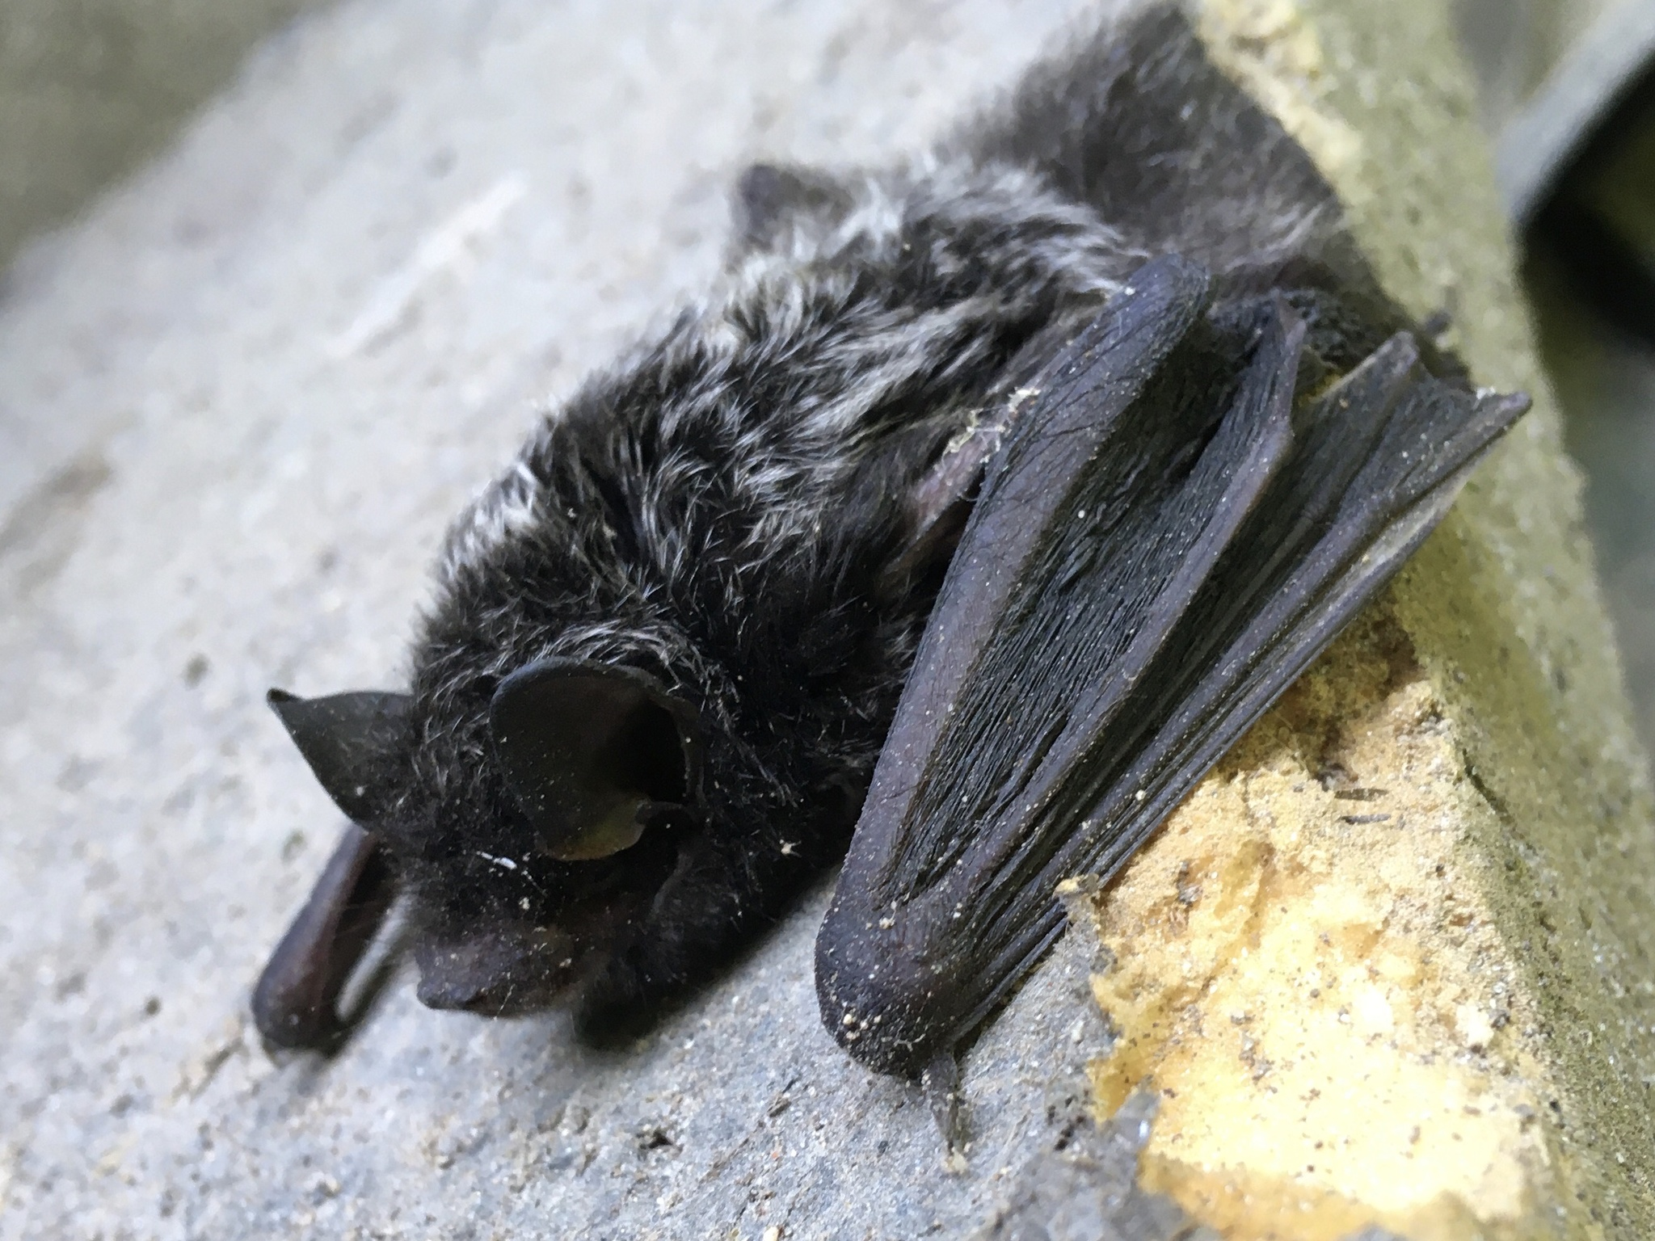
Silver-haired bat. Photo credit: Jake Stacken

Social media posts
Suggested hashtags: #FlyingFriendsPledge #Bats #Birds
To use images and graphics: right click on image and select Save as Picture

Post 1: Flying friends pledge
Facebook: Bird and bat populations are threatened by habitat loss, cat predation, collisions with buildings and cars, pesticides, plastics, diseases, and climate change. The good news: there are many things we can do to help our flying friends! Pledge to protect birds and bats by planting native vegetation, providing food and water sources, not using pesticides, keeping cats indoors, and closing window blinds during bird migration and bat swarming season.
Instagram: Bird and bat populations are threatened by habitat loss, cat predation, collisions with buildings and cars, pesticides, plastics, diseases, and climate change. The good news: there are many things we can do to help our flying friends! Pledge to protect birds and bats by planting native vegetation, providing food and water sources, not using pesticides, keeping cats indoors, and closing window blinds during bird migration and bat swarming season. #FlyingFriendsPledge
Twitter: Bird and bat populations are threatened by habitat loss, cat predation, pesticides, and more. Pledge to protect birds and bats by planting native vegetation, providing food and water sources, not using pesticides, and keeping cats indoors. #FlyingFriendsPledge
Image:
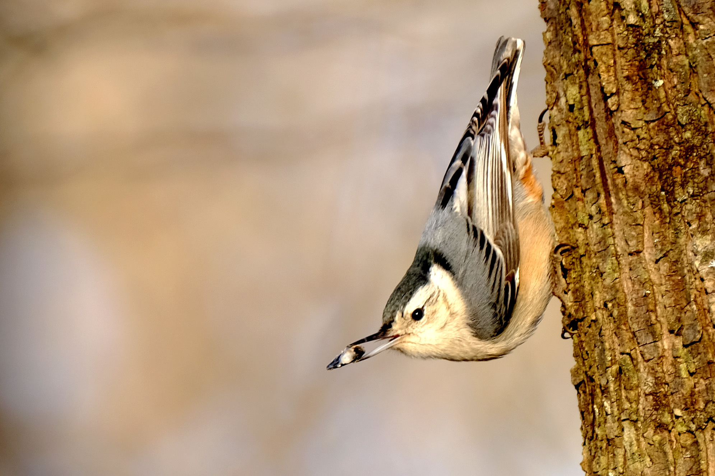
White-breasted nuthatch.

Post 2: Bird houses + NestWatch
Facebook: Providing high quality habitat, including safe places for birds to nest, is one of the best ways we can support Minnesota’s native bird populations. Loss of trees for shelter and food is a leading cause of the decline in many bird populations. Download bird house plans, installation requirements, and other tips from nestwatch.org.
Instagram: Providing high quality habitat, including safe places for birds to nest, is one of the best ways we can support Minnesota’s native bird populations. Loss of trees for shelter and food is a leading cause of the decline in many bird populations. Download bird house plans, installation requirements, and other tips at the link in our bio. #Birds #BirdHouse #FlyingFriends
Twitter: Providing high quality habitat, including safe places for birds to nest, is one of the best ways we can support Minnesota’s native bird populations. Download bird house plans, installation requirements, and other tips from nestwatch.org. #Birds #BirdHouse #FlyingFriends
Image:
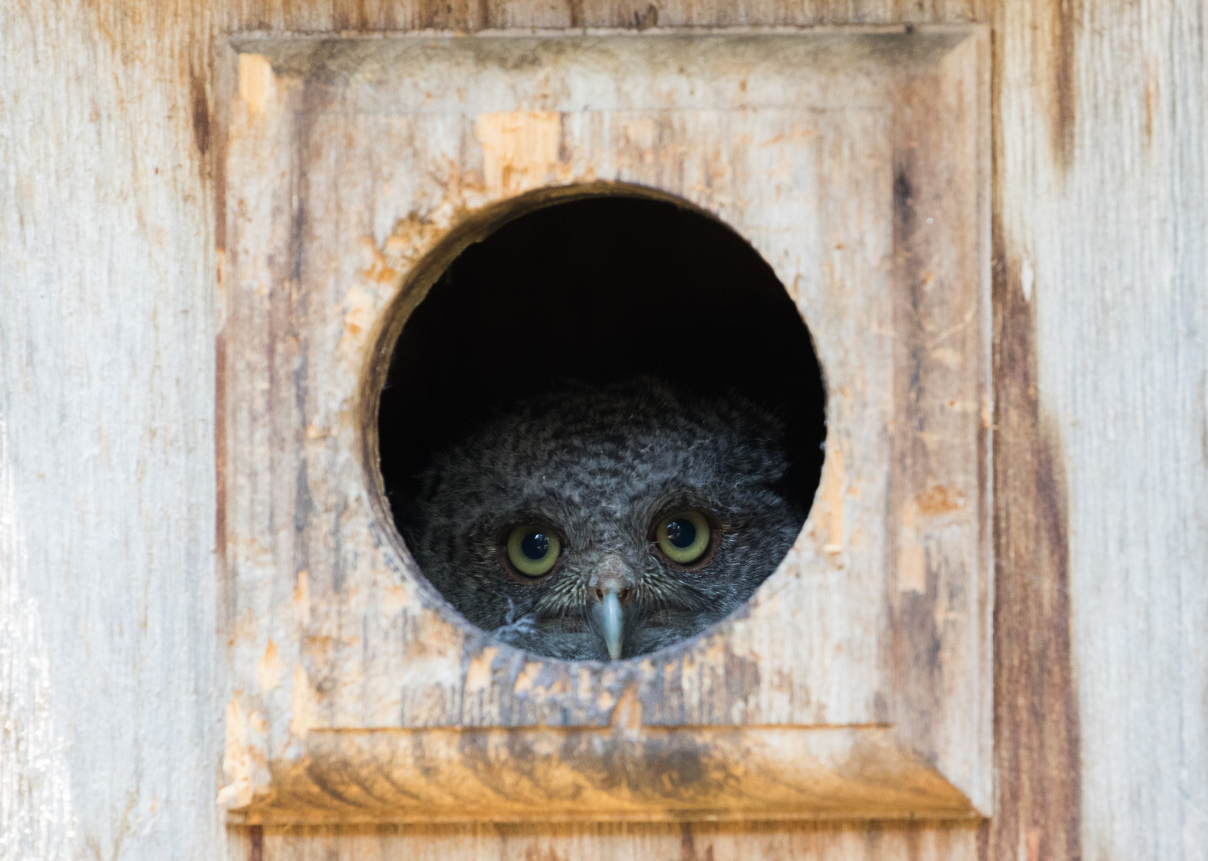
Screech owl. Photo credit: Cullen Hanks

Post 3: Bird baths + Audubon
Facebook: Birds need water sources nearby, especially during the breeding season. Bird baths can be an excellent way to provide fresh, clean drinking and bathing water to backyard birds. Make your own bird bath by repurposing a shallow dish or plant tray. Add a few stones to weigh it down, fill it with about an inch of water, and wait for the birds to show up for a bath! Get tips for keeping your bird baths clean from audubon.org.
Instagram: Birds need water sources nearby, especially during the breeding season. Bird baths can be an excellent way to provide fresh, clean drinking and bathing water to backyard birds. Make your own bird bath by repurposing a shallow dish or plant tray. Add a few stones to weigh it down, fill it with about an inch of water, and wait for the birds to show up for a bath! Get tips for keeping your bird baths clean at the link in our bio. #Birds #BirdBath #FlyingFriends
Twitter: Make your own bird bath by repurposing a shallow dish or plant tray. Add a few stones to weigh it down, fill it with an inch of water, and wait for the birds to show up for a bath! Get tips for keeping your bird baths clean from audubon.org. #Birds #BirdBath #FlyingFriends
Image:
American robin. Photo credit: Jill Wellington

Post 4: Bird feeders + Audubon
Facebook: Bird feeders are a staple of any wildlife lover’s yard, but it’s important to do your research to be sure that you’re providing a healthy, nutritious mix to your visitors. There are several different types of bird feeders, including suet feeders, house feeders, tube feeders, and hummingbird feeders, which will each attract different bird species. Get tailored recipes for your bird feeder from audubon.org.
Instagram: Bird feeders are a staple of any wildlife lover’s yard, but it’s important to do your research to be sure that you’re providing a healthy, nutritious mix to your visitors. There are several different types of bird feeders, including suet feeders, house feeders, tube feeders, and hummingbird feeders, which will each attract different bird species. Get tailored recipes for your bird feeder at the link in our bio. #Birds #BirdFeeder #FlyingFriends
Twitter: Bird feeders are a staple of any wildlife lover’s yard, but it’s important to do your research to be sure that you’re providing a healthy, nutritious mix to your visitors. Get tailored recipes for your bird feeder from audubon.org. #Birds #BirdFeeder #FlyingFriends
Image:
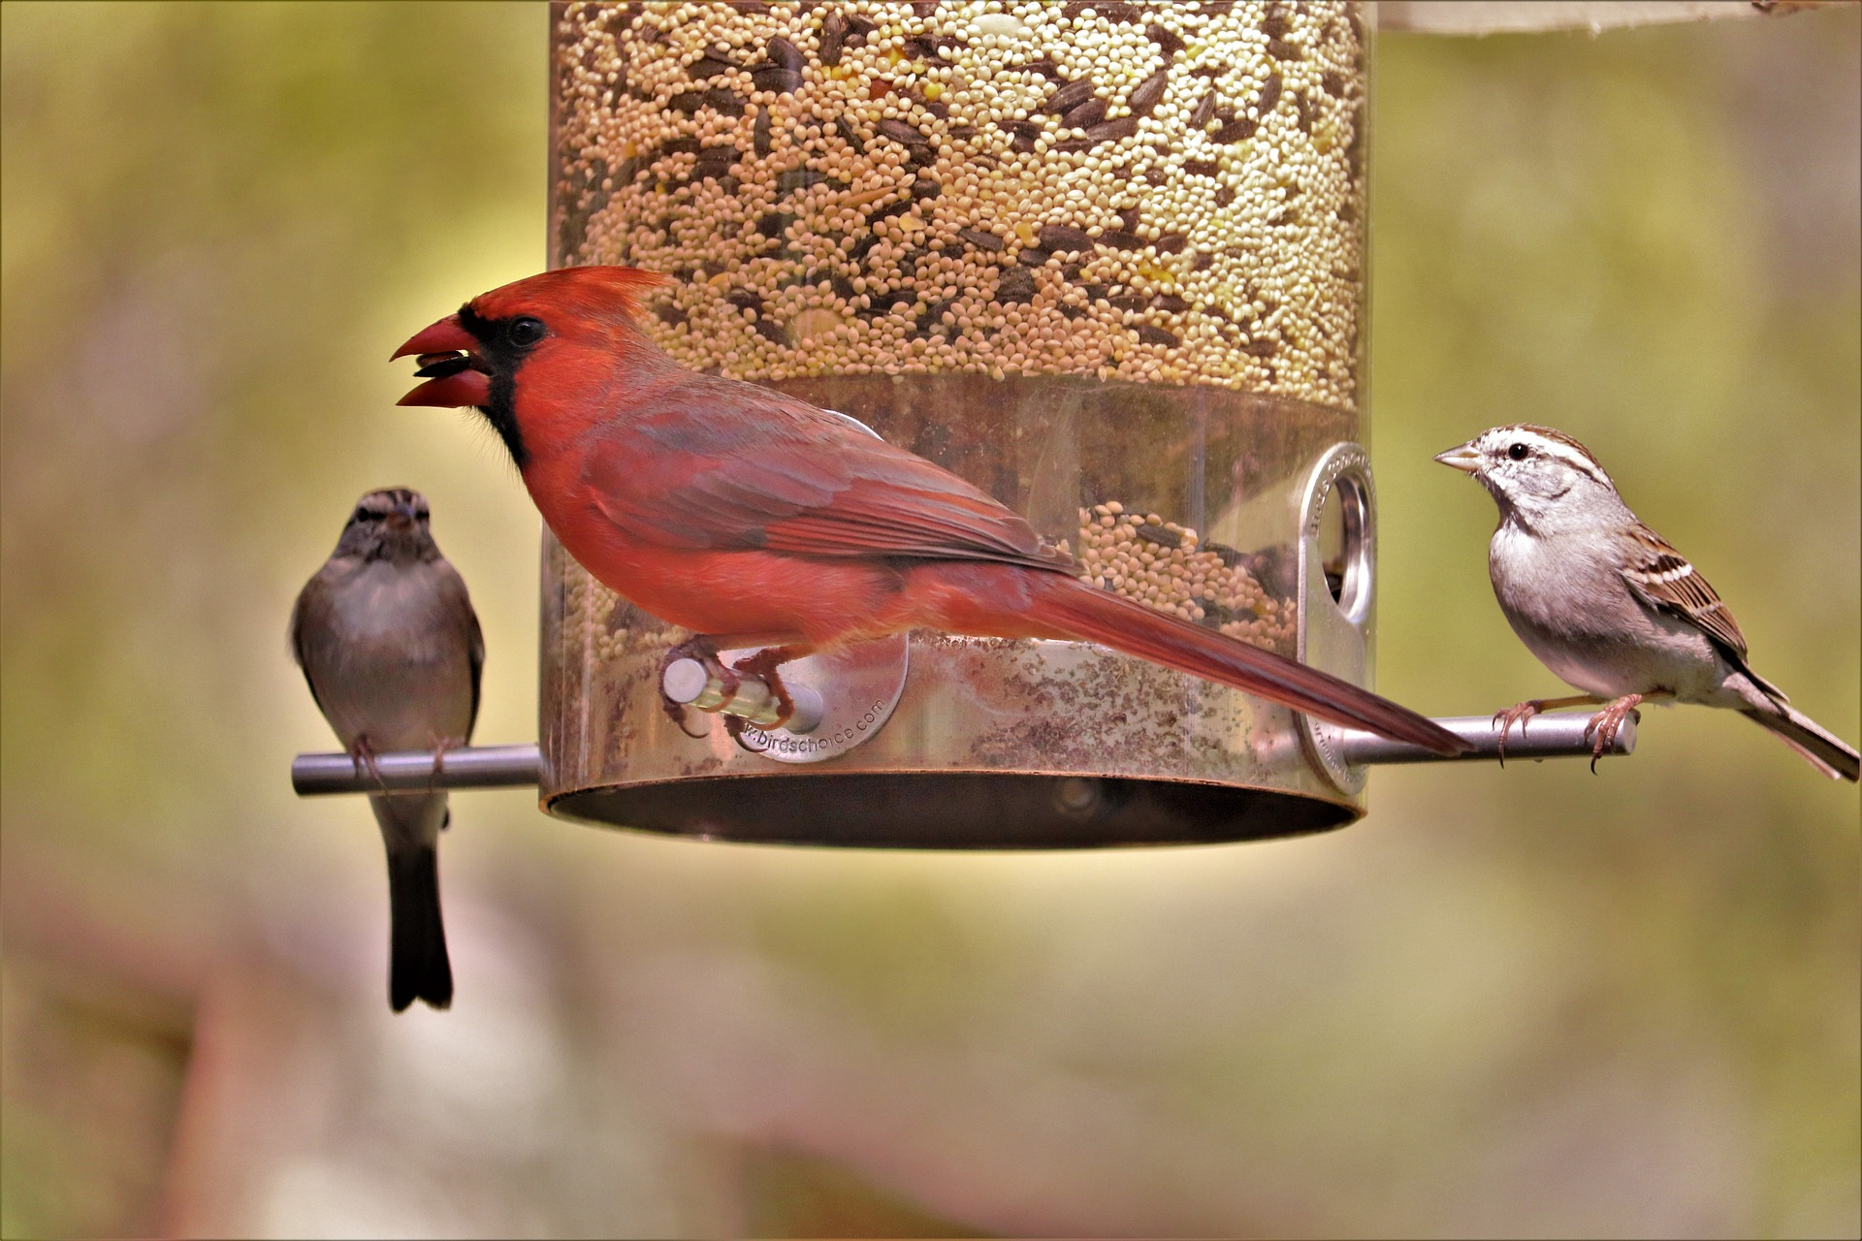
Northern cardinal. Photo credit: George B.

Post 5: Bat houses + BatCon
Facebook: Many species of bats are dependent on dead and dying woody vegetation for shelter. We often remove dead or dying trees for our own safety, leaving bats with no safe places to roost as they migrate, settle, and raise their young. To give our flying friends a safe place to stay, consider building a bat house! Download designs for building your own bat house from batcon.org.
Instagram: Many species of bats are dependent on dead and dying woody vegetation for shelter. We often remove dead or dying trees for our own safety, leaving bats with no safe places to roost as they migrate, settle, and raise their young. To give our flying friends a safe place to stay, consider building a bat house! Download designs for building your own bat house at the link in our bio. #Bats #BatHouse #FlyingFriends
Twitter: By removing dead or dying trees for our own safety, we leave bats with no safe places to roost. To give our flying friends a safe place to stay, consider building a bat house! Download designs for building your own bat house from batcon.org. #Bats #BatHouse #FlyingFriends
Images:
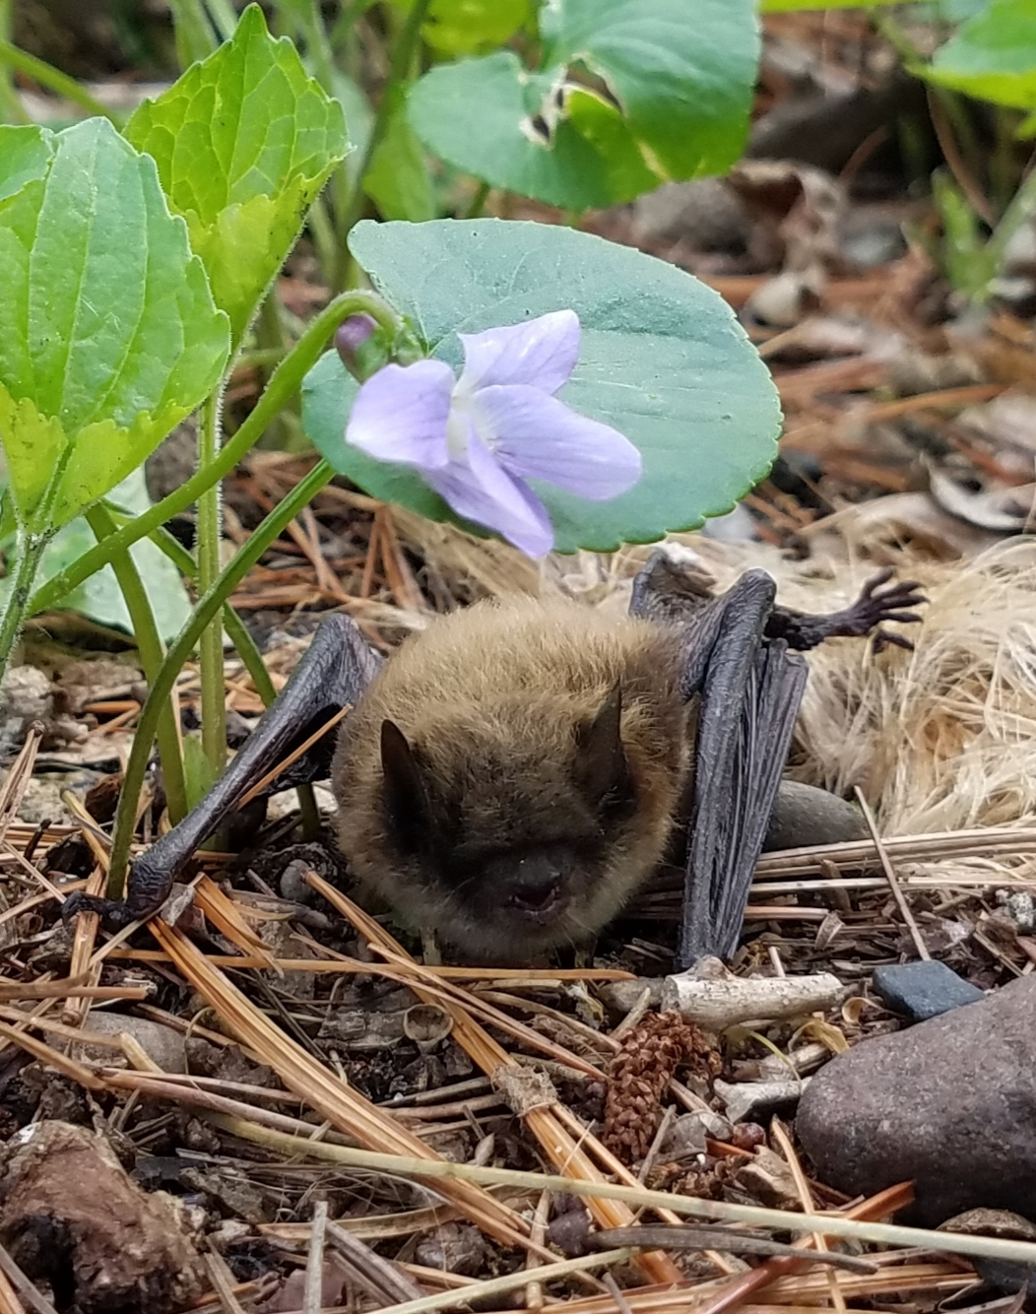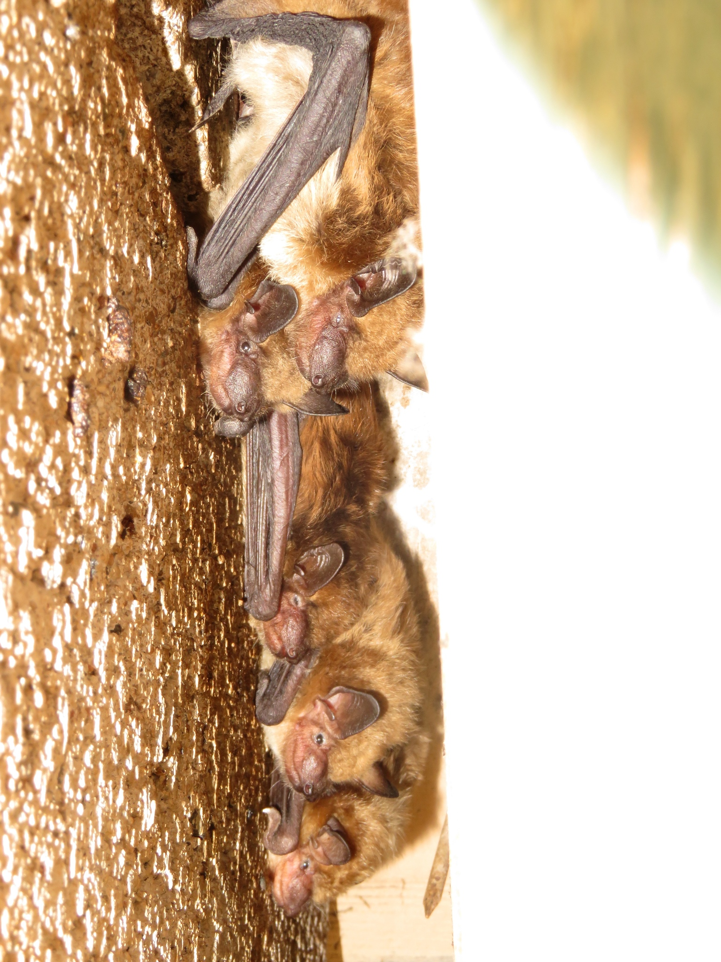
Big brown bats. Photo credit: Christopher Smith
Little brown bat. Photo credit: Paul Erdmann

