MNimize Media Kit and Promotional Materials
About MNimize
MNimize is a new program from Minnesota Waste Wise Foundation offered in partnership with Hennepin County to recognize and support food service businesses in their efforts to reduce single-use plastic and achieve their sustainability goals. As a tiered recognition program, MNimize awards businesses at one of four achievement levels based on their efforts to reduce single-use plastic. The program also helps businesses identify opportunities to continue reducing single-use plastic, and provides technical assistance so they can take further action.
Additionally, MNimize offers financial support to businesses through the MNimize Rebate. Participating businesses can get up to $500 toward eligible expenses to reduce single-use plastic. This rebate could be used to purchase durable reusable or certified compostable alternatives to replace single-use plastic items or for other creative plastic reduction strategies.
Reducing single-use plastic is an impactful opportunity to divert waste, keep plastic out of the environment, build brand loyalty with existing and new customers, and generate cost savings. MNimize is proud to celebrate the efforts of businesses taking action to reduce single-use plastic and advance sustainability in the food service industry!

Help spread the word
- Download and share the social media graphics. Sample social media posts to go with the graphics are included in this document. You can also download these graphics, MNimize logos, and our promotional flyer from our Google Drive.
- Follow MNimize on social media and reshare our posts to promote participating businesses and encourage others to join.
  - Instagram: @mnimizeplastic
  - Facebook: MNimize
- Use the sample newsletter article to share with your organization and network.
- Encourage businesses in your network to learn more about and participate in MNimize using the sample email message below.
- Refer potentially interested businesses directly to the program by emailing us at hello@mnimize.org
- Share our promotional flyer (last page of this document) via email or by printing and distributing
- Support MNimize businesses! Follow them on social media, reshare their content (especially about MNimize), become their customers, and leave positive reviews for them on Yelp or Google!

Social Media Graphics & Posts
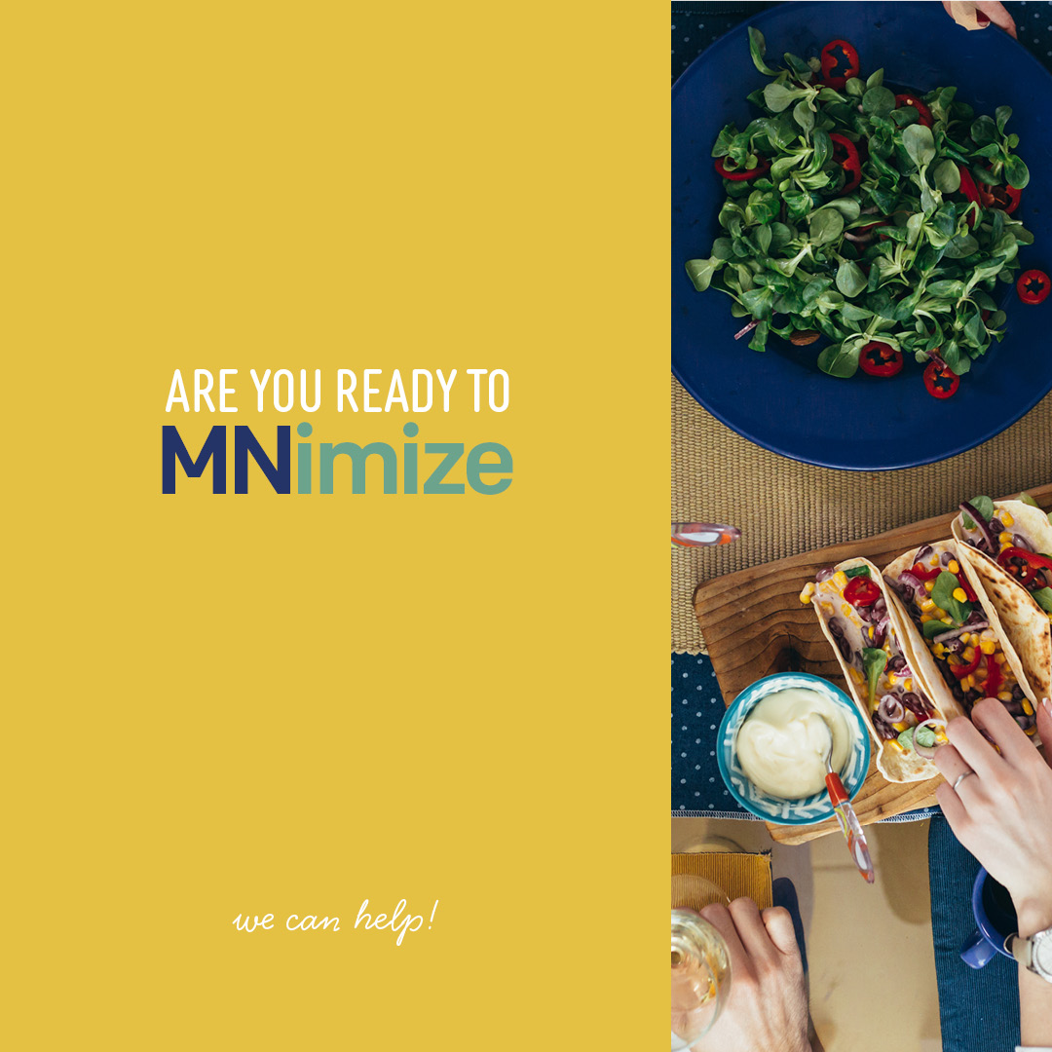Sample Caption #1:
Sick of single-use plastic? So are we.
MNimize is a campaign to help food service businesses reduce plastic waste. Businesses taking action will receive recognition for their plastic reduction efforts and can take advantage of support and funding to go even further. Learn more at mnimize.org
#MNimize #singleuseplastic #sustainablebusiness

Sample Caption #2:
Set your business up for continued success with MNimize. Reducing plastic waste can help you save on procurement costs. Imagine not needing to continually reorder and store plastic items! Plus, customers are excited to see their favorite businesses provide reusable options.
#minnesotafoodie #minnesotanice #sustainablebusiness

.

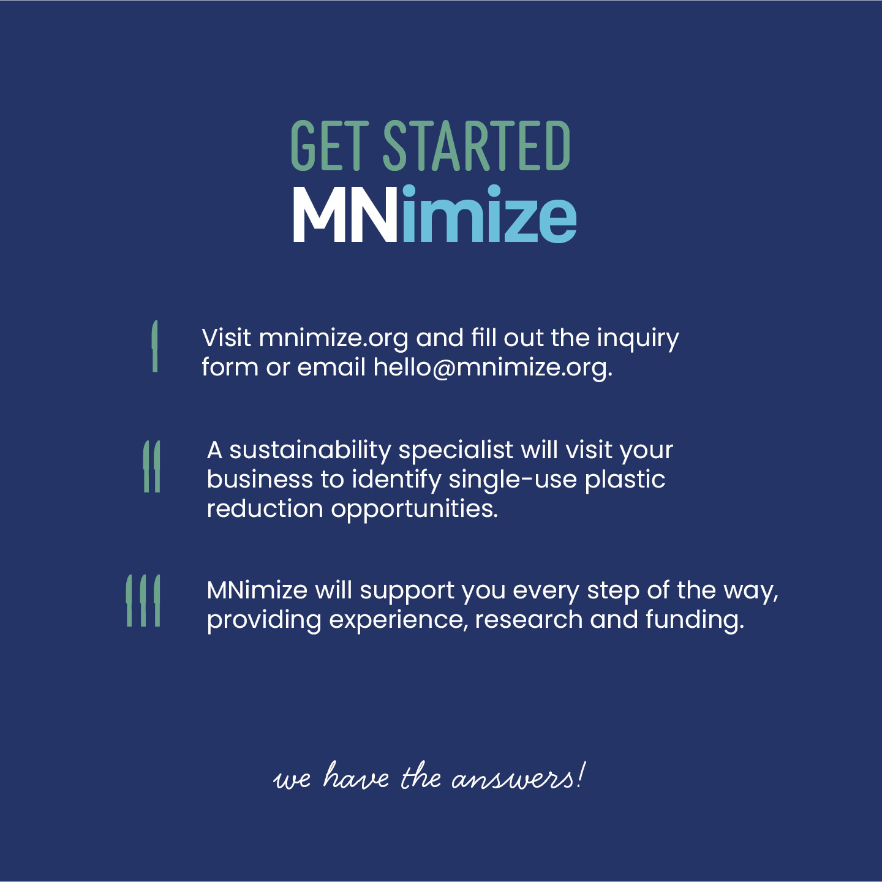Sample Caption #3:
MNimize is now serving expert sustainability experience and knowledge. A sustainability specialist will visit your business to identify single-use plastic reduction opportunities. They will help you through the implementation process by researching alternatives, educating staff, and applying for funding. Reach out and get your specialist today. Mnimize.org/contact
#MNimize #sustainability #sustainableminnesota

Please tag MNimize in all posts so we can reshare on our platform. You can also tag businesses in your network or community in the posts.

Sample newsletter article
Free new plastic reduction program for food businesses
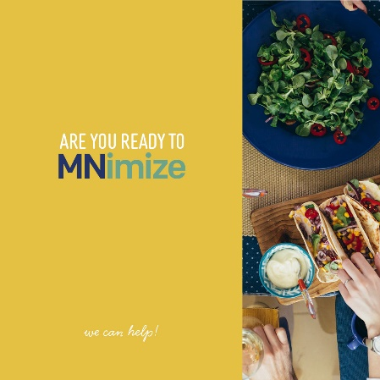
Minnesota Waste Wise Foundation, in partnership with Hennepin County, has launched a new program to help food businesses reduce single-use plastic waste and receive recognition for their efforts. MNimize awards businesses at one of four achievement levels based on their efforts to reduce single-use plastic. The program also helps businesses identify opportunities to continue reducing single-use plastic and provides technical assistance so they can take further action.

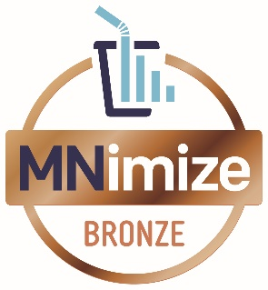
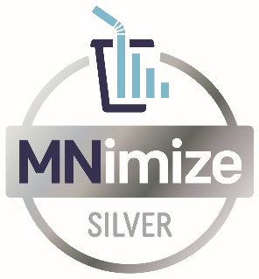
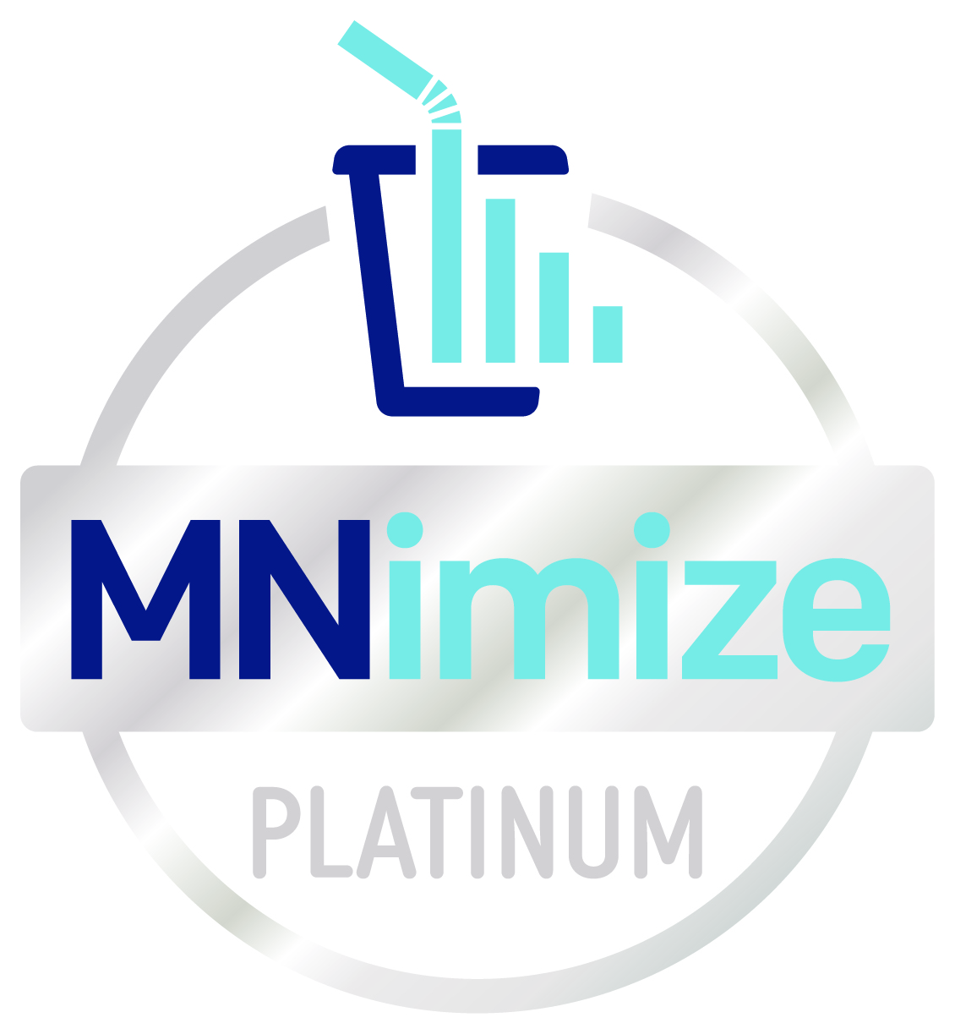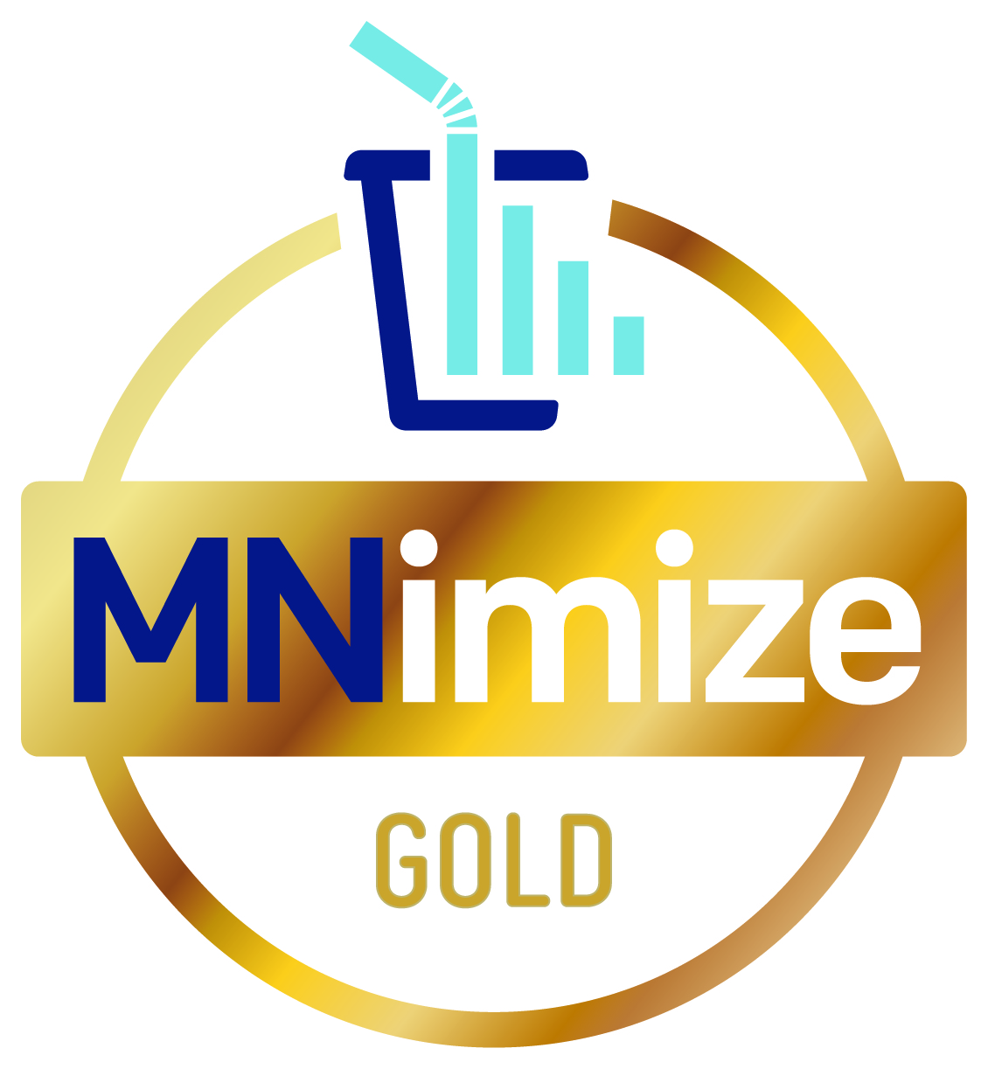

Additionally, participating businesses can get up to $500 through the MNimize Rebate toward eligible expenses to reduce single-use plastic. This rebate could be used to purchase durable reusable or certified compostable alternatives to replace single-use plastic items or for other creative plastic reduction strategies.
Businesses across Hennepin County are already making an impact through their participation in MNimize. La Doña Cerveceria took advantage of the MNimize Rebate to replace their plastic-lined paper food trays with reusable metal trays and durable plastic baskets. This change will avoid an estimated 53,000 disposable items every year, resulting in an annual cost savings of over $1,500.
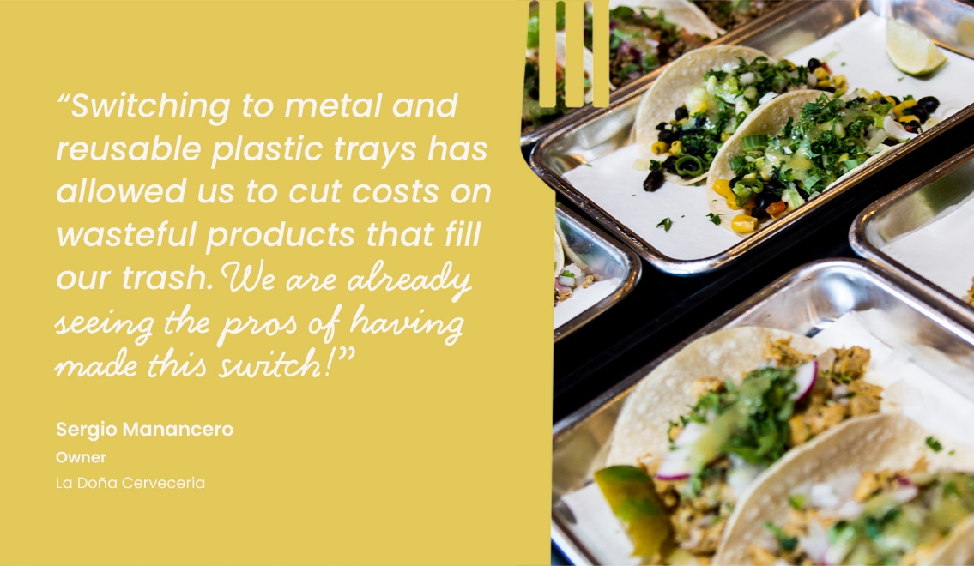
Reducing single-use plastic is an impactful opportunity to divert waste, keep plastic out of the environment, build brand loyalty with existing and new customers, and generate cost savings. MNimize welcomes any and all food businesses that are interested in tackling single-use plastic waste. To get started, visit the website and submit an inquiry form. A MNimize Sustainability Specialist will reach out to schedule a visit to your business and help you take the next steps!

Sample email message to food business owner/operator
Dear (NAME),
Because you are a valued member of our community, we are excited to share a new, free resource to help you save money and receive recognition for your efforts to run a sustainable business.
Minnesota Waste Wise Foundation has launched a new program to help food businesses reduce single-use plastic waste and receive recognition for their efforts. MNimize awards businesses at one of four achievement levels based on their efforts to reduce single-use plastic. The program also helps businesses identify opportunities to continue reducing single-use plastic and provides technical assistance so they can take further action.
Additionally, participating businesses can get up to $500 through the MNimize Rebate toward eligible expenses to reduce single-use plastic. This rebate could be used to purchase durable reusable or certified compostable alternatives to replace single-use plastic items or for other creative plastic reduction strategies.
To learn more, visit the website or reach out directly at hello@mnimize.org. You can also learn more about businesses that have already joined by following MNimize on Instagram or Facebook.
We hope you choose to take advantage of this great opportunity, and we’re excited to celebrate and promote your achievement!
Sincerely,
(YOUR NAME)

Access promotional materials on Google Drive

