How to join a county Microsoft Teams meeting

If you currently use Teams:

- Choose “Join Microsoft Teams Meeting” in the email invitation or click the public link to the meeting.

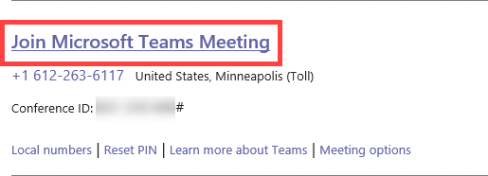
- Participants can choose to join the full audio and video conference by using the Teams application or through the Teams website (teams.microsoft.com).

- Note: any Teams user, not just Hennepin County employees, will have the option of joining meetings through the Teams application.

- You will then be taken to the Lobby for the call.

- Once the meeting creator admits you, you will have access to the meeting.

If you do NOT currently use Teams:

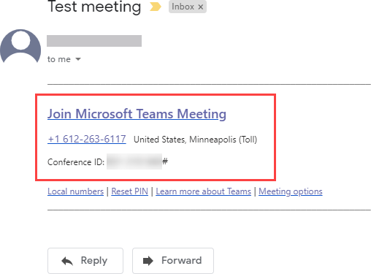
- Choose “Join Microsoft Teams Meeting” in the email invitation or click the public link to the meeting. This will take you to the Teams Web App.

NOTE: If you call in to the meeting, you will only be able to participate in the audio portion and will not see visuals, if any are shared.
- If this is your first time joining a Teams meeting, you will be prompted to either install Teams or use the web app. Select “Join on the web instead” for quicker access.

NOTE: Some browsers, including Internet Explorer, Firefox, and Safari, don’t support Teams calls and meetings. Supported browsers include Microsoft Edge and Google Chrome, both are available for Windows or iOS. While it’s best to download the Teams app or use a different browser, you can join a call or meeting on one of these browsers and use your phone for audio. Learn more
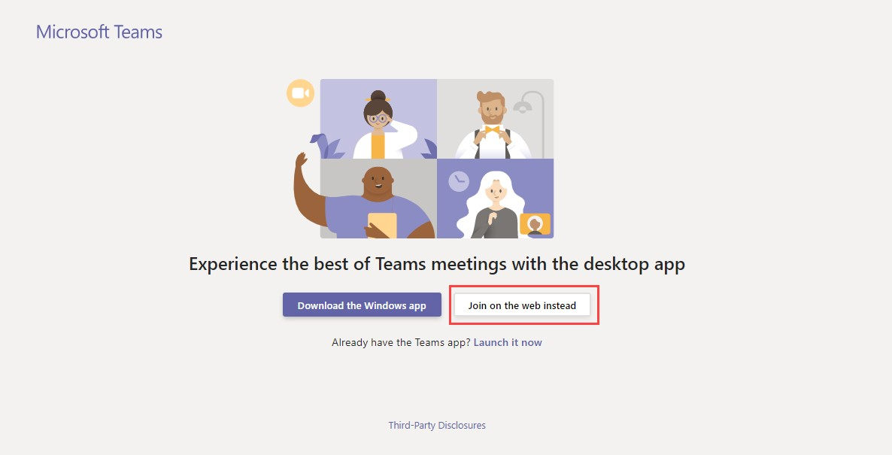

- First, enter your name and click "Join now"
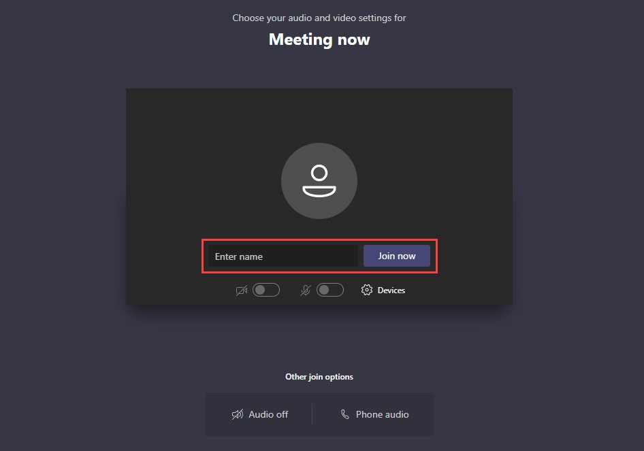

  - You will then be taken to the Lobby for the call.

  - Once the meeting creator admits you, you will have access to the meeting.

